**سبحان الله وبحمده سبحان ربي العظيم**

**[](http://www.google.com.sa/url?sa=i&rct=j&q=&esrc=s&source=images&cd=&cad=rja&uact=8&ved=0ahUKEwiBzpigq8TKAhUISRoKHRIBDKoQjRwIBw&url=http://www.alshmsan.com/arabic-mailing-bulletins.html&psig=AFQjCNH8yzzcA3YFtX7whnwgIuq7pb436Q&ust=1453789806577572)**

**[](http://www.dreamjordan.com/showthread.php?t=49276)**

**[](https://www.google.com.sa/url?sa=i&rct=j&q=&esrc=s&source=images&cd=&cad=rja&uact=8&ved=0ahUKEwj24_bMrMTKAhULVRoKHSVsCNIQjRwIBw&url=https://www.youtube.com/watch?v=BrwJCo2D1oA&psig=AFQjCNH3oGbjQ8D3ayewbl_hBfO4m1tYLQ&ust=1453790138251015)**

**[](http://www.google.com.sa/url?sa=i&rct=j&q=&esrc=s&source=images&cd=&cad=rja&uact=8&ved=0ahUKEwj41ozxrMTKAhUFPxoKHbseA44QjRwIBw&url=http://www.fci.bu.edu.eg/fci/index.php/item/97-%D8%A5%D8%B3%D8%AA%D8%A8%D9%8A%D8%A7%D9%86-%D8%A7%D9%84%D8%B7%D9%84%D8%A7%D8%A8-%D8%A7%D9%84%D8%A5%D9%84%D9%83%D8%AA%D8%B1%D9%88%D9%86%D9%89&psig=AFQjCNFviYt0conoqMi-15-h24H_BuoNNw&ust=1453790247652581)**

**[](http://www.google.com.sa/url?sa=i&rct=j&q=&esrc=s&source=images&cd=&cad=rja&uact=8&ved=0ahUKEwjTm-C4rcTKAhWBfhoKHfY9AK4QjRwIBw&url=http://ar.aliexpress.com/promotion/promotion_color-paper-a4-promotion.html&psig=AFQjCNGWyu1WaEPhKkExBiaUfiqWBlhFQg&ust=1453790391253599)**



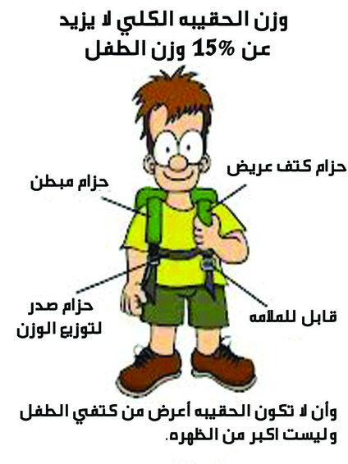

**[](http://www.google.com.sa/url?sa=i&rct=j&q=&esrc=s&source=images&cd=&cad=rja&uact=8&ved=0ahUKEwjq95j5x4PMAhXGbBoKHZPnCSwQjRwIBw&url=http://ar.moroccoworldnews.com/?p=69771&psig=AFQjCNHGvb55FAD4CuzdWeBg7wAscrCSEw&ust=1460360217992174)**

**[](http://www.google.com.sa/url?sa=i&rct=j&q=&esrc=s&source=images&cd=&cad=rja&uact=8&ved=0ahUKEwjxqbjUx4PMAhVIiRoKHeVXDHUQjRwIBw&url=http://themanager1.blogspot.com/2014/03/blog-post_29.html&psig=AFQjCNG_1wnbAqIu7JJnaNbDEuAru9HXEA&ust=1460360146973151)**

[](http://www.google.com.sa/url?sa=i&rct=j&q=&esrc=s&source=images&cd=&cad=rja&uact=8&ved=&url=http://www.laithedu.gov.sa/forum/showthread.php?t=13223&psig=AFQjCNEN8coJFgrsa3iBlhh4JvpMf7FSHA&ust=1460361087288832)

[](http://www.google.com.sa/url?sa=i&rct=j&q=&esrc=s&source=images&cd=&cad=rja&uact=8&ved=0ahUKEwjI2PzBzoPMAhXIuhoKHbOABbgQjRwIBw&url=http://www.nawalalhelali.com/n/news.php?action=view&id=60&psig=AFQjCNGF0vbyqwyqWLhAR4xa6bdqm3D11g&ust=1460361893479506)

**[](http://www.google.com.sa/url?sa=i&rct=j&q=&esrc=s&source=images&cd=&cad=rja&uact=8&ved=0ahUKEwjvtOadzoPMAhVIPBoKHRHdApEQjRwIBw&url=http://forums.roro44.net/390621.html&psig=AFQjCNGF0vbyqwyqWLhAR4xa6bdqm3D11g&ust=1460361893479506)**

**[](http://arabicceo.blogspot.com/2014/04/blog-post_5427.html)**