Kingdom of Saudi Arabia 1st Term Exam
Ministry of Education first Session
Secondary School time : 3 hours.
1st grade
Year: 1436-1437 AH

Q1/ COMPOSITION : A/ Using the following table ; write a paragraph about your best friend

Name | Maha
Age | 25
Job | A teacher
Personality | active , helpful
Skills | Cooking freak ,take pictures

8

....................................................

............................................................................................................................................................... .................................................................................................................................................................. ..................................................................................................................................................................................................................................................................................................................................................................................................................................................................................................................................................................................................................................................................................................................................................................................................................................................................................................................................................................................................................
..........................................................................................................................................................................................................................................................................................................................................................................................................................................................................................................................................

B/ Write an e-mail to your friend inviting her to your graduation party . use the following phrases
writing to invite , It will be in my house , bring , cousins, I need your help, arrangement
waiting for you

………………………………………………………………………………………………………………………………………………………………
………………………………………………………………………………………………………………………………………………………………
………………………………………………………………………………………………………………………………………………………………
………………………………………………………………………………………………………………………………………………………………
………………………………………………………………………………………………………………………………………………………………
……………………………………………………………………………………………………………………………………………………………….
……………………………………………………………………………………………………………………………………………………………….
……………………………………………………………………………………………………………………………………………………………….
………………………………………………………………………………………………………………………………………………………………………………………………………………………………………………………………………………………………………………………………………………………………………………………………………………………………………………………………………………………………………………………………………………………………………………………………………………………………………………………………………………………………………………………………………………………………………………………………………………………………………………………………………………………………………………………………………………………………………………………………………………………………………………………………………………………………………………………………………………………………………………………………………………………………………………………………………………………………………………………………………………………………………………………………………………………………………………………………………………………
Q 2l Comprehension : Read the following passage , then answer the questions in complete sentences

Fast food is the food sold in many inexpensive restaurants as McDonald’s, Kentucky and Hardee's . It called “Fast” because you get your food very quickly. It might take you only twenty minutes to get in, order your meal, eat it and leave. The kind of food served in those restaurants are beef and cheese burger, hot sausage, fried chickens and French fries which are full of fats and carbohydrates. A fast food meal also includes a soft drink like cola, soda, juice or milk shake.
The problem is that such kind of food is so rich in fats, sugar, salt and cholesterol. Doctors advise us to eat less fast food, more salads because they are good for health, and drink less sugary juice. They say that fast food is a reason for getting fat and it might cause some people to get heart problems.
A. Answer the Questions in complete sentences:
- Why is it called fast food ?
…………………………………………………………………………………………………. 12
- What is fast food rich in?
………………………………………………………………………………………………….
- Does eating much fast food cause a person to get fat ?
………………………………………………………………………………………………….

1.
2.
3.
4.
B. Tick ( ) or ( ) next to each statement :
- Doctors advise us to eat more salads.
- Food that contains too much fats is bad for the heart.
- French fries are rich in proteins.
- Eating more beef burgers is healthy.
c. Complete the sentences :

- Soft drinks like ………………..… and ………….……..
- Famous fast food restaurants as…………………………. and ………….…………….

d. From the passage, find the opposite to these words :
expensive …………………… hard ……………………
cold …………………… slow ……………………

e. Write down what each pronoun stands for :

1. they …………………… 2. it ……………………

f. Write under each picture whether its [ Fast food or Healthy food ] :
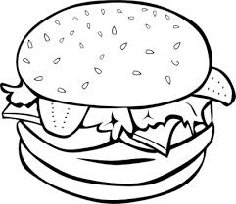  .......................... | 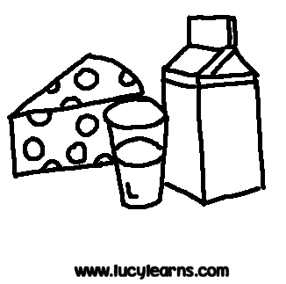  .......................... | ……................... | 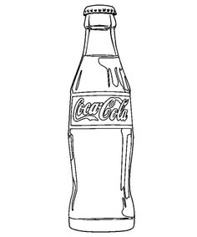  ...........................

''''''''''''''''''''''''''''''''''''''''''''''''''''''''''''''''''''''''''''''''''''''''''''''''''''''''''''''''''''''''''''''''''''''''''''''''''''''''''''''''''''''''''''''''''''''''''
3- Grammar :
a- choose the correct words

1. I am from Saudi Arabia . I am [ Saudi - Saudian ] 10
2. Are [those – this –that ] your bags over there?
3. That’s my brother. [ his – her- their ] name is Hassan.
4. When [does - do –did] he start work ?
5. [ Whose - Who’s -- What] mobile is this?
6. How [ much – many – any ] milk do you drink a day ?
7. I usually put lots of salt [ but , and , so ] pepper on my pasta.
8. Where [do - did -- does ] you go yesterday ?
9. Lucy is still a baby. She can’t speak [ clear – clearly ].
10. Let’s go to bed. We have to [ getting – get – gets ] up early tomorrow morning.
B: Do as shown between brackets:

1 . I want you to lend me your laptop. ( write requests using could)
............................................................................................
2-Can Ali ride a motorbike? [ answer the question ]
...............................................................................
3-He cooks dinner on Friday night [ Rewrite the sentence using never ]
.........................................................................................................................................

4-My parents ............................ (not cook) on Friday evenings . [ make negative ]
5- We eat healthy food . [Rewrite the sentence using have to]
..........................................................................................................................................

''''''''''''''''''''''''''''''''''''''''''''''''''''''''''''''''''''''''''''''''''''''''''''''''''''''''''''''''''''''''''''''''''''''''''''
VOCABULARYA- Give the opposites:

1- Active ....................... 2- Serious .................................. 10
3- Outgoing .......................... 4- Polite ................................

B-Choose the right words:
1. My brother can take really nice pictures. He’s [ doctor -- a photographer -- salesperson ] .
2. This pair of [ bags -- shoes – books ] is very expensive.
3. Ronald is ill in bed. Give him this [ bottle - bowl – can] of Soup to eat.
4. I’m really [ hungry – busy -- ill ] I can’t wait till lunch break.
5. Adam can’t work as a secretary because he can’t [ use – type - ride ] a computer.
6. My brother's new car is in the [ garage –balcony - kitchen ]

C- write the numbers under the pictures:
1-chemistry ,2– thirsty ,3– hungry ,4- photographer ,5– delivery person ,6 –waiter , 7-bed

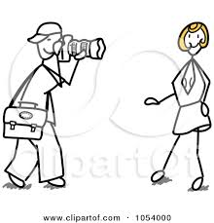
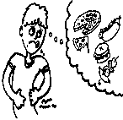

D-Match the two columns

1. lose [ ] sightseeing
2. talk [ ] out with friends
3. hang [ ] on the phone
4. go [ ] my memory
--------------------------------------------------------------------------------------------------------------------
Good Luck

A. Match.
1. do
2. clean
3. go
4. take up
5. hang out
6. have
a. shopping at the mall
b. dinner
c. homework
d. with friends
e. the windows
f. a sport

B. Complete the sentences with the words in the
box. Thursdays receptionist invite
screen graphic designer Saturday

A. Match.
a. conditioner
b. room
c. driver
d. machine
e. table
f. centre
1. bedside
2. living
3. air
4. city
5. bus
6. washing

3. Visit the museum. It’s a beautiful building / ceiling.
4. I love Paris, special / especially in the spring.
5. My son / daughter has lots of fun when her
cousins come to our house.
6. Don’t decide / bring your umbrella. It never rains

.
4. I have a horrible rash / flu on my arm.
5. Naim always buys strong / trendy clothes.
6. Drinking the water from this river can be
harmful / dizzy to your health.
7. Ronald is ill in bed. Give him this bowl / bottle of
soup to eat.

3. Listen! The phone is hitting / ringing!
48- My favourite subject is ( hiking – chemistry - cherries ).
49- My favourite holiday activity is ( camping – biology-

