اسم الطالب/ة : ................................................ الفصل: .......................

6

**I- General Questions:**

A- Match the questions in column (A) with the correct answers in column (B):

|  |  |
| --- | --- |
| B | A |
| ( ) He is a doctor.  ( ) I cooked breakfast.  ( ) I made a rocket  ( ) 2 cups of flour  ( )I want to be a teacher  ( ) I usually go to bed at 9:00 | 1- What did you do over the weekend?  2- How much flour do we need ?  3-What good things happened to you last year ?  4- What does your dad do ?  5- What time do you go to bed ?  6- What do you want to be when you grow up ? |

**II- Controlled Writing:**

5

A- Complete the sentences with the correct word:

**sick**

**fires**

**thirty**

1- Firefighter put out ______

2- Ten , twenty , ________ , forty.

3- Doctors help _________ people.

B- Rearrange the words to form a sentence:

1- game / We / a football / won

………………………………………………….

2- scary / How

………………………………………………….

**III- Grammar:**

5

A) Choose the correct word:

1- I usually ( take – took ) a bath in the morning.

2- Yesterday , I ( play – played ) computer games.

3- We don't have ( some – any ) oil.

B) Fill in the spaces with **much** or **many** :

1- How ________ oil do you need ?

2- How ________ apples do you eat ?

**IV- Reading Short Sentence:**

A- Read the sentences and match them with the correct pictures:

4

1- It's 10:30 2- a half past three 3- He is a baker

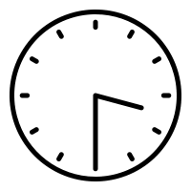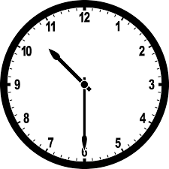

B- Read the question and choose the correct answer:

1- I broke my leg.

a) congratulations b) How nice c) sorry about that

6

**V- Vocabulary:**

A) Write the correct number under each picture:

**1**- pizza **2**- teacher **3**- boot **4**- diver **5**- bed **6**- reporter

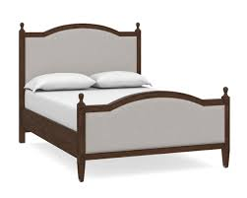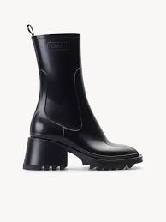

( ) ( ) ( ) ( ) ( ) ( )

**VI- Orthography:**

4

A) Choose the correct letter:

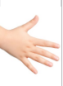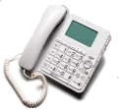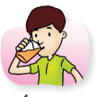

1- dri_ _ 2- _ _one 3- ha_ _ 4- lau_ _

( nk – sh – ch ) ( f – ph – kn ) ( gh – sh – nd ) ( gh – nt – nk )

|  |  |  |  |  |  |  |
| --- | --- | --- | --- | --- | --- | --- |
| MMLKH  وزارة التعليم  الإدارة العامة للتعليم بمنطقة مكة المكرمة  مدرسة عبدالرحمن بن عوف الابتدائية | images | رقم السؤال | الدرجة | | المصحح | المراجع |
| رقماً | كتابة |
| 1 |  |  |  |  |
| |  |  | | --- | --- | | المادة | لغة إنجليزية | | الصف | الرابع الابتدائي | | الزمن | ساعة ونصف | | 2 |  |  |  |  |
| 3 |  |  |  |  |
| المجموع |  | | | |
| أسئلة اختبار الفصل الدراسي ( الثاني ) للعام الدراسي 1445هـ | | | | | | |

|  |  |  |  |
| --- | --- | --- | --- |
| اسم الطالب : |  | رقم الجلوس |  |

**Q1. A– Answer the following questions :**

**10**

|  |  |  |
| --- | --- | --- |
| 1. **Where do you work?**  **I work ………………** | | |
| **B.** **in time** | **A**. **in a school** |  |
| **2. What time is it?** | | |
| **B. It's 9 o'clock** | **A. It's 6 o'clock** |  |
| **3. How much flour do we need?** | | |
| **B. We need 2 cups.** | **A. It is 10 SAR.** |  |
| **4. I won a table tennis game 21 to 3 .** | | |
| **B. bad** | **A. good** |  |
| **5 – What would you like ?** | | |
| **B. I would like a burger .** | **A. No, thanks.** |  |

**_____________________________________________________________________________________**

**B- Read and put 🗸 or 🗴 :**

|  |  |  |  |
| --- | --- | --- | --- |
| **1. It is seven o'clock** |  | **🗸** | **🗴** |
| **2-**  **That's boring .** |  | **🗸** | **🗴** |
| 3- **He is fire fighte** |  | **🗸** | **🗴** |
| **4- He is a pilot.** |  | **🗸** | **🗴** |
| **5- She watched TV.** |  | **🗸** | **🗴** |

**__________________________________________________________**

**Q2. A- Choose the correct answer:**

**10**

|  |  |  |  |  |
| --- | --- | --- | --- | --- |
| 1- I usually ………….to bed at 11 p.m. | goes | go | went |  |
| 2-Yesterday, I …………. my room. | clean | cleaned | cleans |  |
| 3-How.……….tomatoes do you need? | is | much | many |  |
| 4-last year, I …………. my leg. | break | broke | breaks |  |
| 5-We have.......................apples. | a | some | any |  |

**B- Write the word under the correct picture**

1-Three hundred 2- doctor 3- trampoline 4 -brush teeth 5- drink

|  |  |  |  |  |
| --- | --- | --- | --- | --- |
|  |  |  |  |  |
| .................... | .................... | .................... | .................... | .................... |

**______________________________________________________________________**

**Q3 A**- **Do as shown between brackets:**

**10**

|  |  |  |  |  |
| --- | --- | --- | --- | --- |
| 1- room _ my _ cleaned _ I . | (Rearrange) | ……………………................................. | | |
| 2– pilot – a – is - He | (Rearrange) | ……………………................................. | | |
| 3 – 100______500 | (complete) | 100, 200, …….............,400,500 | | |
| 4- I'd like ……………. please . | (choose) | cheese | pizza | Ice cream |
| 5-  [………… time do you come home](https://t.me/madty6/7679)? | ( choose ) | Where | What | When |

**B. Fill in the missing letters with: [ ph – kn – ng – nt – nd ]**

|  |  |  |  |  |
| --- | --- | --- | --- | --- |
|  |  |  |  |  |
| **Sta ………** | **Te ………** | **Ri …………** | **………ife** | **ele ………ant** |

**______________________________________________________________________**

**GOOD LUCK**

|  |
| --- |
| **اختبار نهاية الفصل الدراسي الثاني للعام الدراسي 1445 (الدور الأول) – لغة انجليزية –– للصف السادس ابتدائي** |

**Q1 : Choose the right answer:**

|  |  |
| --- | --- |
| **A**. **I'm 10 years.** **B**. **He is a doctor.** | **1 – What does your dad do ?** |
| **A**. **Yes, please.** **B**. **No, I'm not.** | **2-Can I help you?** |
| **A**. **It's ten o'clock.** **B**. **It's ten thirty.** | **3- What time is it? 10:30** |
| **A**. **He puts out fire. B** .**He flies planes.** | **4 – What does the firefighter do?** |
| **A**.**I got up at 6:00 B** .**I usually get up at 6:00** | **5- What time do you get up in the morning?** |
| **A**. **I broke my leg. B. I'm playing tennis**. | **6- What happened to you last week?** |

**Q2:Do as shown between brackets:**

|  |  |  |  |
| --- | --- | --- | --- |
| **…......................................................** | | | **1 – sick – was – I (Rearrange)** |
| **million** | **thousand** | **hundred** | **2 –One _________ (Complete )** |
| **six** | **four** | **five** | **3-It's ________ o'clock (Complete)** |
| **soup** | **Ice cream** | **Cheese** | **(choose) 4-I'd like ______ please.** |
| **grocer** | **park** | **bank** | **5-I went to the _____ to buy some milk.** |

|  |  |  |
| --- | --- | --- |
| Using a digital clock**1. It's seven o'clock** | **🗸** | **🗴** |
| Cartoon Little Girl Waking Up in the Morning Stock Vector - Illustration of  yawn, kids: 173059130**2.I eat my lunch** | **🗸** | **🗴** |
| **3. He is a pilot.** | **🗸** | **🗴** |
| Free To Use & Public Domain People Clip Art - Page 10 | Nurse clip art, Nurse  cartoon, Nurse art**4. She works in a school.** | **🗸** | **🗴** |

**Q3: Choose (🗸 ) or ( × ) :**

**1**

**Q4:Choose :**

|  |  |  |  |
| --- | --- | --- | --- |
| **get** | **got** | **go** | **1 – I usually ____ up at 5:00 .** |
| **go** | **came** | **come** | **2- yesterday, I ____ home at 1:00 .** |
| **what** | **which** | **who** | **3 – ____ is he ? He is Abdullah.** |
| **where** | **what** | **who** | **4- ____ does she do ? She is a nurse .** |
| **much** | **many** | **some** | **5-How _____ oil do we need?** |
| **many** | **any** | **some** | **6- We don't have ____ flour.** |

**Q5: Choose the right word under the picture :**

|  |  |  |  |  |
| --- | --- | --- | --- | --- |
| Premium Vector | Baker cartoon character holding a bread. vector hand drawn  illustration | Cute doctor vector illustration isolated on white background. Doctor cartoon  illustration Stock Vector Image & Art - Alamy | Toothbrush Cartoon Images – Browse 23,759 Stock Photos, Vectors, and Video  | Adobe Stock |  | Cartoon Little Girl Waking Up in the Morning Stock Vector - Illustration of  yawn, kids: 173059130 |
| 1. **Baker** 2. **nurse** | 1. **police man** 2. **doctor** | 1. **brush** 2. **watch TV** | 1. **house wife** 2. **firefighter** | 1. **get up** 2. **play** |

**Q6:Fill in the missing letters :**

|  |  |  |  |
| --- | --- | --- | --- |
| Premium Vector | Cute alarm clock cartoon character |  | Cartoon Light Stock Illustrations – 284,989 Cartoon Light Stock  Illustrations, Vectors & Clipart - Dreamstime | Ring Cartoon Diamond - Free vector graphic on Pixabay | Wedding ring  drawing, Engagement ring drawings, Clip art |
| **_ _ock**   1. **cl** 2. **th** | **_ _ ee**   1. **rt** 2. **kn** | **li_ _t**   1. **gh** 2. **sh** | **ri _ _**   1. **ch** 2. **ng** |

**GOOD LUCK**

**T.Afaf Asiri**

**2**

|  |  |  |
| --- | --- | --- |
| المملكة العربية السعودية  وزارة التعليم  إدارة تعليم .......................  مكتب تعليم ....................  مدرسة .......................... |  | اختبار مادة اللغة الإنجليزية  الصف السادس الابتدائي  الفصل الدراسي الثاني  التاريخ ........................  الزمن : ساعة ونصف |

|  |  |  |  |
| --- | --- | --- | --- |
| المعلم/ة | التوقيع | المراجعـ/ة | التوقيع |
|  |  |  |  |

|  |  |  |  |  |  |  |
| --- | --- | --- | --- | --- | --- | --- |
| السؤال الأول | السؤال الثاني | السؤال الثالث | السؤال الرابع | السؤال الخامس | السؤال السادس | المجموع |
| 6 | 5 | 4 | 5 | 6 | 4 | 30 |
|  |  |  |  |  |  |  |

|  |  |  |  |  |  |
| --- | --- | --- | --- | --- | --- |
| اسم الطالب : |  | الصف : |  | رقم الجلوس : |  |

استعن بالله

***1. General Questions***

***A. Choose***



1. when I grow up, I want to be ( ***a doctor – police man*** )
2. I usually get up at ( ***half past six – 6 o'clock*** ) . 6:30
3. I ( ***watch – watched*** ) a scary movie last night .

/ 4

1. ***What did you do over the weekend?***

* I ........................... my room. ( ***cooked – cleaned*** )

*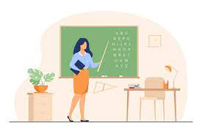****B. Complete***

1. Who is she ?

* she is a ( ***teacher – nurse*** )

/ 2

1. Where does she work?

* She works in a ( ***hospital – school*** )

***2. Controlled Writing***

***Complete the story: A.***

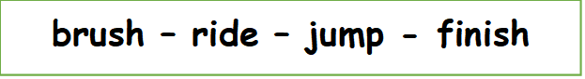

/ 2

At six o'clock, I ………… out of bed and ………………… my teeth. At one o'clock, I ………………… school and ……………… the bus home.

**P.T.O**

***B. Rearrange:***

/ 1

***firefighter – a – is – He***

…………………………………………………………………..

***C. Complete:***

/ 2

***100 - 200 - ………. - 400 - ……… - ………. – 700 – 800 – 900 - ………. .***

***3. Reading short sentences:***

***A. Write each word under the suitable picture:***

/ 2

***Rocket – Operation – Ball – fire fighter***

|  |  |  |  |
| --- | --- | --- | --- |
|  |  |  |  |
| ………..……….. | …………..……… | ……………..….. | ……………….… |

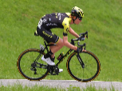***B. Write true or False:***

1. **He kicked a ball ( )

/ 2

1. 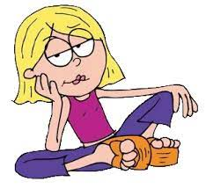He is a doctor ( )
2. That's great ( )
3. That's boring ( )

***4. Grammar :***

***A. Choose the correct answer:***

1. ( ***What – Where*** ) time do you go to bed ?
2. yesterday , I ( ***get up – got up*** ) at 8 : 00.
3. ( ***How much – How many*** ) cheese do you have?

/ 3

1. What did you do on the weekend ( ***! - ?*** )
2. He's ( ***a – an*** ) teacher .
3. We have ( ***some – any*** ) Flour .

**P.T.O**

***B. put in the suitable column :***

***Milk – Tomatoes – Juice – Potatoes***

/ 1

|  |  |
| --- | --- |
| ***Uncountable*** | ***Countable*** |
|  |  |
|  |  |

/ 1

***C. Do as shown between brackets :***

I see a rainbow ……………………………………….. ***( change to past )***

***5. Vocabulary:***

***A. Choose the suitable word with suitable pictures?***

/ 2

***Cook – tent – drink – knife – doctor – pilot***

|  |  |  |  |  |  |
| --- | --- | --- | --- | --- | --- |
|  |  |  |  |  |  |
|  |  |  |  |  |  |

***B. Circle the odd word.***

1. Cheese – chocolate – phone – cake

/ 2

1. architect – astronaut – chip – diver.
2. great – pizza – funny – happy .
3. played – cleaned – got – kicked.

***C. Match .***

/ 1

|  |  |
| --- | --- |
| ***9 : 30*** |  |
| ***1 : 10*** |  |
| ***3 : 00*** |  |
| ***5 : 45*** |  |

**P.T.O**

***D. Match .***

/ 1

|  |  |
| --- | --- |
| plant |  |
| stand |  |
| paint |  |
| hand |  |

***6. Orthography:***

/ 1

***A. Fill in with ( cl – ph – gh )***

*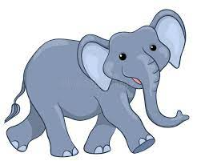****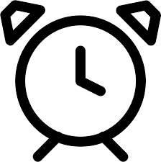***



*_ _ ock ele _ _ ant _ _ oto Li _ _ t*

*****B. Rearrange the letters :***

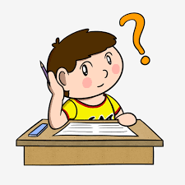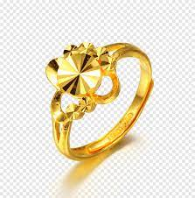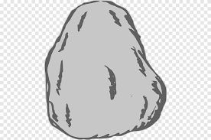

/ 1

Ockr \ ………. ingr \ …….. inkth \ ……… nki \ ………

***C. Choose the correct sound : ( \z\ - \s\ - \iz\ )***

/ 1

***1-Sleeps ______ 2- teaches ______***

***3-Walks _______ 4- goes _______***

***D. Fill in the missing letter :***

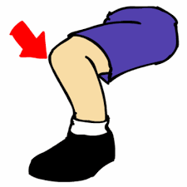

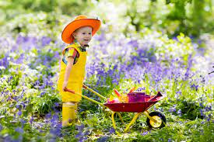

***_ rog _ now _ _ ee sprin__***

/ 1

Best of wishes

|  |  |  |
| --- | --- | --- |
| المملكة العربية السعودية  وزارة التعليم  إدارة تعليم .......................  مكتب تعليم ....................  مدرسة .......................... |  | اختبار مادة اللغة الإنجليزية  الصف السادس الابتدائي  الفصل الدراسي الثاني  التاريخ ........................  الزمن : ساعة ونصف |

|  |  |  |  |
| --- | --- | --- | --- |
| المعلم/ة | التوقيع | المراجعـ/ة | التوقيع |
|  |  |  |  |

|  |  |  |  |  |  |  |
| --- | --- | --- | --- | --- | --- | --- |
| السؤال الأول | السؤال الثاني | السؤال الثالث | السؤال الرابع | السؤال الخامس | السؤال السادس | المجموع |
| 6 | 5 | 4 | 5 | 6 | 4 | 30 |
|  |  |  |  |  |  |  |

|  |  |  |  |  |  |
| --- | --- | --- | --- | --- | --- |
| اسم الطالب : |  | الصف : |  | رقم الجلوس : |  |

استعن بالله

***1. General Questions***

***A. Choose***



1. when I grow up, I want to be ( ***a doctor – police man*** )
2. I usually get up at ( ***half past six – 6 o'clock*** ) . 6:30
3. I ( ***watch – watched*** ) a scary movie last night .

/ 4

1. ***What did you do over the weekend?***

* I ........................... my room. ( ***cooked – cleaned*** )

*****B. Complete***

1. Who is she ?

* she is a ( ***teacher – nurse*** )

/ 2

1. Where does she work?

* She works in a ( ***hospital – school*** )

***2. Controlled Writing***

***Complete the story: A.***



/ 2

At six o'clock, I jump out of bed and brush my teeth. At one o'clock, I finish school and ride the bus home.

***B. Rearrange:***

/ 1

***firefighter – a – is – He***

He is a firefighter

***C. Complete:***

/ 2

***100 - 200 - 300 - 400 - 500 - 600 – 700 – 800 – 900 - 1000 .***

***3. Reading short sentences:***

***A. Write each word under the suitable picture:***

/ 2

***Rocket – Operation – Ball – fire fighter***

|  |  |  |  |
| --- | --- | --- | --- |
|  |  |  |  |
| ***Ball*** | ***fire fighter*** | ***Rocket*** | ***Operation*** |

***B. Write true or False:***

1. **He kicked a ball ( F )

/ 2

1. He is a doctor ( T )
2. That's great ( F )
3. That's boring ( F )

***4. Grammar :***

***A. Choose the correct answer:***

1. ( ***What – Where*** ) time do you go to bed ?
2. yesterday , I ( ***get up – got up*** ) at 8 : 00.
3. ( ***How much – How many*** ) cheese do you have?

/ 3

1. What did you do on the weekend ( ***! - ?*** )
2. He's ( ***a – an*** ) teacher .
3. We have ( ***some – any*** ) Flour .

***B. put in the suitable column :***

***Milk – Tomatoes – Juice – Potatoes***

/ 1

|  |  |
| --- | --- |
| ***Uncountable*** | ***Countable*** |
| ***Milk*** | ***Tomatoes*** |
| ***Juice*** | ***Potatoes*** |

/ 1

***C. Do as shown between brackets :***

I see a rainbow I saw a rainbow  ***( change to past )***

***5. Vocabulary:***

***A. Choose the suitable word with suitable pictures?***

/ 2

***Cook – tent – drink – knife – doctor – pilot***

|  |  |  |  |  |  |
| --- | --- | --- | --- | --- | --- |
|  |  |  |  |  |  |
| ***knife*** | ***doctor*** | ***Cook*** | ***pilot*** | ***drink*** | ***tent*** |

***B. Circle the odd word.***

1. Cheese – chocolate – phone – cake

/ 2

1. architect – astronaut – chip – diver.
2. great – pizza – funny – happy .
3. played – cleaned – got – kicked.

***C. Match .***

/ 1

|  |  |
| --- | --- |
| ***9 : 30*** |  |
| ***1 : 10*** |  |
| ***3 : 00*** |  |
| ***5 : 45*** |  |

***D. Match.***

/ 1

|  |  |
| --- | --- |
| plant |  |
| stand |  |
| paint |  |
| hand |  |

***6. Orthography:***

/ 1

***A. Fill in with ( cl – ph – gh )***

********



*cl ock ele ph ant ph oto Li gh t*

*****B. Rearrange the letters :***

**

/ 1

Ockr \ rock ingr \ ring inkth \ think nki \ ink

***C. Choose the correct sound : ( \z\ - \s\ - \iz\ )***

/ 1

***1- Sleeps s 2- teaches iz***

***3- Walks s 4- goes z***

***D. Fill in the missing letter :***

**

**

***f rog s now kn ee spring***

/ 1

Best of wishes

|  |  |  |
| --- | --- | --- |
| المملكة العربية السعودية  وزارة التعليم  إدارة تعليم .......................  مكتب تعليم ....................  مدرسة .......................... |  | اختبار مادة اللغة الإنجليزية  الصف السادس الابتدائي  الفصل الدراسي الثاني  التاريخ ........................  الزمن : ساعة ونصف |

|  |  |  |  |
| --- | --- | --- | --- |
| المعلم/ة | التوقيع | المراجعـ/ة | التوقيع |
|  |  |  |  |

|  |  |  |  |  |  |  |
| --- | --- | --- | --- | --- | --- | --- |
| السؤال الأول | السؤال الثاني | السؤال الثالث | السؤال الرابع | السؤال الخامس | السؤال السادس | المجموع |
| 6 | 5 | 4 | 5 | 6 | 4 | 30 |
|  |  |  |  |  |  |  |

|  |  |  |  |  |  |
| --- | --- | --- | --- | --- | --- |
| اسم الطالب : |  | الصف : |  | رقم الجلوس : |  |

استعن بالله

***General Questions***

***A. Write the time under the correct clock ( 2 marks )***

7 o'clock – 8:30 – 5:45 – 9:20

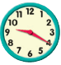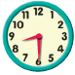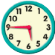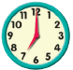

…………… …………… …………… ……………

*****B. Complete ( 2 marks )***

1. Who is she ?

* she is a ( ***teacher – nurse*** )

1. Where does she work?

* She works in a ( ***hospital – school*** )

***C. Circle good or bad : ( 2 marks )***

1. I got first place in a race ( good - bad )
2. I saw a rainbow ( good - bad )
3. I caught a cold ( good - bad )
4. I broke my leg ( good - bad )

**P.T.O**

***Controlled Writing***

***A. Complete the story: ( 2 marks )***



At six o'clock, I ………… out of bed and ………………… my teeth. At one o'clock, I ………………… school and ……………… the bus home.

***B. Rearrange: ( 1 mark )***

***firefighter – a – is – He***

…………………………………………………………………..

***C. Complete: ( 2 marks )***

***100 - 200 - ………. - 400 - ……… - ………. – 700 – 800 – 900 - ………. .***

***Reading short sentences:***

***A. Read and circle the correct answer : ( 2 marks )***

***-* How ( *many* – *much* ) flour do we have ?**

**- We have ( *some* – *any* ) flour .**

**- How ( *many* – *much* ) tomatoes do we have ?**

**- We don't have ( *some* – *any* ) tomatoes .**

***B. Write true or False: ( 2 marks )***

1. **He kicked a ball ( )
2. He is a doctor ( )
3. That's great ( )
4. That's boring ( )

***Grammar :***

***A. Choose the correct answer: ( 3 marks )***

1. ( ***What – Where*** ) time do you go to bed ?
2. yesterday , I ( ***get up – got up*** ) at 8 : 00.
3. ( ***How much – How many*** ) cheese do you have?
4. What did you do on the weekend ( ***! - ?*** )
5. He's ( ***a – an*** ) teacher .

**P.T.O**

1. We have ( ***some – any*** ) Flour .

***B. Do as shown between brackets : ( 2 mark )***

I see a rainbow ……………………………………….. ***( change to past )***

I play football ……………………………………….. ***( change to past )***

***Vocabulary:***

***A. Choose the suitable word with suitable pictures? ( 3 marks )***

***Cook – tent – drink – knife – doctor – pilot***

|  |  |  |  |  |  |
| --- | --- | --- | --- | --- | --- |
|  |  |  |  |  |  |
|  |  |  |  |  |  |

***B. Circle the odd word. ( 2 marks )***

1. Cheese – chocolate – phone – cake
2. architect – astronaut – chip – diver.
3. great – pizza – funny – happy .
4. played – cleaned – got – kicked.

***D. Match .( 1 mark )***

|  |  |
| --- | --- |
| plant |  |
| stand |  |
| paint |  |
| hand |  |

***Orthography:***

***A. Fill in with ( cl – ph – gh ) ( 2 marks )***

********



*_ _ ock ele _ _ ant _ _ oto Li _ _ t*

*****B. Rearrange the letters : ( 2 marks )***

**

Ockr \ ………. ingr \ …….. inkth \ ……… nki \ ………

|  |  |  |
| --- | --- | --- |
| المملكة العربية السعودية  وزارة التعليم  إدارة تعليم .......................  مكتب تعليم ....................  مدرسة .......................... |  | اختبار مادة اللغة الإنجليزية  الصف السادس الابتدائي  الفصل الدراسي الثاني  التاريخ ........................  الزمن : ساعة ونصف |

|  |  |  |  |
| --- | --- | --- | --- |
| المعلم/ة | التوقيع | المراجعـ/ة | التوقيع |
|  |  |  |  |

|  |  |  |  |  |  |  |
| --- | --- | --- | --- | --- | --- | --- |
| السؤال الأول | السؤال الثاني | السؤال الثالث | السؤال الرابع | السؤال الخامس | السؤال السادس | المجموع |
| 6 | 5 | 4 | 5 | 6 | 4 | 30 |
|  |  |  |  |  |  |  |

|  |  |  |  |  |  |
| --- | --- | --- | --- | --- | --- |
| اسم الطالب : |  | الصف : |  | رقم الجلوس : |  |

استعن بالله

***General Questions***

***A. Write the time under the correct clock ( 2 marks )***

7 o'clock – 8:30 – 5:45 – 9:20



9:20 7 o'clock 8:30 5:45

*****B. Complete ( 2 marks )***

1. Who is she ?

* she is a ( ***teacher – nurse*** )

1. Where does she work?

* She works in a ( ***hospital – school*** )

***C. Circle good or bad : ( 2 marks )***

1. I got first place in a race ( good - bad )
2. I saw a rainbow ( good - bad )
3. I caught a cold ( good - bad )
4. I broke my leg ( good - bad )

**P.T.O**

***Controlled Writing***

***A. Complete the story: ( 2 marks )***



At six o'clock, I jump out of bed and brush my teeth. At one o'clock, I finish school and ride the bus home.

***B. Rearrange: ( 1 mark )***

***firefighter – a – is – He***

He is a firefighter

***C. Complete: ( 2 marks )***

***100 - 200 - 300 - 400 - 500 - 600 – 700 – 800 – 900 - 1000 .***

***Reading short sentences:***

***A. Read and circle the correct answer : ( 2 marks )***

***-* How ( *many* – *much* ) flour do we have ?**

**- We have ( *some* – *any* ) flour .**

**- How ( *many* – *much* ) tomatoes do we have ?**

**- We don't have ( *some* – *any* ) tomatoes .**

***B. Write true or False: ( 2 marks )***

1. **He kicked a ball ( F )
2. He is a doctor ( T )
3. That's great ( F )
4. That's boring ( F )

***Grammar :***

***A. Choose the correct answer: ( 3 marks )***

1. ( ***What – Where*** ) time do you go to bed ?
2. yesterday , I ( ***get up – got up*** ) at 8 : 00.
3. ( ***How much – How many*** ) cheese do you have?
4. What did you do on the weekend ( ***! - ?*** )
5. He's ( ***a – an*** ) teacher .

**P.T.O**

1. We have ( ***some – any*** ) Flour .

***B. Do as shown between brackets : ( 1 mark )***

I see a rainbow I saw a rainbow  ***( change to past )***

I play football I played football ***( change to past )***

***Vocabulary:***

***A. Choose the suitable word with suitable pictures? ( 3 marks )***

***Cook – tent – drink – knife – doctor – pilot***

|  |  |  |  |  |  |
| --- | --- | --- | --- | --- | --- |
|  |  |  |  |  |  |
| ***Knife*** | ***doctor*** | ***Cook*** | ***pilot*** | ***drink*** | ***Tent*** |

***B. Circle the odd word. ( 2 marks )***

1. Cheese – chocolate – phone – cake
2. architect – astronaut – chip – diver.
3. great – pizza – funny – happy .
4. played – cleaned – got – kicked.

***D. Match .( 1 mark )***

|  |  |
| --- | --- |
| plant |  |
| stand |  |
| paint |  |
| hand |  |

***Orthography:***

***A. Fill in with ( cl – ph – gh ) ( 2 marks )***

********



*cl ock ele ph ant ph oto Li gh t*

*****B. Rearrange the letters : ( 2 marks )***

**

Ockr \ rock ingr \ ring inkth \ think nki \ ink

|  |  |  |  |  |  |  |  |  |  |  |  |
| --- | --- | --- | --- | --- | --- | --- | --- | --- | --- | --- | --- |
| **المملكة العربية السعودية** | |  | | | | **المادة:** | | **اللغة الانجليزية (شفوي)** | | | |
| **وزارة التعليم** | | **الصف** | | **الخامس الابتدائي** | | | |
| **الادارة العامة للتعليم بالإحساء** | | **التاريخ:** | | **/١٤٤٥هـــ** | | | |
| **مدرسة________الابتدائية** | | **الزمن:** | | **نصـف ساعة** | | | |
| **اختبار نهاية الفصل الدراسي الثاني – الدور الأول للعام الدراسي ١٤٤٥هـ** | | | | | | | | | | | |
| **أسم المصحح** |  | **التوقيع** |  | **أسم المراجع** |  | | | | **التوقيع** | |  |
| **الاستماع 5** |  | **التحدث 5** |  | **المجموع 10** |  | | | | | | |
| **أسم الطالب** |  | | | **الفصل** | **سادس /** | | **رقم الكشف** | | |  | |

**Listen and circle the right answer:**

|  |
| --- |
| 1. What time is it?   It’s ten - eleven – twelve o’clock. |

|  |
| --- |
| 1. Noura stayed home.   That’s okay - boring – great . |

|  |
| --- |
| 1. What bad things happened to you last year?   We lost a tennis – basketball – football game by 8 to zero. |

|  |
| --- |
| 1. An architect designs buildings.   He works in an office – company – laboratory . |

|  |
| --- |
| 1. When I grow up,   I want to be a cook - policeman – businessman . |

|  |
| --- |
| 1. At half past twelve,   I eat my lunch - snack – sandwich . |

|  |
| --- |
| 1. Nd says   hand - sand – around . |



** Write or :**

|  |
| --- |
| 1. Her dad and mom are lawyers. ( ) 2. The girls are making salad. ( ) 3. The boy ate an ice cream. ( ) |

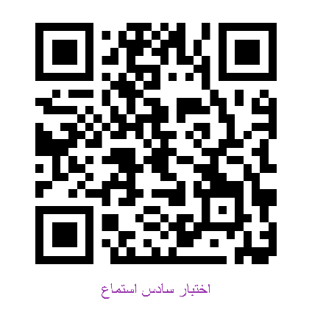**Audio Script:**

|  |  |
| --- | --- |
| We Can 3 Listening | Resources |
| 1. *Teacher*: What time is it?   *Boys*: It’s twelve o’clock. | Unit 5 - Page 43  Finding Out Time  Audio CD2 trick 14 |
| 1. *Girl:* Nourah stayed home.   *Boy:* That’s boring. | Unit 7- Page 50  Finding Out Time  Audio CD3 trick 02 |
| 1. *Teacher:* What bad things happened to you last year?   *Boy:* We lost a football game by 8 to 0. | Unit 8– Page 58  Finding Out Time  Audio CD3 trick 16 |
| 1. *Narrator:* An architect designs buildings.   He works in an office. | Unit 6 – Page 182  Grammar in Action  Audio CD7 trick 45 |
| 1. *Boy:* When I grow up, I want to be a businessman. | Unit 6 – Page 184  Rhythms and Reading  Audio CD7 trick 47 |
| 1. B*oy:* At half past twelve , I eat my lunch. | Unit 5 – Page 39  Challenge time  Audio CD2 trick 21 |
| 1. *Teacher:* ND Sand, sand , sand   *Girls:* sand, sand | Unit 7 – Page 56  Phonics  Audio CD3 trick 12 |
| 1. *Girl 1:* What does your dad do?   *Girl 2:* He’s a businessman.  *Girl 1:* What does your mom do?  *Girl 2:* She’s a teacher. | Unit 6– Page 42  Finding Out Time  Audio CD2 trick 26 |
| 1. *Girl 1:* Are you hungry?   *Girl 2:* Yes, I am. Is there anything to eat?  *Girl 1:* Why don’t we make a pizza?  *Girl 2:* That’s great idea. What do we need? | Unit 7– Page 54  Reading and Writing  Audio CD3 trick 9 |
| 1. *Boy:* Yesterday, we went to an adventure park.   Our father drove us there. It was great fun.  After the rides, dad got me a burger.  My sister didn’t want one, so he got her an ice cream.  We were really good so Dad promised to take us again  next week. I can’t wait. | Unit 8 – Page 65  Challenge Time  Audio CD3 trick29 |

Audio :<https://youtube.com/watch?v=mTRg5c3Li5U&si=EnSIkaIECMiOmarE>

|  |  |  |  |  |  |  |  |  |  |
| --- | --- | --- | --- | --- | --- | --- | --- | --- | --- |
| **المملكة العربية السعودية** | |  | | | | **المادة:** | | **اللغة الانجليزية (شفوي)** | |
| **وزارة التعليم** | | **الصف** | | **الخامس الابتدائي** | |
| **الادارة العامة للتعليم بالإحساء** | | **التاريخ:** | | **/١٤٤٥هـــ** | |
| **مدرسة________الابتدائية** | | **الزمن:** | | **نصـف ساعة** | |
| **اختبار نهاية الفصل الدراسي الثاني – الدور الأول للعام الدراسي ١٤٤٥هـ** | | | | | | | | | |
| **الاستماع 5** |  | **التحدث 5** |  | **المجموع 10** |  | | | | |
| **أسم الطالب** |  | | | **الفصل** | **سادس /** | | **رقم الكشف** | |  |

**Listen and choose**

|  |  |  |
| --- | --- | --- |
| 1. What time is it? | |  |
| 🔿 | It’s ten o’clock. |
| 🔿 | It’s eleven o’clock. |
| 🔿 | It’s twelve o’clock. |

[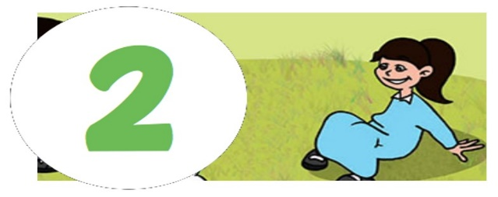](https://t.me/wecann123)

|  |  |  |
| --- | --- | --- |
| 1. Noura stayed home. | |  |
| 🔿 | That’s okay. |
| 🔿 | That’s boring. |
| 🔿 | That’s great. |

|  |  |  |
| --- | --- | --- |
| 1. What bad things happened to you last year?   We lost a______ game by 8 to 0. | |  |
| 🔿 | tennis. |
| 🔿 | football. |
| 🔿 | basketball. |

|  |  |  |
| --- | --- | --- |
| 1. An architect designs buildings   He works in a _________ | |  |
| 🔿 | office. |
| 🔿 | company. |
| 🔿 | factory. |

|  |  |  |
| --- | --- | --- |
| 1. When I grow up, I want to be_____ | |  |
| 🔿 | cook. |
| 🔿 | policeman. |
| 🔿 | businessman. |



Audio :<https://youtube.com/watch?v=mTRg5c3Li5U&si=EnSIkaIECMiOmarE>