|  |  |  |  |  |
| --- | --- | --- | --- | --- |
|  | | |  |  |
| **Kingdom of Saudi Arabia Ministry of Education**  **third Intermediate** | | | **English Language 3rd Intermediate Grade 2nd Term Exam 1443 -2022**  **Time: 2 hours The first session** |  |
|  | **Name/** …………………………………………………………… | **Seat No**./ ……………………… | |  |

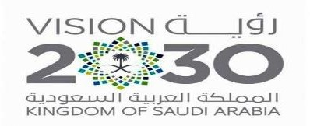

|  |  |  |  |  |
| --- | --- | --- | --- | --- |
| **Number** | **Question** | | **Student’s Mark Number** | **Student’s Mark Written** |
| **Question** | **Mark** |
| **Q1** | **Writing** | **5** |  |  |
| **Q2** | **Reading Comprehension** | **7** |  |  |
| **Q3** | **Grammar** | **8** |  |  |
| **Q4** | **Vocabulary** | **8** |  |  |
| **Q5** | **Orthography** | **2** |  |  |
| **Total Written Tasks** | | **30** |  |  |

1

***Q : 1 ( Writing )***

5

***Write a paragraph about (* yourself *) not less than 3 lines using the following words .***

***( name – age – favorite subject – hobby –food )***

*………………………………………………………………………………………………………………………………………………………*

*………………………………………………………………………………………………………………………………………………………*

*………………………………………………………………………………………………………………………………………………………*

*…………………………………………………………………………………………………………………………………………………………………………………………………………………………………………………………………………………………………………..................................................................................................................................................................................................................................................................................................................................*

***Q : 2 ( Reading )***

7

**Read the following passage then answer the questions :**

Prophet Mohammad (PBUH ) was born in Makkah in 571AD. He was an orphan. His father , Abdullah, died before he was born. His mother ,Amena, died when he was achild of six . He lived with his grandfather, Abdulmuttaleb. Prophet Mohammad died in Al-Madina in 11 Hijra( 633AD).

# A – Where was prophet Mohammad born ?

………………………………………………………………………………………………………………………….

# B – Choose the correct answer :

1 – Prophet Mohammad was born in ( **571AD – 434AD – 999AD** ) 2 – His father`s name is ( **Khaled – Ahmad – Abdullah** )

3 – His mother died when he was (**a child – a young – an adult** ) of six. 4 – He lived with his ( **aunt – uncle – grandfather** )

# C – Put ( T ) or ( F ):

1. – His mother is Amena . ( )
2. – Prophet Mohammad died in Tabouk . ( )



2

***Q : 3 ( Grammar )***

8

***B – Complete :***

1. **The Chinese ( invent – invented ) ice cream 4000 years ago.**

2– Your name is Khaled, ( **is it – isn`t it** ).

3– You ( **must – should** ) stop at the traffic lights when it`s red.

4– Ahmad works ( **good – well** )

5 – He drives very(**slow – slowly )**

1. – My hometown has the ( **clean – cleanest**) air of all the towns in the city.

***C – Write the correct answer :***

# ( for – since )

1. – Hameed has had the same TV 15 years.
2. – I`ve had my laptop last June.

***Q : 4 ( Vocabulary )***

8

# A – Choose :

1. – **Technique** means ( ***a way of doing things – actions and events*** ) 2 – **Miniature** means ( ***stop in the middle – a small model)***

# 

3

# B – Put the correct word under its picture :

***( cups – spoons – rearview – hose )***

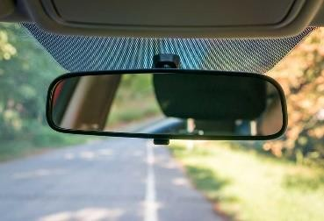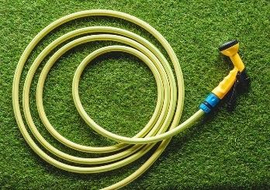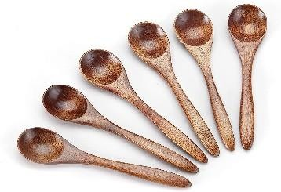

…………………………… ………………………………. ………………………… ……………………….

# C – Write the command under its sign :

***( Speed limit – No parking – Stop )***

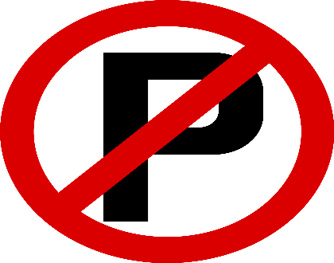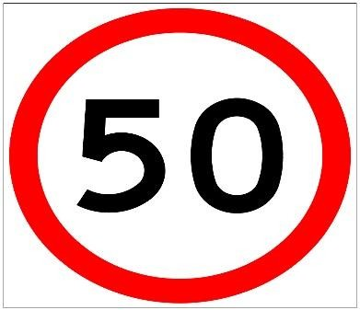

…………………………………….. ……………………………………

***Q : 5 ( Orthography )***

2

# A – Write the missing letter :

1 – b…..oom ( **r – d** ) 2 – Fa…… (**– n – i** )

3 – lad….er ( e - d ) 4 – Kni……es ( **v – d** )

# Good luck….

**T.**

# 

4