We Can! Book 2 Unit 5: Feelings and Things

1. Listen, choose and write.
[Play CD1 45 or read.]

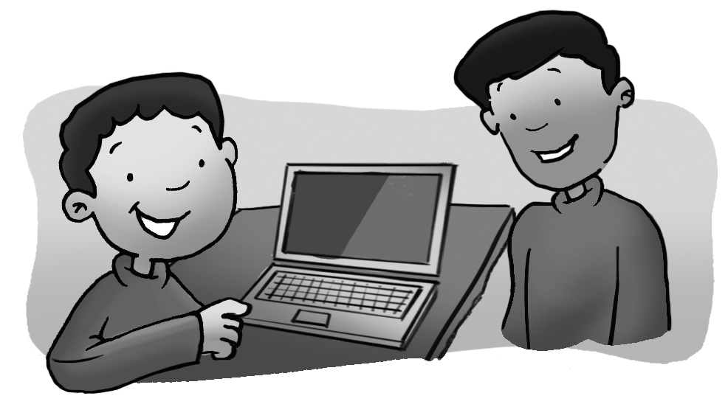 | I am  Are you  laptop

Are you happy?
Yes, I am. I have a new laptop. Look!
2. Listen and number.

[Play CD1 46 or read.]

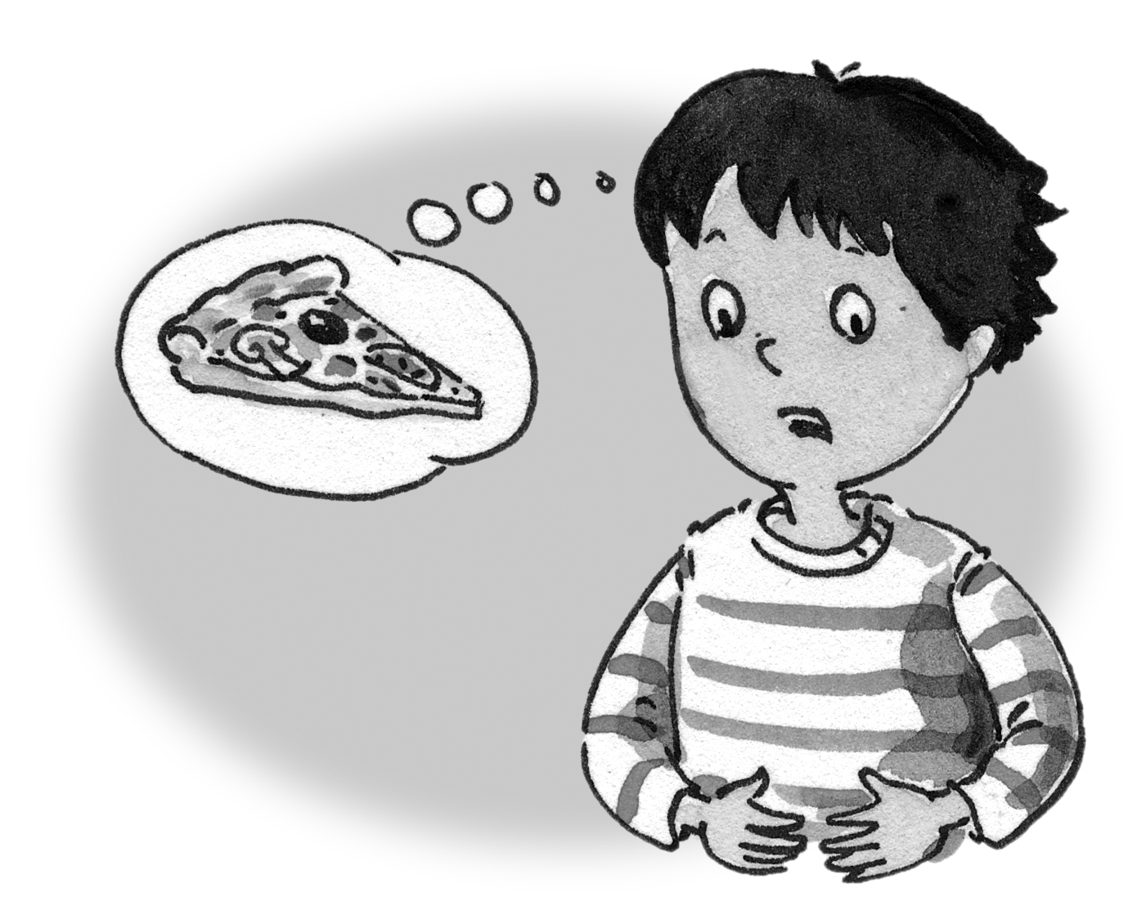  __2___ | 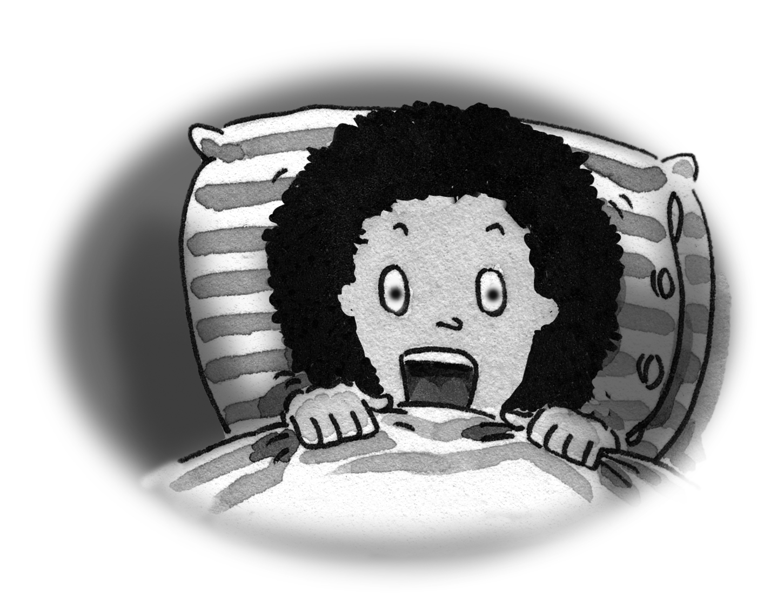  ___6___ | 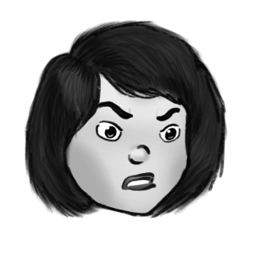  ___4___
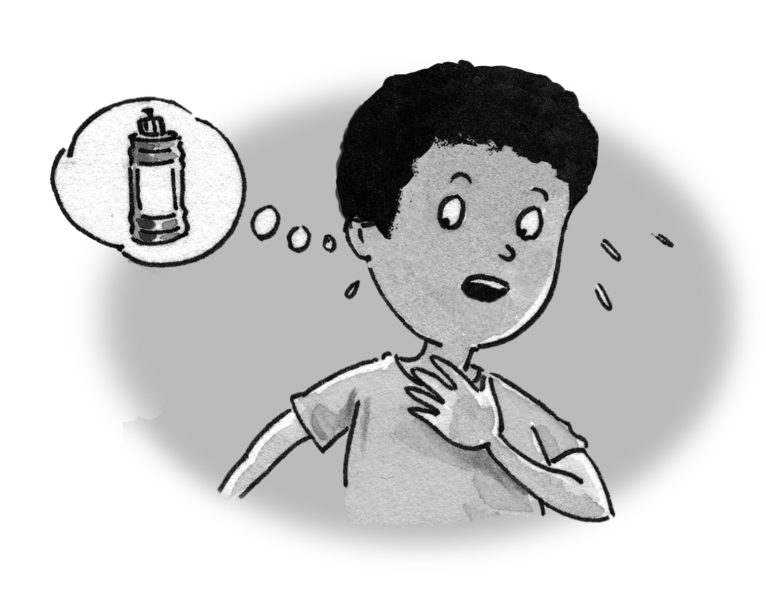  __3__ | 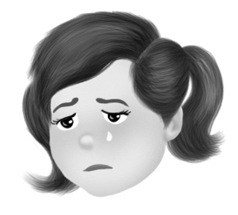  ___5___ | 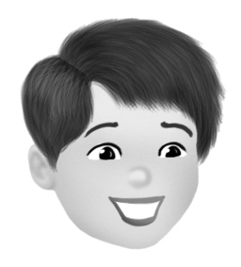  __1__

3. Read and underline These or Those. Then color.

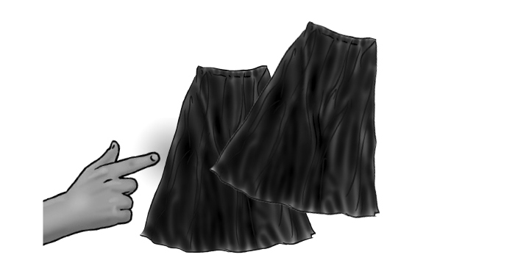 | These / Those skirts are blue.
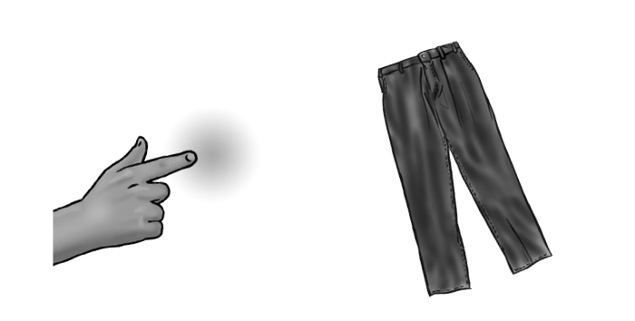 | These / Those pants are blue.
 | These / Those glasses are brown.
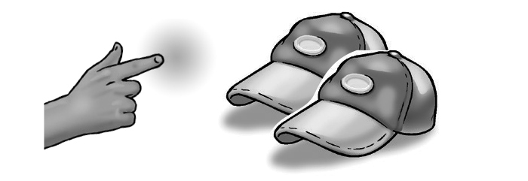 | These / Those caps are green.
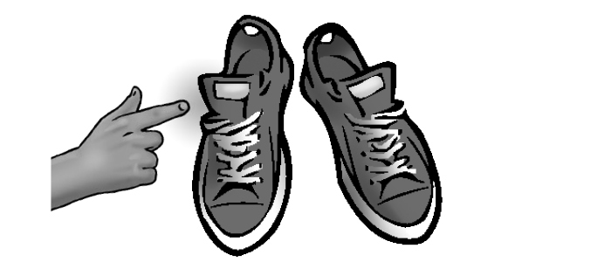 | These / Those shoes are red.
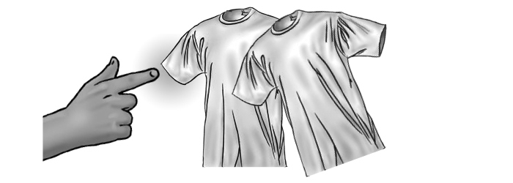 | These / Those T-shirts are white.

4. Answer the questions.

1. What’s the matter? Are you bored?

________________________________

2. Is your friend angry? _________________

3. Is your friend sleepy? _________________

