

المملكة العربية السعودية
وزارة التعليم
الادارة العامة للتعليم بمنطقة ----------------
مدرسة ------------------ الثانوية
Second Term- Second Session Test
Name: ------------------------------------------------------ Grade: 2nd Sec.
ABOKHALEDAMER
0557325813
1. Write the correct number under its picture: (6M)
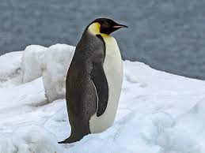
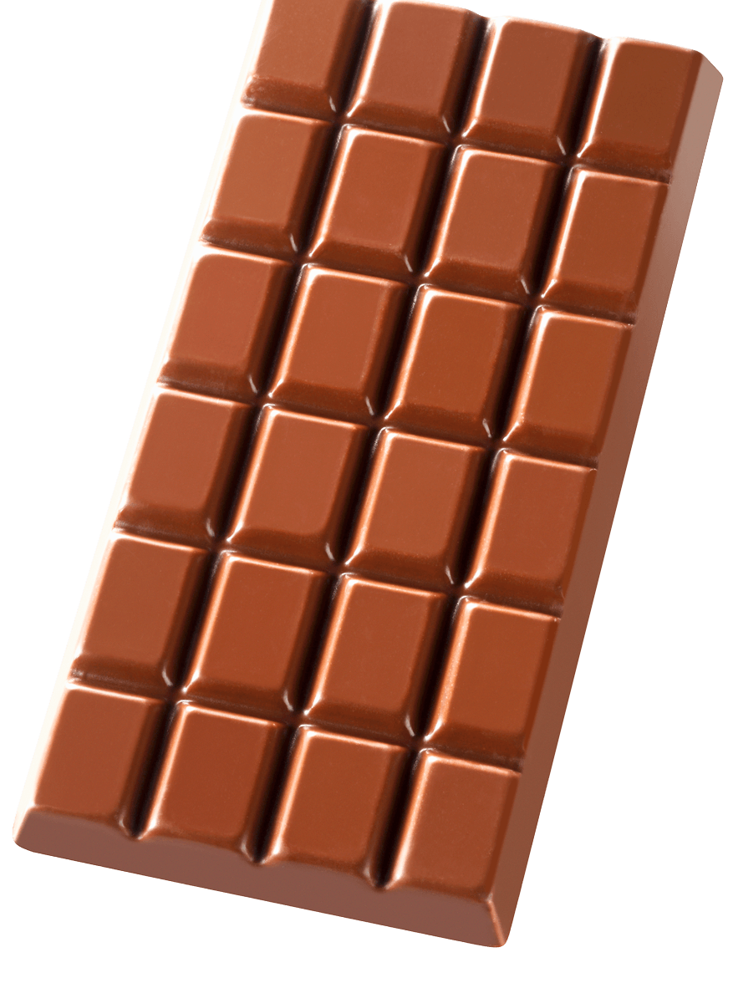
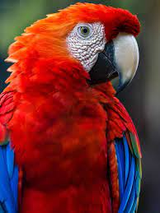
1.penguin 2.blowfish 3.vegetables 4.chocolate 5.parrot 6.snail
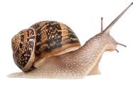

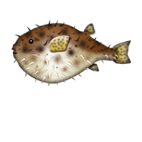

( ) ( ) ( ) ( ) ( ) ( )
2. Match the following: (4M)
1. ---- in no time a. seller
2. ---- vendor b. love dessert and candy
3. ---- have a sweet tooth c. very quickly
4. ---- bilingual d. someone who can speak Arabic and English.
3. Choose the correct answer: (7M)
1. He is [so – such – because] a smart boy that he passes all the tests.
2. He (can't – must – might) be at home. I rang and there is no answer.
3. Most of the news on TV is (depressing – depressed – depress).
4. My mom (get – gets – getting) worried if I'm not at home by 11.00.
5. I don't have a car. I wish I (have – has – had) a car.
6.The chef (cut it up – cut up it – it cut up).
7. The older you get, the ( happy – happier – happiest ) you are.
4. Supply the missing letters: (3M) ( o – c – f – u – v – h )
1. biling__al 2. dri__er 3. grass__opper
4. che__ 5. inse__t 6. ar__ma

(2) Top Goal - YouTube End of Questions https://t.me/abokhaledamer

