
المملكة العربية السعودية الصف: الثالث الابتدائي
وزارة التعليم الفترة الدراسية: الثانية
المدرسة الابتدائية …………… العام الدراسي 1447 هـ
الزمن: ساعتان
الاختبار النهائي لمادة اللغة الإنجليزية – الصف الثالث الابتدائي – الفترة الدراسية الثانية (الدور الأول) لعام 1447 هـ
عزيزتي الطالبة:
- استعيني بالله ثم اجيبي عن الأسئلة
- فضلا تأكدي من كتابة اسمك الرباعي ورقم الجلوس
- الإجابة باللون الأزرق فقط

اسم الطالبة رباعيا
رقم الجلوس: |  | الصف: الثالث الابتدائي | المادة: اللغة الإنجليزية
اليوم: | التاريخ: / 1 / 1448 هـ

المدققة وتوقيعها | المراجعة وتوقيعها | المصححة وتوقيعها | الدرجة كتابة | الدرجة رقما | السؤال
 |  |  | فقط |  | General  Questions
 |  |  | فقط |  | Guided  Composition
 |  |  | فقط |  | Reading  Short Sentence
 |  |  | فقط |  | Grammar
 |  |  | فقط |  | Vocabulary
 |  |  | فقط |  | Orthography
 |  |  | فقط | 40 | المجموع


Kingdom of Saudi Arabia 3rd Elementary Grade
Ministry of Education Time: Two Hours
………. Elementary School Number of papers: 3 . Final Exam – Second Term – 1447 AH
- General Questions:
/ 7
  - Match the questions with the correct answers:
A |  | B
1. What did you do over the weekend? |  | I live in Jeddah.
2. Which city do you live in? |  | Yes, please.
3. How long does it take to get there? |  | I cooked a big breakfast.
4. Can I help you? |  | It takes about two hours.
  - Choose the correct answer:
1. What good things happened to you last year?
a- I broke my leg. | b- I saw a rainbow.
2. What’s the matter?
a- I have a stomachache. | b- It is 60 Riyals.
3. Where are you going?
a- I’m going to the candy store. | b- I’m a doctor.
/ 7
- Guided Composition:
  - Complete the paragraph about your school. Use the words from the box.
Hi! Let me introduce my school.
The ……………. of my school is the 3rd Elementary School. There are about 400 ……………. in my school. I go to school by the school ……………. . All the students wear the same ……………. . Our school ……………. at 6:45. Our teachers are ……………. and helpful. We ……………. English, math, science, and Arabic. I love my school and my friends.

study starts name uniform kind studentsbus



- Reading Short Sentences:
/ 7
  - Read the sentences then match them with the correct pictures:
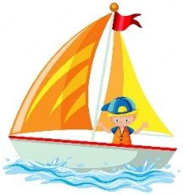 | 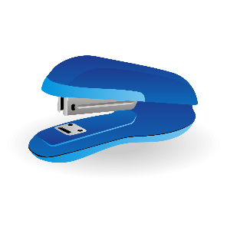 |  | 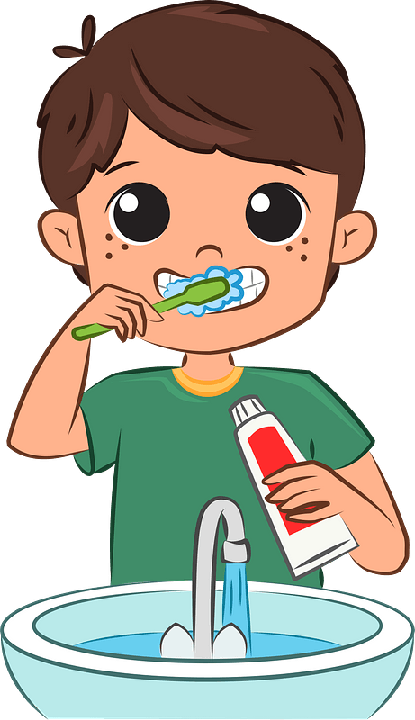 | 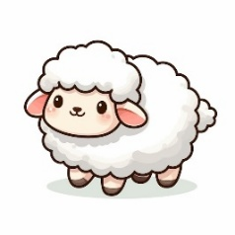
a-_I’m going to shop.  b-_I’m going to sail. | a-_I want a stapler.  b-_I want a pen. | a. I won a match.  b. I lost a match. | a-_I eat breakfast.  b-_I brush my teeth. | a-_I had a little cat.  b-_I had a little lamb.

  - Look at the email then choose the correct option.
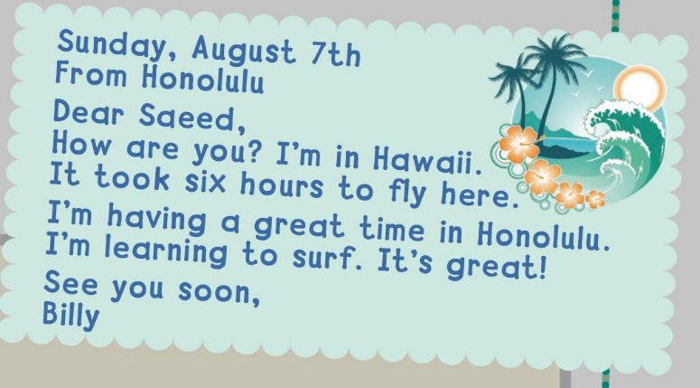
    - Where is Billy now?

      - in London.
      - in Hawaii.
      - in Paris.

    - What is Billy learning?
a- swimming.
b- riding a bike.
c- surfing.

- Grammar:
/ 7
  - Choose the correct answer:
    - We don’t have (some – any – a) oil.
    - Dad got (my – I – me) an ice cream.
    - This year Ali (like – likes – liked) social studies.
    - I didn’t (drink – drinks – drank) milk this morning.
    - He (am – is – are) going to the supermarket.
    - You’re going (eat – to eat – eating) traditional dishes.
    - There (was – are – were) a chair in the bedroom.

- Vocabulary:
/ 7
  - Write the words under the correct pictures:
kick – listen – sick – skateboard – sweater

 | 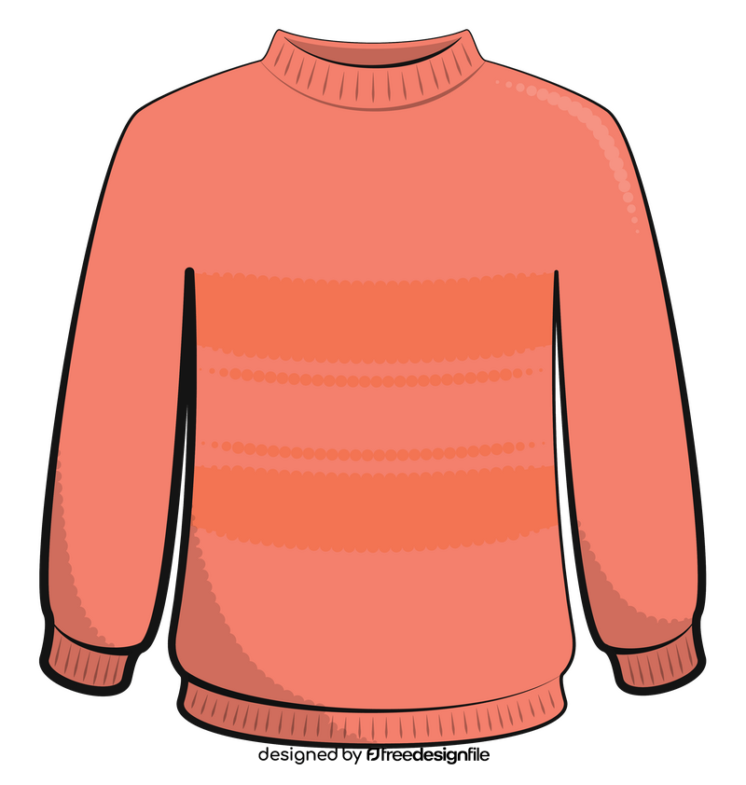 | 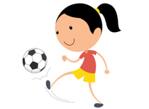 | 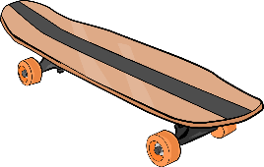 | 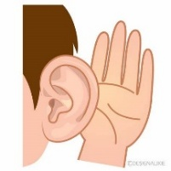

  - Circle the odd word:
1- Days: Sunday – Tuesday – September – Friday
2- Meals: breakfast – green – lunch – dinner

- Orthography:
/ 5
  - Choose the correct missing letters:
  __ __arf |  | 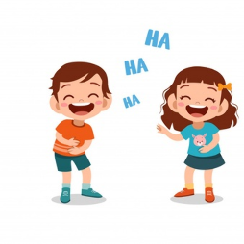  lau__ __ |  | 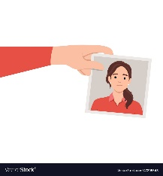  __ __oto |  |   sa__ __ |  | 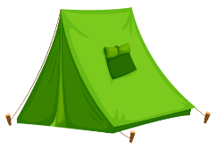  te__ __
sk | sc | ph | gh | ph | gh | nd | nt | nd | nt
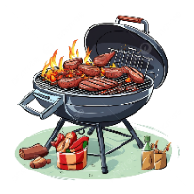  barbec__ __ |  | 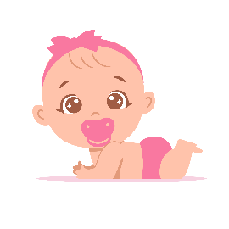  c__t__ |  | 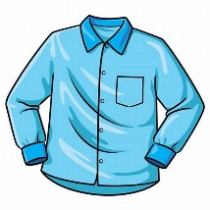  sh__ __t |  | 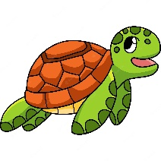  t__ __tle |  | 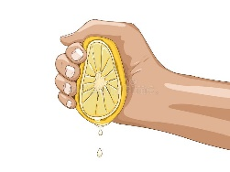  __ __ueese
ue | ou | o_e | u_e | ir | ur | ir | ur | sc | sq

END OF QUESTIONS
BEST OF LUCK
Ms. Tahani AlGhamdi

