General Questions

1 – This is my friend Nora ?
A. Nice to meet you Nora . B. I am 10 .
2 – Good morning !
A. Nice to meet you,too . B. Good morning.
3 – Is he playing ?
A. Yes, he is . B. No, he isn’t .
4- Where is she ?
A. She is playing . B. She is at home.

Reading short sentences

1. Lemons are sour .

They are walking . .2

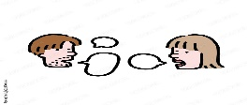

Controlled writing

___________________ |  |  | 1 – hot – rice – is . ( Rearrange )
sweet | cold | hot | 2-Apples are ______ .
Grammar

are | am | is | 1 – She _____ playing .
am | is | are | 2- They _____ cycling .
or | and | but | 3- I have apples ___ oranges .

morning - soup – chips -carrots - bath

Vocabulary
 |  |  |  | 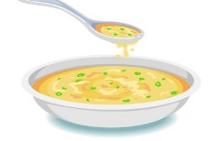
---------- | ---------- | --------- | --------- | ---------

Orthography (spelling)

Choose the correct letter: ( ch , l , g , o )

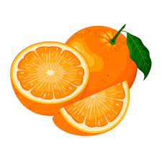 | 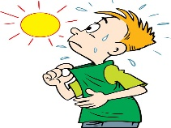 |  | 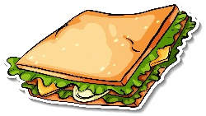
Oran _ e | H _ t | Co _ d | Sandwi _ _

Controlled writing

4

Good luck

M_zaid0

