

The Grade
الاسم ثلاثي: |  | الفصل | / | الدرجة
Unit 1& 2 Exam

I. CHOOSE

- How many students are there in your school?
- No, I am not . | - About 500
- What should you do to live a healthy life ?
- I should go to bed early. | - I should skip breakfast.

222
II. CHOOSE  OR 

Our school has a school bus . | I shouldn't do some exercise . | Don't shout
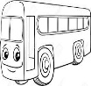 | 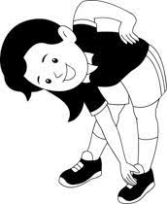 | 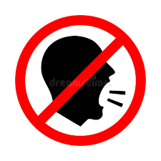
  |   |  
III. DO AS SHOWN BETWEEN BRACKETS

................................................................................................... |  |  | 1- in – live – I - Riyadh . ( rearrange )
earache | toothache | headache | 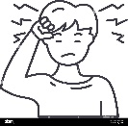  2– I have a _______. ( choose )
IV. CHOOSE
did | does | do | 1- Which subject ______ you like this year ?
got up | get up | do | 2- Did you ____ early this morning ?
plays | played | was | 3- The PAST of ( play ) is ____
V. CHOOSE
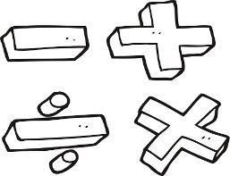 | 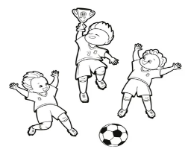 | 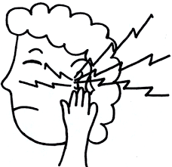 | 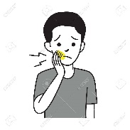 | 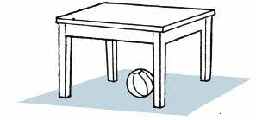
Math | Science | stomachache | Headache | Don't shout
Engilsh | PE | earache | toothache | Listen

VI. CHOOSE THE CORRECT LTTER
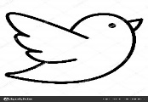  b_ _ d | 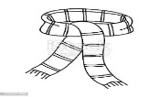  _ _arf | 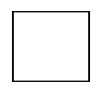  _ _uare | 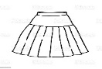  _ _ irt | 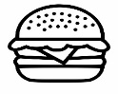  b_ _ger
ur | sk | sq | sk | ar
ir | sc | sk | sc | ur

TEACHER :

