We Can! Book 2 Unit 4: Days and Weather

1. Listen, choose and write.

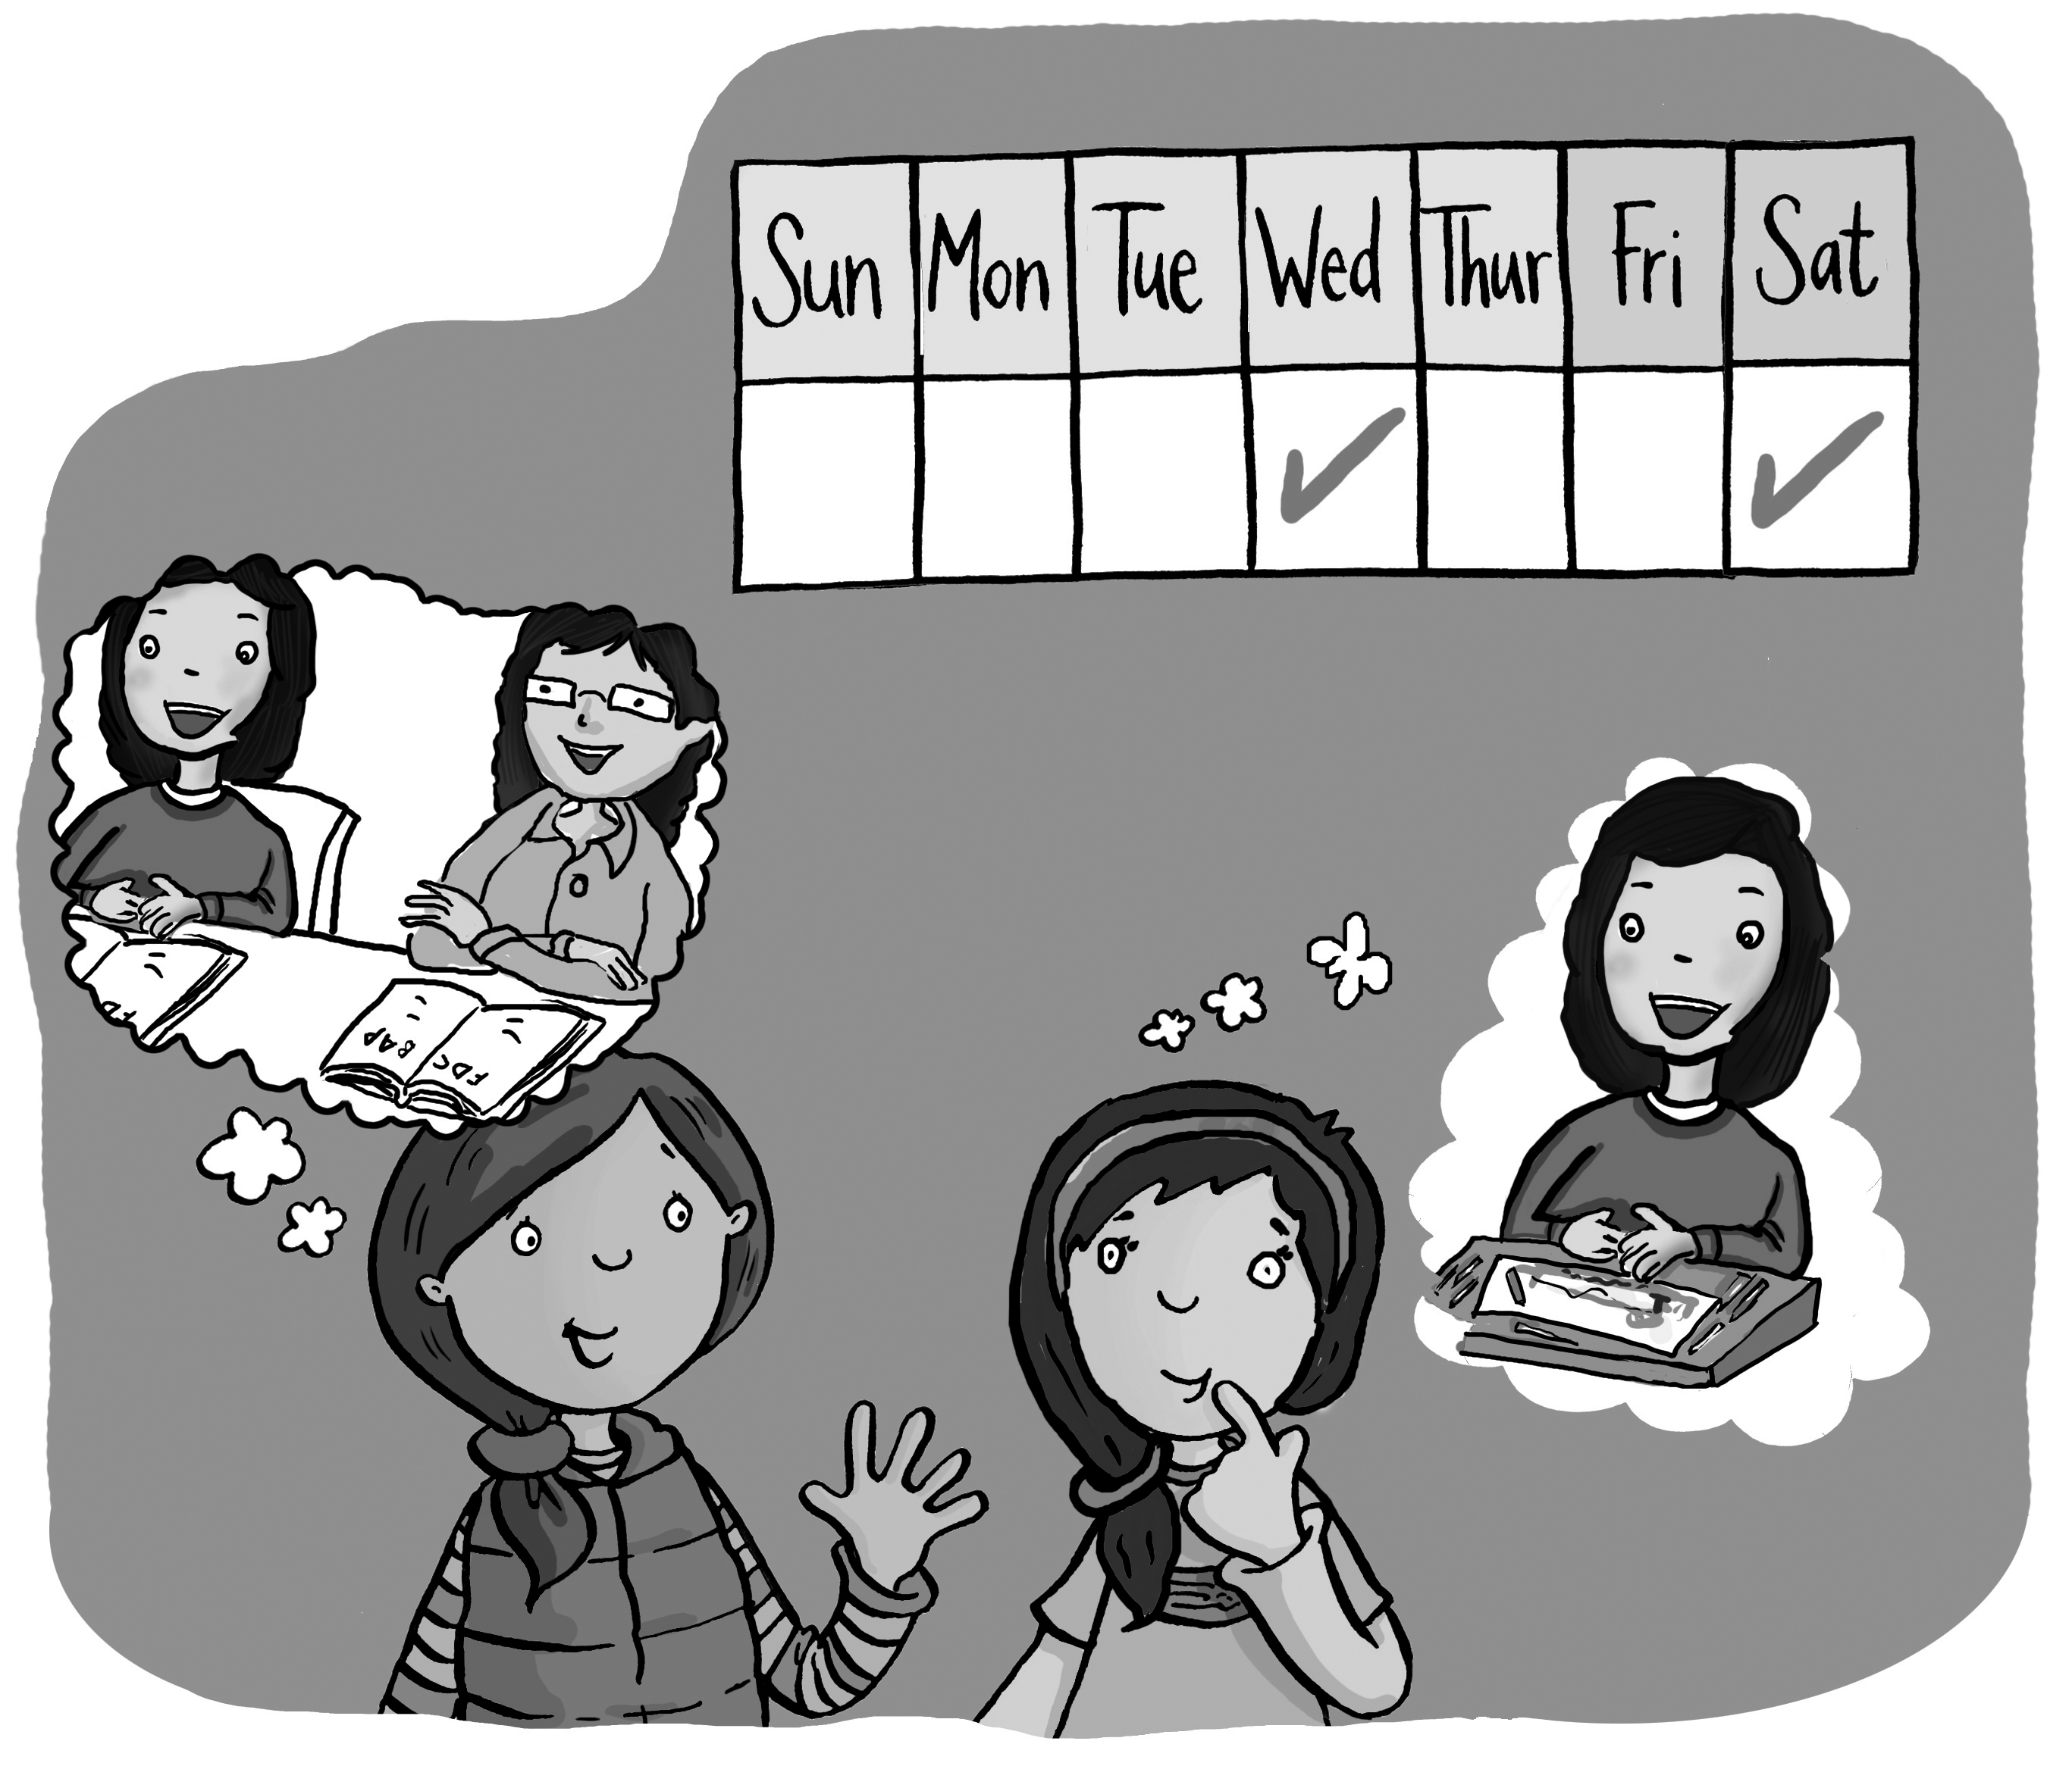 | do you  Saturday  like

What day ________ like?
I __________ Wednesday. How about you?
I like ____________.
2. Listen, number, and write.

Monday __ Sunday __ Thursday __ Saturday __
Sunday, (1)____________, Tuesday,
Wednesday, (2)____________,
Thursday,
Friday, (3)____________,
(4)____________comes again.
3. Listen and number.

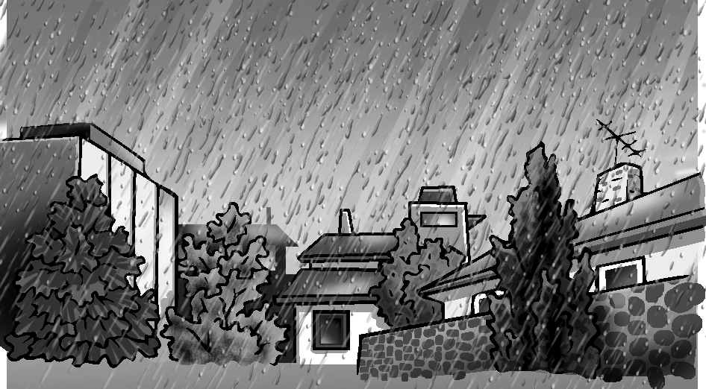  __ rainy | __ snowy | 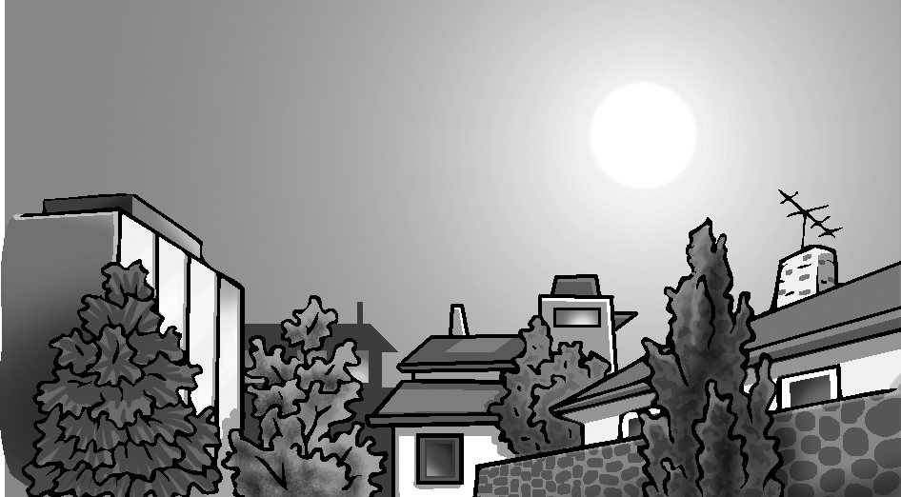  __ sunny
__ cloudy | 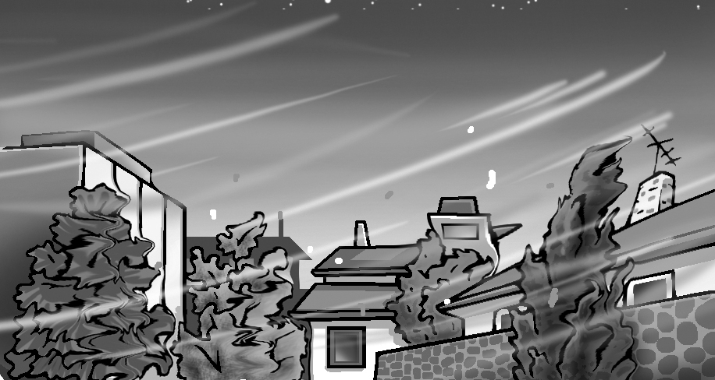  __ windy

4. Listen and circle the right letter. Then write.

1. | T U V W X Y Z  __ OLF
2.  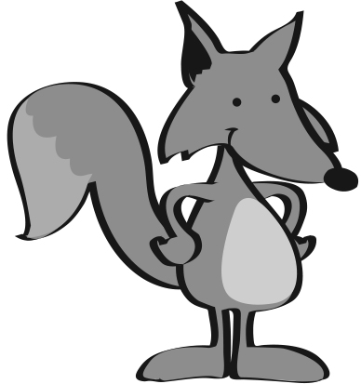 | T U V W X Y Z  __ OX
3. | T U V W X Y Z  __ ARD
4. | T U V W X Y Z  __ EBRA

