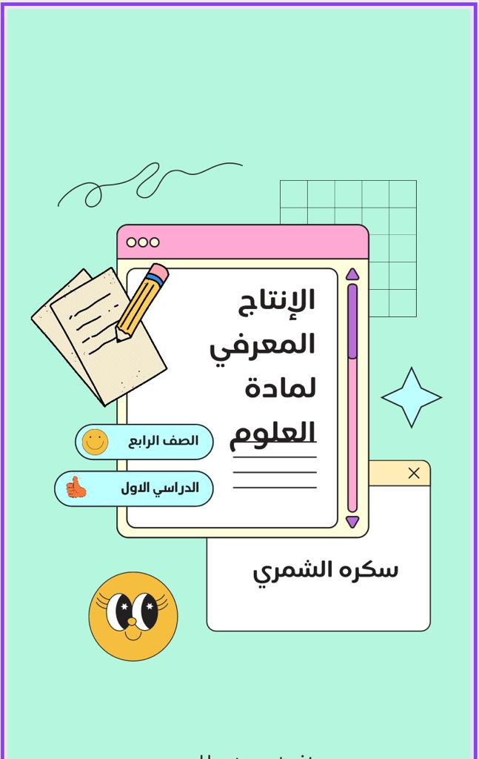

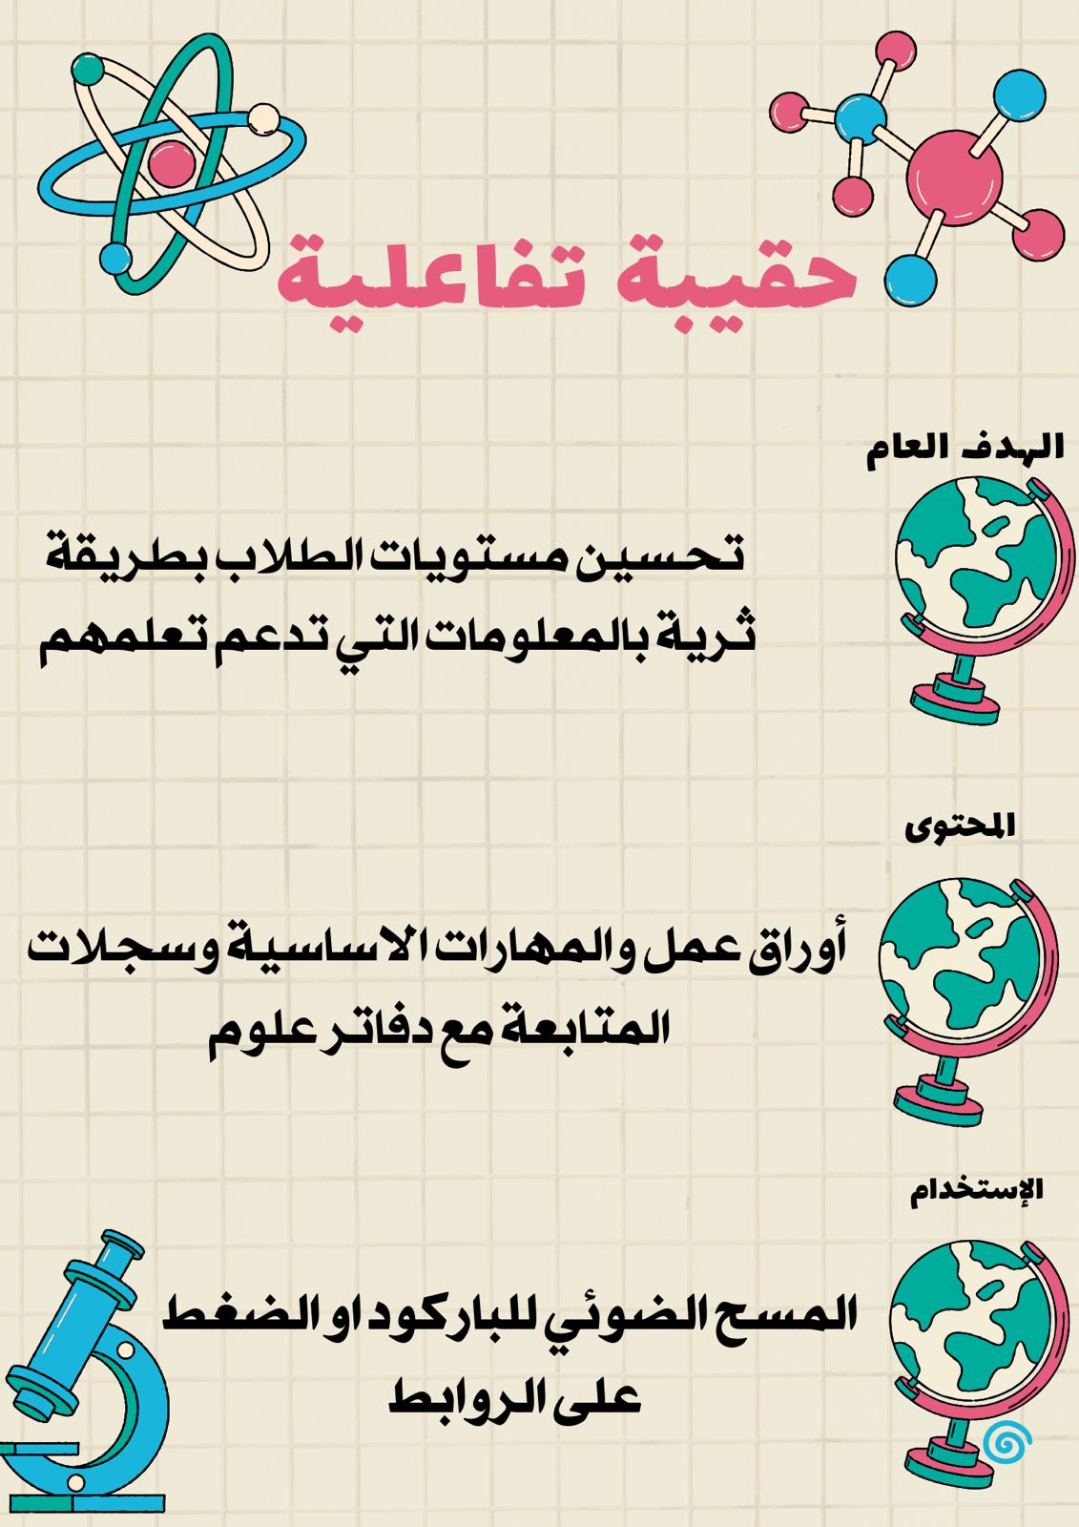

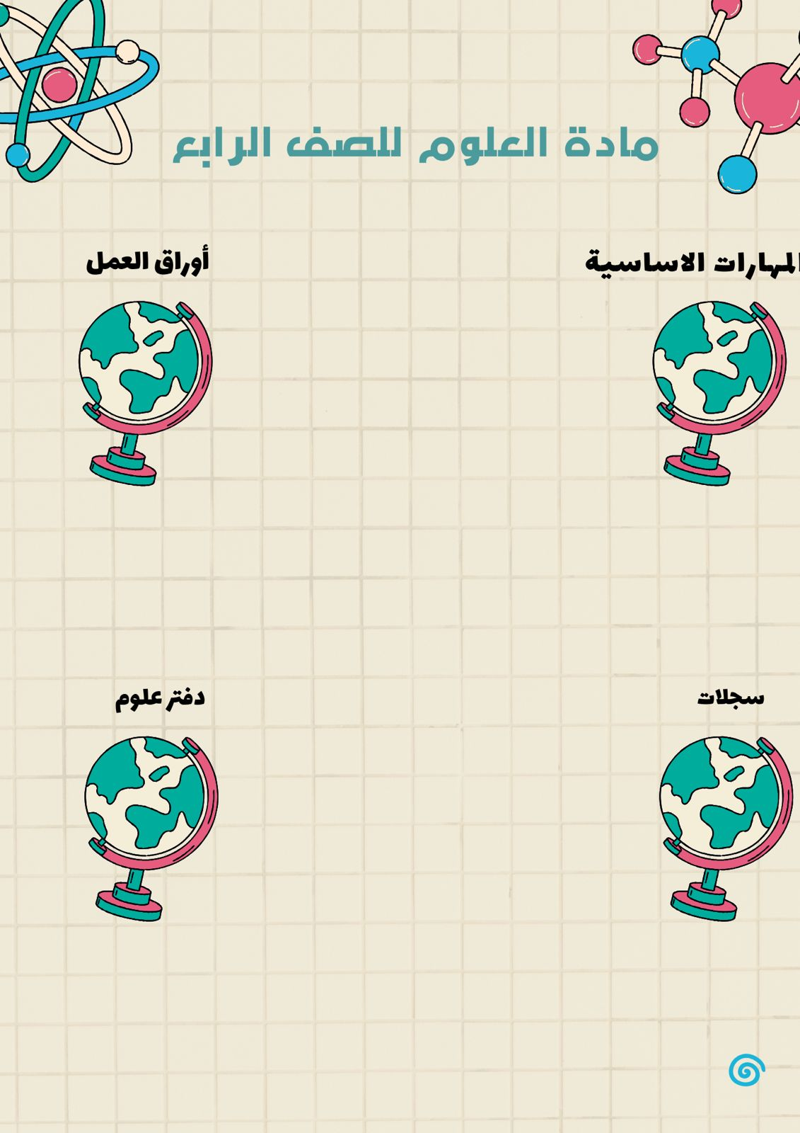

[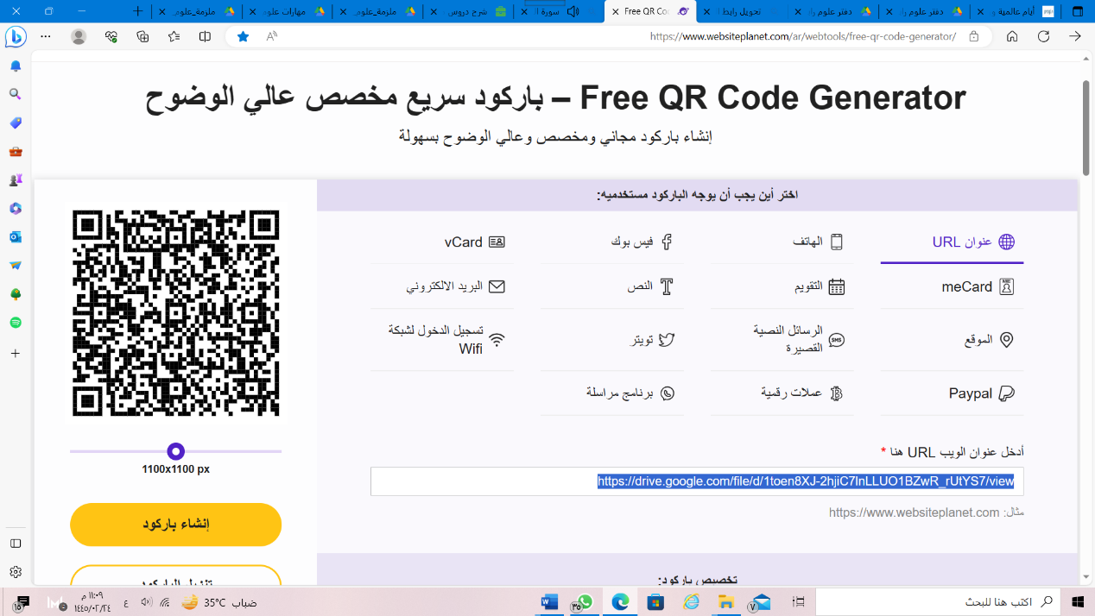](https://drive.google.com/file/d/1toen8XJ-2hjiC7lnLLUO1BZwR_rUtYS7/view)[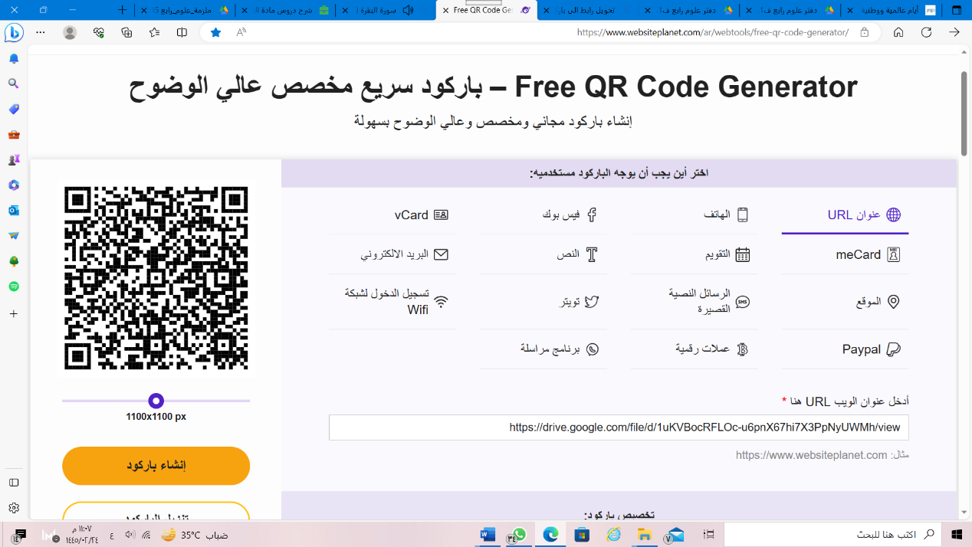](https://drive.google.com/file/d/1uKVBocRFLOc-u6pnX67hi7X3PpNyUWMh/view)

[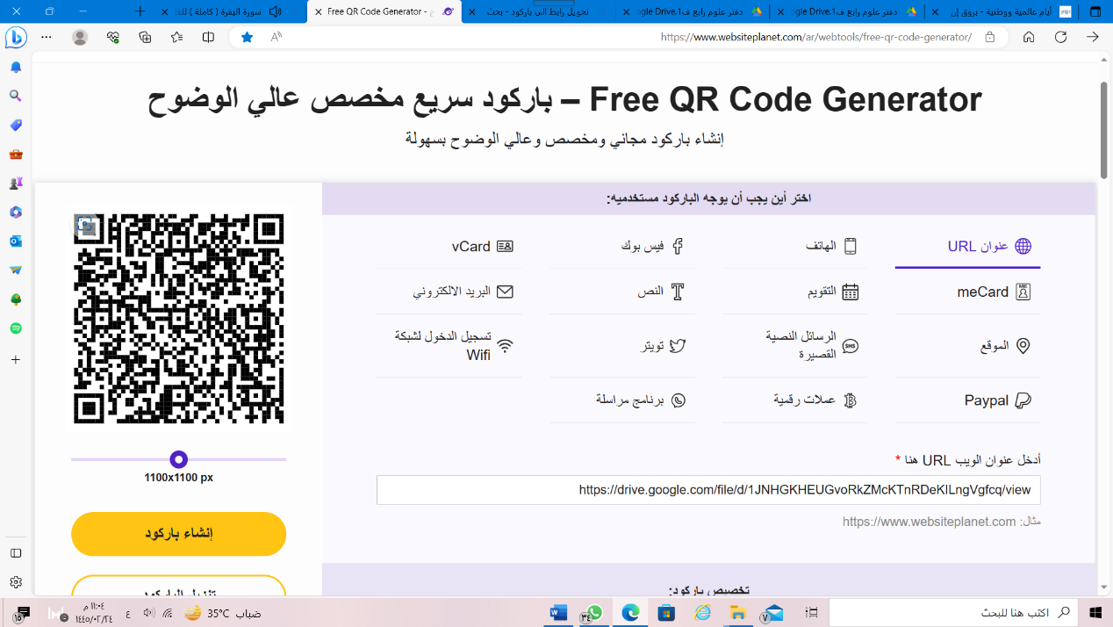](https://drive.google.com/file/d/1JNHGKHEUGvoRkZMcKTnRDeKILngVgfcq/view)[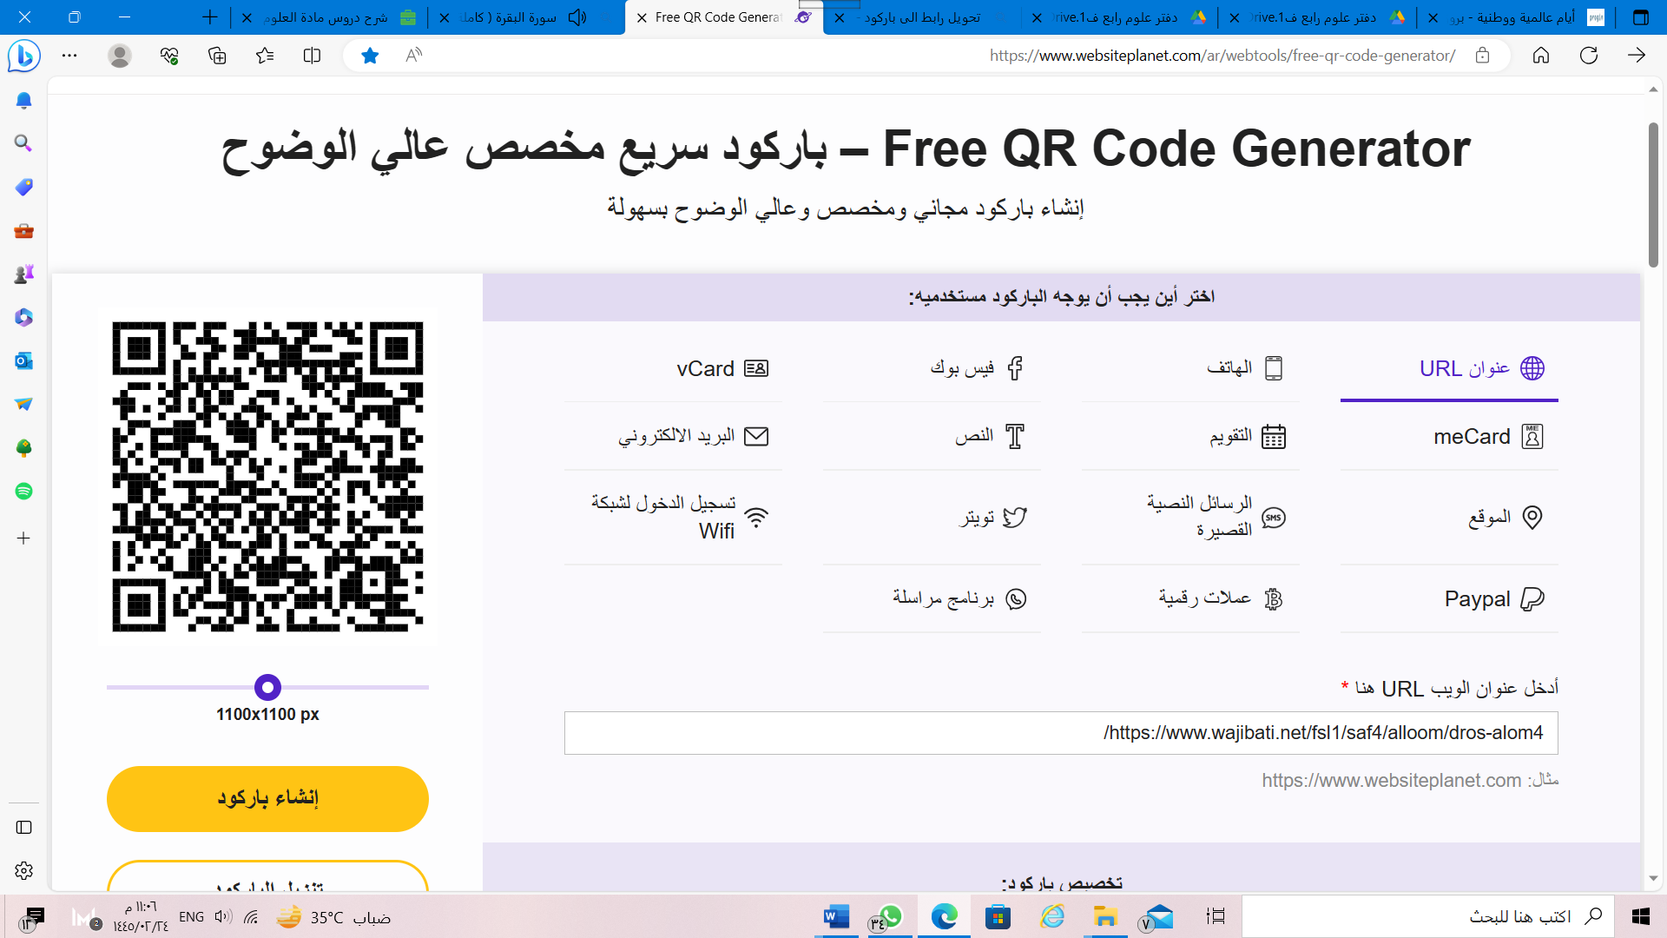](https://www.wajibati.net/fsl1/saf4/alloom/dros-alom4/)