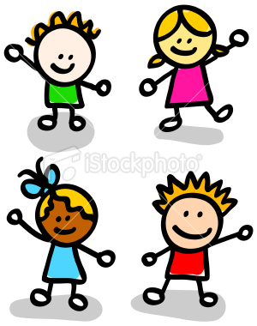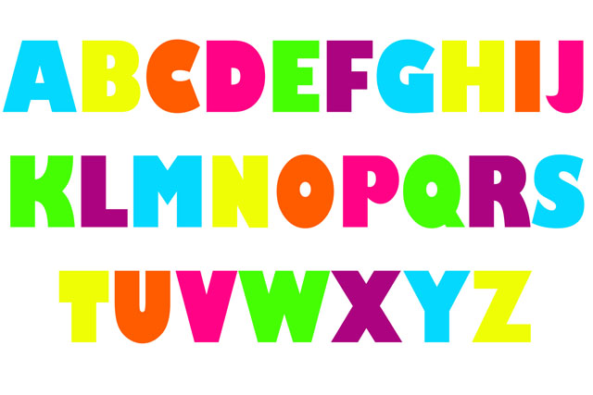

**My name:**

**……………………………**

**Grade: one**

**Year: 1433 - 1434.**

My ABC

**Classroom instructions**

|  |  |
| --- | --- |
| sit down properly | Sit |
| Listen to the teacher | Listen |
| Don't play or jump | http://www.hot-can.com/Corporate/Why%20cant%20I%20let%20my%20Hot-Can%20freeze_files/dont.gifJump |
| Don't talk – be quite . | http://www.mpsaz.org/taft/general_information/teachers_specialists/pe/disciplinerulesrewards/images/shhhh.jpg |

**General Questions**

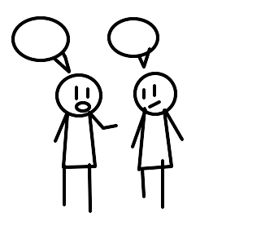1- What is your name?

My name is …………….

2- What is your family name?

My family name is …………...

3- How old are you?

I am seven years old .

4- Where are you from?

I am from Saudi Arabia .

5- What is your religion ?

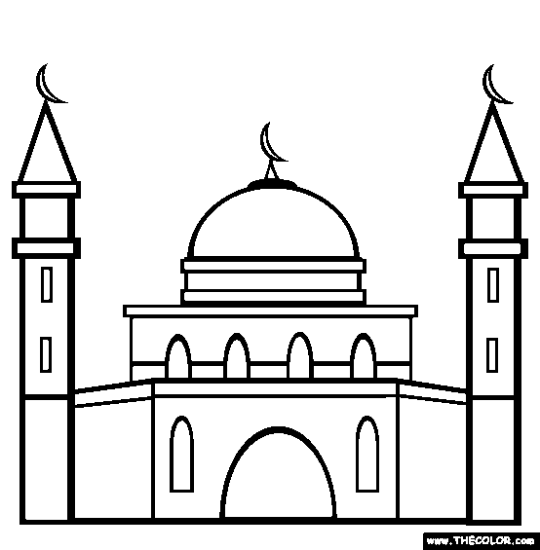My religion is Islam.

6- Who is your prophet?

Mohammad Peace Be Upon Him.

7- How are you?

I am fine thank you

**Teacher's notes**

……………………………………………………………………………………………………………………………………………..……………………………………………………………………………………………………………………………………………..……………………………………………………………………………………………………………………………………………..……………………………………………………………………………………………………………………………………………..……………………………………………………………………………………………………………………………………………..……………………………………………………………………………………………………………………………………………..……………………………………………………………………………………………………………………………………………..……………………………………………………………………………………………………………………………………………..

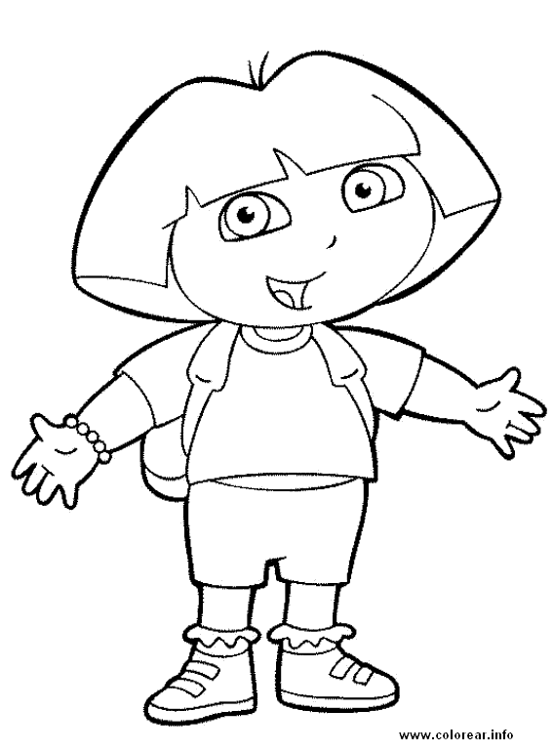

**My name is Dora**



**My name is Sponge bob**

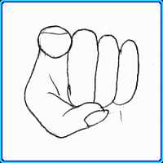

**What is your name?**

**What is your name?**

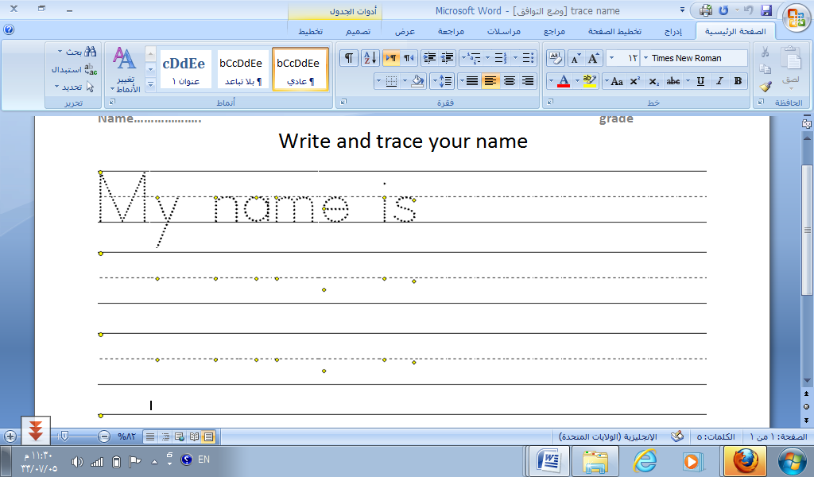





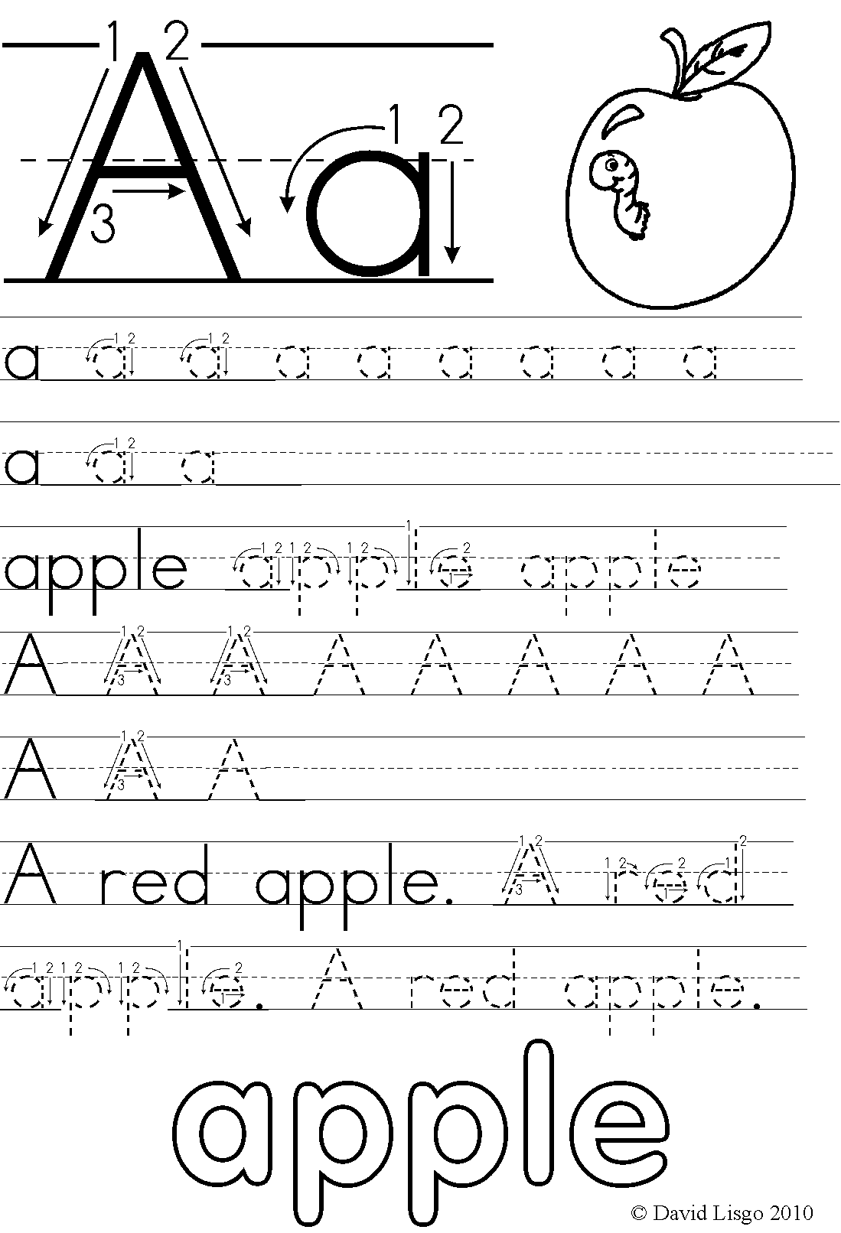

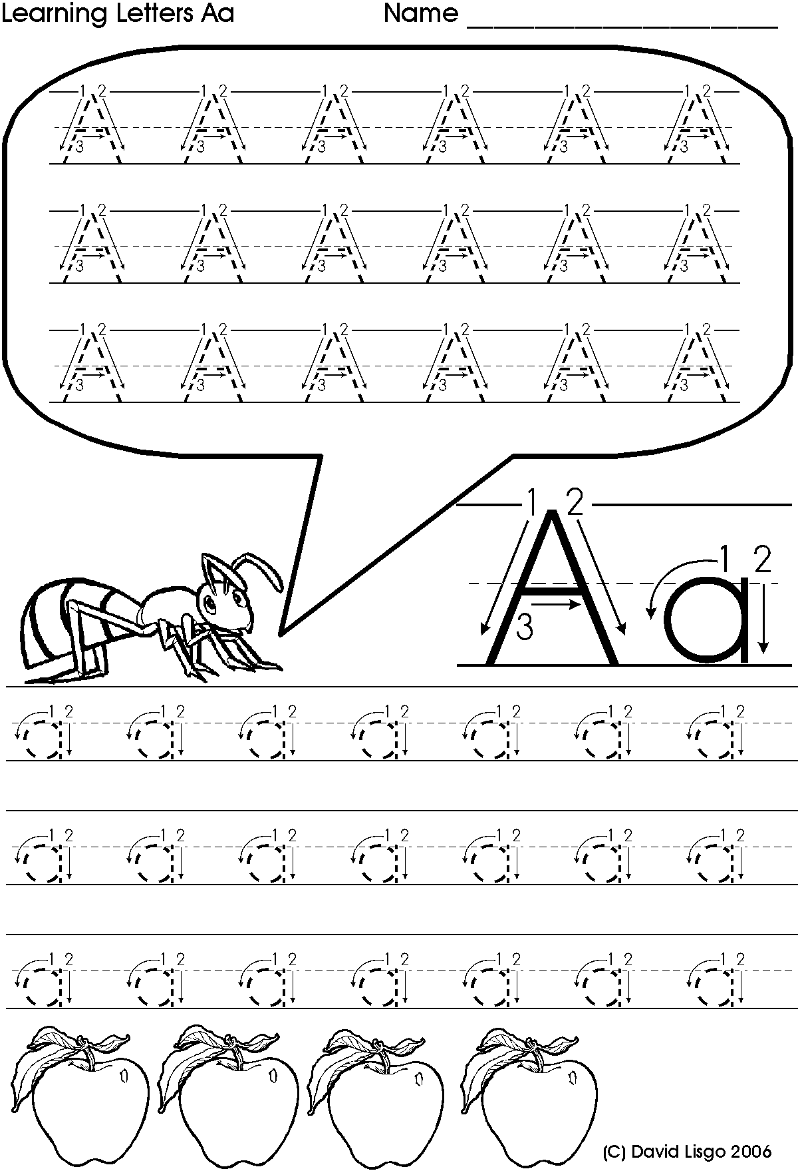

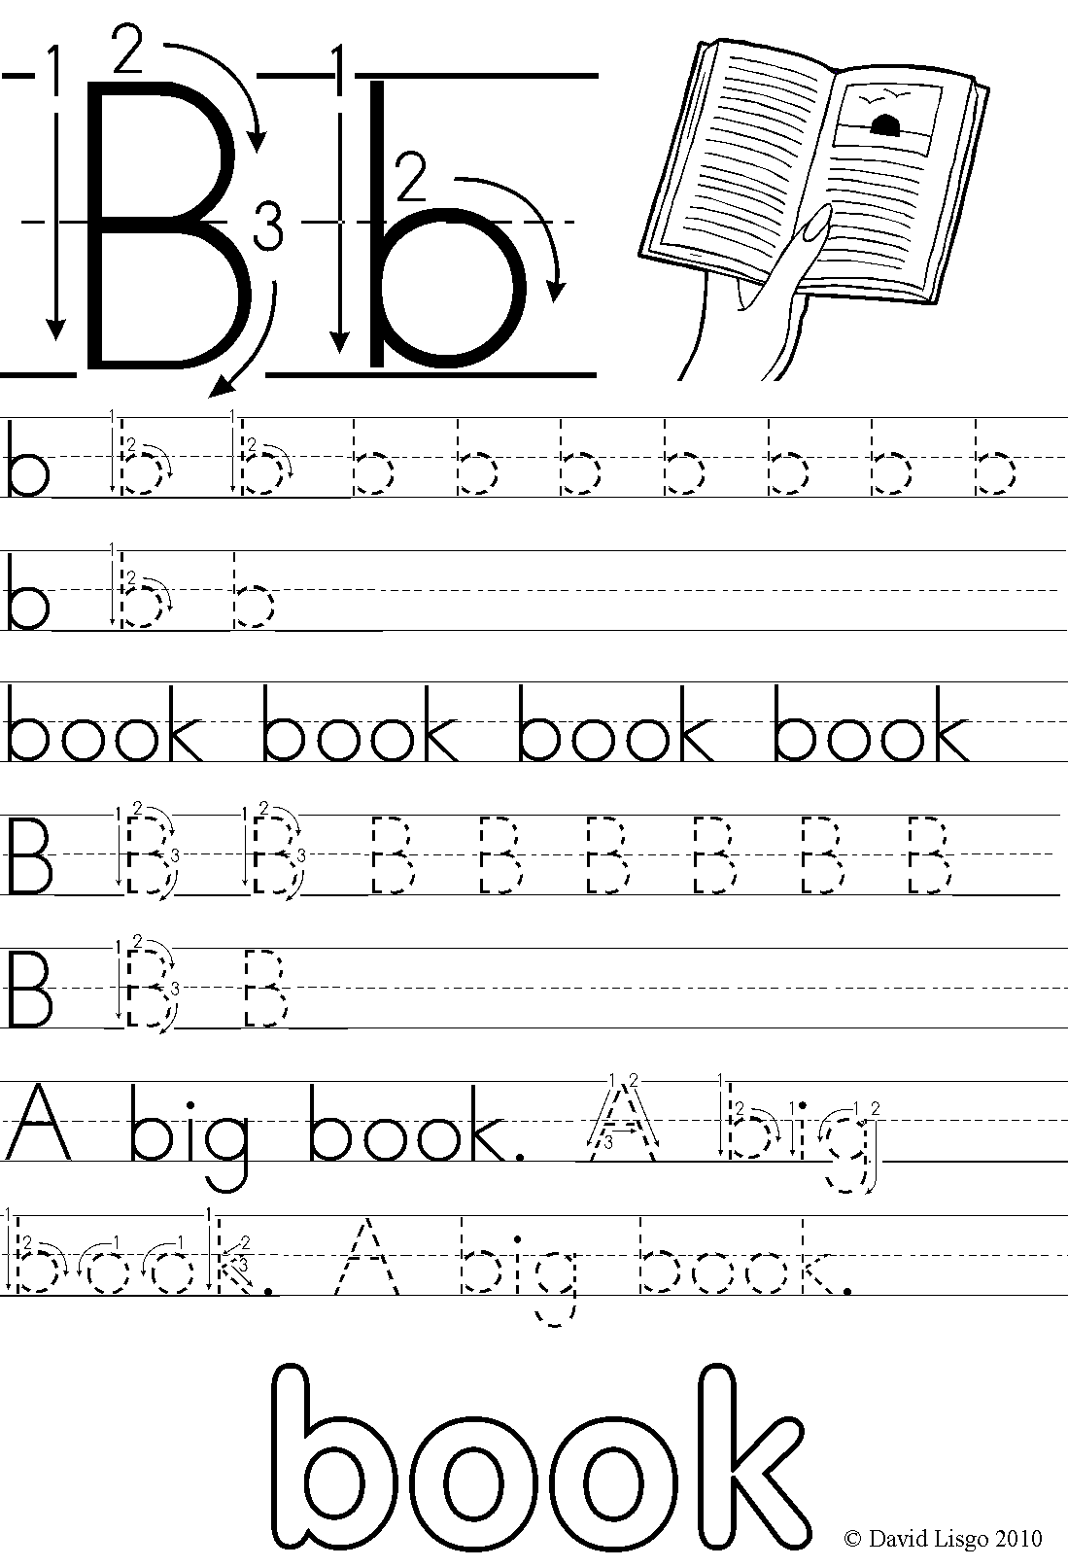

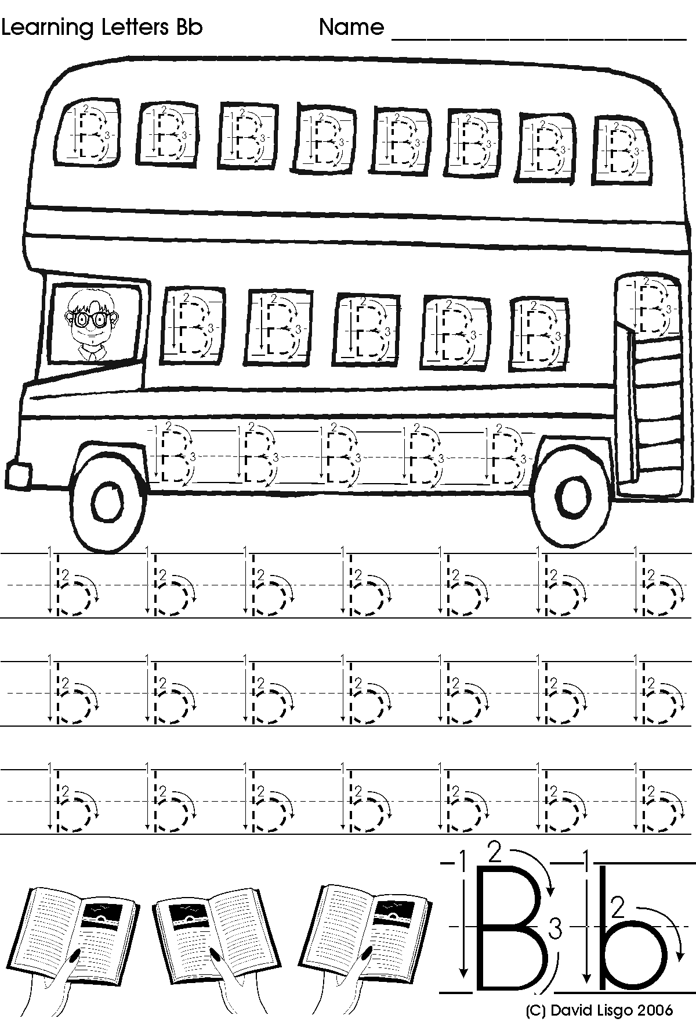

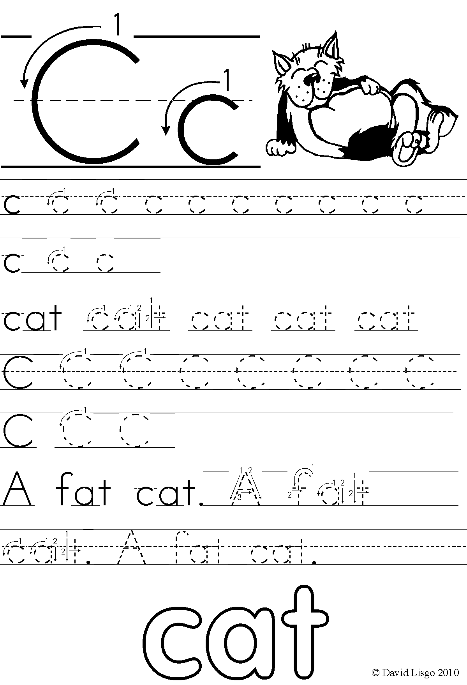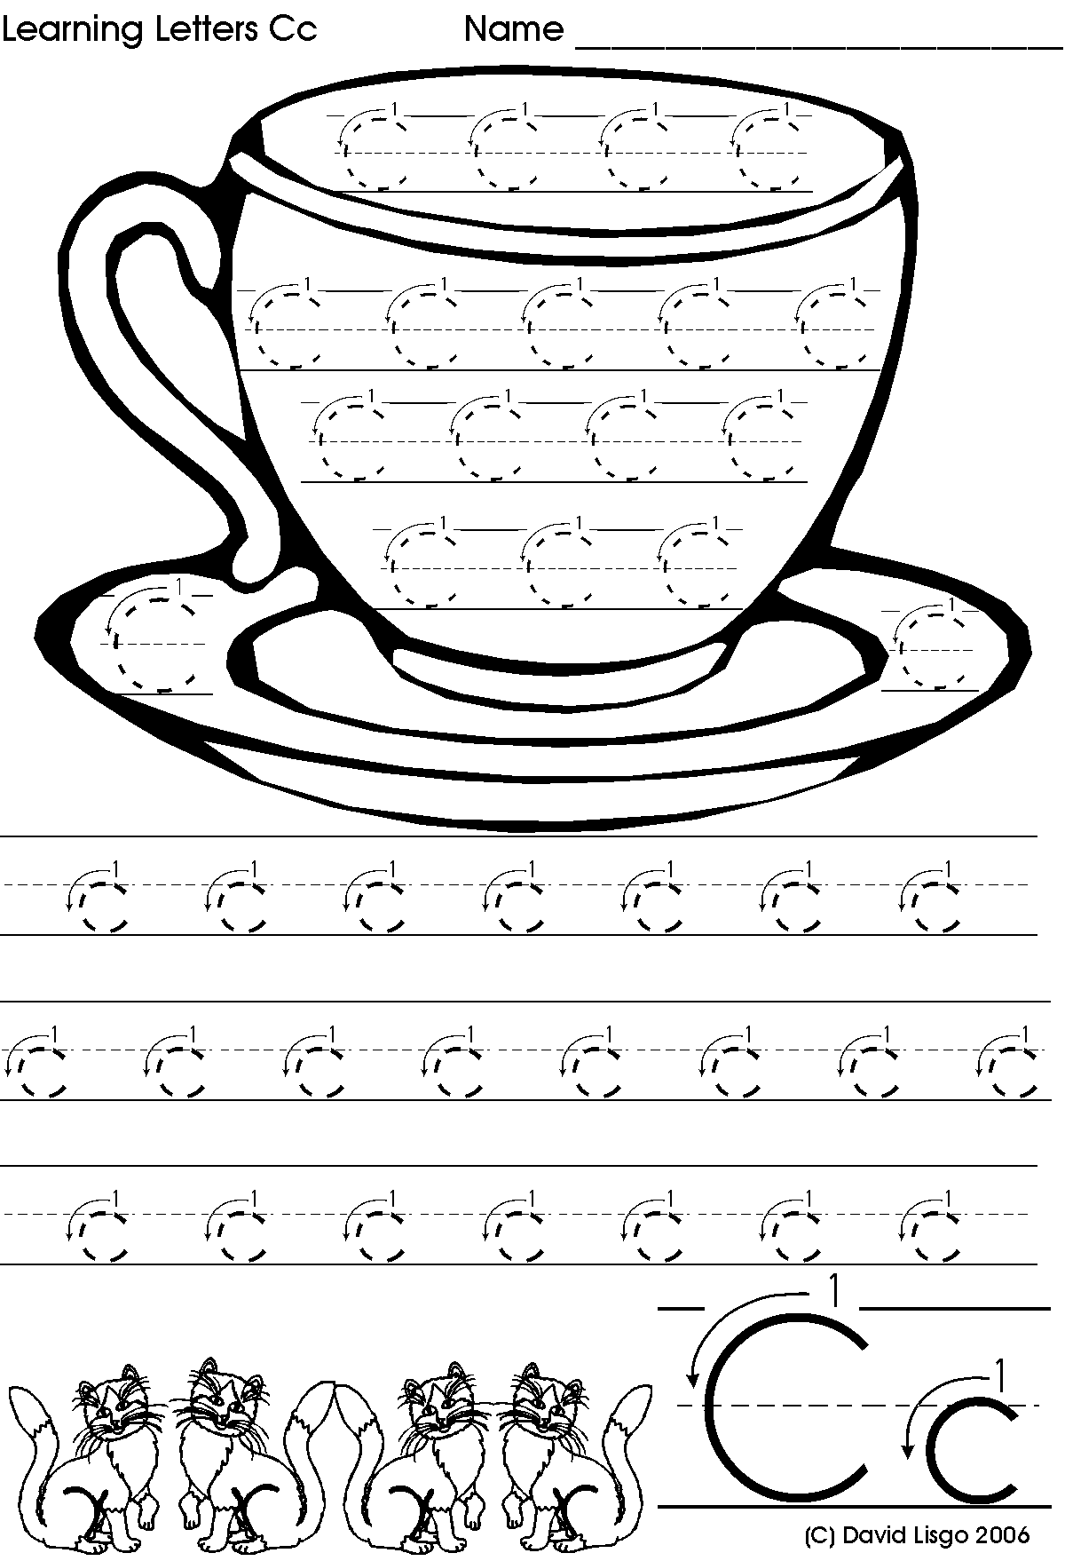

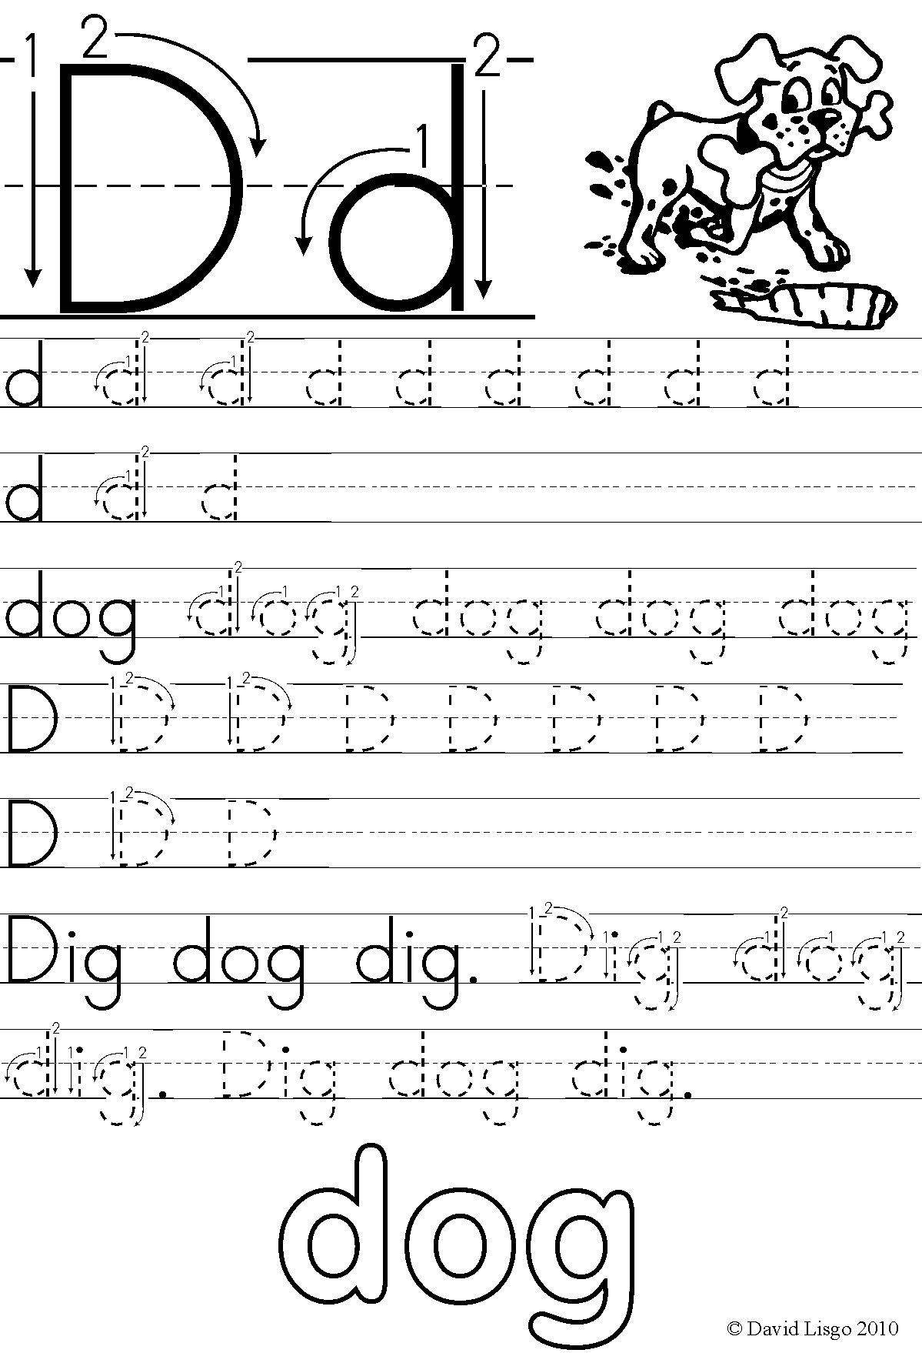

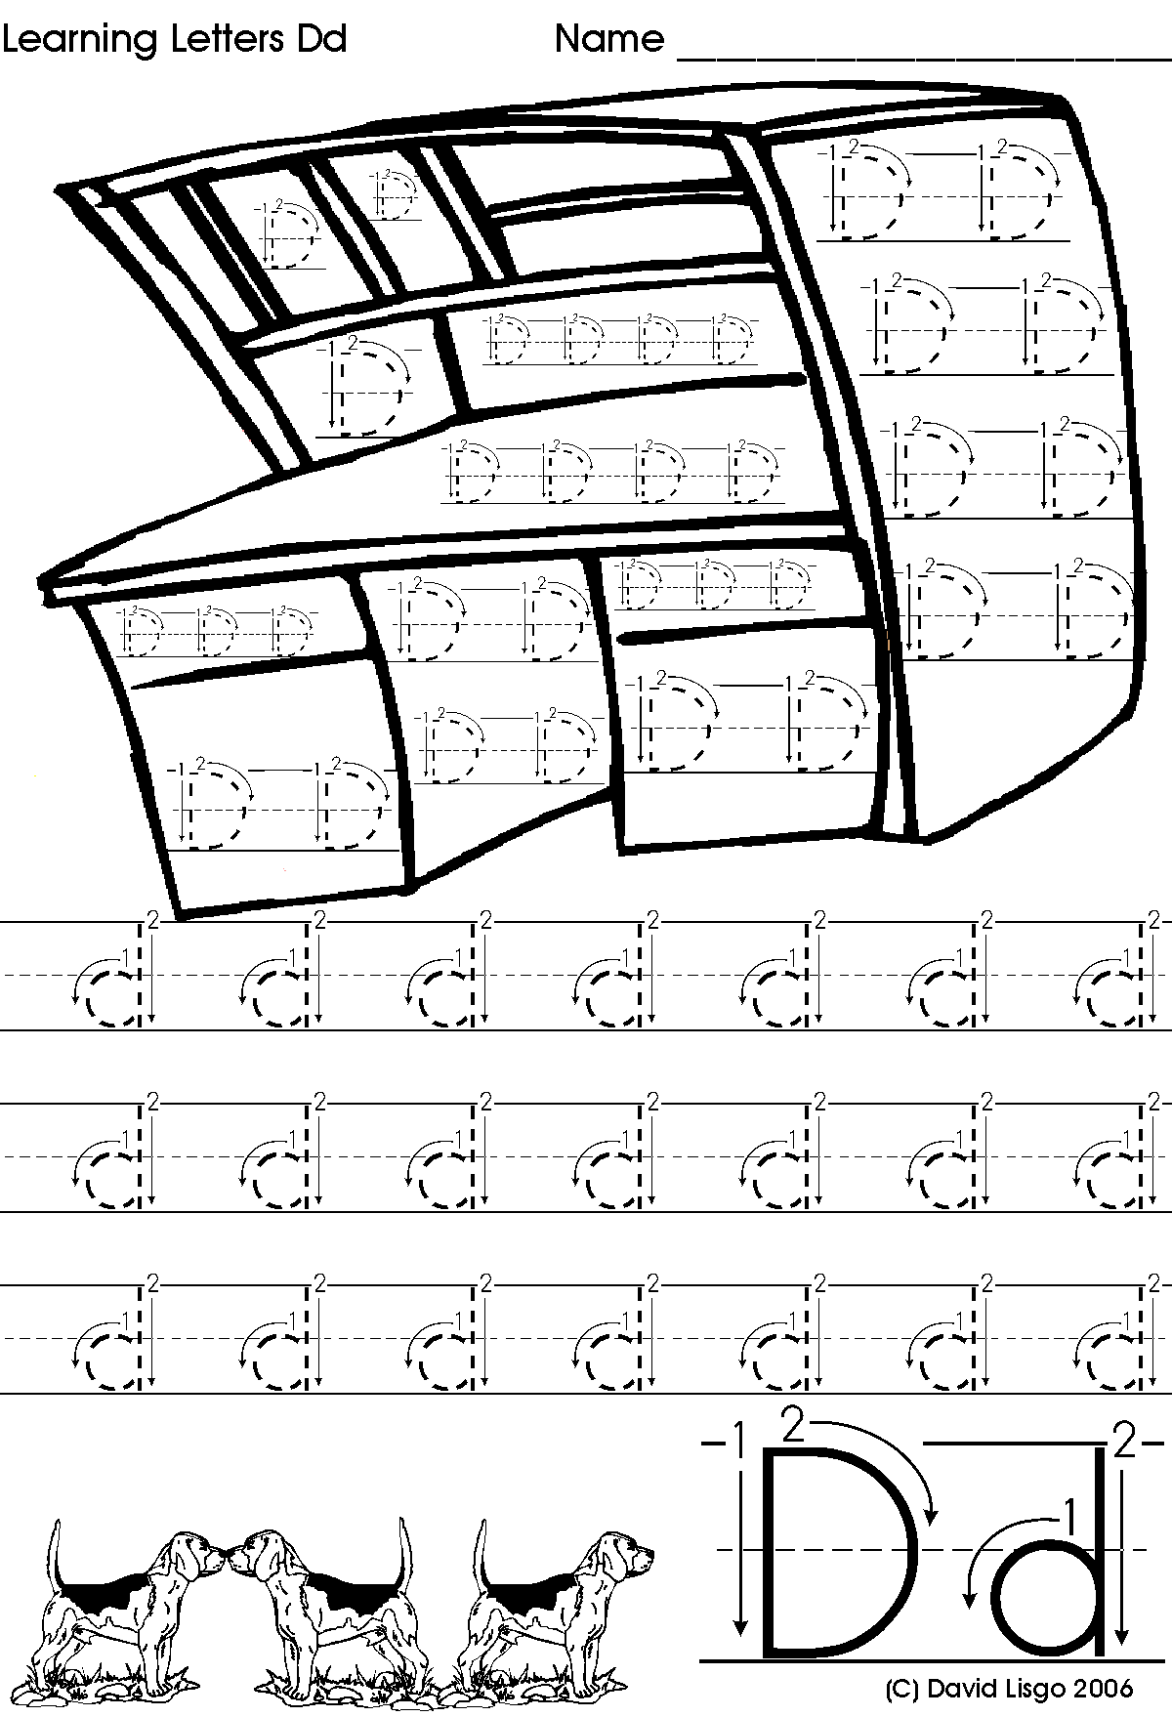

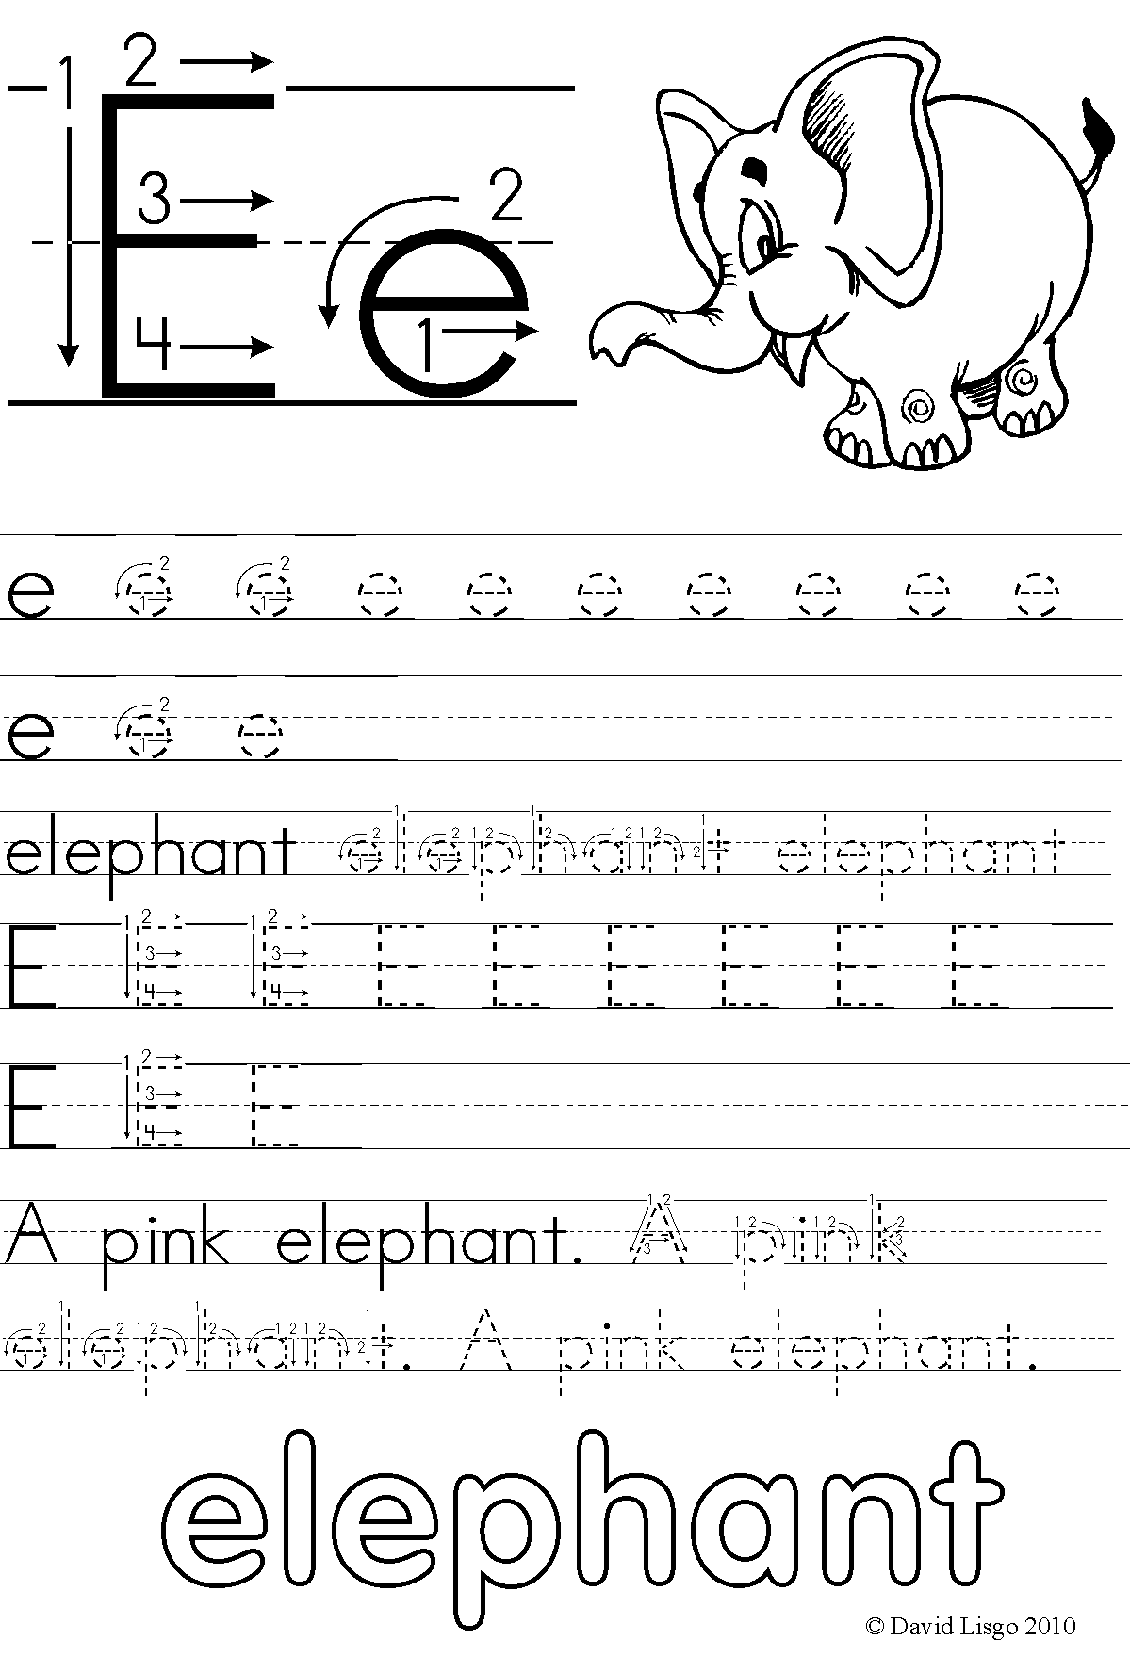

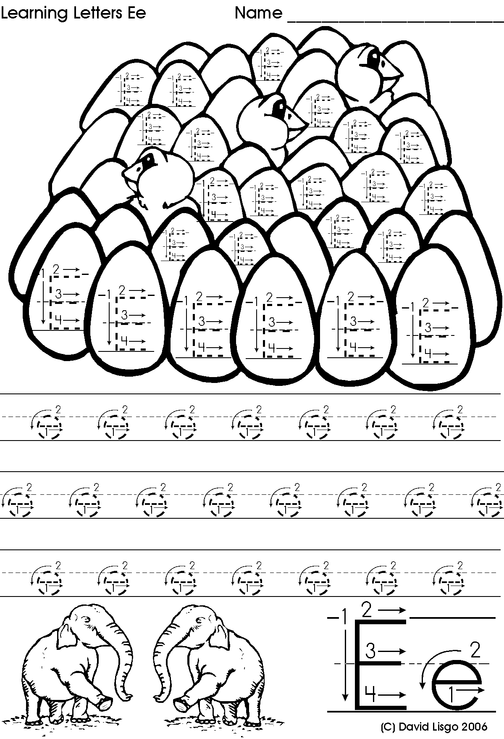

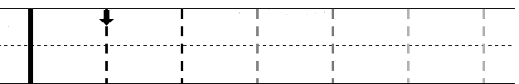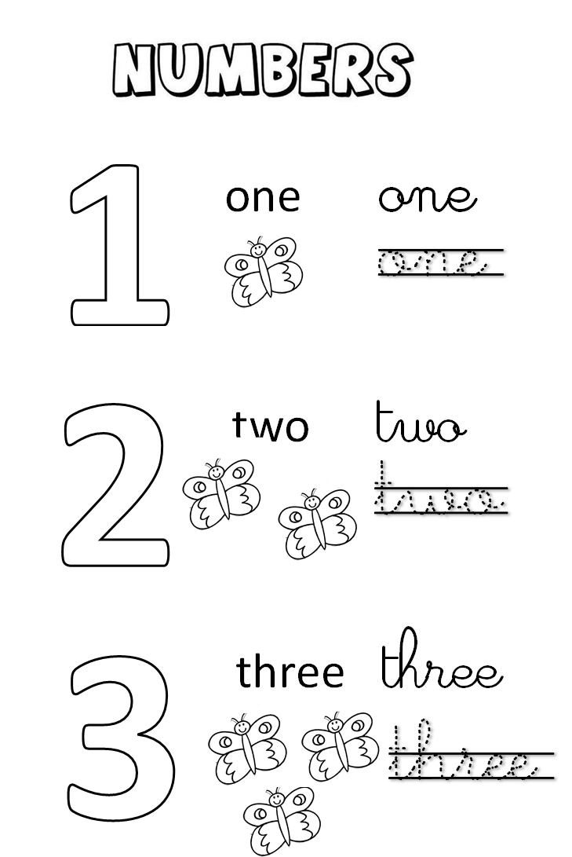

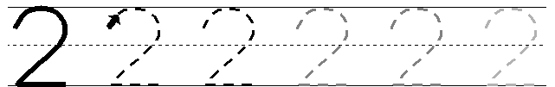



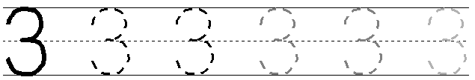

**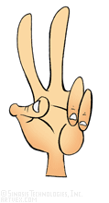Count the numbers and write them :**



**Count and match :**

|  |  |
| --- | --- |
| **Untitled-6 copy** | **1** |
| **Untitled-4 copyUntitled-4 copyUntitled-4 copy** | **2** |
| **Untitled-4 copy** | **3** |

**Count and write :**



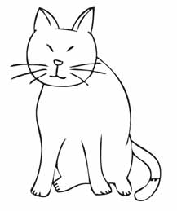





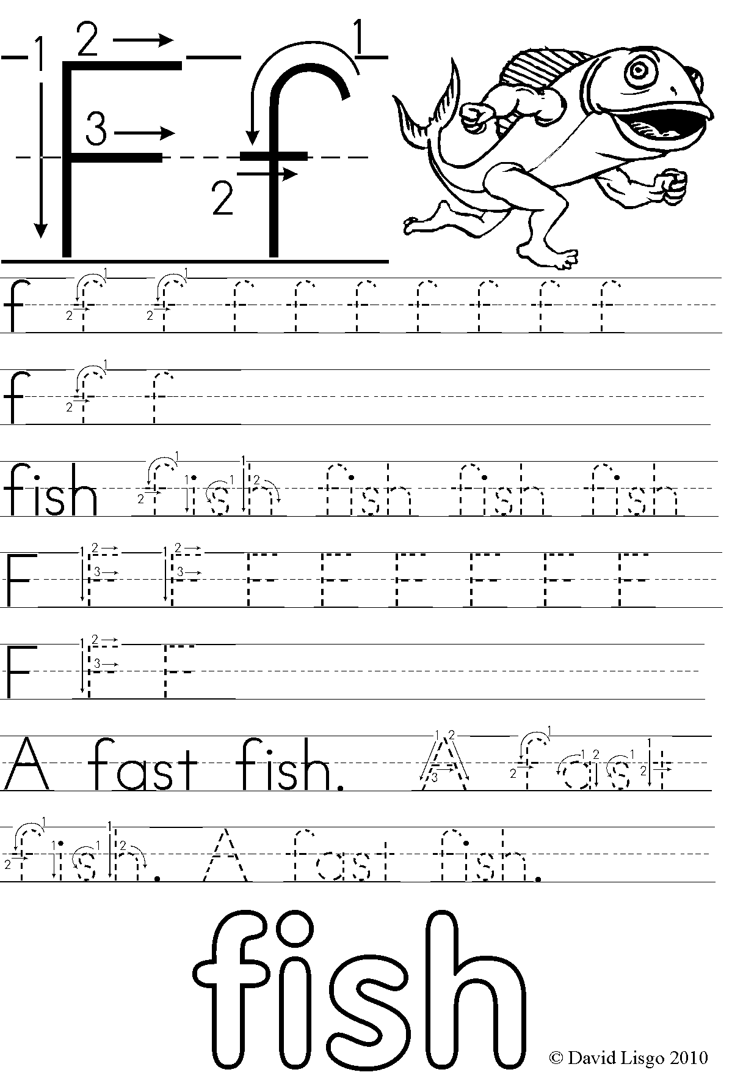

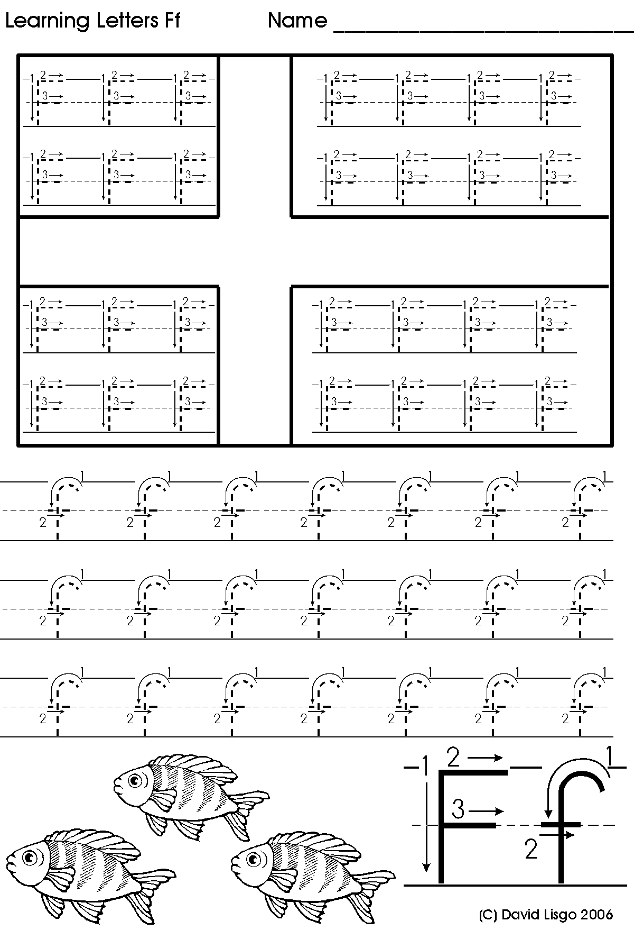

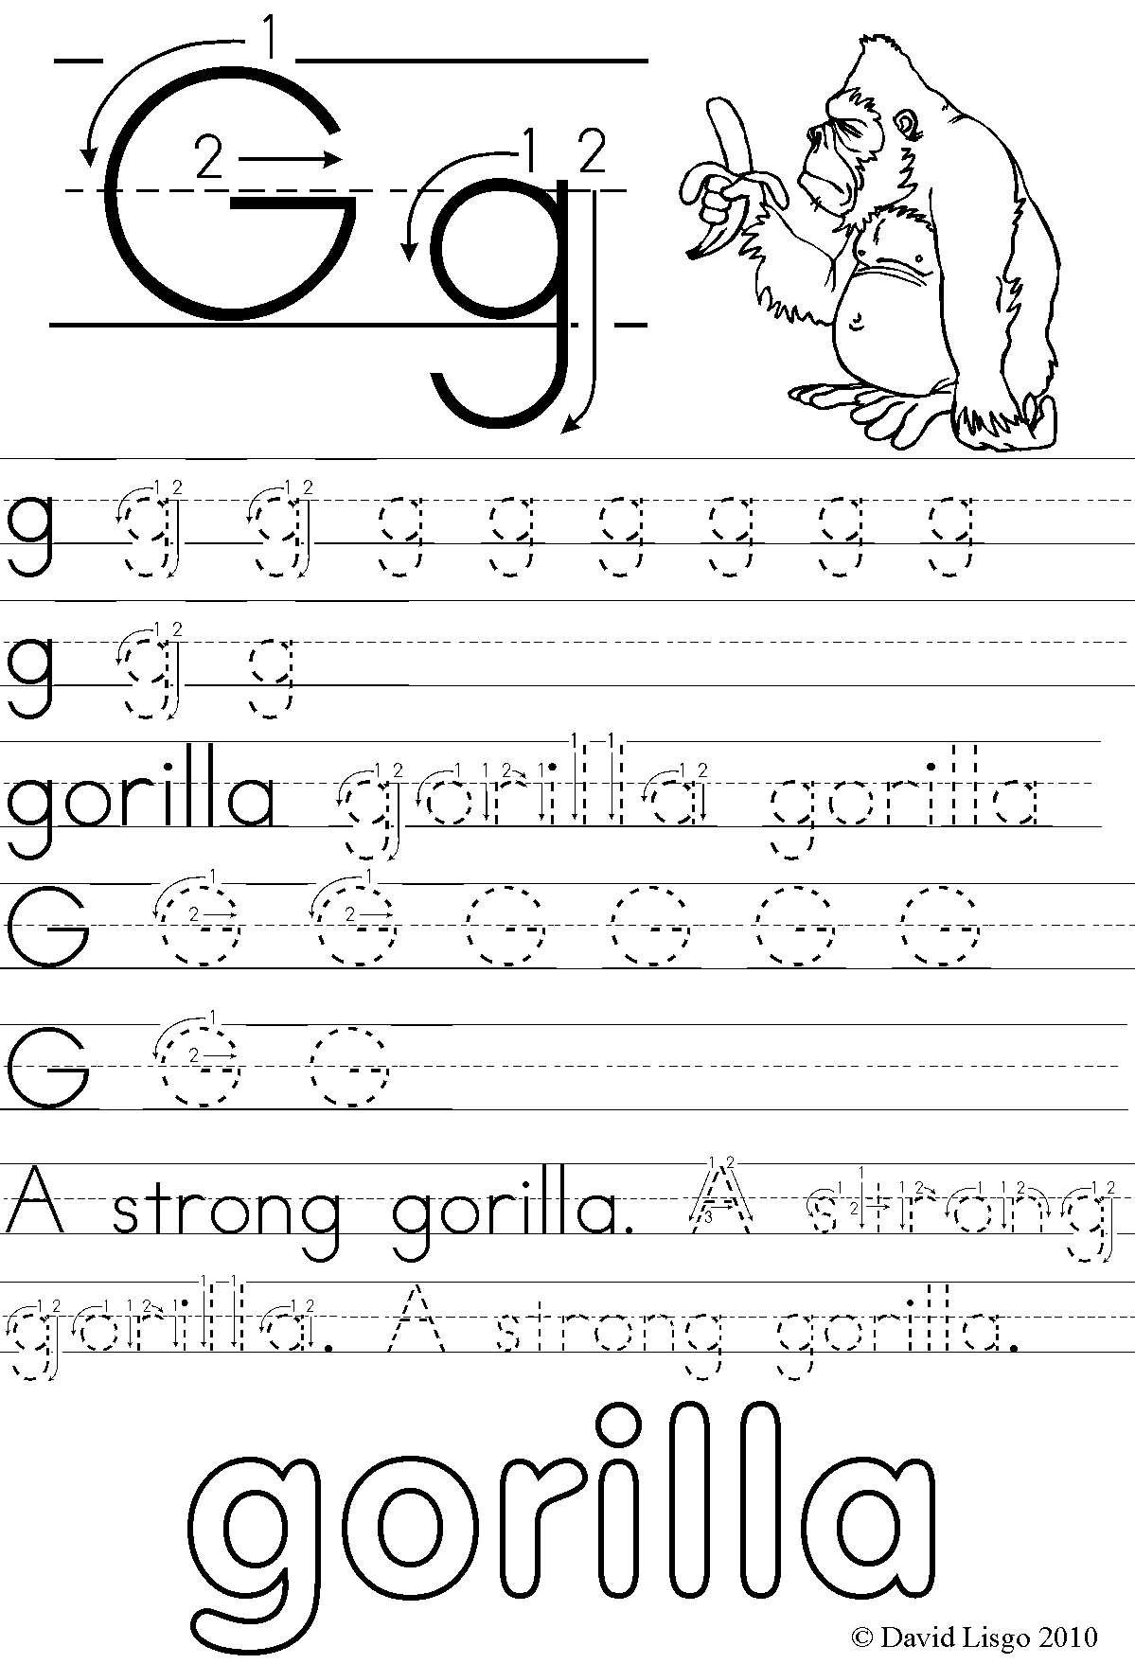

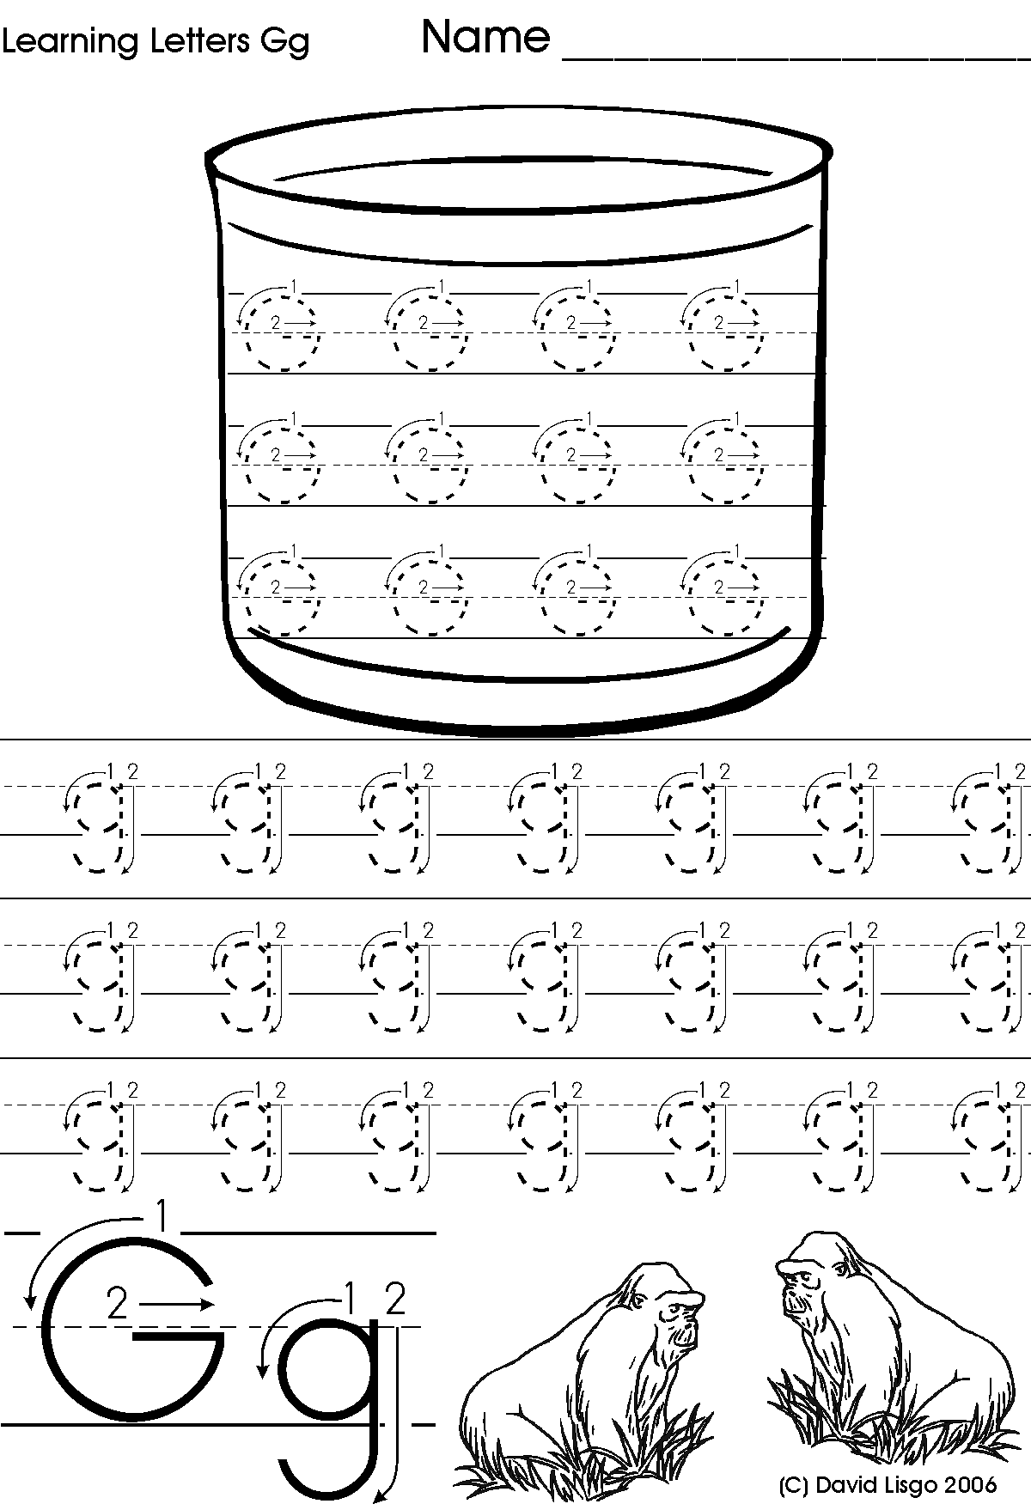

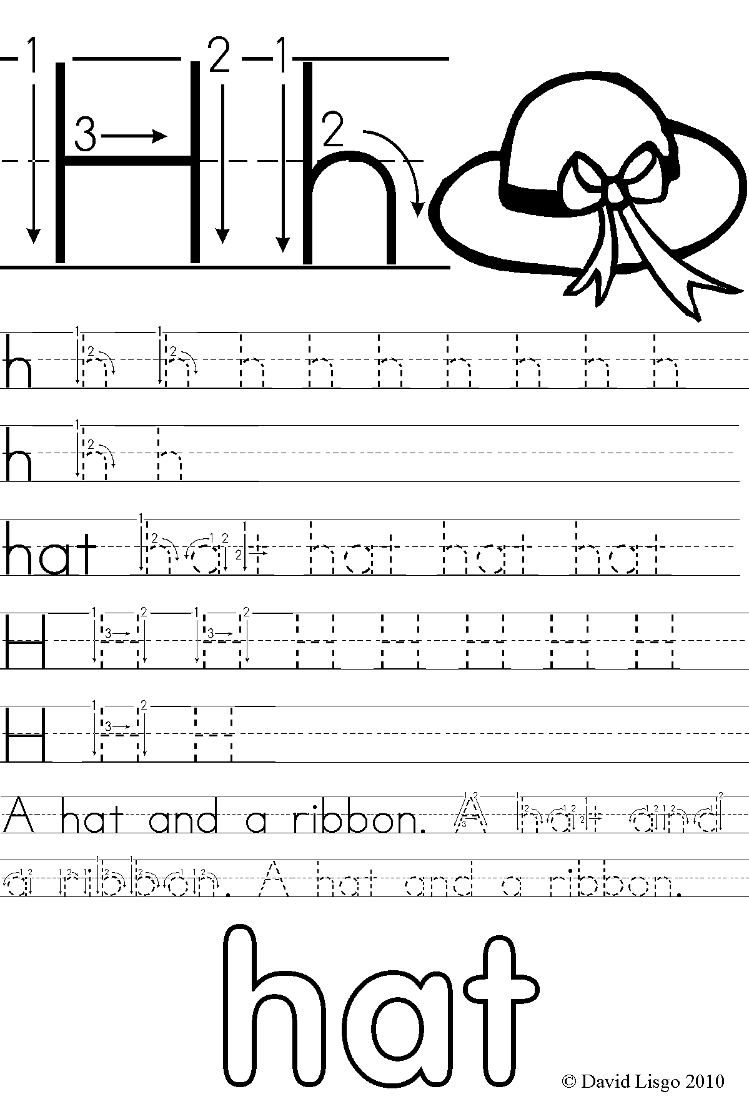

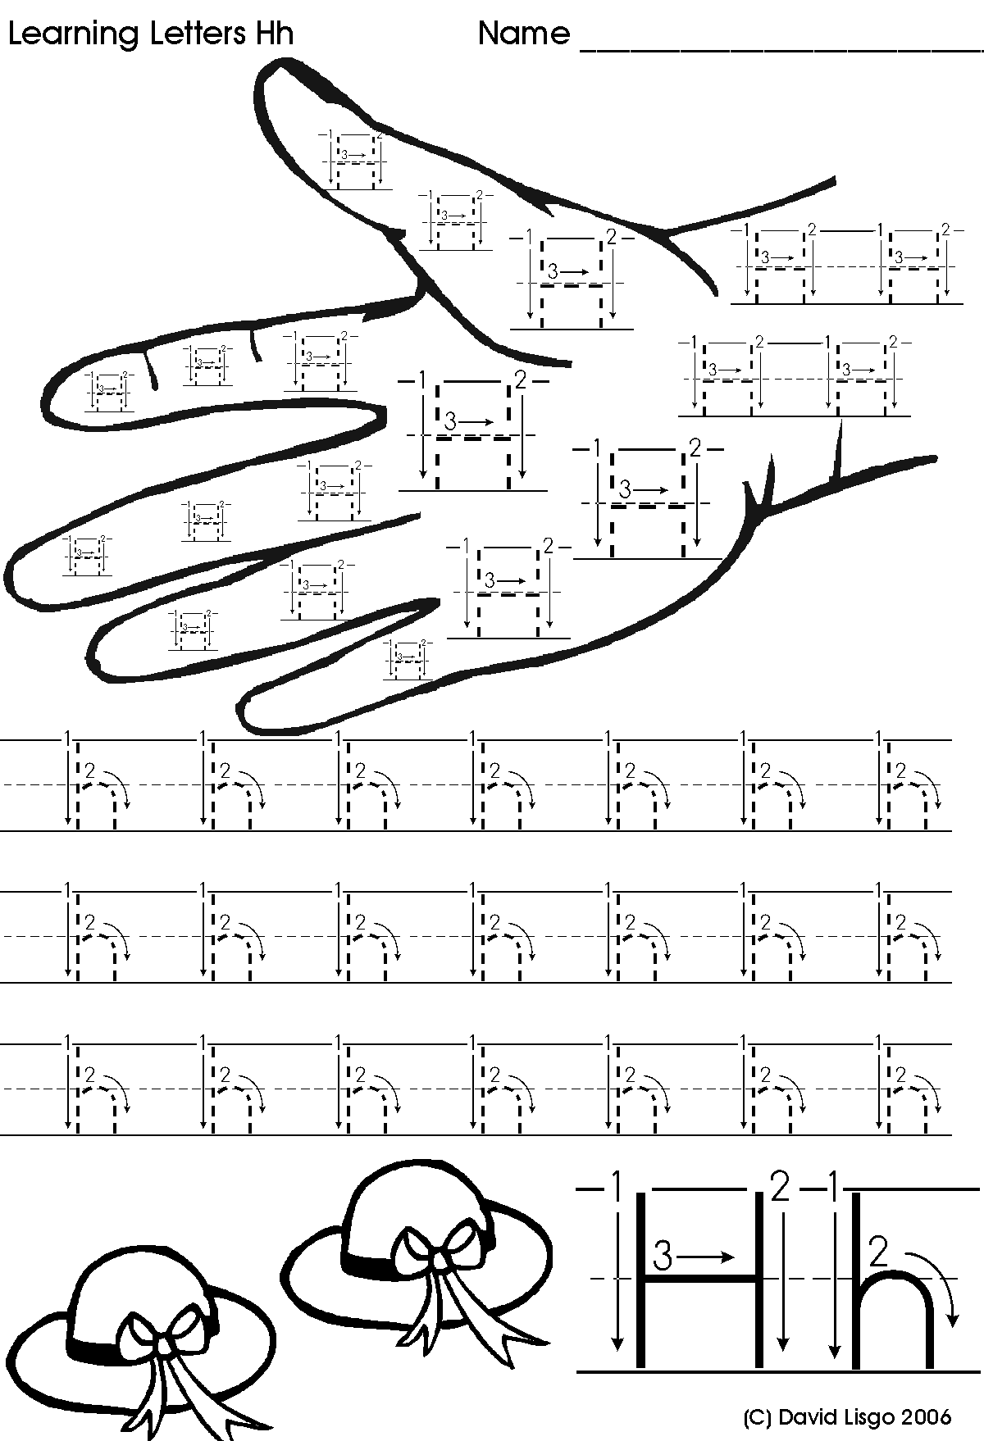

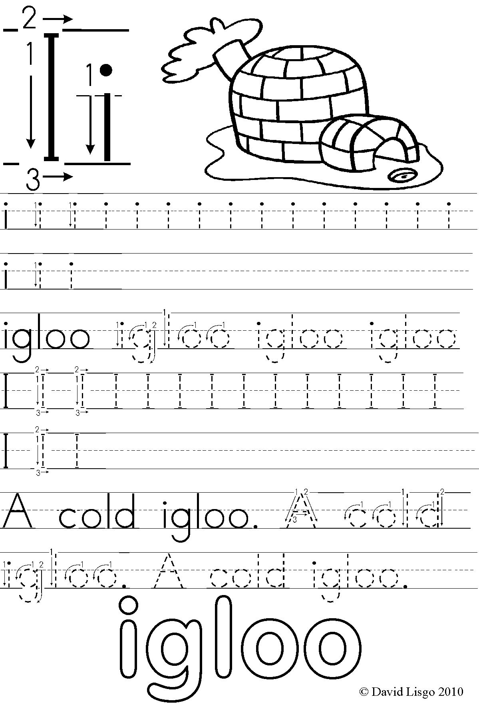

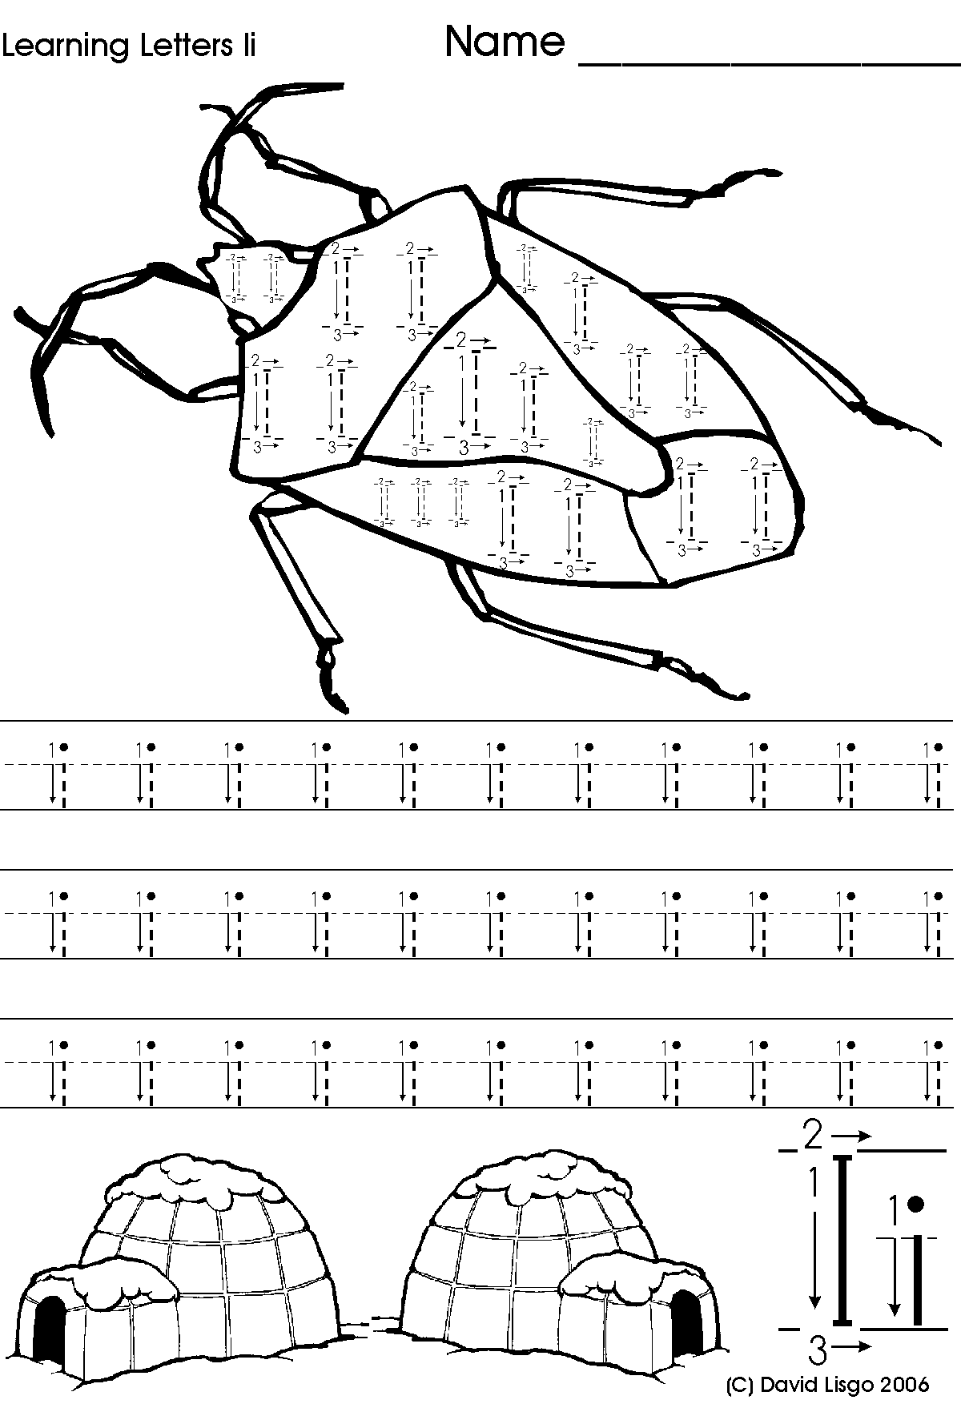

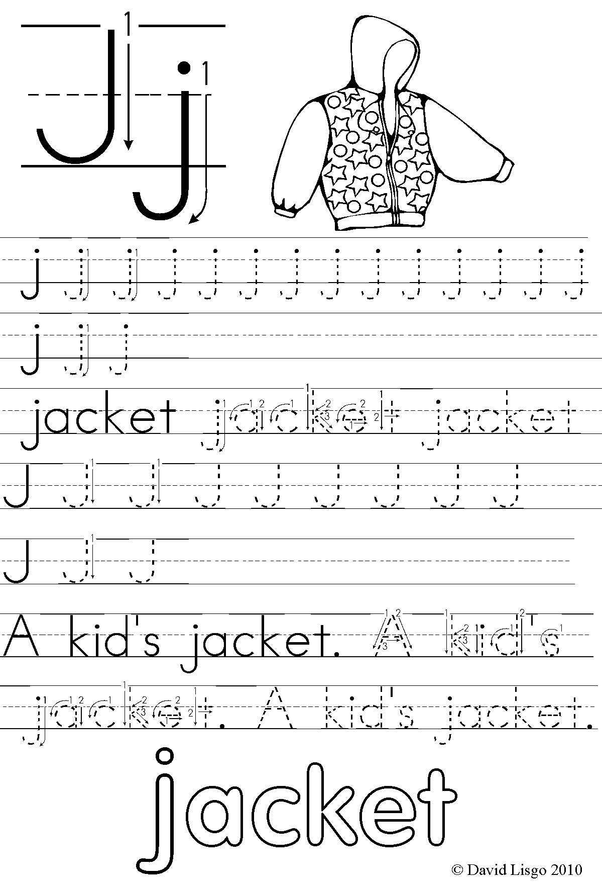

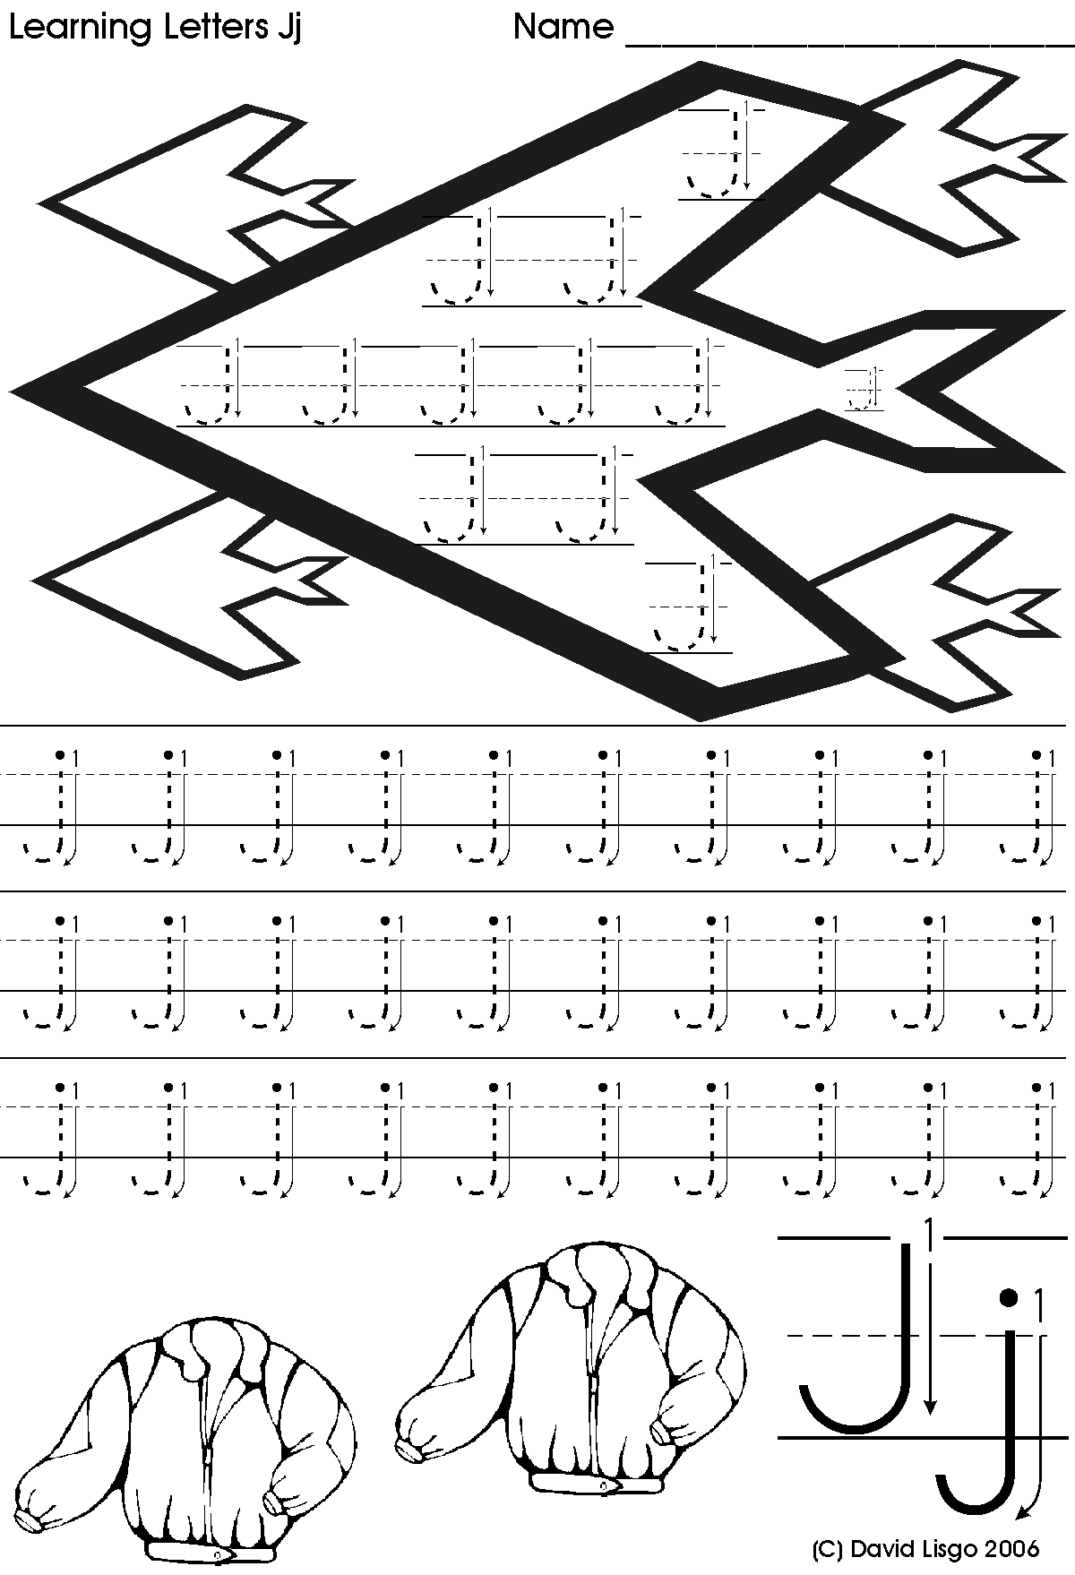

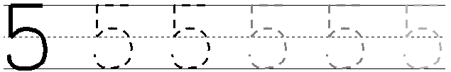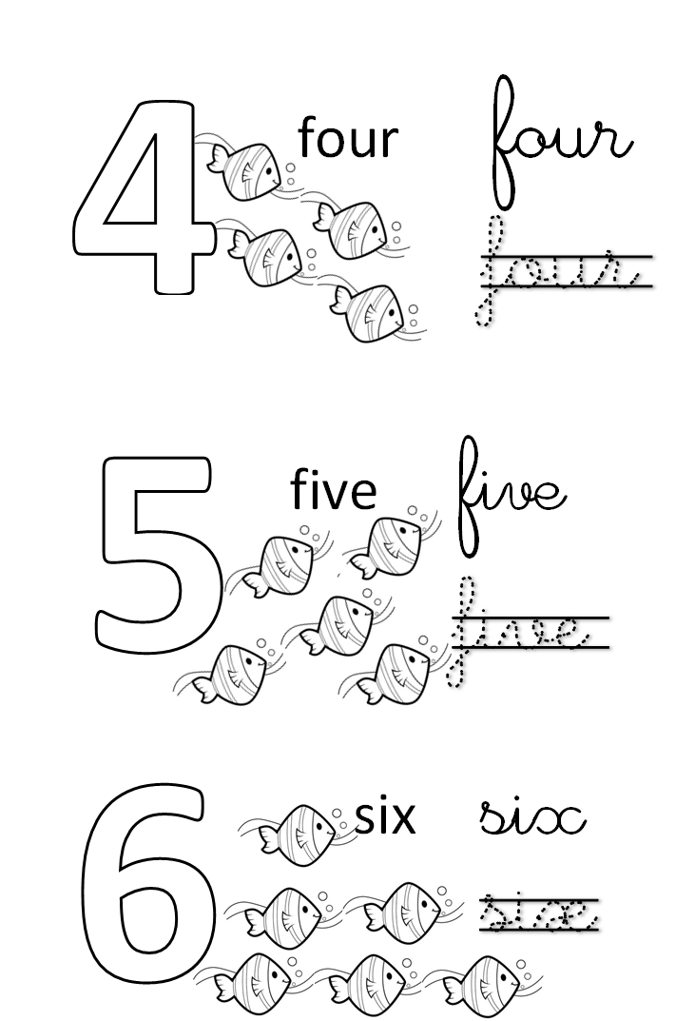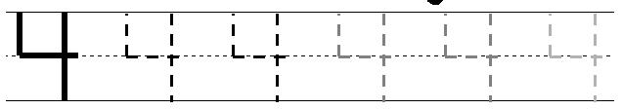



1234

**Count the numbers and write them : 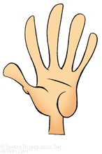**

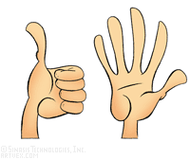









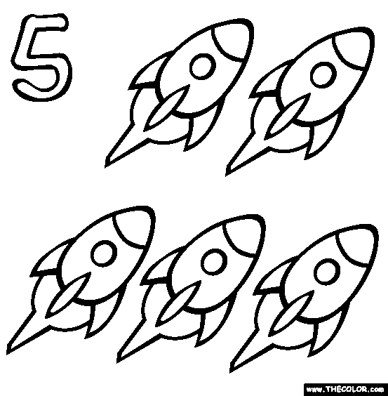





1234

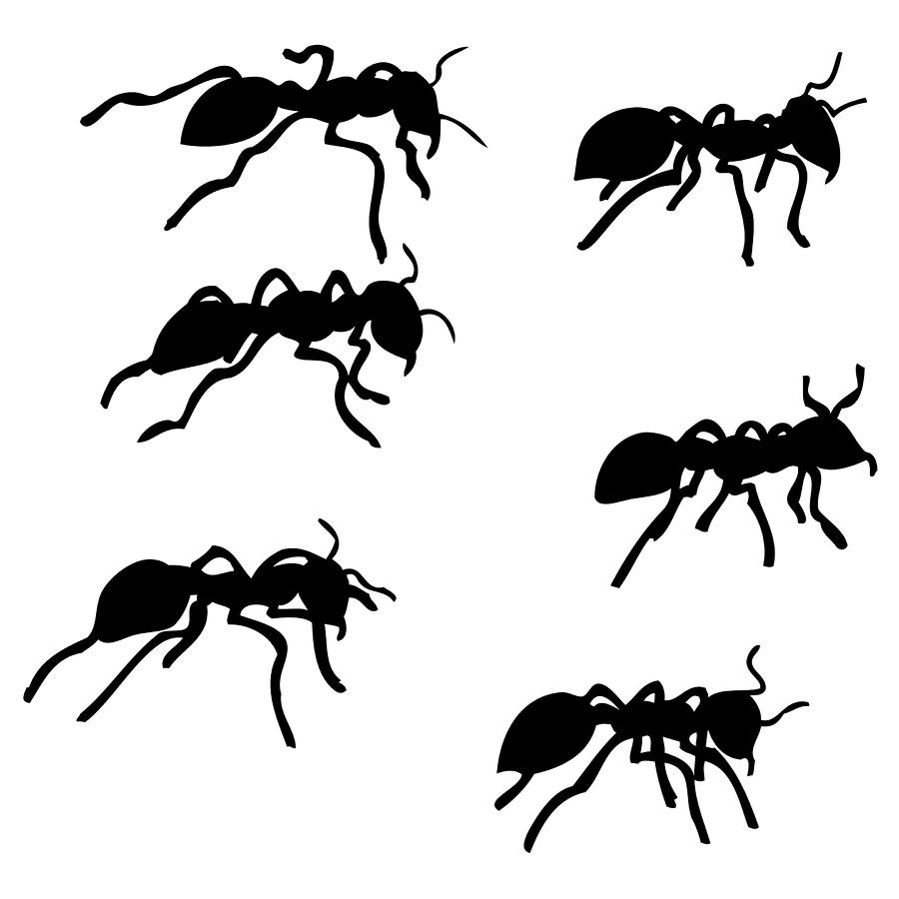1234

1234

**Count and match :**

|  |  |
| --- | --- |
| **Untitled-6 copyUntitled-6 copyUntitled-6 copyUntitled-6 copyUntitled-6 copyUntitled-6 copy** | **4** |
| **Untitled-4 copyUntitled-4 copyUntitled-4 copyUntitled-4 copy** | **6** |
| **http://www.getyourpeople.com/iloveluci/five%20stars.png** | **5** |

**Count and write :**



**Match the correct alphabet with picture and small letter :**

|  |  |  |
| --- | --- | --- |
| **D** | frog | **e** |
| **E** | 121617897960609915lemmling_2D_cartoon_elephant | **d** |
| **F** | images | **g** |
| **G** | cube | **i** |
| **H** | http://wwwdelivery.superstock.com/WI/223/1538/PreviewComp/SuperStock_1538R-55706.jpg | **f** |
| **I** | http://www.cowboyclipart.net/animals/goats7.jpg | **h** |

**Match the picture with the beginning letter**

**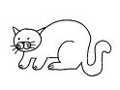**

* **e**
* **g**
* **a**
* **i**
* **k**
* **C**
* **c**

**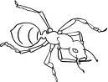**

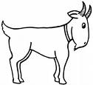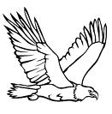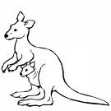

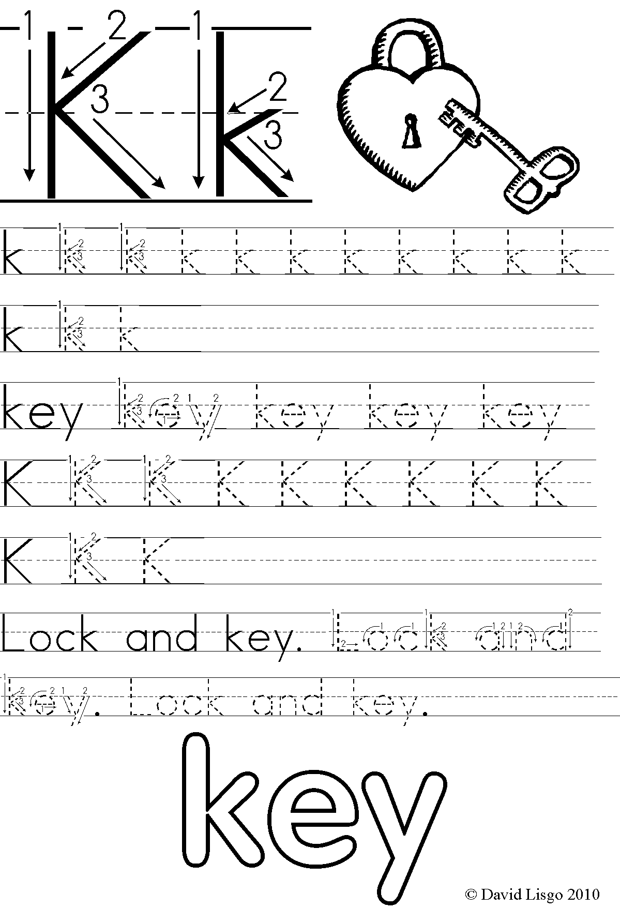

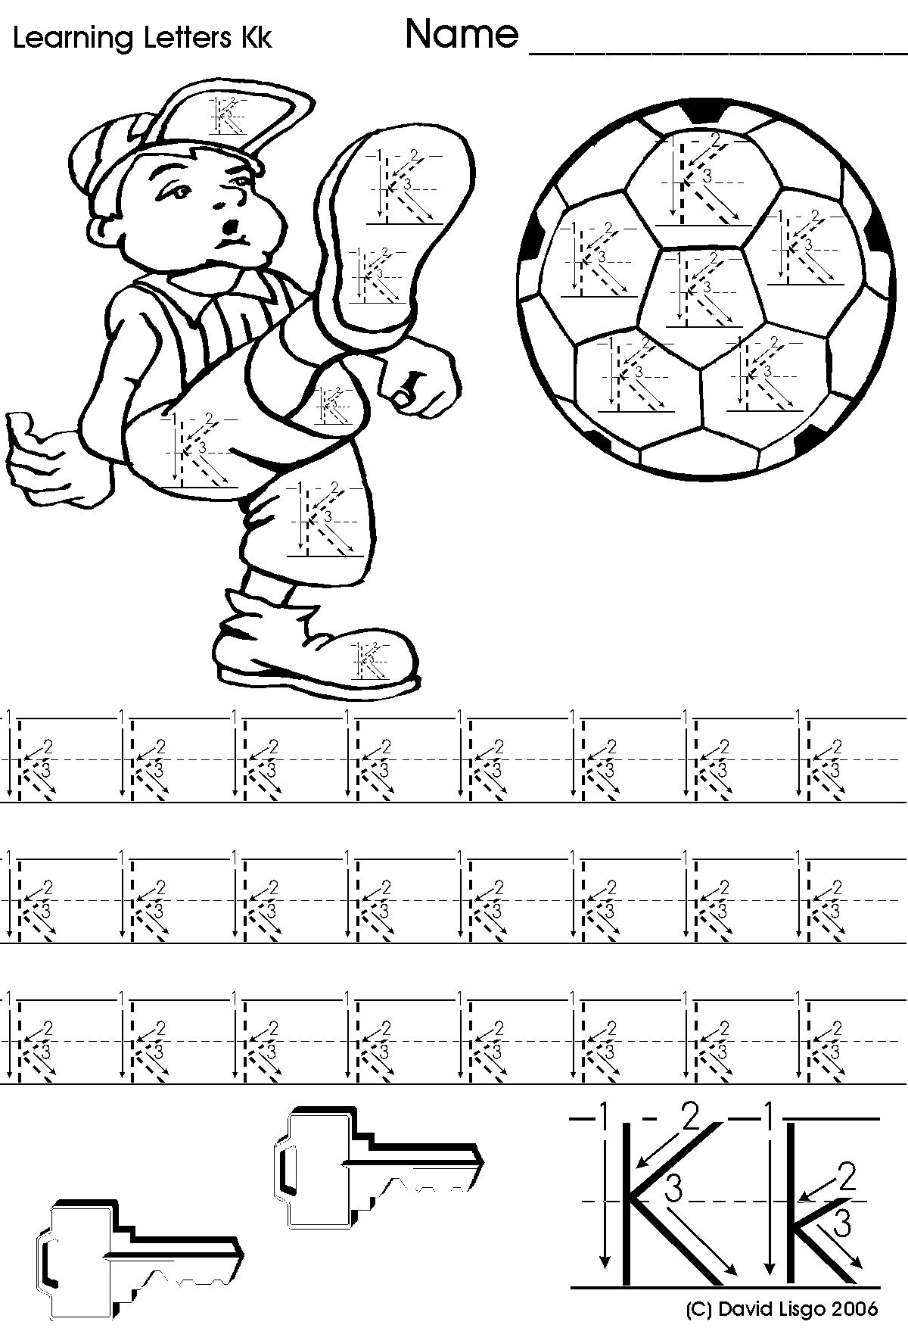

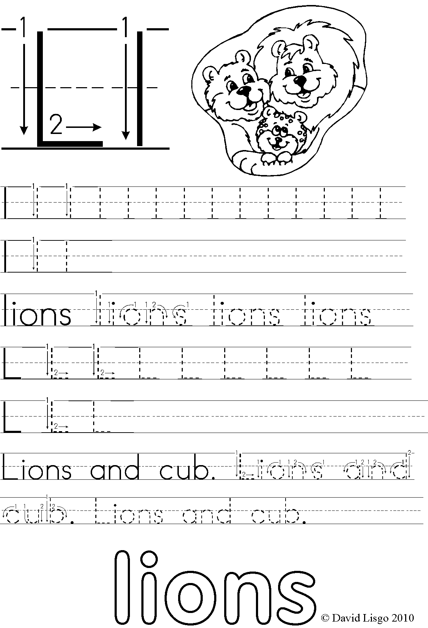

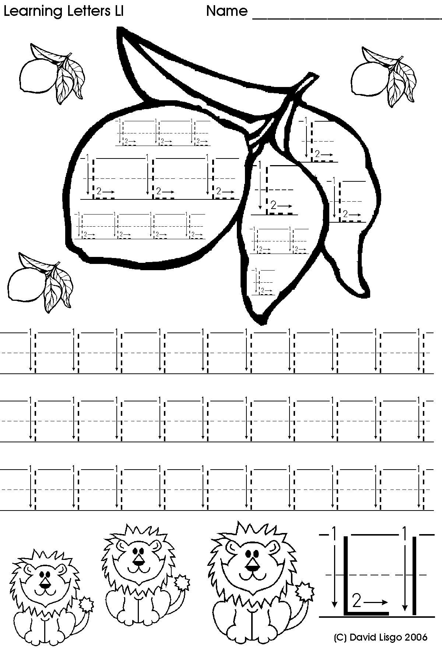

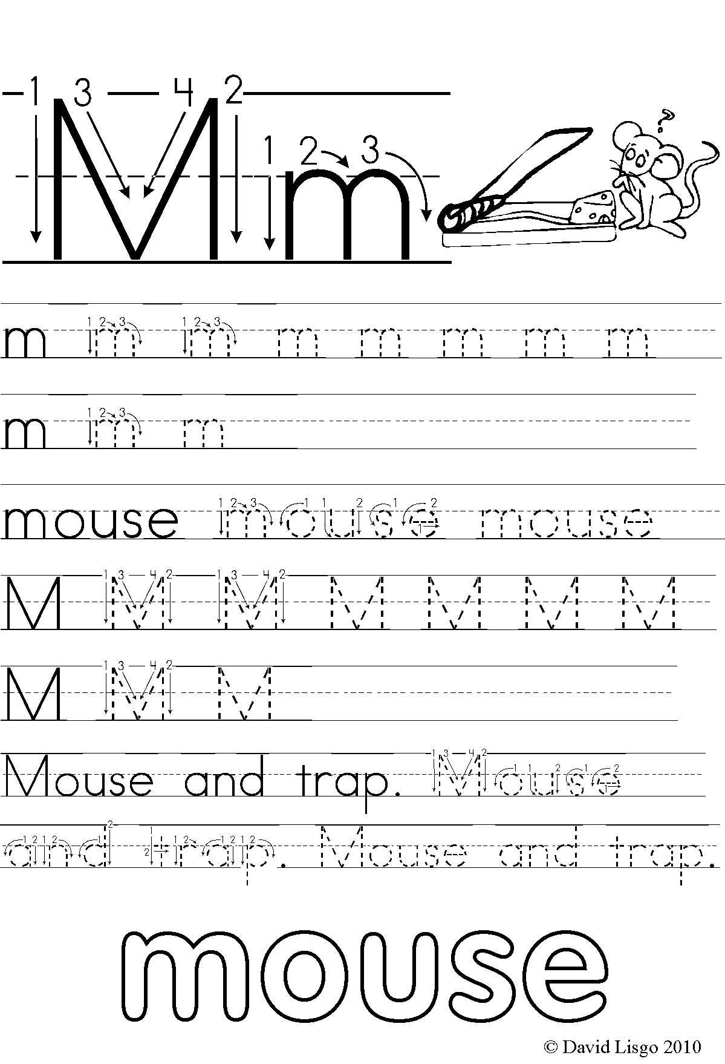

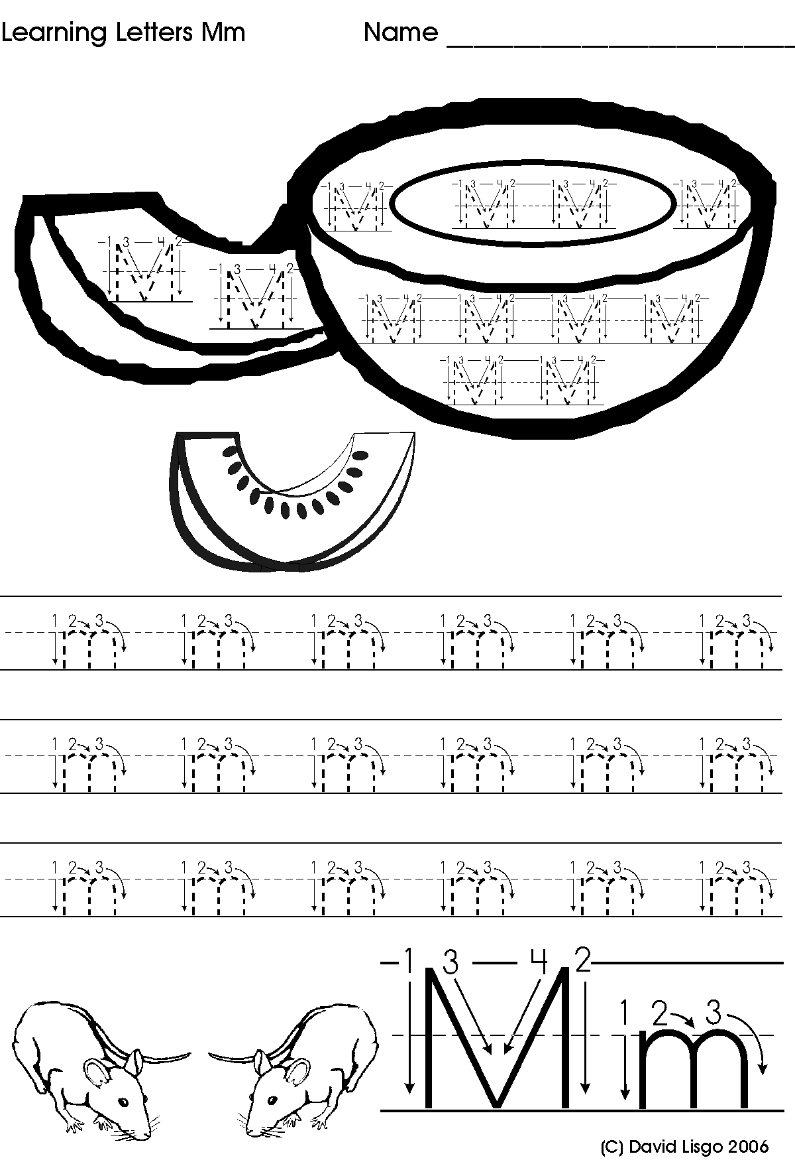

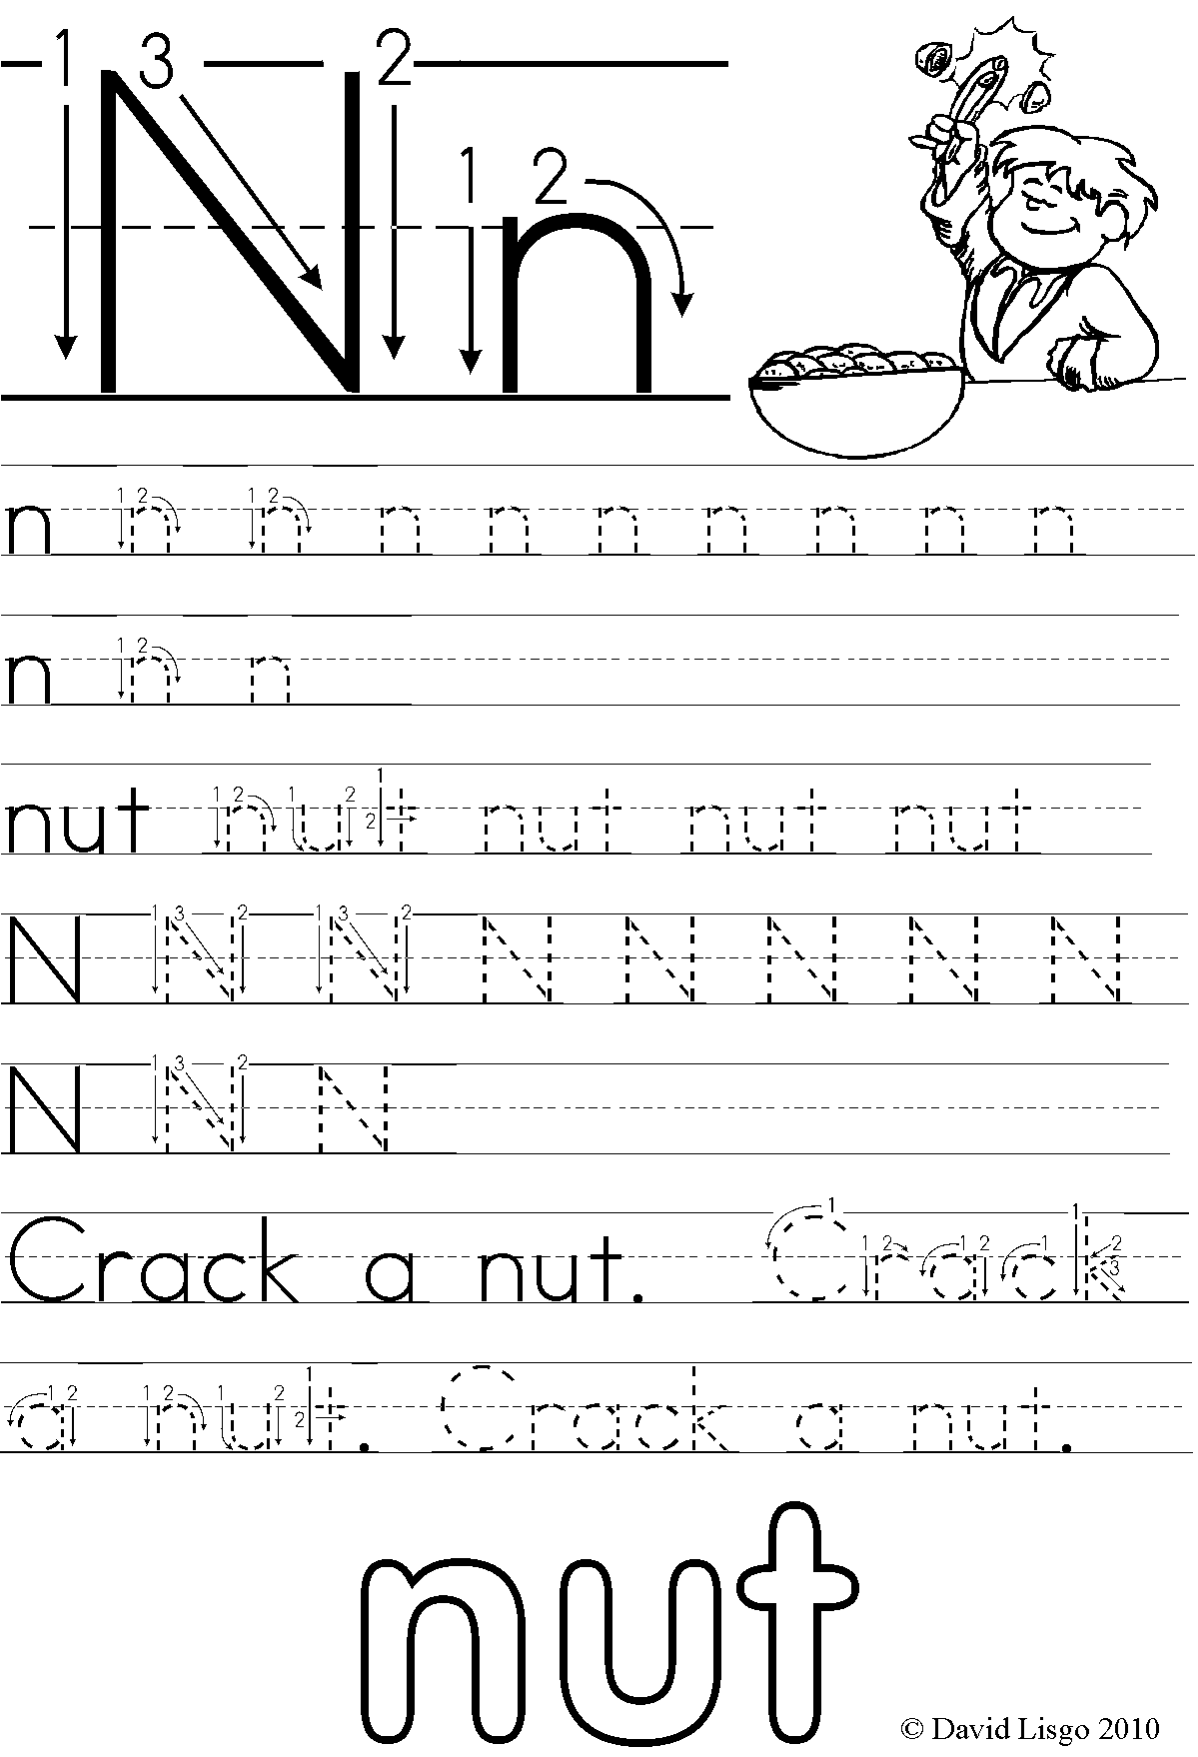

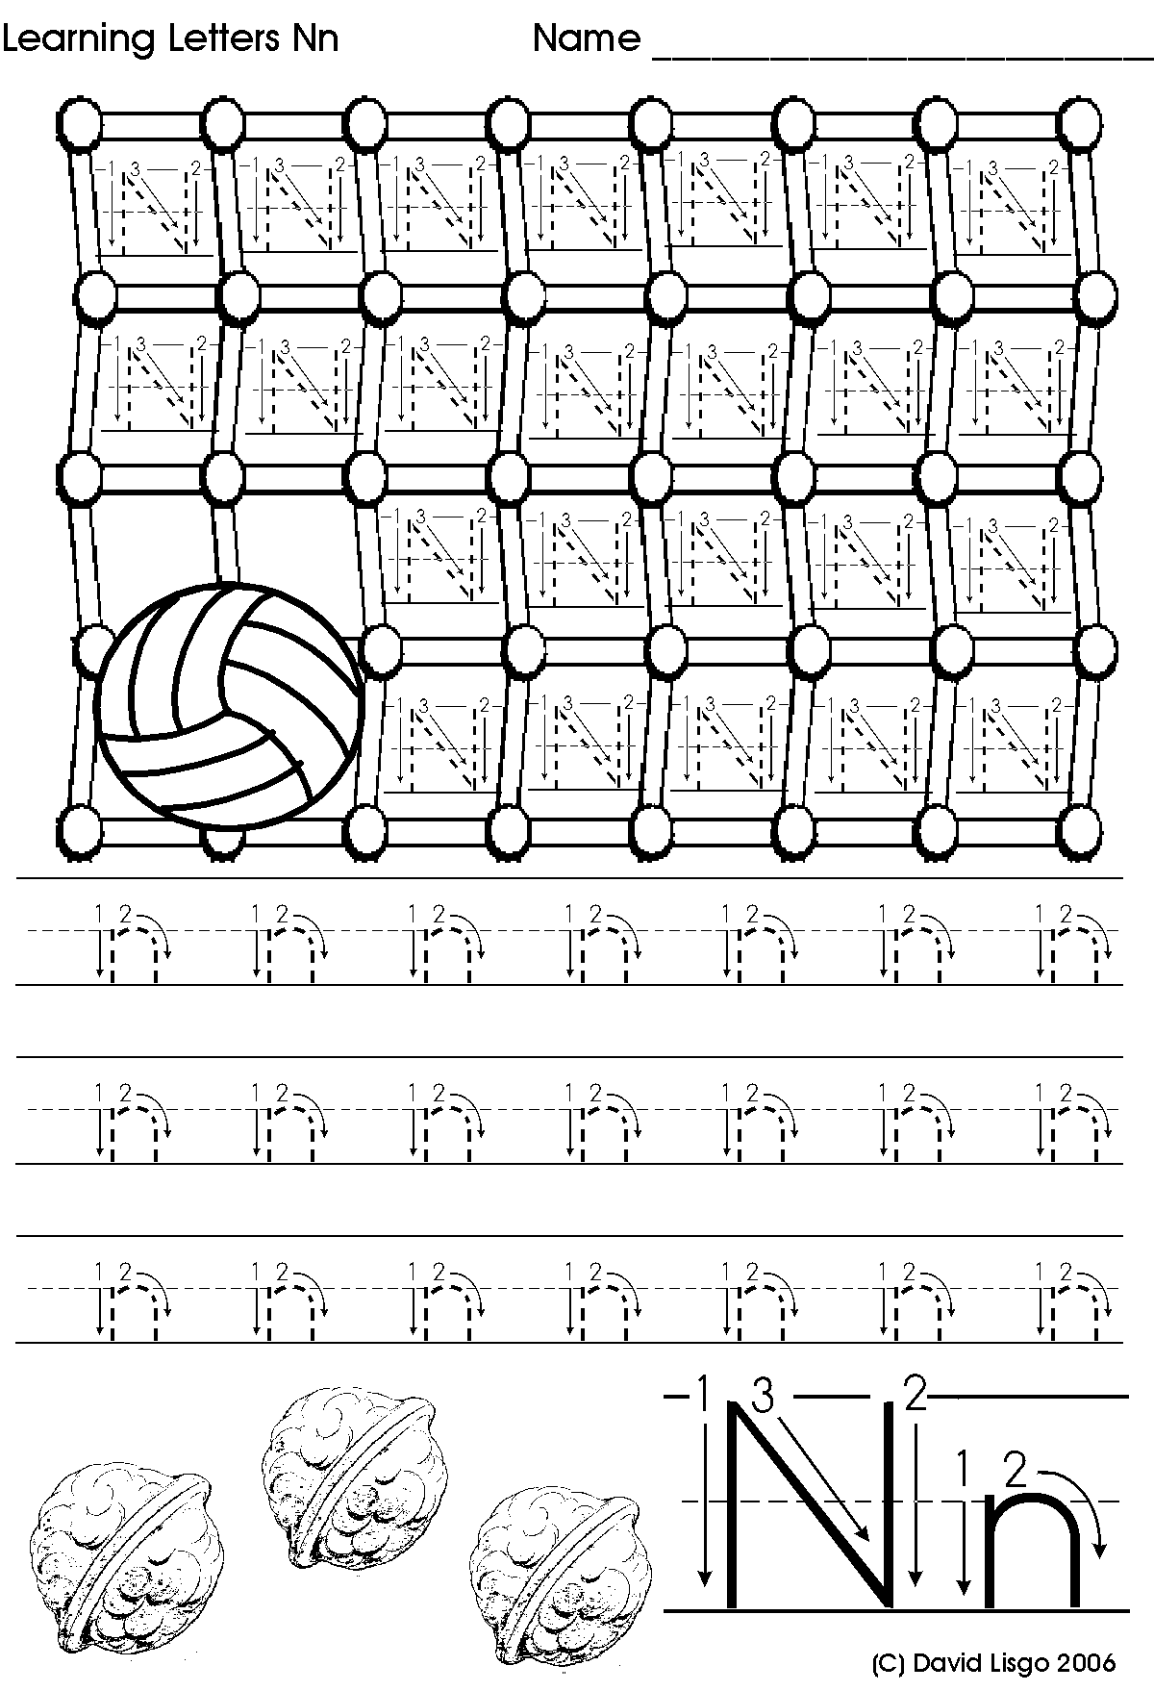

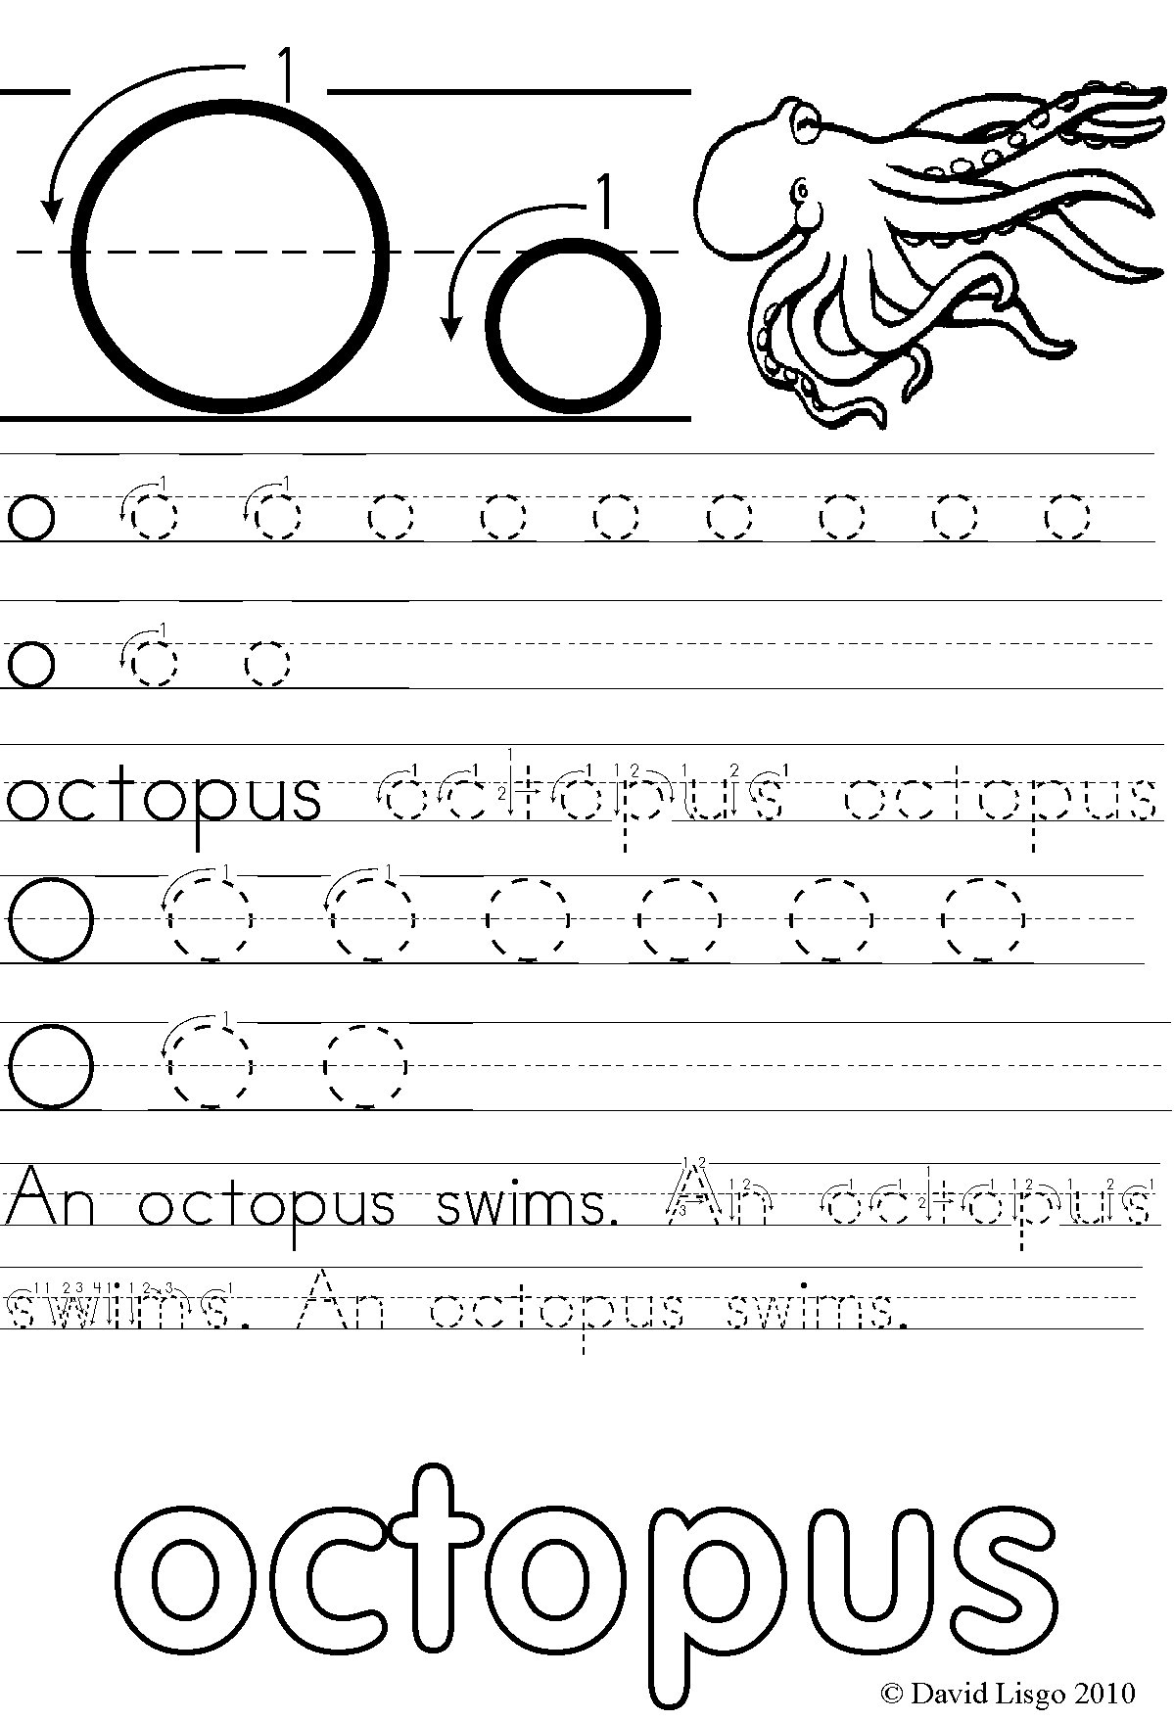

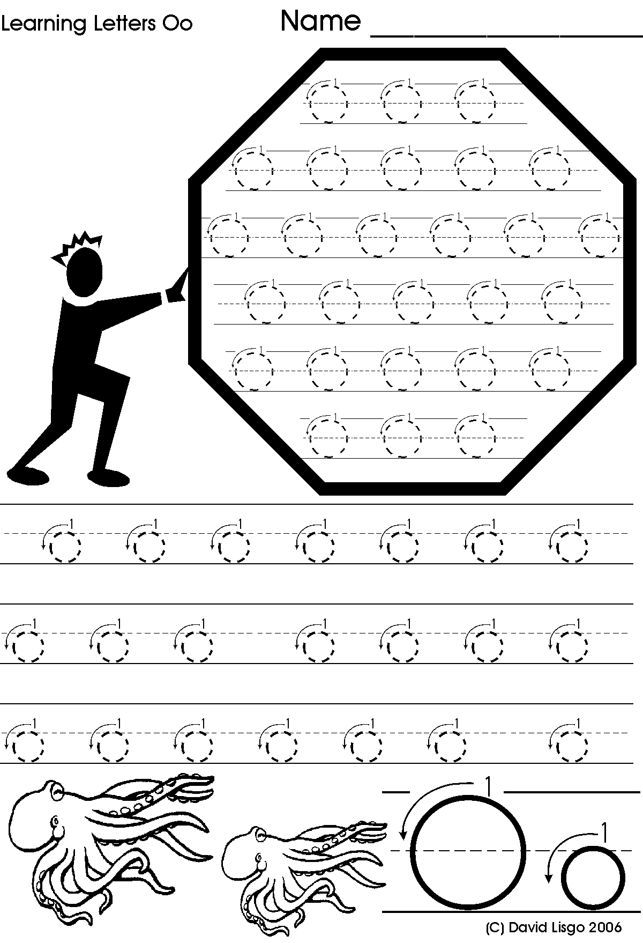

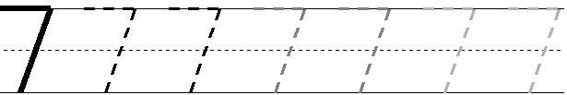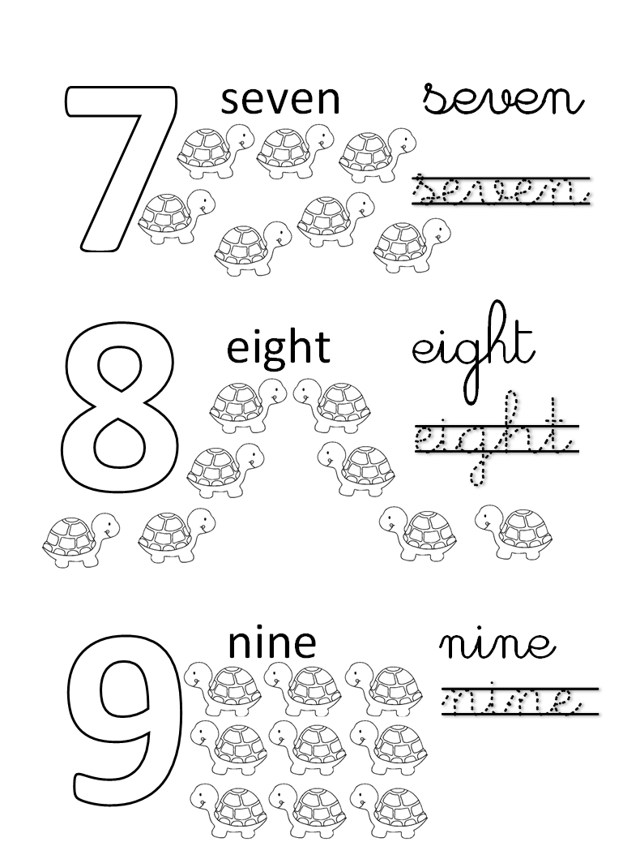



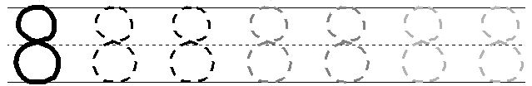



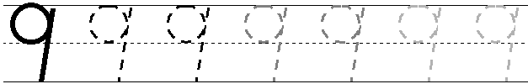





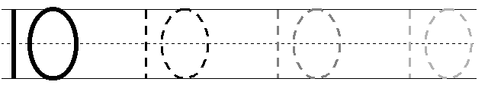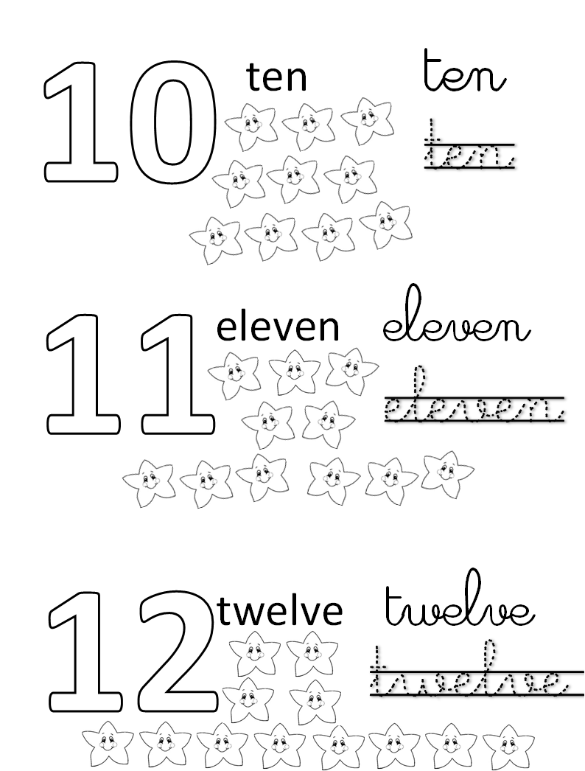



**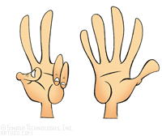Count the numbers and write them :**

**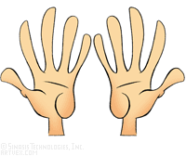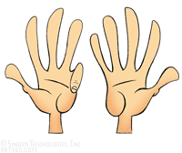**

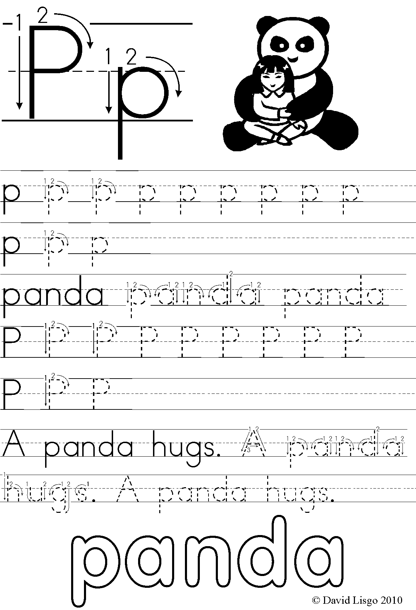

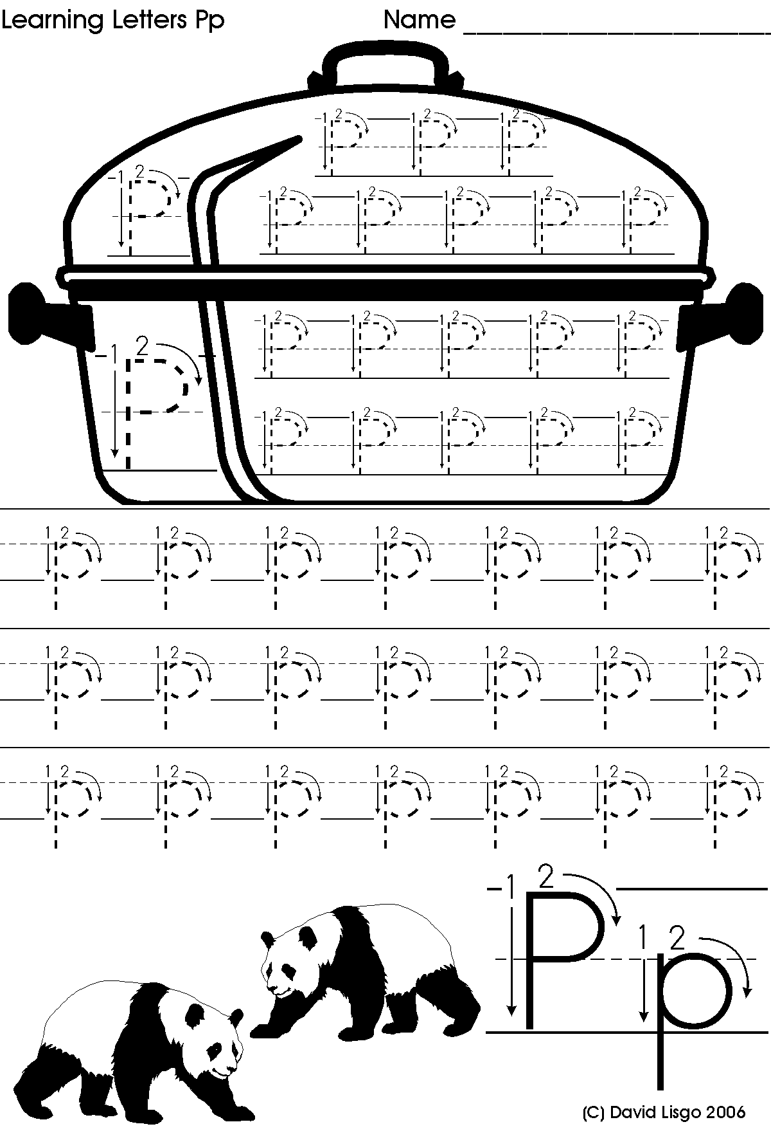

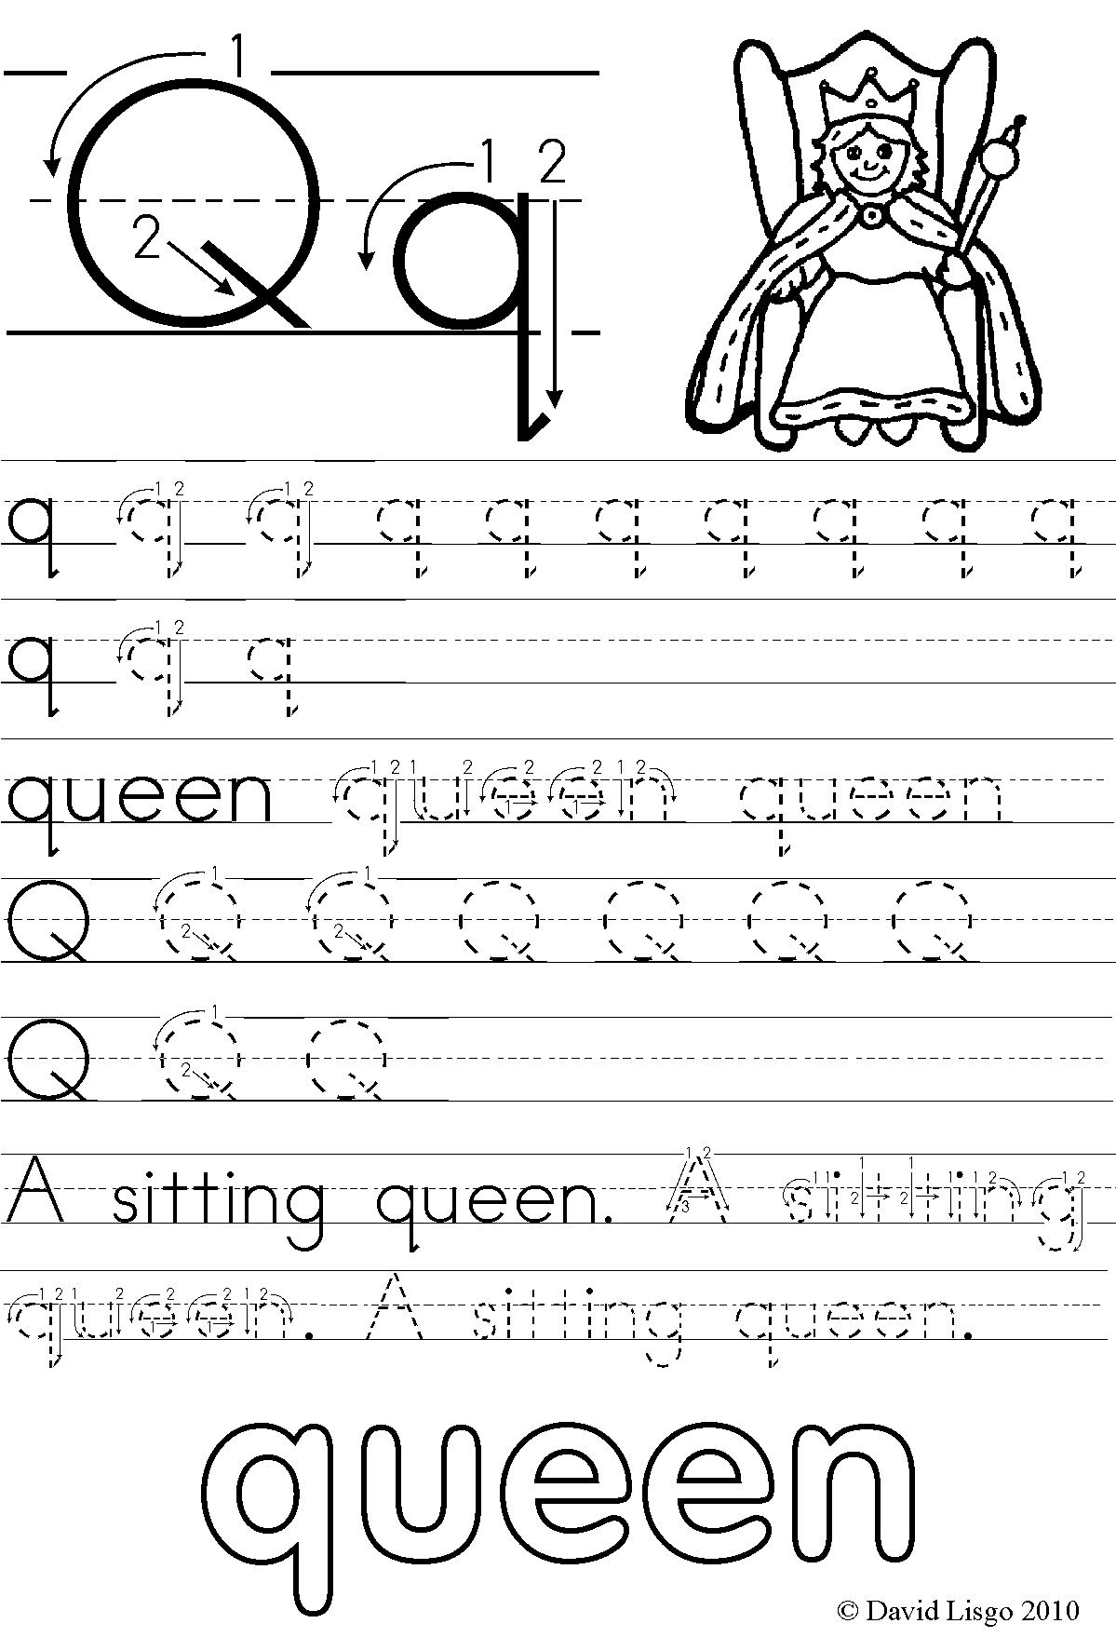

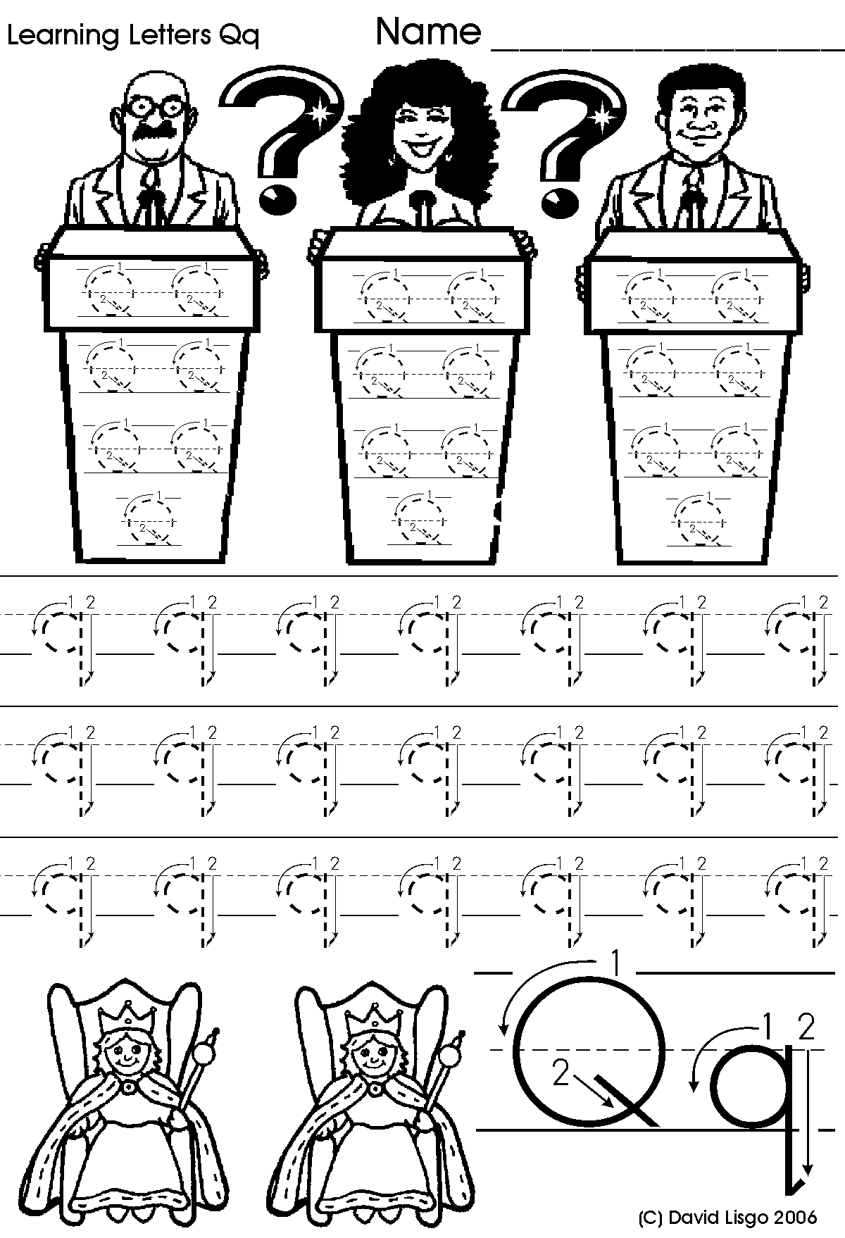

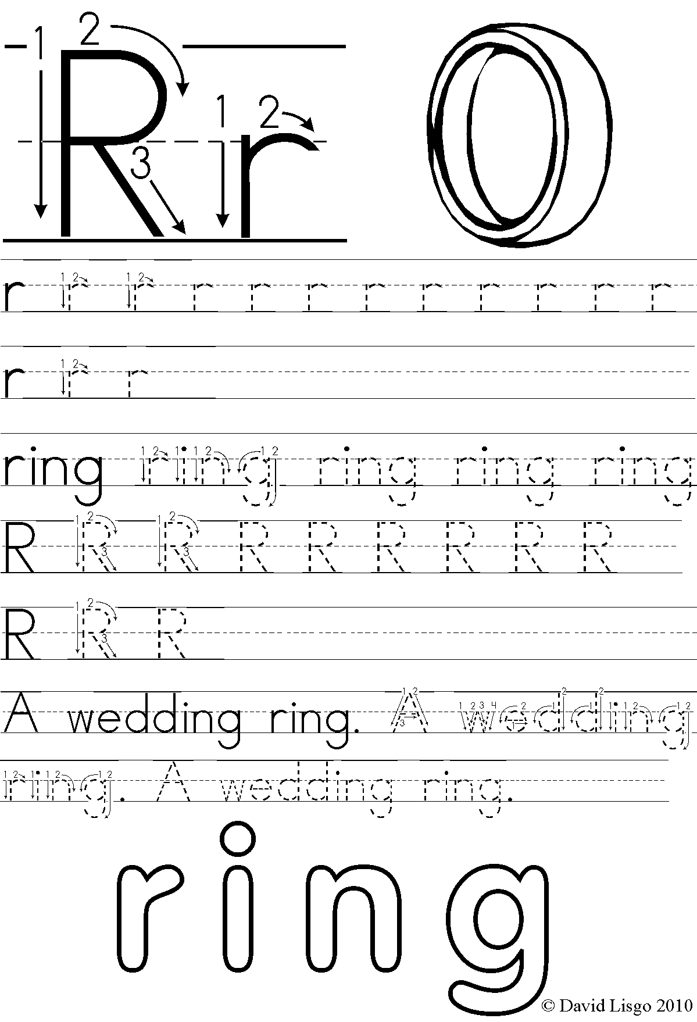

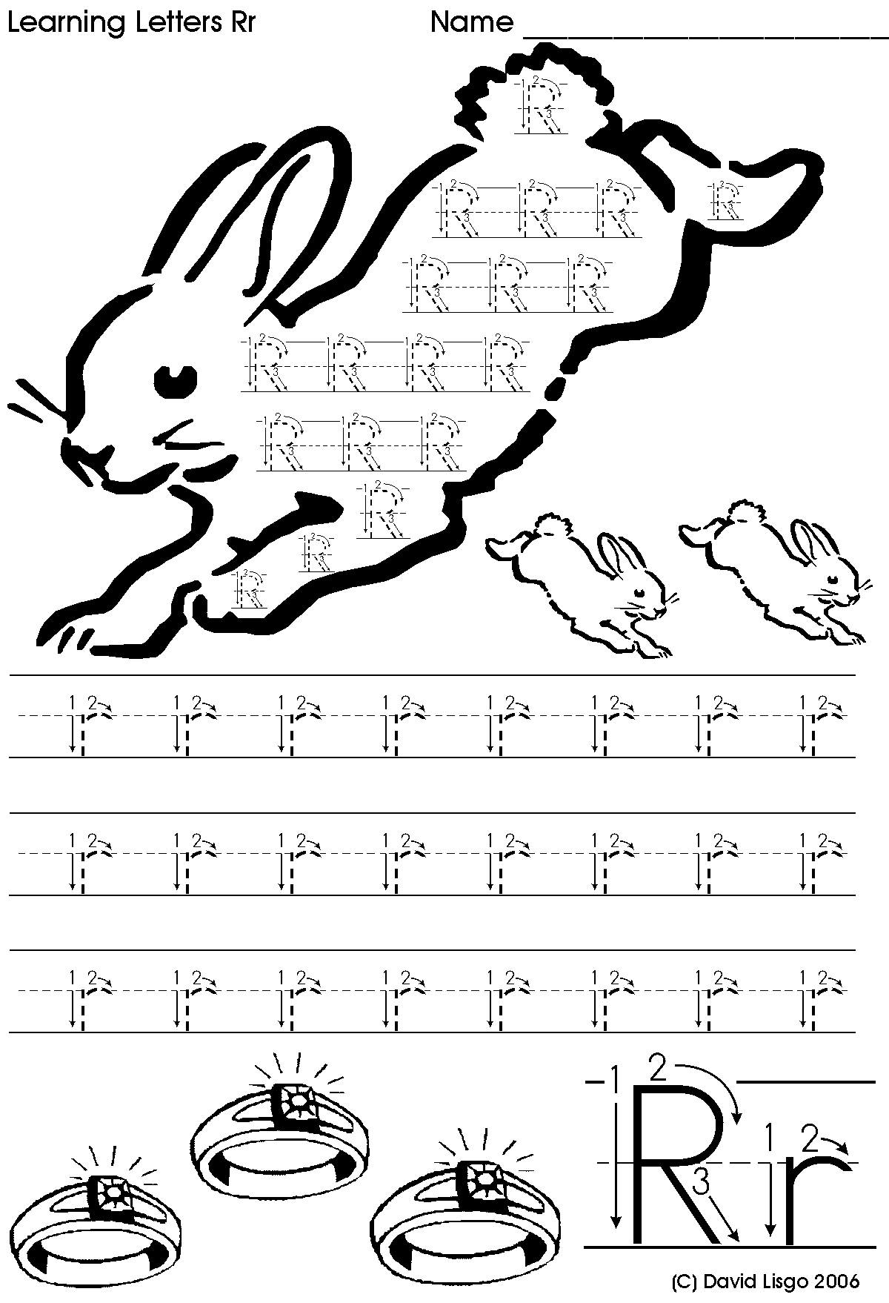

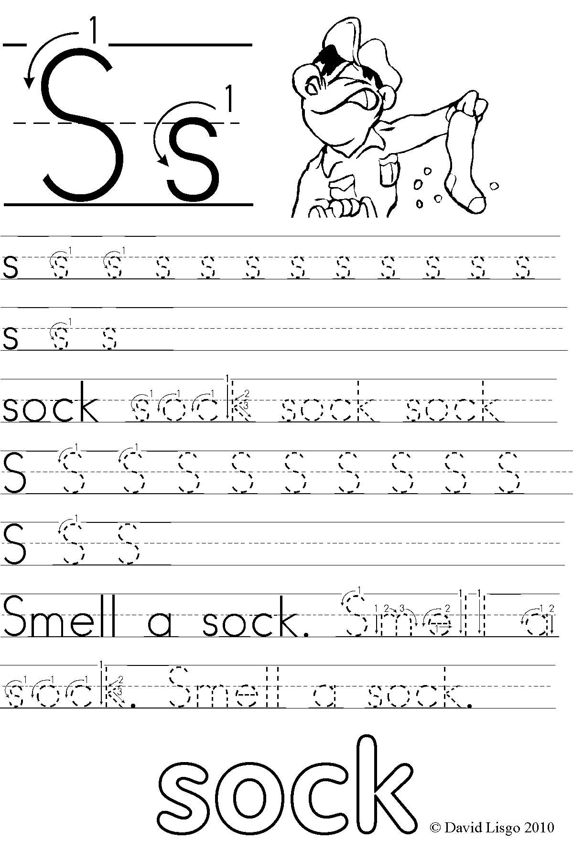

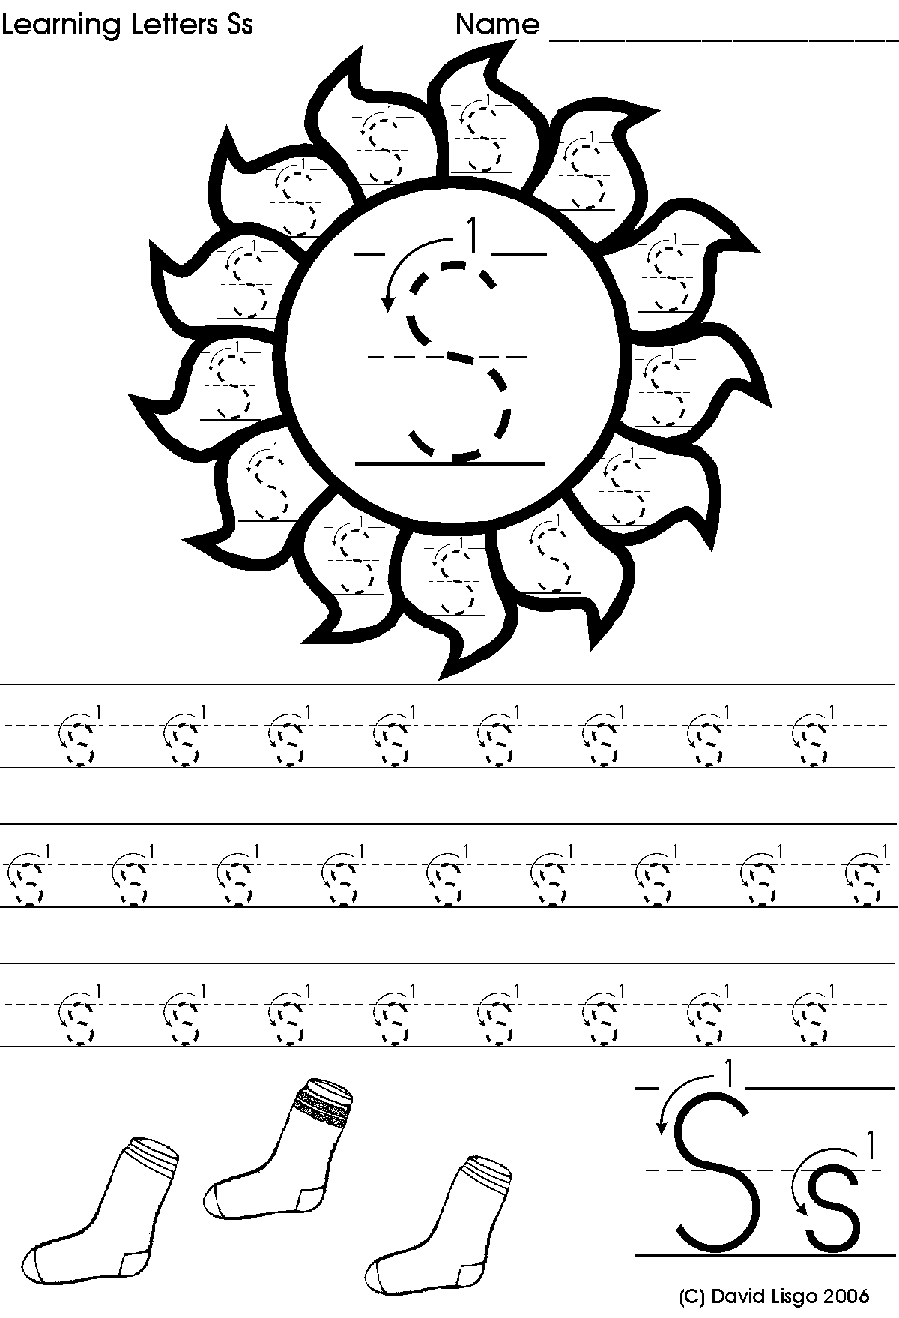

**Match the picture with the beginning letter**

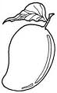

* L
* R
* M
* P
* S

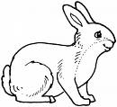

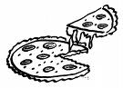

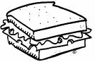http://t1.gstatic.com/images?q=tbn:KFW1VMr3IEl2vM:http://www.hillbillyhousewife.com/images/lemon.jpg

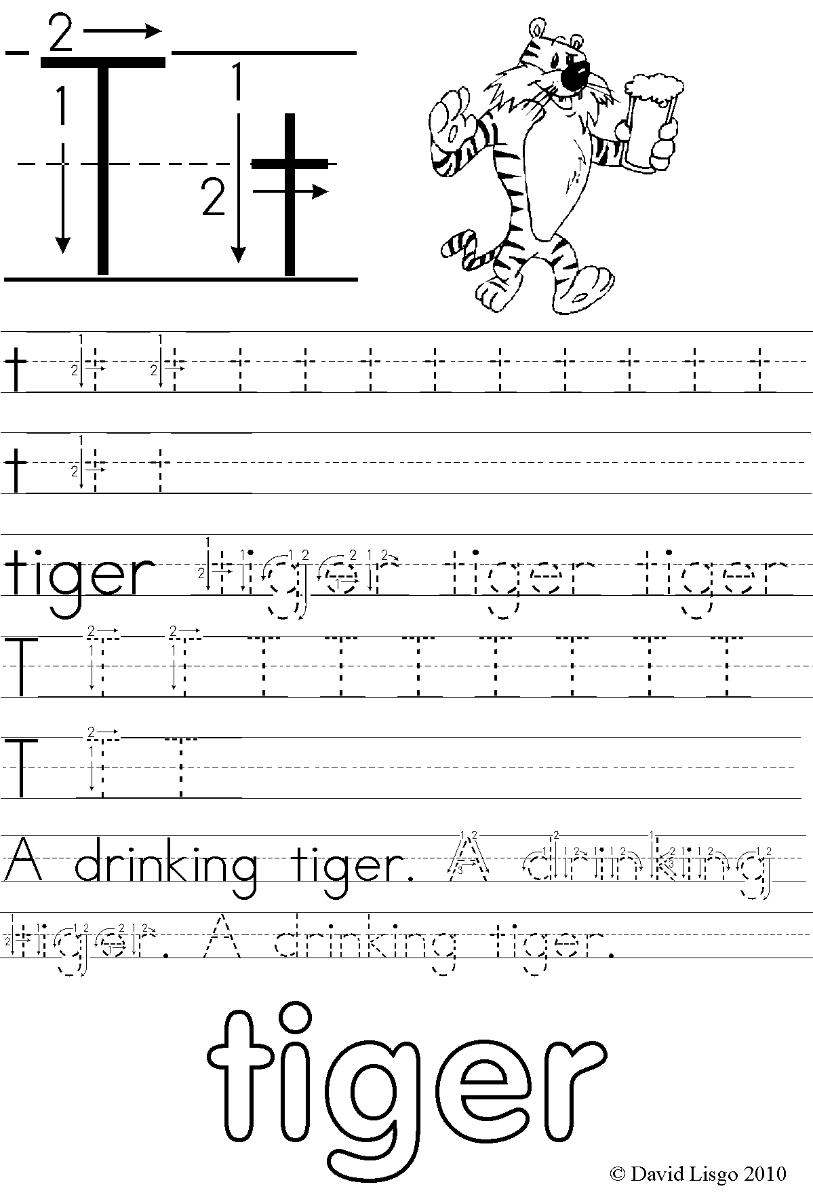

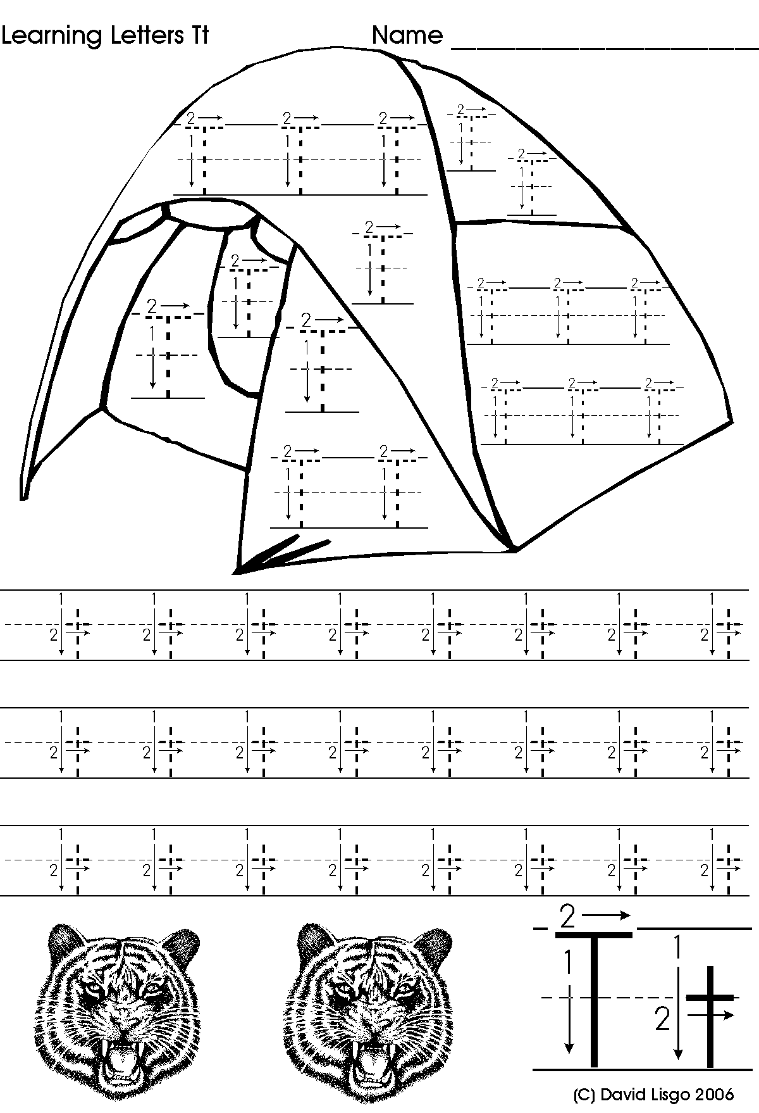

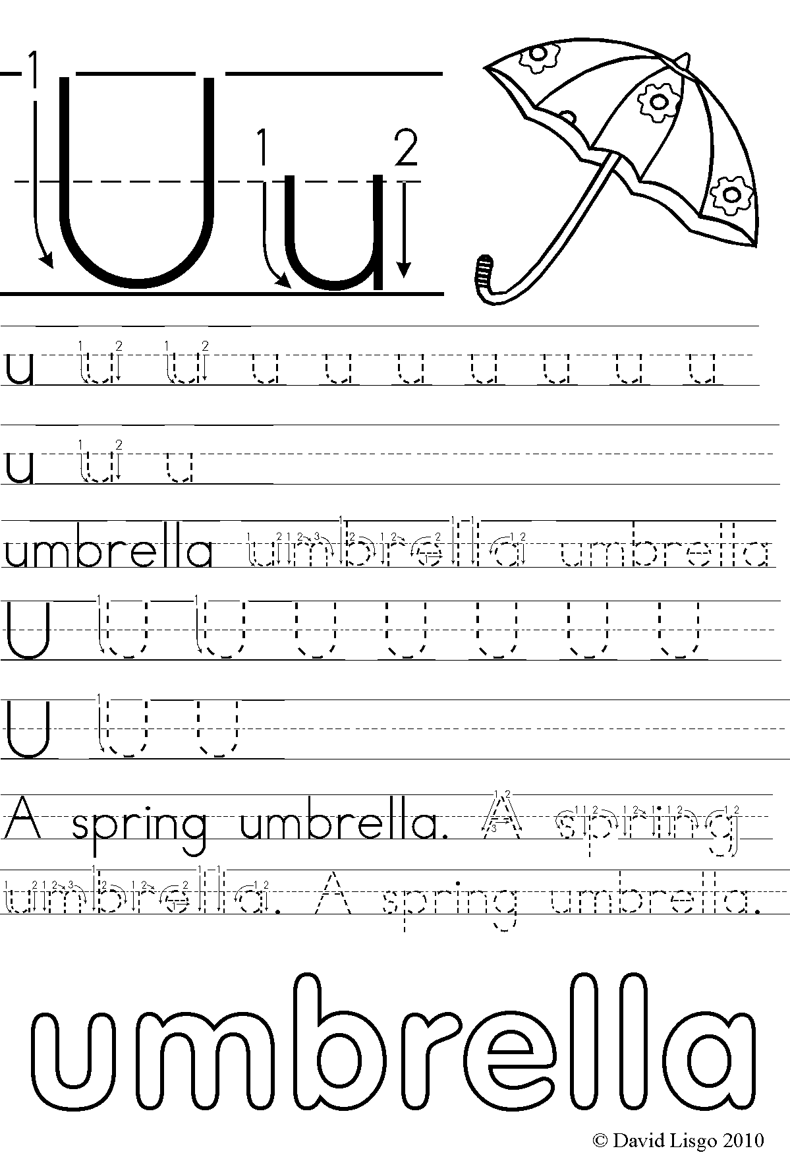

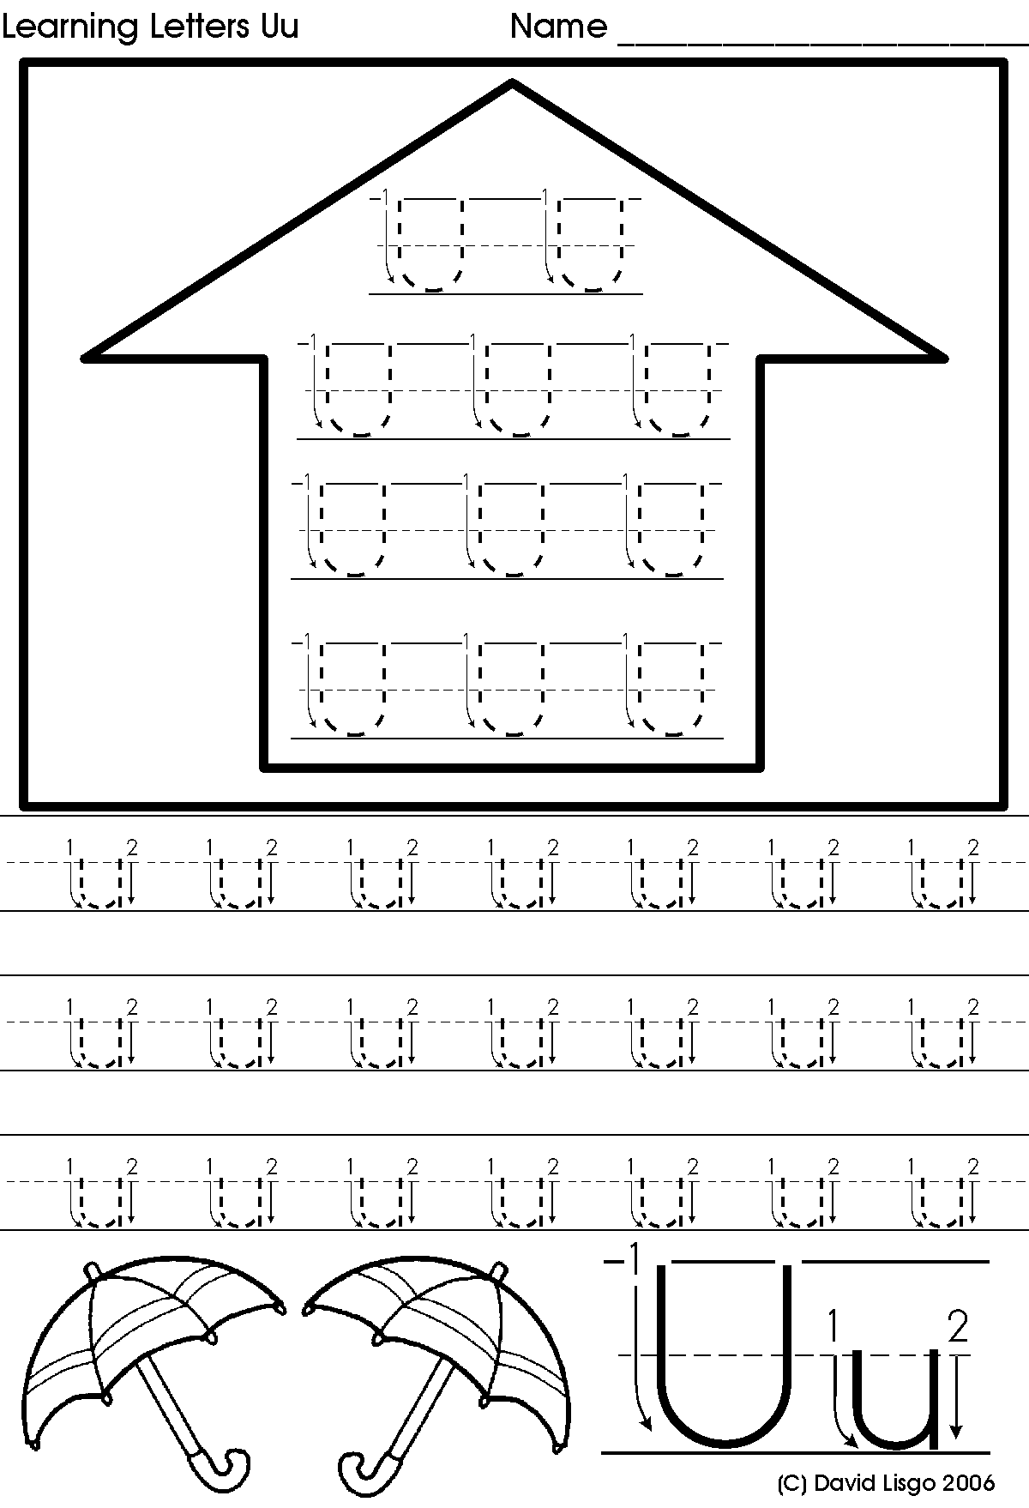

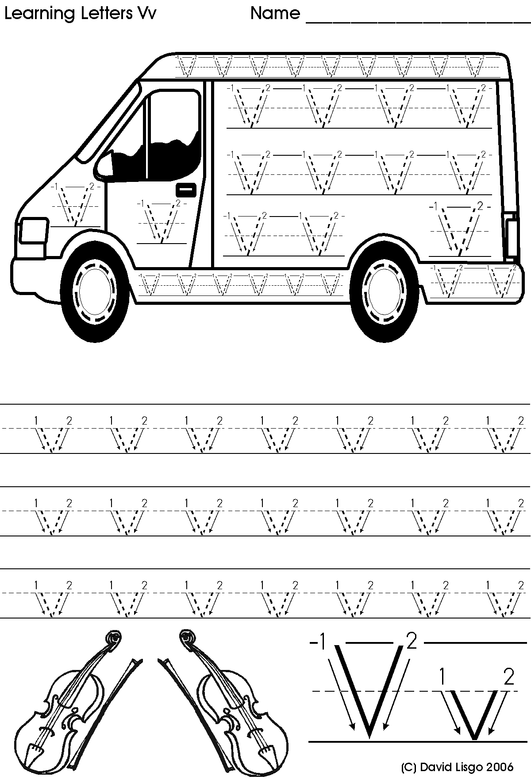

van

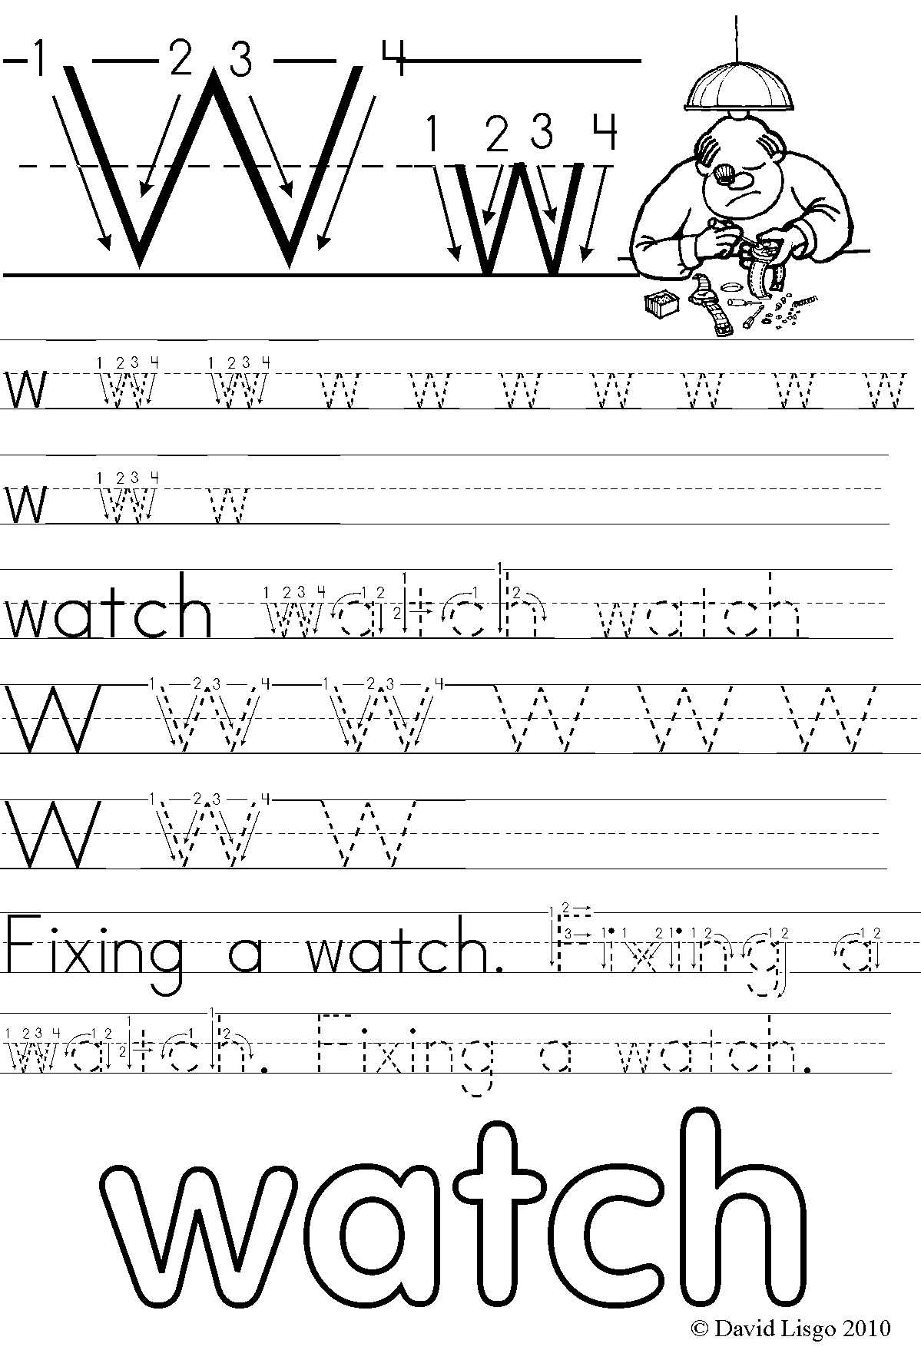

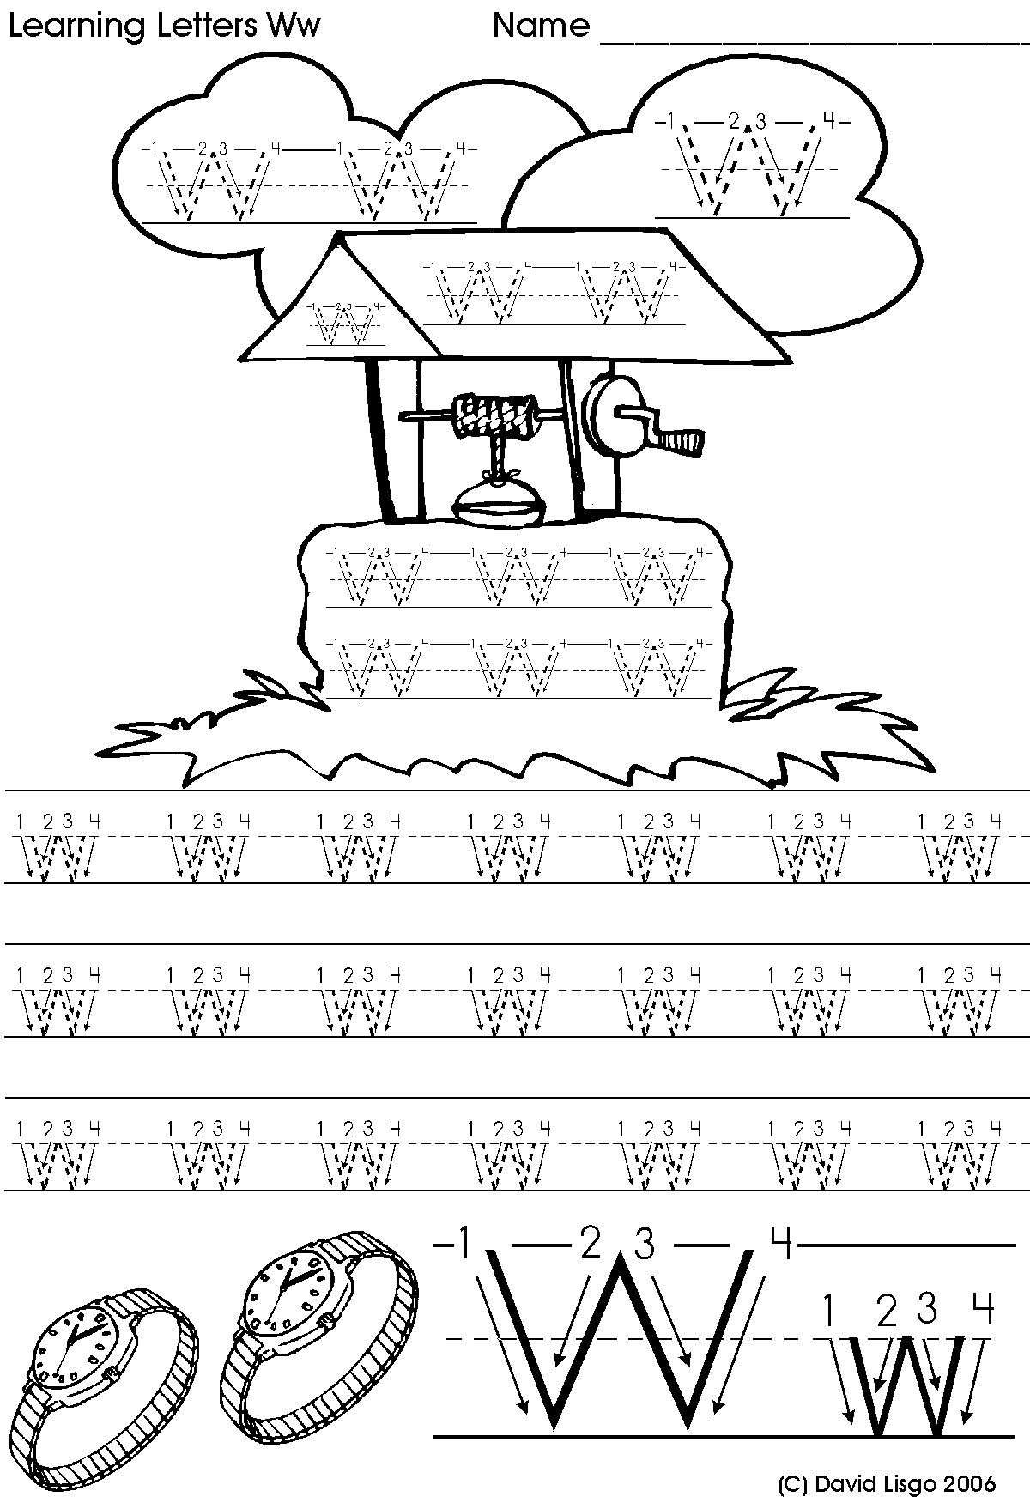

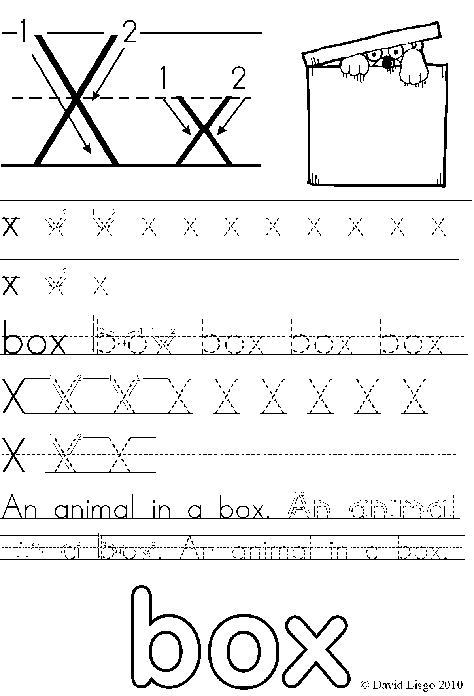

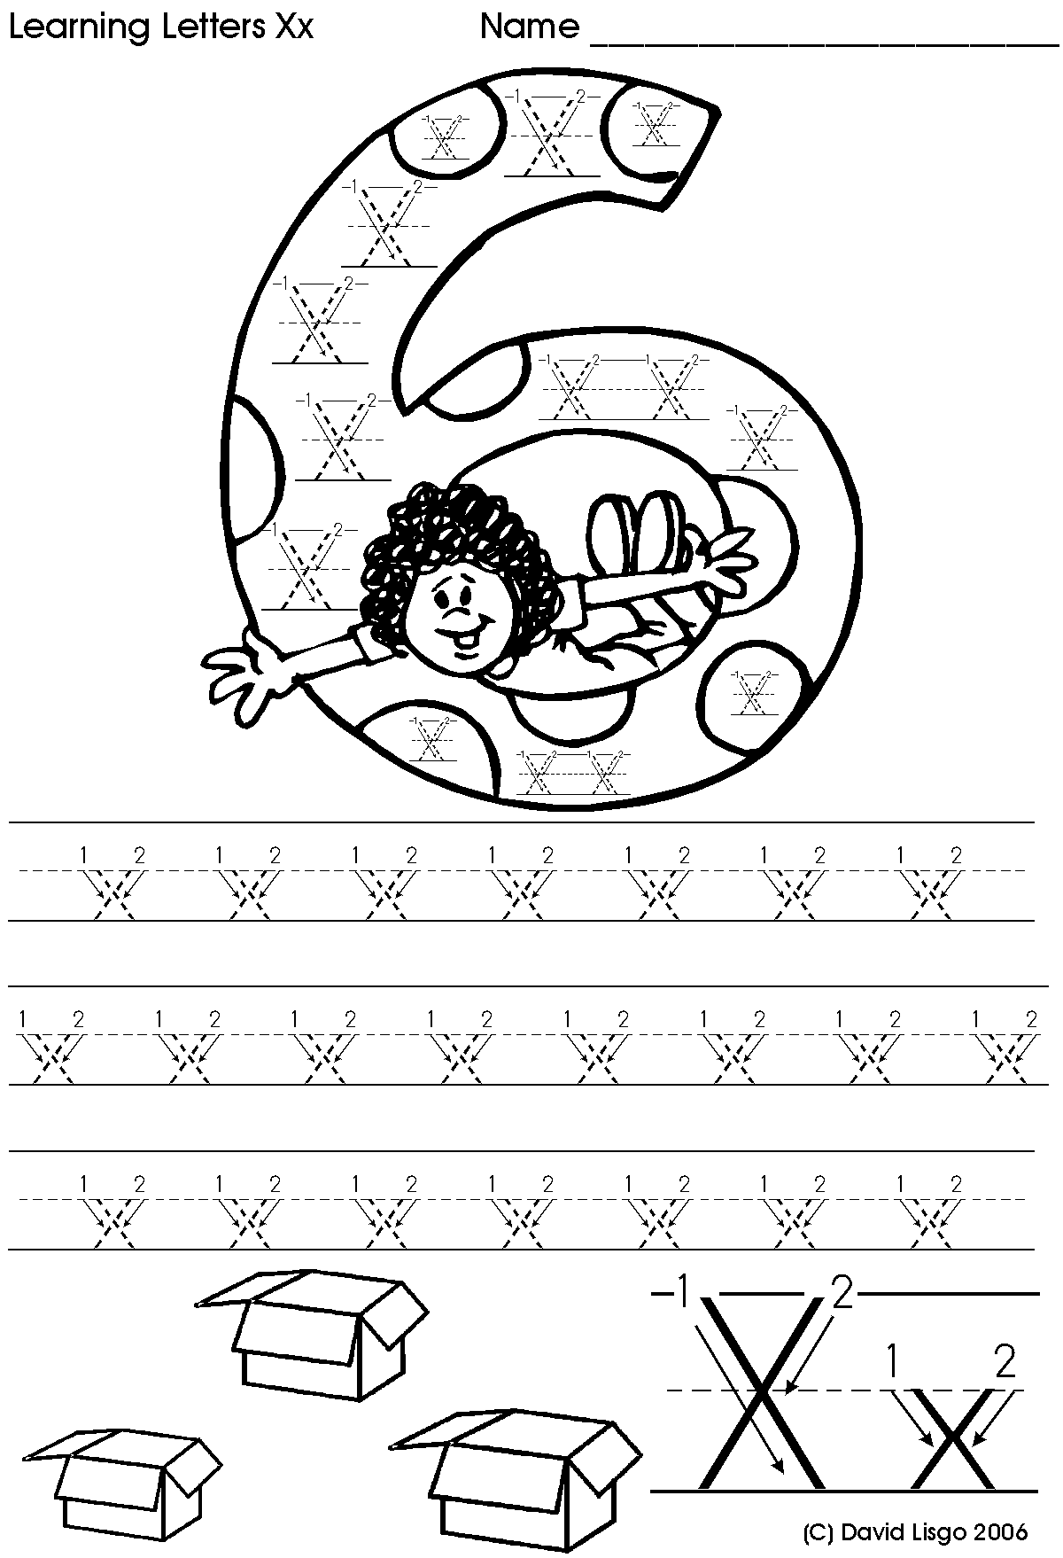

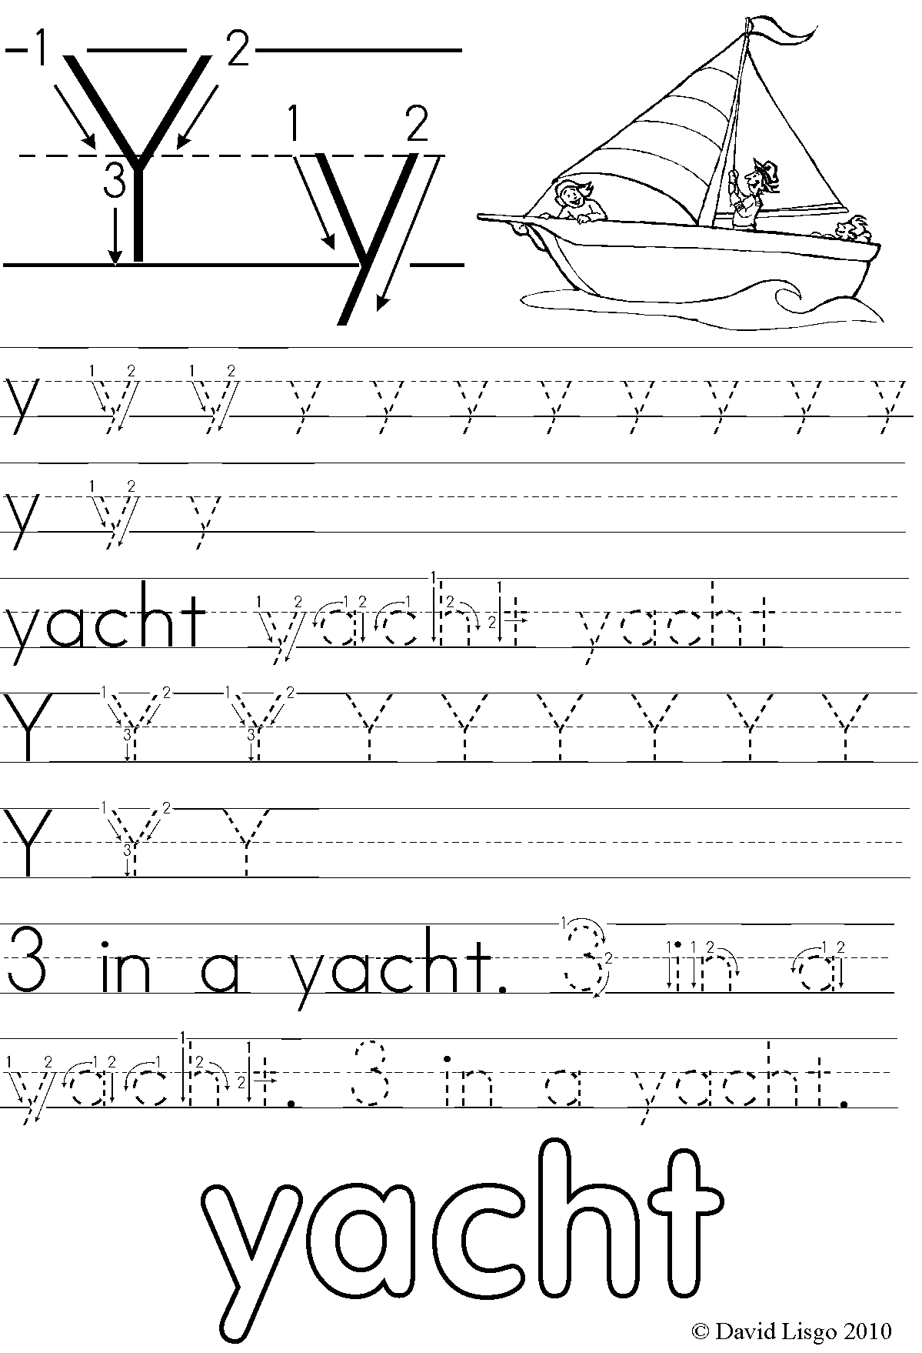

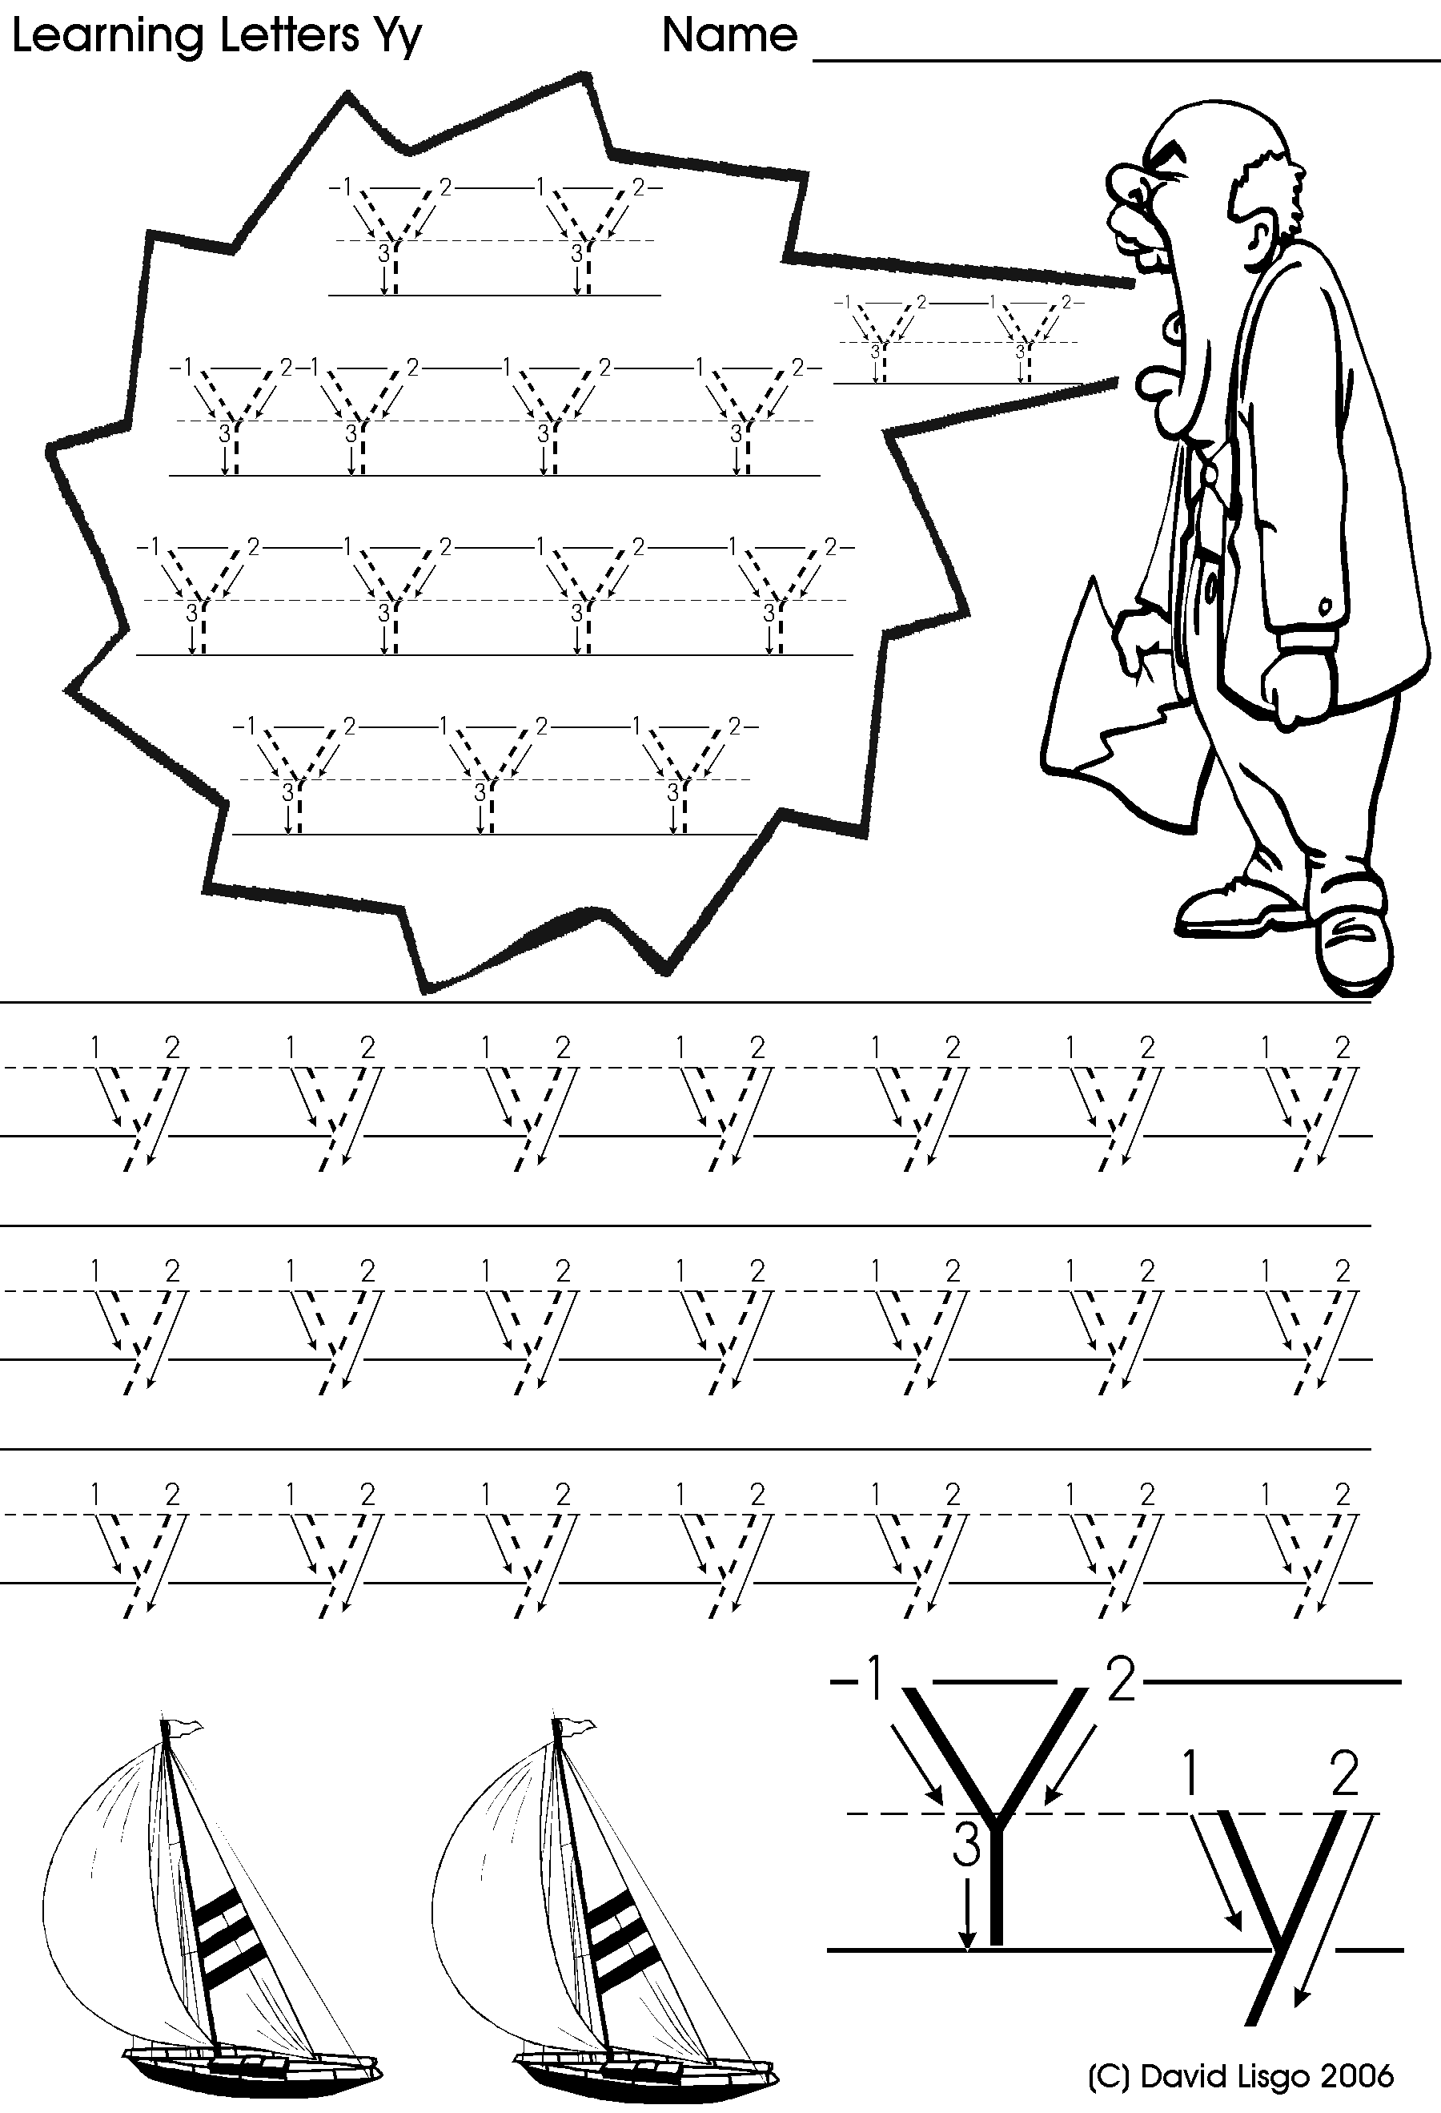

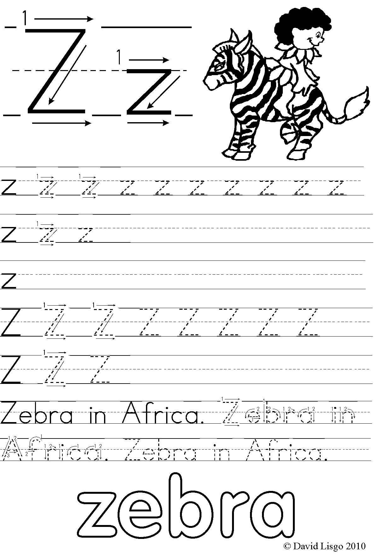

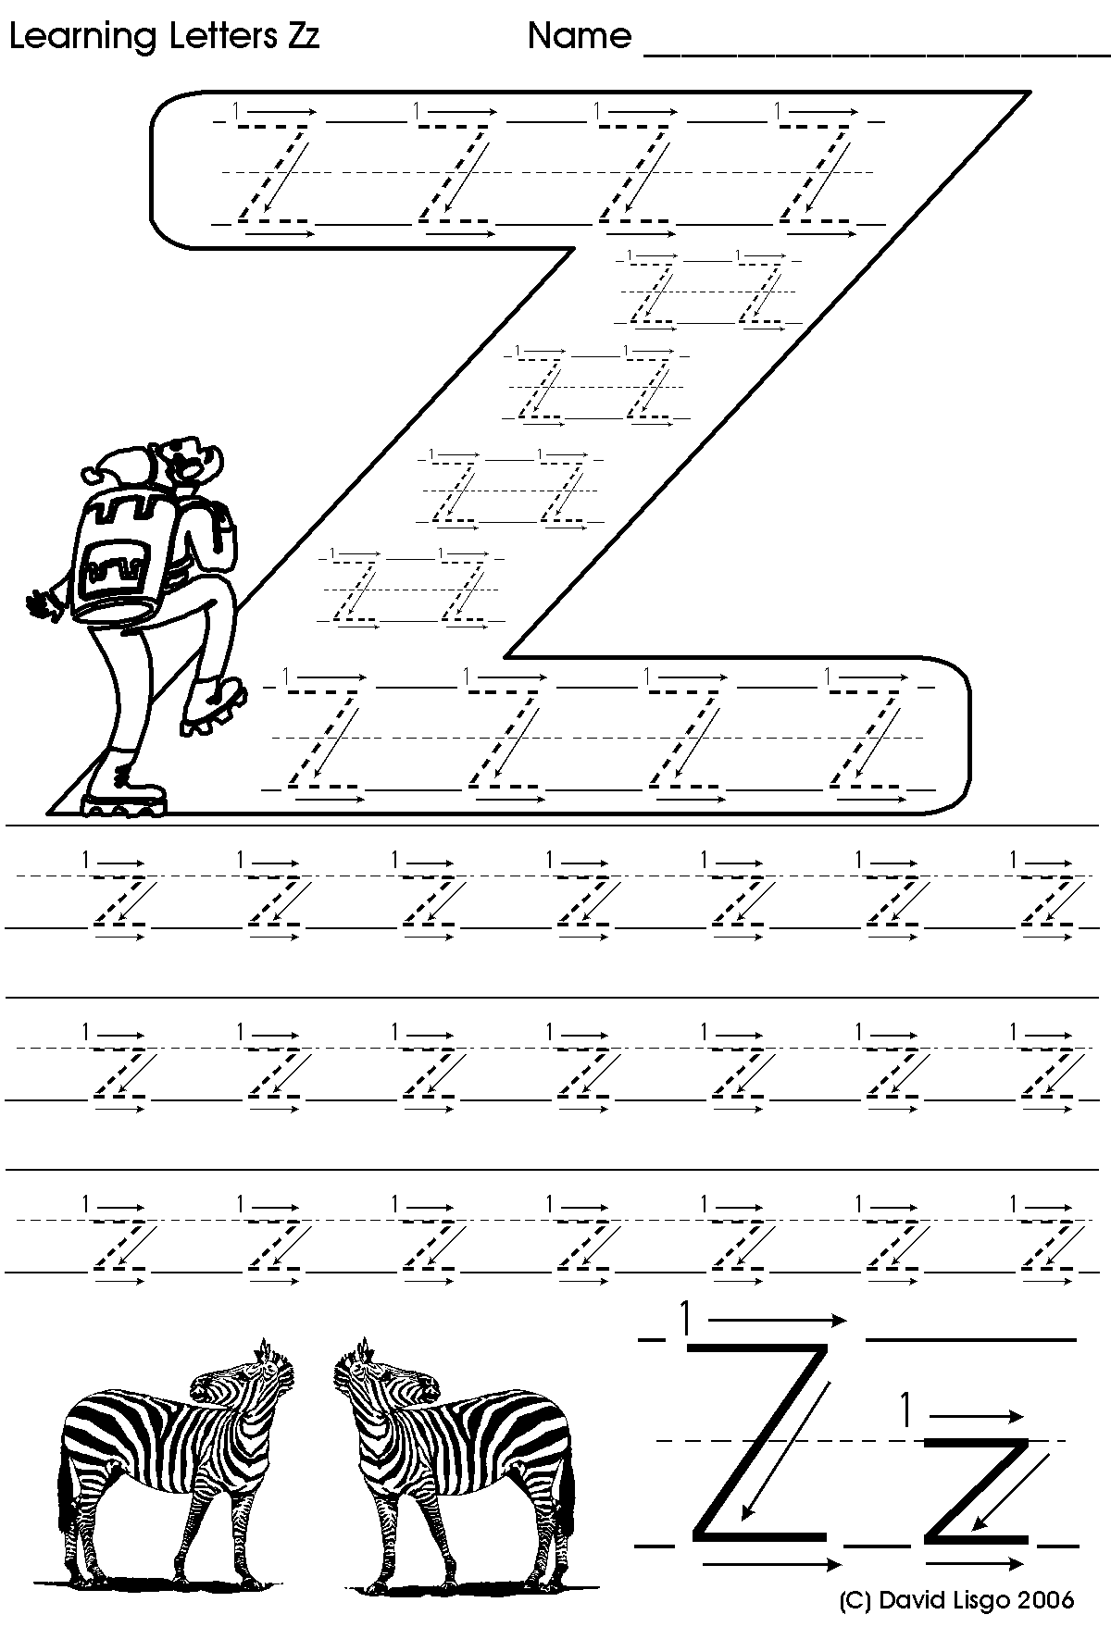

**Find and color :**

Capital : Z – A – D

Small : m – I - r

C:\Documents and Settings\soha\My Documents\unit3.wmf

**The vowels are :**

Short and Long Sound for ‘a’

|  |  |
| --- | --- |
| Short Sound /a/ | Long Sound /A/ |
| apple  ask  lap  cat  clap | rain  train  play  day  raid |

What can you see? How many letters for the short sound? \_\_\_. How many letters for the long sound? \_\_\_. The short sound has one vowel. The long sound has two vowels together.

Short and Long Sounds

|  |  |
| --- | --- |
| Short Sound | Long Sound |
| /a/ as in apple  /e/ as in egg  /i/ as in ink  /o/ as in octopus  /u/ as in ugly | /A/ as in rain  /E/ as in sea  /I/ as in die  /O/ as in road  /U/ as in you |

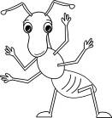

Ant

apple

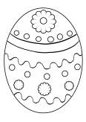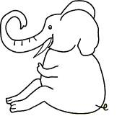

Egg

Elephant

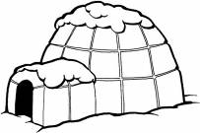

igloo

ice cream

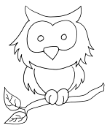

orange



Owl

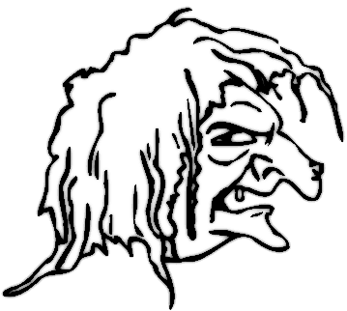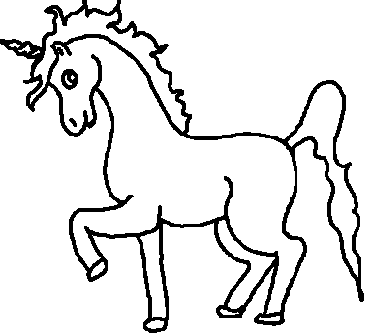

Unicorn

ugly

## Complete the Missing vowels



C \_ T

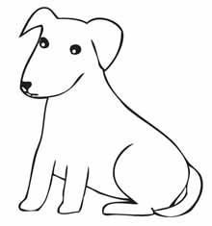

D \_ G

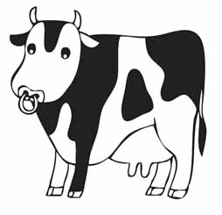

C \_ W

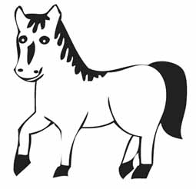

H \_ RS E

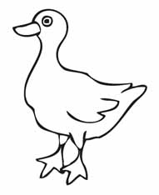

D \_ CK

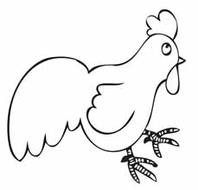

CH \_ CK \_ N

|  |  |  |  |  |  |
| --- | --- | --- | --- | --- | --- |
|  |  |  | |  |  |
|  | bed  bed | chick  chick | | dog  http://4.bp.blogspot.com/_LYNVGEXliZ4/TS8Wk0jGmFI/AAAAAAAABLk/V8LKQgltrT0/s400/normal_coloring-dog-pages-kids.jpg | bug  http://www.clker.com/cliparts/C/Q/m/f/Z/q/ladybug-hi.png |
|  | | | | | |
| cake  cake | feet | | bike  bike | home  cartoon-house | ruler  ruler |

Complete with correct vowel and choose is it long or short vowel :

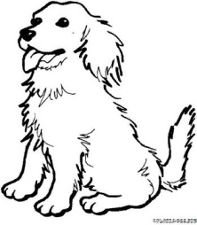

C\_ke

Short - long

D\_g

Short - long

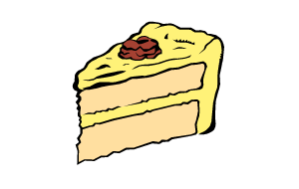

R\_ler

Short - long

B\_g

Short - long

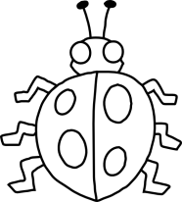

F\_et

Short - long

Ch\_ck

Short - long

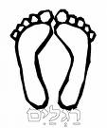[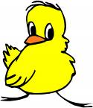](http://images.google.com/imgres?imgurl=http://www.smpl.org/reading/chick.bmp&imgrefurl=http://www.smpl.org/reading/chicklit.htm&h=869&w=750&sz=1912&hl=en&start=6&tbnid=ugWXA_afjV1VxM:&tbnh=145&tbnw=125&prev=/images?q=chick&gbv=2&svnum=10&hl=en)

Complete the vowels and color the pictures:



\_ppl\_



**\_c\_**

**cr\_ \_ m**