
المملكة العربية السعودية الصف: الرابع الابتدائي
وزارة التعليم الفصل الدراسي: الأول
المدرسة ............................. العام الدراسي 1447 هـ
الزمن: ساعة ونصف
الاختبار النهائي لمادة اللغة الإنجليزية – الصف الرابع الابتدائي – الفصل الدراسي الأول (الدور الأول) لعام 1447 هـ
عزيزتي الطالبة:
- استعيني بالله ثم اجيبي عن الأسئلة
- فضلا تأكدي من كتابة اسمك الرباعي ورقم الجلوس
- الإجابة باللون الأزرق فقط

اسم الطالبة رباعيا
رقم الجلوس: |  | الصف: الرابع الابتدائي | المادة: اللغة الإنجليزية
اليوم: | التاريخ: / 7 / 1447 هـ

المدققة وتوقيعها | المراجعة وتوقيعها | المصححة وتوقيعها | الدرجة كتابة | الدرجة رقما | السؤال
 |  |  | فقط |  | General  Questions
 |  |  | فقط |  | Guided  Composition
 |  |  | فقط |  | Reading  Short Sentence
 |  |  | فقط |  | Grammar
 |  |  | فقط |  | Vocabulary
 |  |  | فقط |  | Orthography
 |  |  | فقط | 40 | المجموع


Kingdom of Saudi Arabia 4th Elementary Grade
Ministry of Education Time: An hour and a half
……….. Elementary School Number of papers: 3 . Final Exam – First Term – 1447 AH
- General Questions:
/ 7
  - Match the questions with the correct answers:
A |  | B
1. What school subject is more difficult? |  | It was good.
2. Whose dress is this? |  | Yes, please!
3. Can I help you with your homework? |  | No, I didn’t.
4. What time do you get up in the morning? |  | It is mine.
5. How was your day at school yesterday? |  | Math
6. What activities do you do in your free time? |  | At 6 o’clock
7. Did you go shopping on Saturday? |  | I go swimming.
/ 7
- Guided Composition:
  - Complete the paragraph about Your Family. Use the words from the box.
mother – live – spending – sister – five – happy – big
My Family
I ………… with my family in a ………… house. There are ………… people in my family. I have one brother and one …………. My father and …………. take care of us. My family makes me …………... I love …………. time with them.



- Reading Short Sentences:
/ 7
  - Read the sentences then match them with the correct pictures:
 |  | 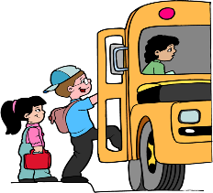 |  | 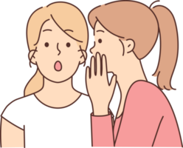
a-_He’s naughty.  b-_He’s brilliant. | a-_I always eat fish.  b-_I never eat fish. | a-_I get on the bus.  b-_I get off the bus. | a- She looks sad.  b- She looks happy. | a-_She talks loudly.  b-_She talks quietly.

  - Look at the text and choose the correct option.
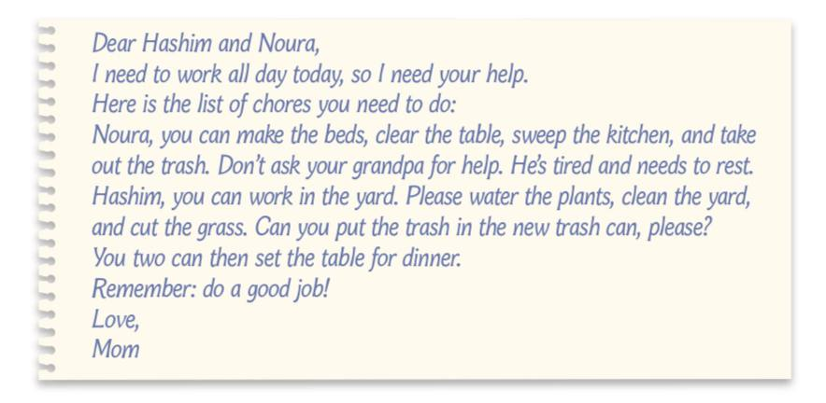
    - This text is:
      - an e-mail.
      - a story.
      - a play.

    - The text is from:
a- Hashim and Noura.
b- Mom
c- Dad

- Grammar:
/ 7
  - Choose the correct answer:
    - Huda is (tall – taller – tallest) than Rana.
    - She (was – were – are) in Makkah last weekend.
    - Hind (read – reads – is reading) a story now.
    - It is my pen. It is (hers – mine – his).
    - How often (do – does – are) she walk in the park?
    - He didn’t (play – plays – played) soccer.
    - I can speak Arabic (and – but – so) English.

- Vocabulary:
/ 7
  - Write the words under the correct pictures:
cycling – cry – comic book – piano – afraid

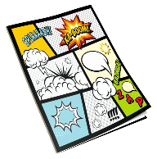 |  |  |  | 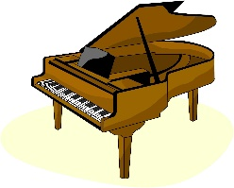

  - Circle the odd word:
1- Ordinal Numbers: first – third – nine – tenth
2- Family Members: aunt – grandmother – cousin – writer

- Orthography:
/ 5
  - Choose the correct missing letters:
  ca__era |  |   d__ums |  | 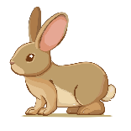  r__bbit |  |   chatt__ |  |   lea__es
n | m | r | l | a | e | u | y | f | v
  du__t |  | 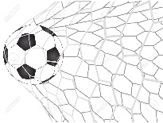  sc__re |  |   shou__ |  |   te__ting |  | 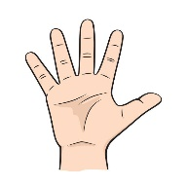  fin__ers
c | s | w | o | t | d | v | x | j | g

END OF QUESTIONS
BEST OF LUCK
Ms. Tahani AlGhamdi

  وزارة التعليم  الإدارة العامة للتعليم بمنطقة ...................  مدرسة .............................. |  |    | السؤال | الدرجة |  | اسم المصحح وتوقيعه | اسم المراجع وتوقيعه
 |  |  | السؤال | رقما | كتابة | اسم المصحح وتوقيعه | اسم المراجع وتوقيعه
 |  | الاختبار النهائي للفصل الدراسي الاول  ( الدور الأول )  للعام الدراسي      1447 هـ | الأول
 |  |  | الثاني
التاريخ | / / 1447 هـ |  | الثالث
المادة | اللغة الانجليزية |  | الرابع
الزمن | ساعة ونصف |  | الخامس
الصف | الرابع |  | المجموع
اسم الطالب : ............................................................................................. |  |  |  | رقم الجلوس : ............................
- General Questions:

7

- Choose the correct answer:
- What is your favorite story? A - I like to jump a rope B- Cinderella
- How was your day at school yesterday? A - It was great B - I played soccer
- What time do you get up in the morning? A - At 6 o’clock B - Yes, she did
4 - Whose dress is this? A - I usually do it on weekend B - It is mine
5 - Can I help you with your homework? A - Yes, please! B - No, I couldn’t
6 - What are you doing now? A - I am watching TV B - It was boring
7 - How many brothers do you have? A - No, I didn’t. B - I have 3 brothers

- Controlled Writing:
takes out – feed – sweep – wash – clears
- Fill in the missing words:
My brother and I help our grandparents on Saturdays. I usually (1)……………... the floor. Then, I (2)……………... the animals. My brother (3)……………... the trash. My brother always (4)……………... the table after we eat and then I (5)……………... the dishes for my grandma.

- Rearrange the words to form a sentence:

7

    - took photos – zoo – at the – She
………………………………….…………………………………..
    - he – the movie? – like – Did
…………………………………………………………………..
- Reading Short Sentence:
- Read the sentences then choose the correct sentence for each picture:
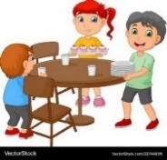 |  |  |   7
a-_They set the table.  b-_They cut the grass. | a-_I fix the hose.  b-_I water the plants. | a-_I play video games.  b-_I play board games. | a-_She is shy.  b-_She is lazy.

B-Read the sentences and match them with the correct pictures:
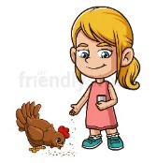


1– She feeds the chickens 2– I always read comic books 3– They catch the bus.

- Grammar: A – Choose the correct answer:

7

- She (didn’t see – didn’t saw) a movie.
- They (play – are playing) football every day.
- How often ( does / do ) you help your family?
- Did you (take – took) photos in the park?
- She (always sleeps – sleeps always) early.
- ( Does – Did ) he send an e-mail last week?
- I like soccer, (and – but) I don’t like tennis.

7

- Vocabulary:
- Choose the correct answer:
1 – present 2 – helpful 3 – fix 4 – piano 5 – cry 6 – wash the dishes 7 – graduation

 |  |  |  | 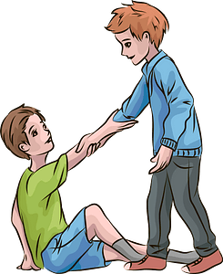 |  | 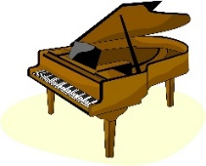


5

- Orthography:
- Choose the correct missing letters:
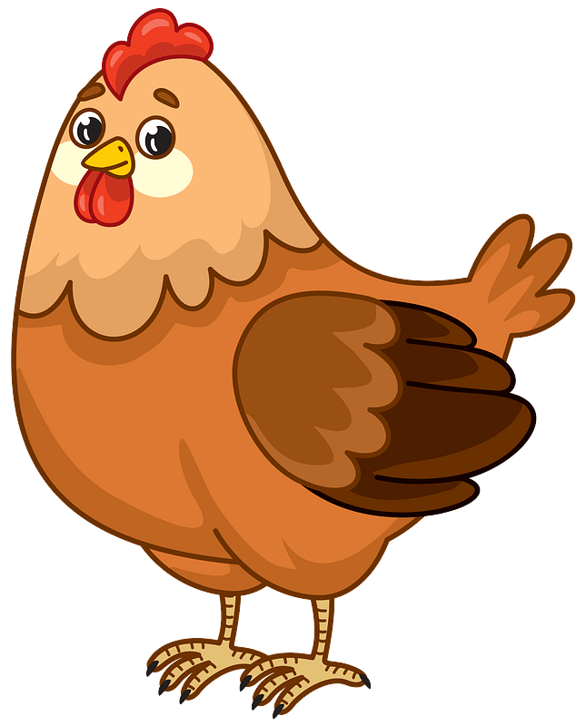  chicke__ |  |   te__ting |  |   mu__ic |  | 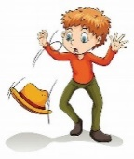  dr__p |  |   shou__
m | n | x | k | s | k | o | u | e | t


40

اختبار نهاية الفصل الأول ( الدور الأول )
للعام الدراسي 1447هـ
المادة /اللغة الانجليزية
الصف :رابع (.......)
زمن الإجابة / ساعة ونصف
التاريخ : 12/7/1443 هـ

المملكة العربية السعودية
وزارة التعليم
الإدارة العامة للتعليم ب…

الدرجة كتابة :

اسم الطالب ……………………………………………………………………….……………………………………………رقم الجلوس …………………………

Match the questions to their answers:ضع أرقام الأسئلة أمام الإجابات الصحيحة


1-How big is your family? I Nine different museums.
2- How often do you play football? My I It is near to Riyadh.
3- Where is Diriyah located? I always play football.
4- How many museums will be in Diriyah? I have a brother, 2 sisters.
5- What's your favorite chore? One person searches, others hide.
6- Why should we wash our hands? You hop on one foot.
7- How do you play hopscotch? To remove germs and bacteria.
8- What do you do in “Hide and Seek”? I like to sweep the floor.

Put ()or():ضع علامة (صح) أمام الجملة الصحيحة وعلامة (خطأ) أمام الجملة الخاطئة

1-This book mine is ( )
2-story is My favorite Heidi. ( )
3-go you Can there? ( )
4-She is reading. ( )
5-I like tennis. ( )
6- Mark Twain was an American. ( )
7- She usually cleans the house. ( )

Choose the correct answer:ضع دائرة حول الإجابة الصحيحة


1. My uncle is tall. 3. Peter bought a gift. 5. The game is fun.
Who is tall? Who bought it? How is the game?
a Uncle b Aunt a Peter b Daisy a Fun b Boring

2. Nasir loves drawing. 4. It is a graduation.
اقلب الورقة
What does he love? What is the event?
a Drawing b Running a Graduation b Eid

ضع دائرة على الإجابة الصحيحة Choose the correct answer:

- How often …. he play football? a do b does
- How often …..they swim? a do b does
- This is……bag a my b mine.
- That’s their car, It’s ….. a theirs b his
- He always ……at the mosque. a pray b prays
- We are ……TV now. a watch b watching
- I like pizza….burger. a but b and

Match the words to the correct pictures: ضع رقم الكلمة تحت الصورة الصحيحة

1 dreamed 2 family 3 strong 4 scored 5 vlogging 6 shout 7 carried 8 E-mail

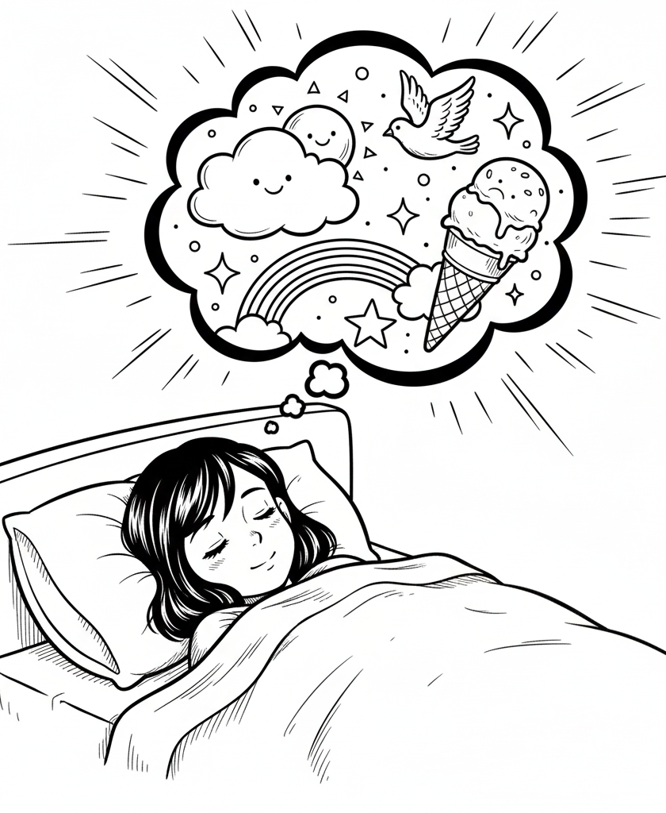
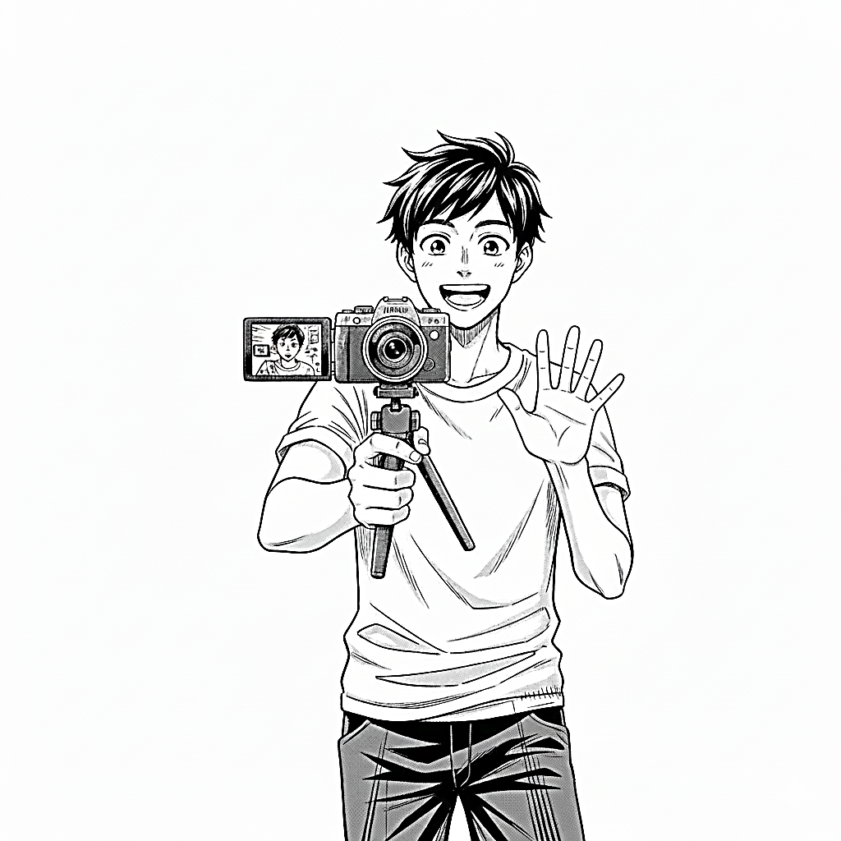

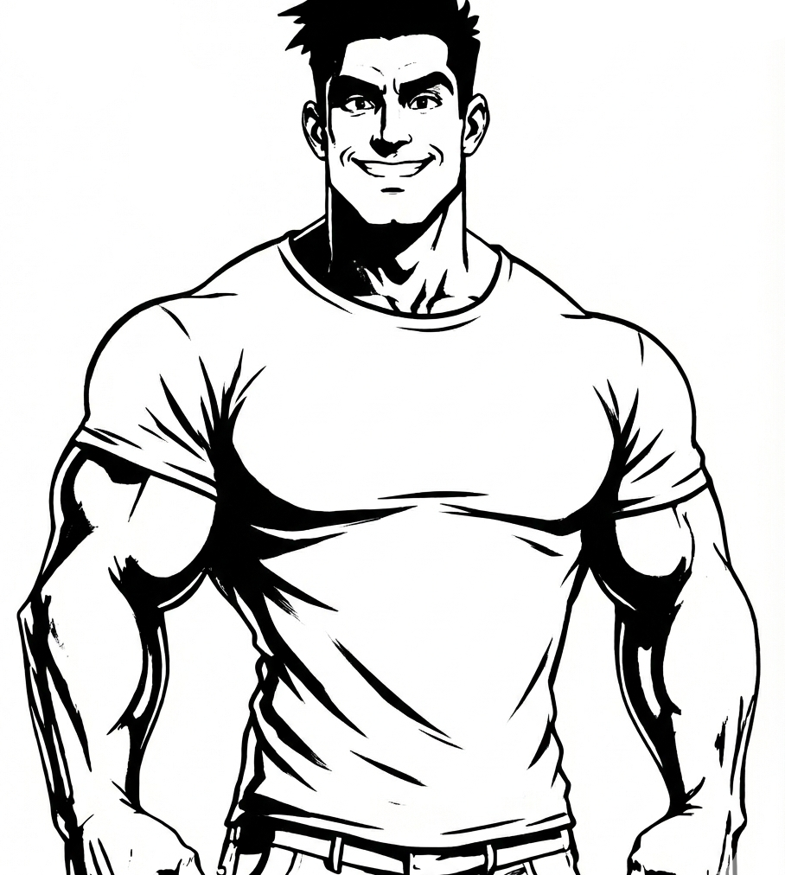
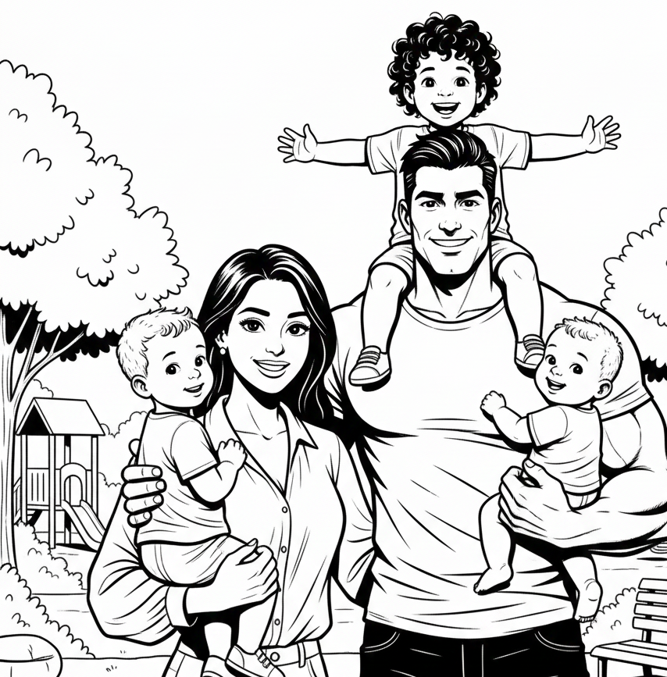
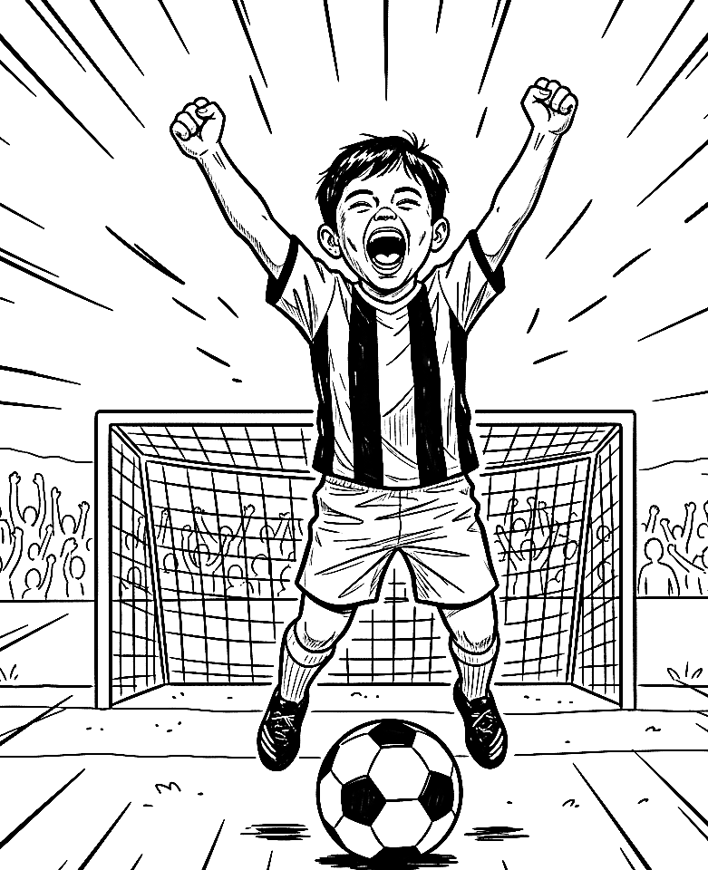
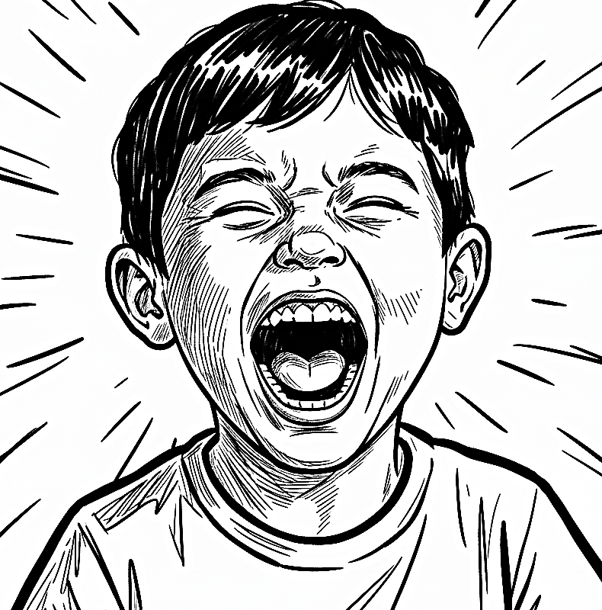
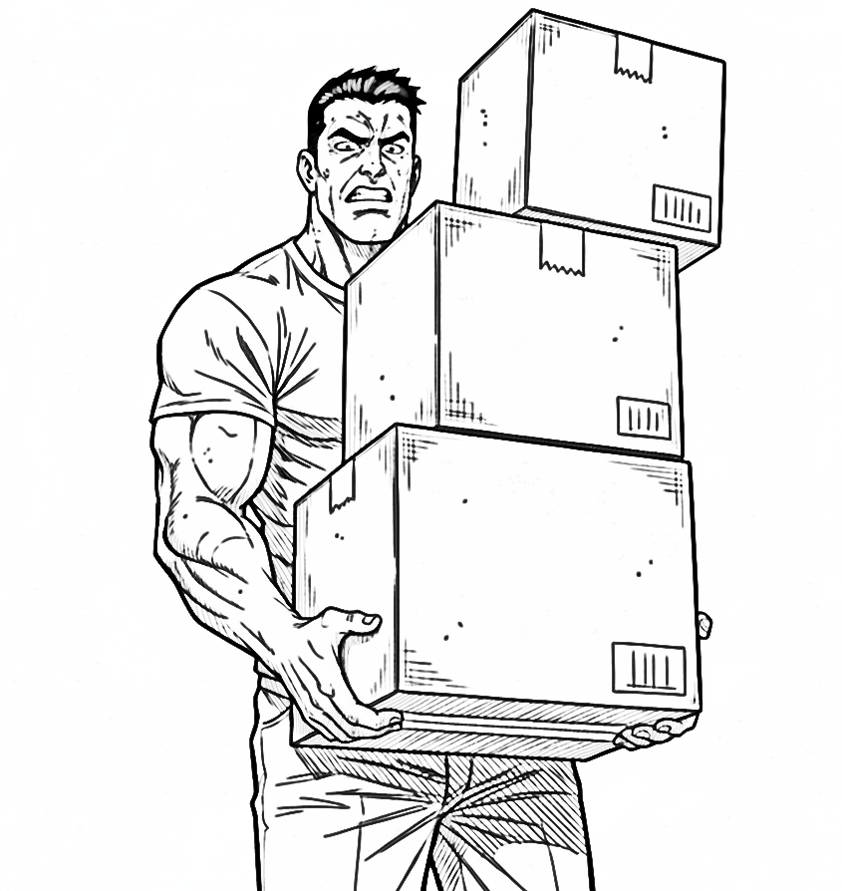

ضع دائرة حول الحرف المفقود Circle the missing letter:

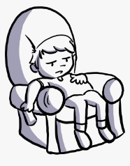  Laz__  y  w | 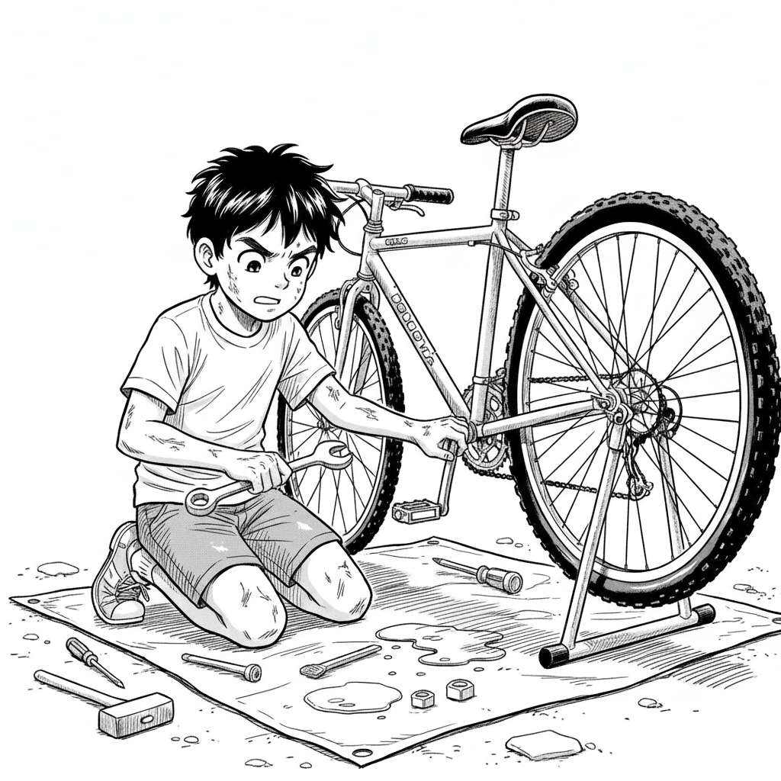  F__x  i  t | 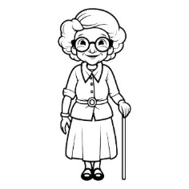  grand__a  m  p |   g_t up  e  l | 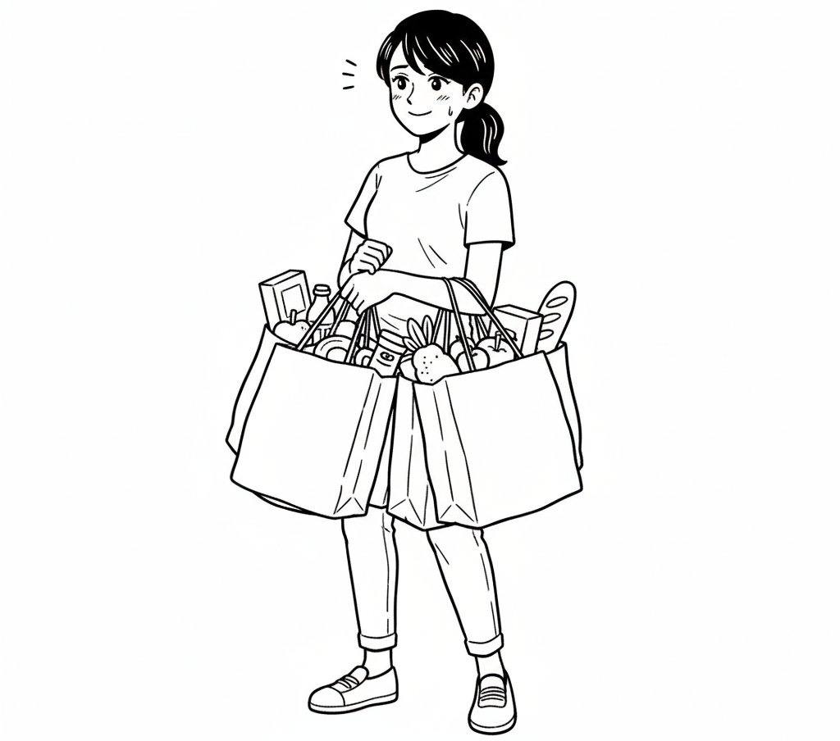  Sh__pping  s  o
انتهت الأسئلة

أ.........................

المملكة العربية السعودية اسم المادة: اللغة الانجليزية
وزارة التعليم الصف: الرابع الابتدائي
الإدارة العامة للتعليم بـ ---------- الزمن: ساعة ونصف
مدرسة / -----------------------
أسئلة اختبار مادة اللغة الإنجليزية للصف الرابع الابتدائي
الفصل الدراسي (الأول) للعام الدراسي 1447هـ

اسم الطالب: ------------------------------------------- رقم الجلوس: ------------ الصف: --------

Total  Written | 6  Orthography | 5  Vocabulary |  | 4  Grammar | 3  Reading Short Sent. | 2  Controlled Writing |  | 1  General Questions | Q. NO.
 |  |  |  |  |  |  |  |  | Mark Given
40 | 5 | 8 |  | 7 | 5 | 7 |  | 8 | Mark
Checker: |  |  | Revisor:  ABOKHALEDAMER  0557325813 |  |  |  | Corrector:

8
I- General Questions:(8M)
A. Match the following :
1. They liked to play board ------ A. I like to jump rope.
2. Did she invite her friend at home? B. games.
3. He is books worm He likes reading ----- C. books.
4. What do you like to do for fun? D. Yes, she did.
E. It is a balloon.
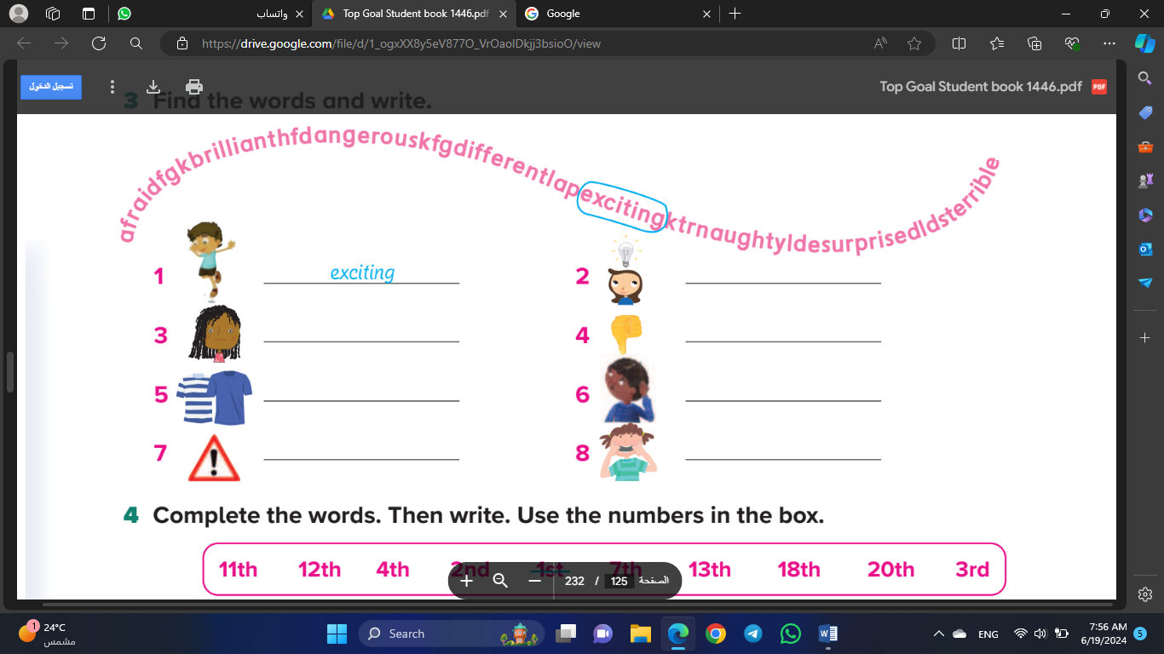


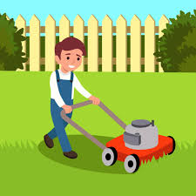
B. Put (✔️) or ( ✖️):
1. He emailed his cousin. ( )
2. It is dangerous. ( )
3. They like to catch a ball. ( )
4. He cuts the grass. ( )

7
II- Controlled Writing:(7M)
A. Fill in the missing words: clapped – loudly – video games – rope





1.The boy is playing 2.He (….) the house. 3.The boy is speaking 4.He (-----) his hands
-------------- -------------------- ---------------------- ----------------
B. Rearrange the words to form a sentence:
1. likes – photos. – She – to take -------------------------------------------------
2. How – girl – is – walking? – the --------------------------------------------------------
3. makes / My dad / dinner. / often -------------------------------------------------------
III- Reading Short Sentence:(5M)

5
A. Match the pictures:




1. I have a big drum.
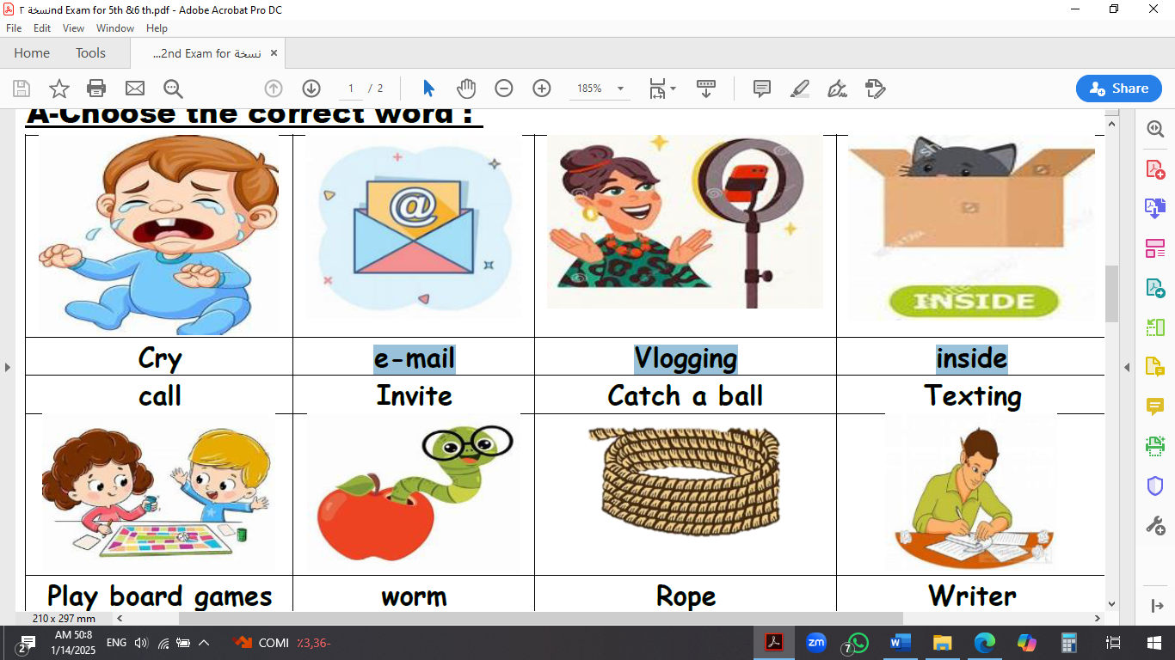
2. I like vlogging.
3. It is a long rope.
4. He is watering the plants.
5. The girl jumped happily. ( ) ( ) ( ) ( ) ( )
IV- Grammar:(7M)

7
A. Choose the correct answer:
1) Did she ………. ( played – play – plays ) tennis?
2) They …………..( go – going – went ) shopping yesterday.
3) They…. ( always – never – rarely ) have dinner together. They meet every day.
4) How often ………… ( do – does – are ) you play soccer?
5) Sunday ………… ( was – were – are ) the back to School Celebration Day.
6) We ………… ( take rarely – rarely take – takes rarely ) my little kitten to the vet.
7) He cooks ……….( badly – bad – quick ).
8) He likes to ( went – goes – go ) make models.
V- Vocabulary:(8M)

8

A. Write the correct number under each picture:
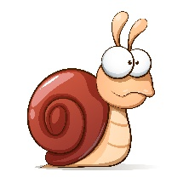
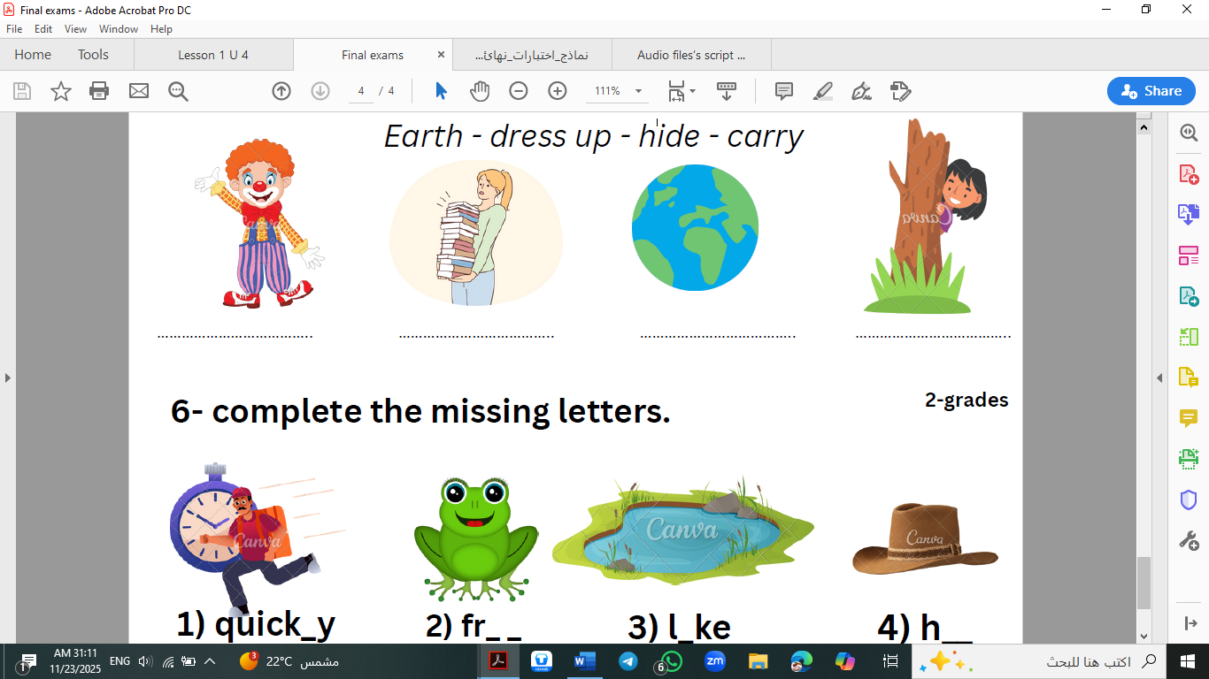
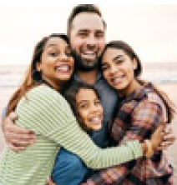
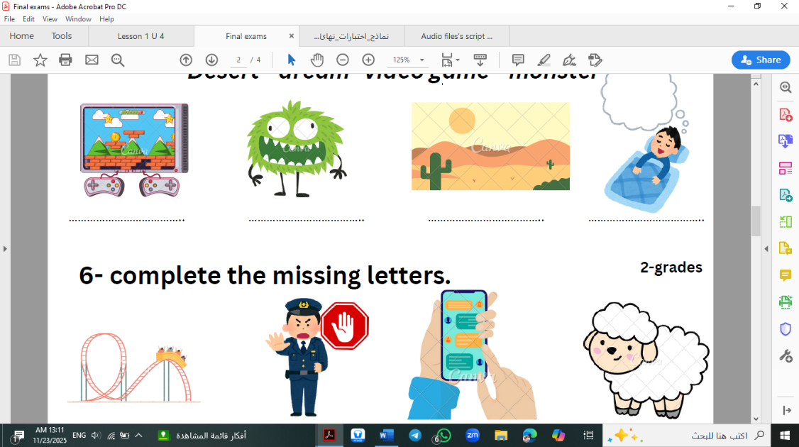
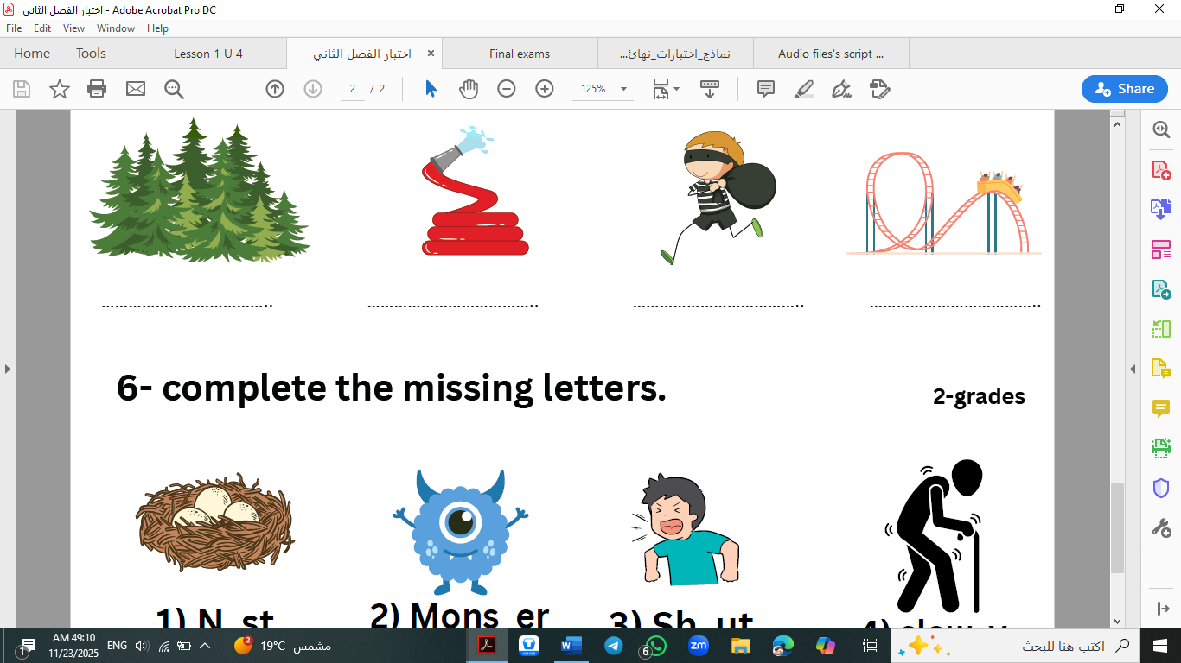
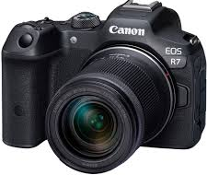

( ) ( ) ( ) ( ) ( ) ( ) ( ) ( )
VI- Orthography:(5M)

5

- Fill in the missing letters:
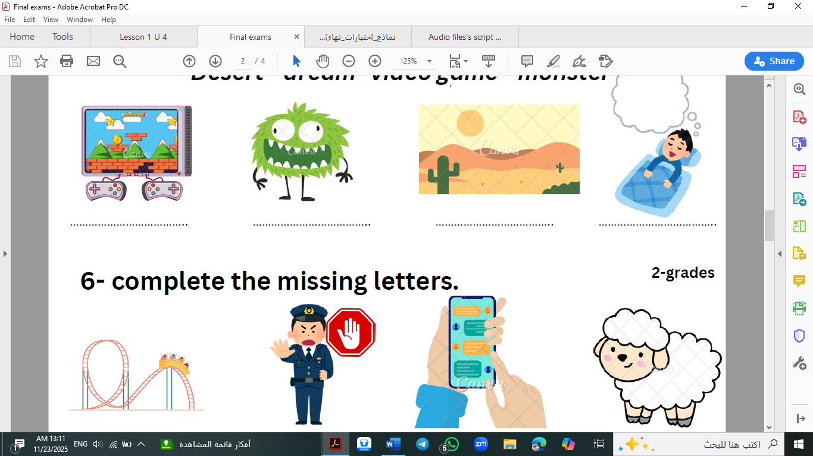
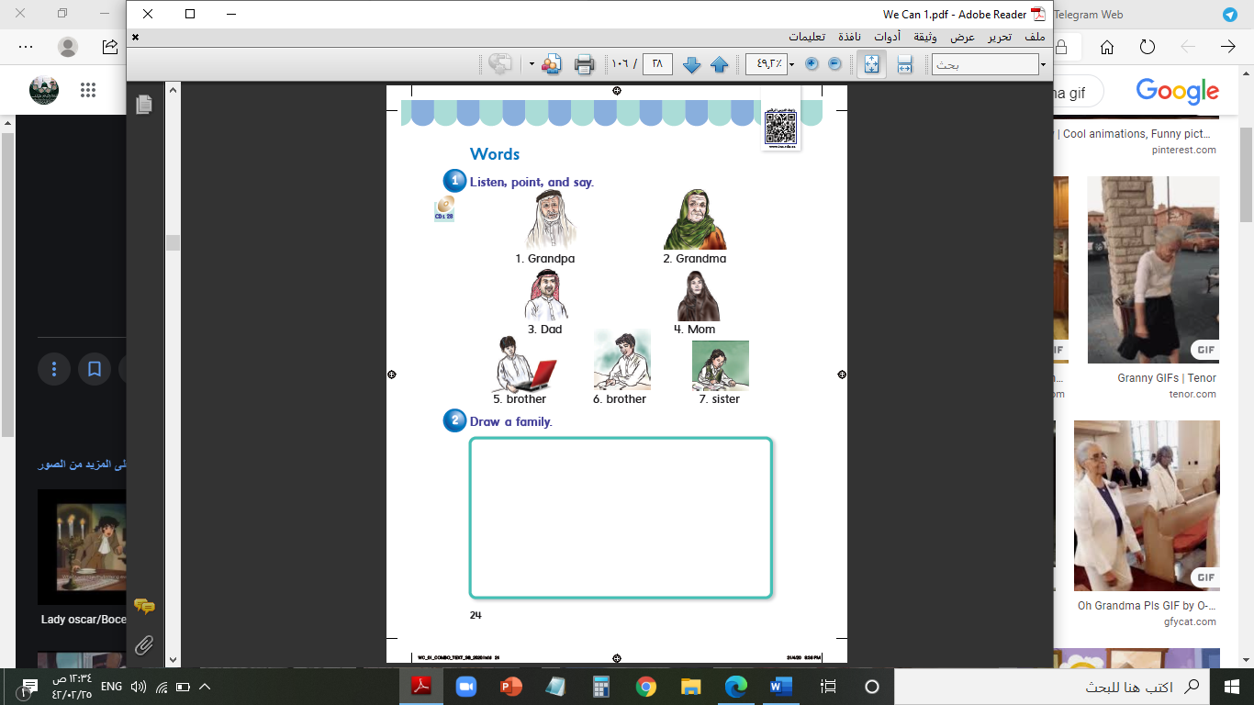

sho__t grand__a slo__ly tex__ing ch__tty
( u – a ) ( b – p ) ( u – w ) ( t – d ) ( a – u )

End of Questions
ABOKHALEDAMER
0557325813

https://t.me/abokhaledamer
Top Goal - YouTube

