Sample Picture Unit 6:
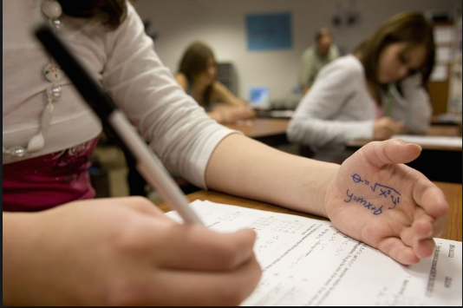
In this picture, I can see a girl. She is sitting in an exam hall. She is copying exam questions from her hand.
- I think cheating is a bad thing because It’s not allowed in Islam.
- We are all Muslims.
- We should not cheat.
- We should be honest and tell the truth.
- In my opinion, honesty is important all the time.
- Some people lie to get good jobs.
- I think it’s not the right thing to do.
Sample Picture Unit 7
In this picture, I can see ____________________________________________________________.
- I don’t like many changes in my life because I am happy with it.
- Some people like changes.
- They think you can change at any age.
- People change a lot of things like jobs, houses and habits.
- The last big change in my life was my graduation.
- It was a big change.

Sample Picture Unit 8
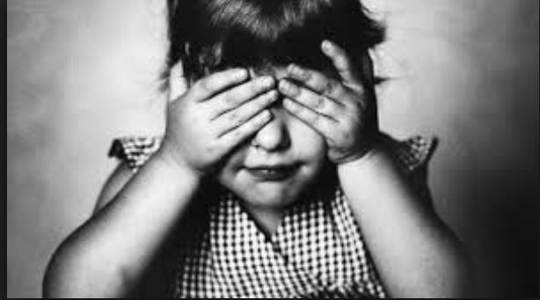
In this picture, I can see a small girl. She is wearing a dress. She is putting her hands on her eyes. I think she is afraid of something.
- I think fear can be good and bad.
- It’s good when it protects you.
- It can be bad when it becomes a phobia.
- Many people have phobias , for example, high places, insects and animals.
- I think we can overcome these fears.
- We can read Quran and make dua.
- We can go to the doctor who can help us.
Sample Picture Unit 1 Book 2
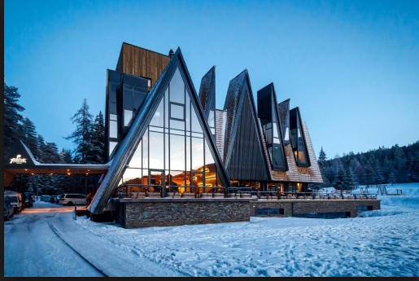
In this picture, I can see a modern house. Its shape is triangular. The background is blue. Its front is made of glass. It looks like winter season because there is snow on the ground.
- Modern buildings are very popular these days.
- People are using glass, aluminium and wood in new houses.
- I think buildings should be sustainable.
- They should help the environment.
- There are many beautiful buildings in my city like Al Haram.
- Some buildings are boring like old houses near Quba.

