English Language  1st Secondary Grade, 1443-1444  Quiz 1, 2nd Term  Mega Goal 1.2 | الإجابة في ورقة التظليل الخارجية | Kingdom of Saudi Arabia  Ministry of Education  … Secondary School  نموذج  Taif . (A)
Mark: | Class | Name
1. Comprehension
Read the following passage to answer the questions:
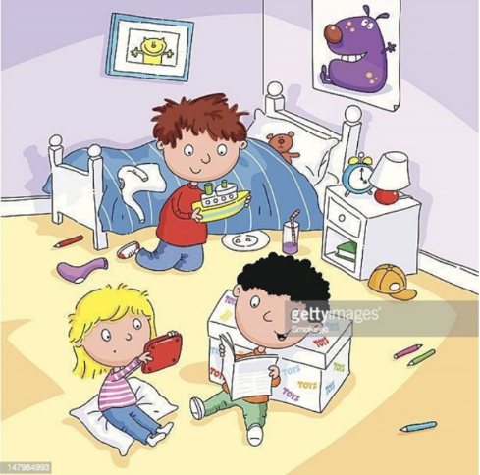
Our Room
My name is Tony, and they are my two siblings Ana and George. We are in our room. My hair is black, but Ana and George are very different. His hair is brown and her hair is yellow. He is a brunette. She is a blonde.
This is our room. It isn’t clean and organized. It is very messy and dirty. There are three beds and bedside tables but their beds aren’t in the photo. There is a white trunk with our toys, and there is a lamp and alarm clock on my table.
On the walls, there are two pictures, one poster of a purple monster and one photograph of our cat. Its name is Mr. Whiskers, it is 10 years old and it is a very nice cat. Its hair is soft and yellow and its teeth are very big.
Our toys are in the big, white trunk, but Ana prefers coloring pencils. Her pencils are on the floor.
George loves his boat; his boat is yellow and big. My favorite toys are my teddy bear, on the bed and my mystery books. Our room is our favorite place.
Questions:
- Put (T) for true sentences and (F) for false ones:
- Tony's hair is black. □ T □ F
- George is a brunette. □ T □ F
- Their room is very messy and not organized. □ T □ F
- There are two pictures on the wall. □ T □ F
- His teddy bear's name is Mr. Whiskers. □ T □ F

يتبع
3. Grammar

- Choose the correct form of the verb :

- I bought ……………. a new computer.
- herself | - myself | - himself | - itself
2. He was ill …………….he didn’t go to school yesterday.
- so | - because | - after | - before
3.You must………………….. your parents.
- respects | b. respecting | c. respect | d. respected
4. She must eat ………………to stay fit and healthy.
a. well | b. good | c. best | d. better

4. Vocabulary
- Match the word in (A) with its meaning in (B) :

A |  | B
1. stuck in |  | a. tired
2. fatigue |  | b. a day of a good fortune
 |  | c. unable to move out

- Choose the correct word under each Picture:

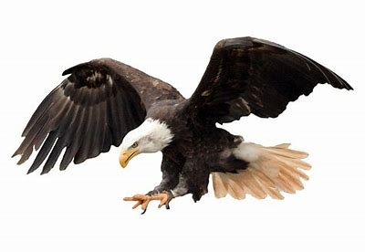  - 1. | 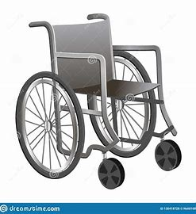  2. | 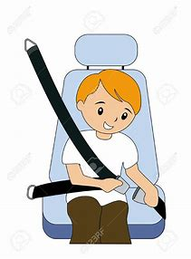 | 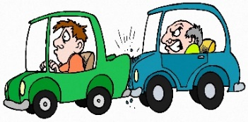
a. eagle | a. knee pads | a. pills | a. socket
b. tortoise | b. cast | b. seatbelt | b. skateboard
c. squirrel | c. wheelchair | c. matches | c. snowstorm
d. helmet | d. dynamite | d. accident | d. tailgating


☺The End ☺
انتهت الأسئلة
English Language  1st Secondary Grade, 1443-1444  Quiz 2, 2nd Term  Mega Goal 1.2 | الإجابة في ورقة التظليل الخارجية | Kingdom of Saudi Arabia  Ministry of Education  1st Secondary School  نموذج  Taif . (B)
Mark: | Class | Name
1. Composition الإجابة في ورقة الأسئلة

♣ “A car accident takes place when a car, truck, or bus, or other motorized vehicle hits another vehicle, person, or object, such as a tree or power pole.” Have you recently heard or read about an accident?

Write a paragraph about “ A car accident ” in not less than 60 words using the following graphic organizer:
What was happened ?
Car Accident
Who it happened to?
Where it happened?
Why it happened?
How it happened ?
………………………………………………………………………………………………………………………………………………………………………………………………………………………………………………………………………………………………………………………………………………………………………………………………………………………………………………………………………………………………………………………………………………………………………………………………………………………………………………………………………………………………………………………………………………………….…………………………………………………………………………………………………………………………………………………………………………………………………………………………………………………………………………………………………………………………………………………………………………….…………………………………………………………………………………………………………………………………………………………………………………………………………………………………………………………………………………………………………………………………………………………………………….…………………………………………………………………………………………………………………………………………………………………………………………………………………………………………………………………………………………………………………………………………………………………………….…………………………………………………………………………………………………………………………………………………………………………………………………………………………………………………………………………………………………………………………………………………………………………….…………………………………………………………………………………………………………………………………………………………………………………………………………………………………………………………………………………………………………………………………………………………………………….…………………………………………………………………………………………………………………………………………………………………………………………………………………………………………………………………………………………………………………………………………………………………………….…………………………………………………………………………………………………………………………………………………………………………………………………………………………………………………………………………………………………………………………………………………………………………….…………………………………………………………………………………………………………………………………………………………………………………………………………………………………………………………………………………………………………………………………………………………………………….

يتبع

3. Grammar
- Choose the correct form of the verb :
- You should ……………. hard.
- studied |  | - study | - studying |  | - studies
2. There is no place here. Put your books away. (Rewrite it with an object pronoun)
- put away your books | - Put away them |  |  | - Put it away |  | - Put them away
3. ………………….. apples do you eat? I eat 3 apples.
- How |  | b. How much | c. How many |  | d. Whose
4. He has ……….. good friends, so he is happy.
a. much |  | b. a little | c. any |  | d. a few

4. Vocabulary
- Match the word in (A) with its meaning in (B) :

A |  | B
1. give up |  | a. Start; begin
2. Take up |  | b. stop doing
 |  | c. be friendly

- Choose the correct word:

1. ……………means being in a good physical condition; healthy and strong.
a. Anorexia | b. fitness | c. advice | d. checklist
2. A meat that has little fat
a. lean meat | b. condiment | c. bland meal | d. comfort eating
3. “put off” means ………….
a. avoid | b. postpone | c. control | d. discard
4. think only about yourself and not care about other people
a. stick to your decision | b. feeling down | c. to be honest | d. look out for myself

☺The End ☺
انتهت الأسئلة
Choose the correct answer: -
A | myself | B | himself | C | itself | D | oneself
1. I hurt ………… when I fell over. Subject & Object are the Same Person
2. I eat ………… I am hungry.
A | for | B | so | C | that | D | because
3. A: I don’t like pizza. B: ……… do I.
Grammar
A | So | B | Neither | C | can | D | am
4. He drives …………….. .
A | fastly | B | fasting | C | fast | D | fasted
5. You had better ………… to the mosque.
A | go | B | went | C | gone | D | going
6. …………… I stay or not?
A | Ought to | B | Might | C | Should | D | Had better
7. How ……… fruit do you buy?
A | many | B | much | C | long | D | often
8. What do you do ……… you have a flu?
A | where | B | how | C | what | D | when

1- appetite  .. |  |  | 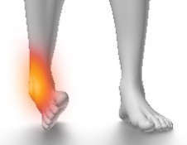
2- sprained ankle
..
3- peer pressure
..
 | A | B | C
Match: -

4. die ≠ ……. (….) | A- caught and unable to move out
5. stuck in (….) | B- refuse
6. turn down (….) | C- alive
 | D- little fat

2. What do the words at the top tell?
A. months
B. days
C. years

Comprehension
1. What will the weather be like on Monday?
A. Sunny
B. Rainy
C. cloudy

