We Can! Book 2 Unit 4: Days and Weather

1. Listen, choose and write.

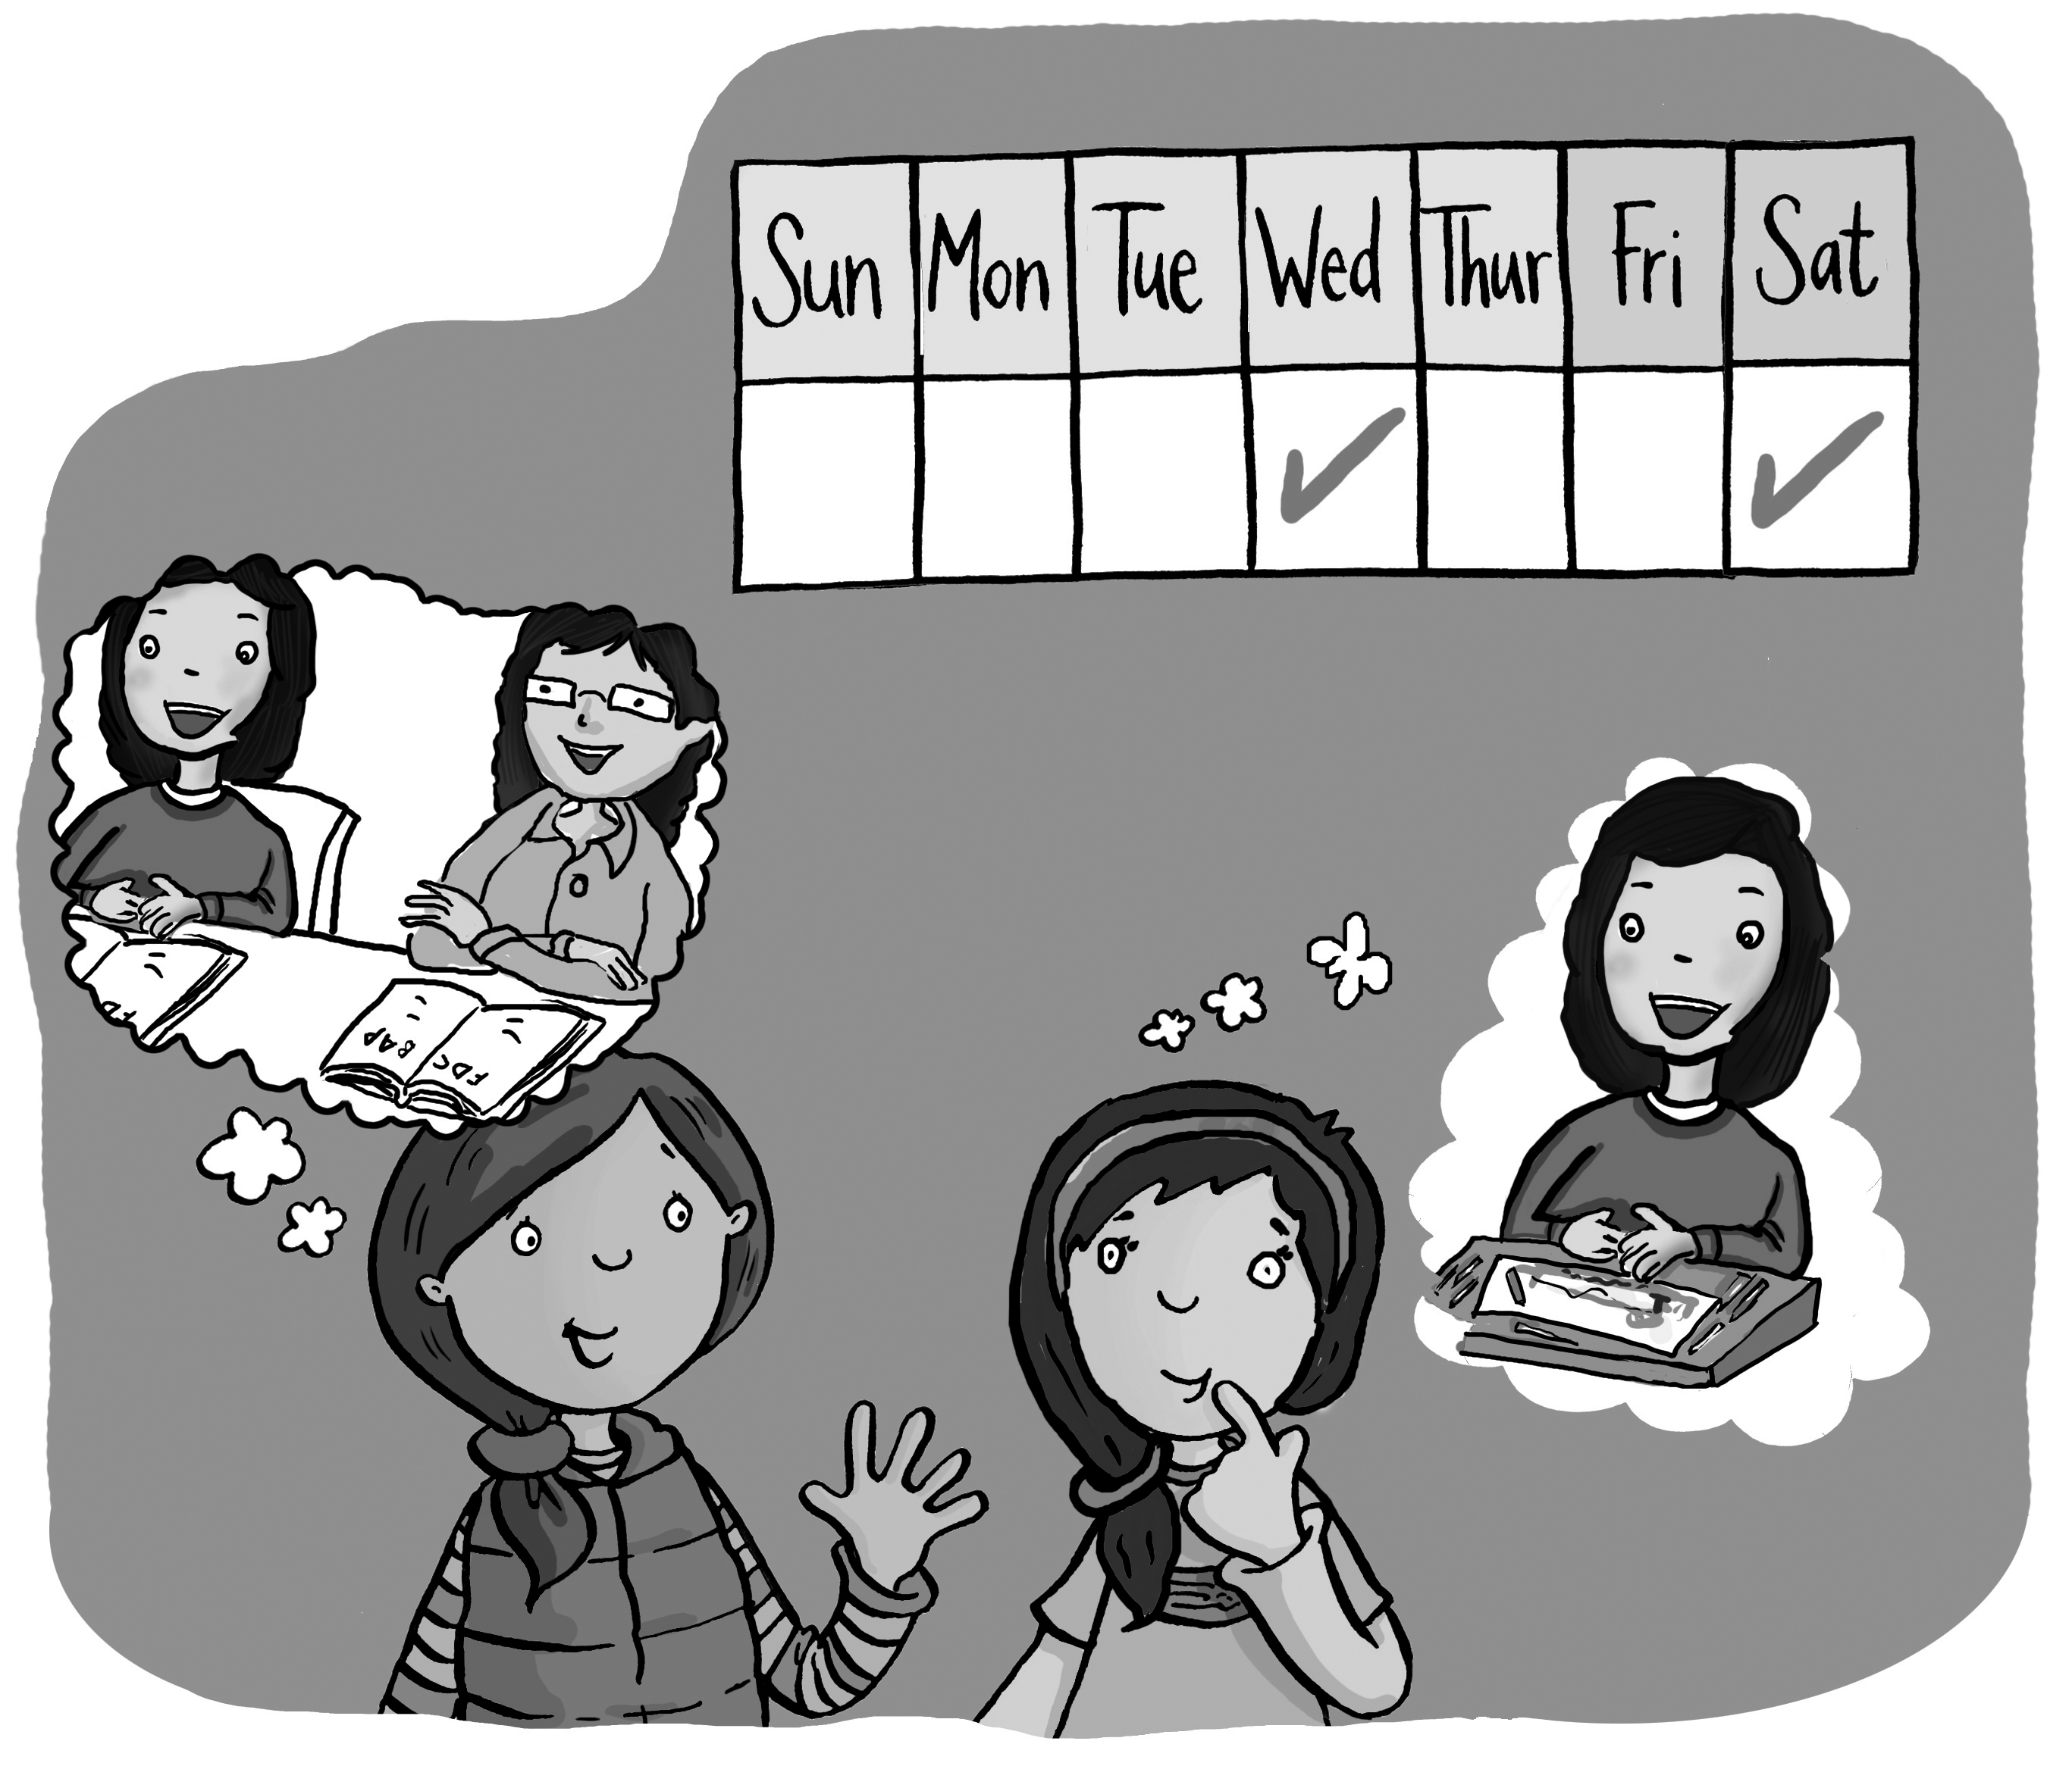 | do you  Saturday  like

What day do you like?
I like Wednesday. How about you?
I like Saturday.
[Play CD1 34 or read.]
2. Listen, number, and write.

Monday 1 Sunday 4 Thursday 2 Saturday 3
Sunday, (1) Monday , Tuesday,
Wednesday, (2) Thursday,
Thursday,
Friday, (3) Saturday,
(4) Sunday comes again.
[Play CD1 36 or read.]
3. Listen and number.

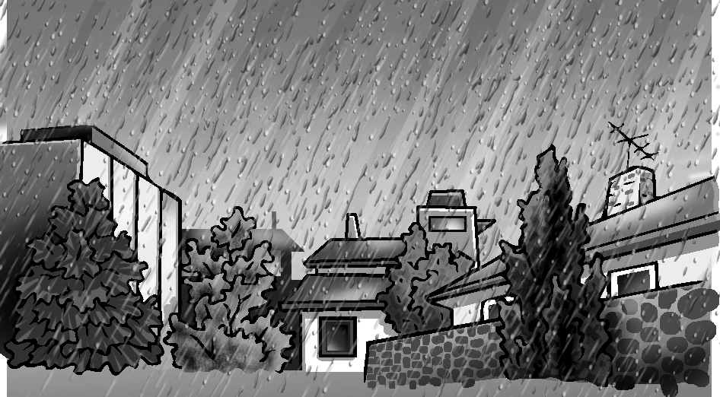  3 rainy | 4 snowy | 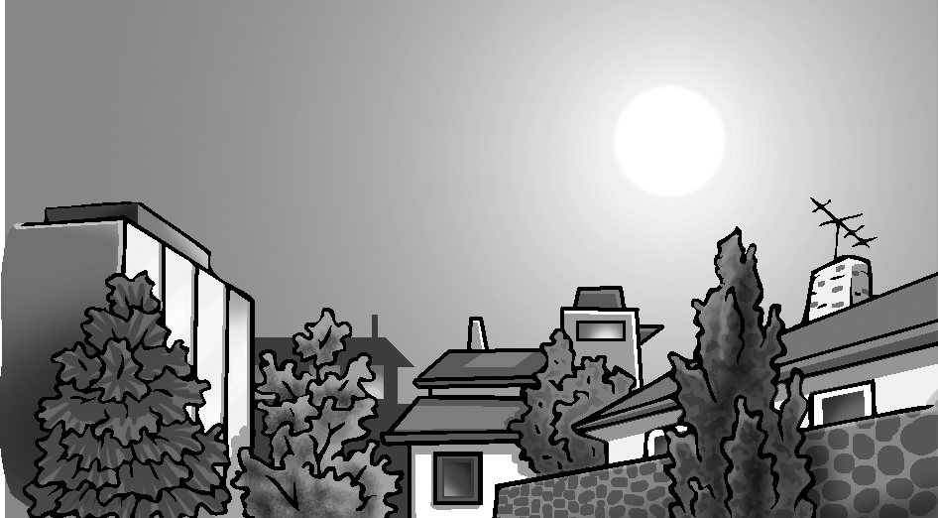  1 sunny
2 cloudy | 5 windy | [Play CD1 39 or read.]

4. Listen and circle the right letter. Then write.

1. | T U V W X Y Z  W OLF
2. | T U V W X Y Z  FO X
3. | T U V W X Y Z  Y ARD
4. | T U V W X Y Z  Z EBRA
[Play CD1 42 or read.]

