We Can! Book 4 Unit 1: Wild Animals

1. Listen and match pictures and words. Number the words.
__chimpanzee | __koala | __ostrich | __lion
__elephant | __hippo | __snake | __giraffe
__kangaroo | __ zebra | __iguana | __polar bear
__hyena | __tiger | __rhinoceros

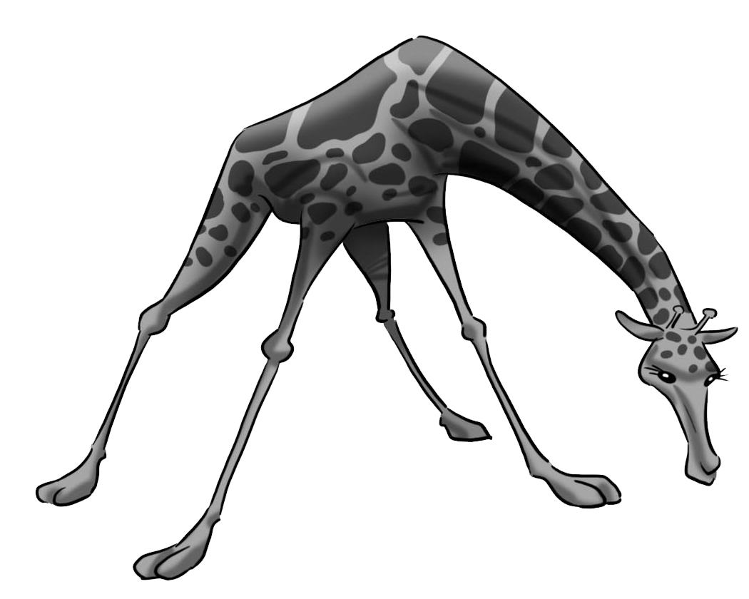  1. | 2. 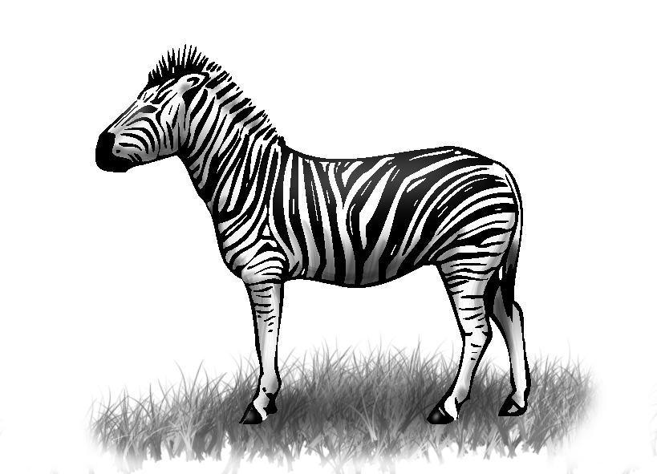 | 3. 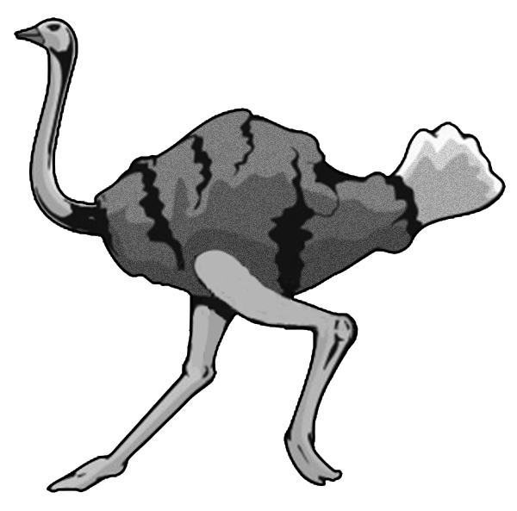
4. 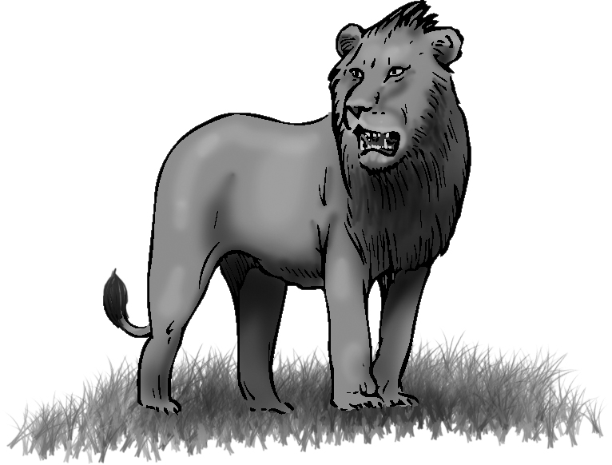 | 5. 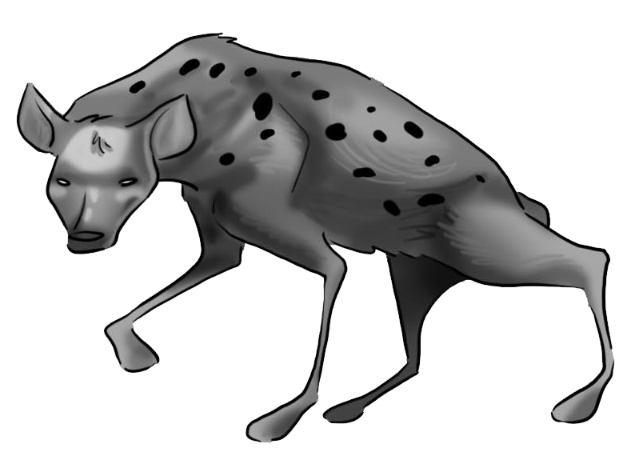 | 6. 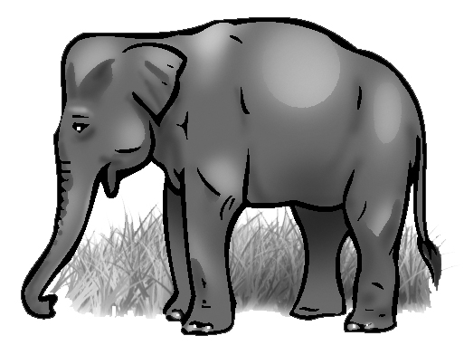
7. 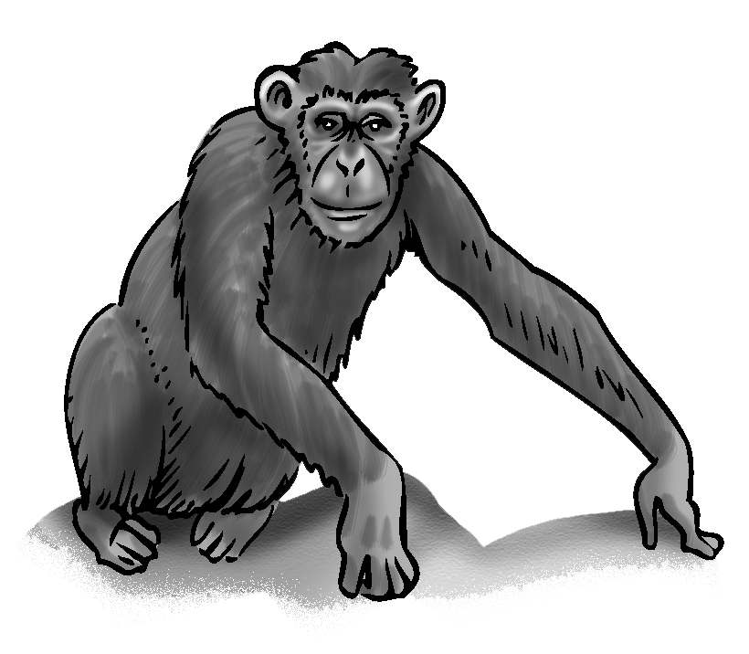 | 8. 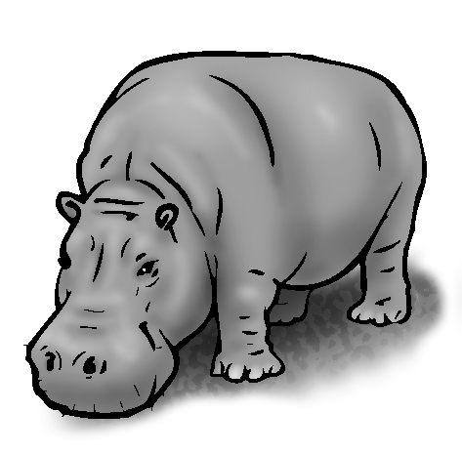 | 9. 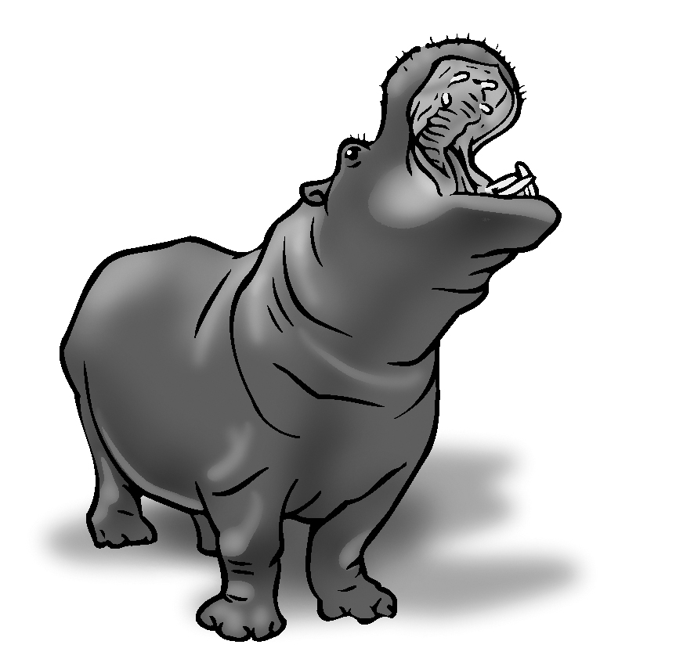
10. 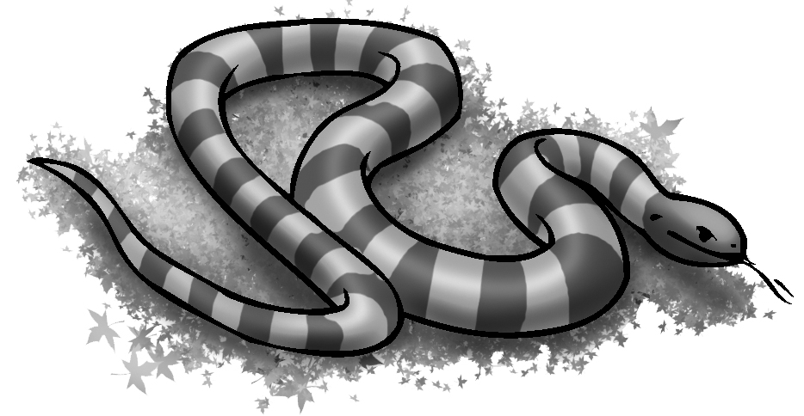 | 11. 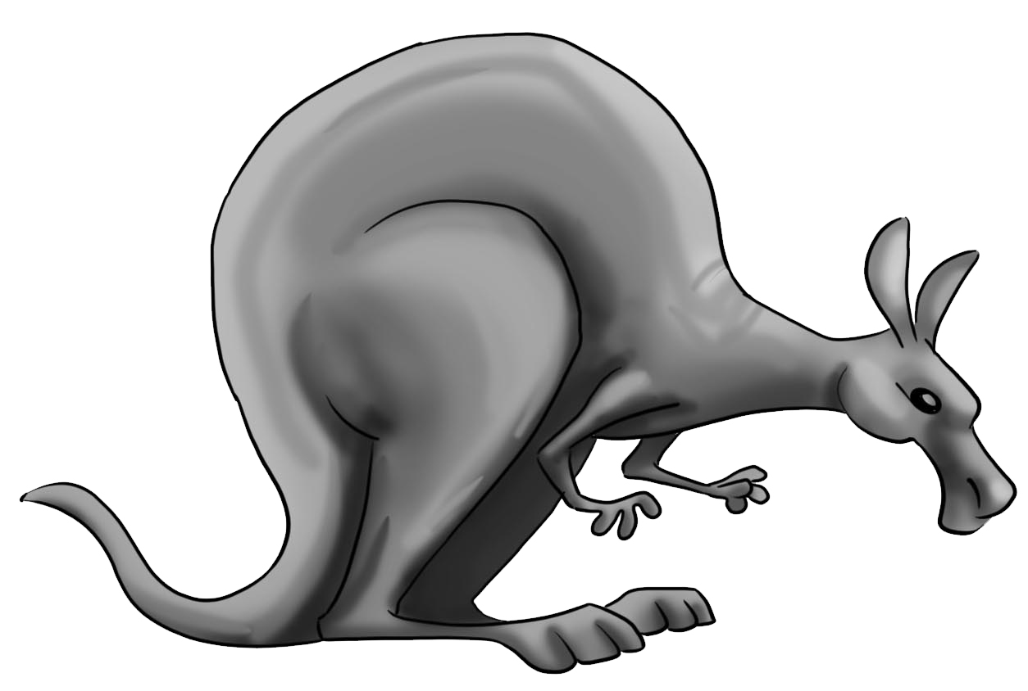 | 12. 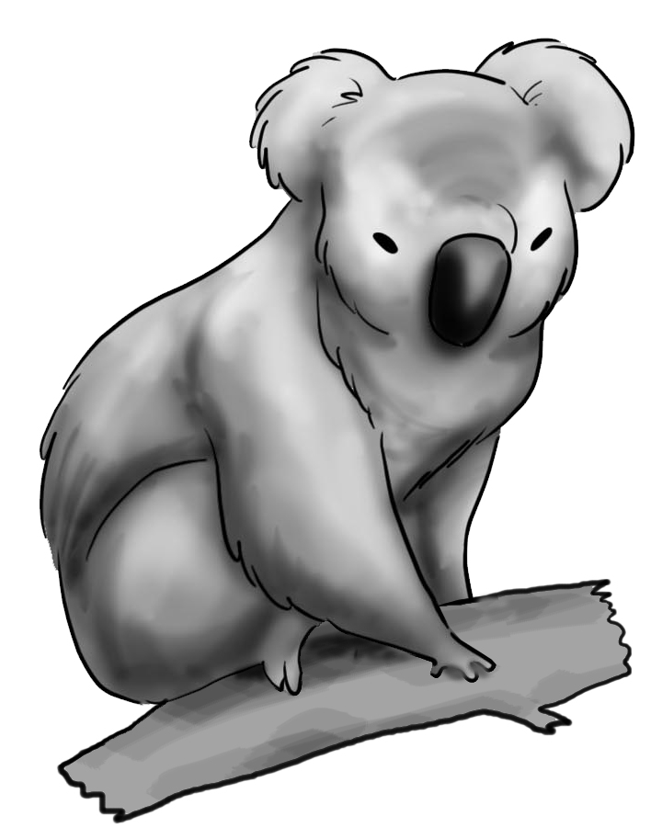
13. 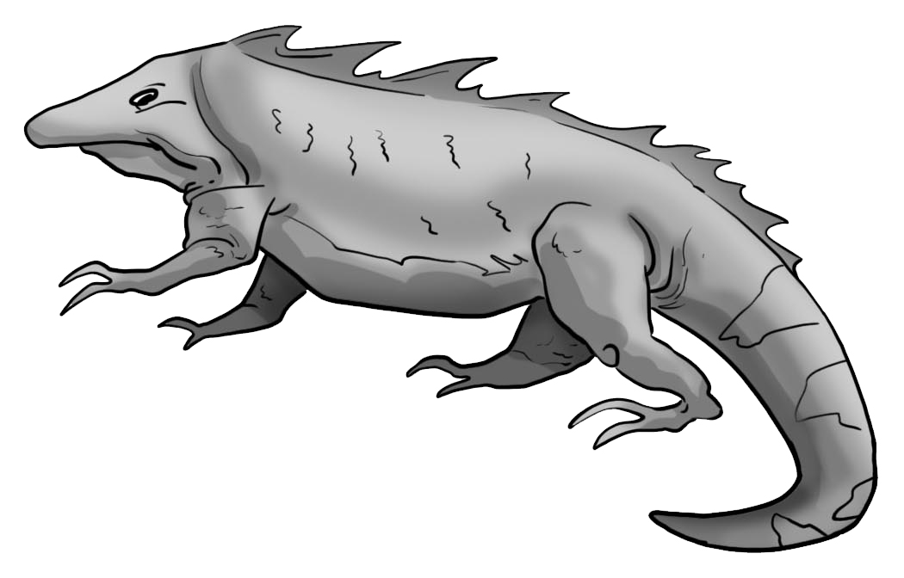 | 14. 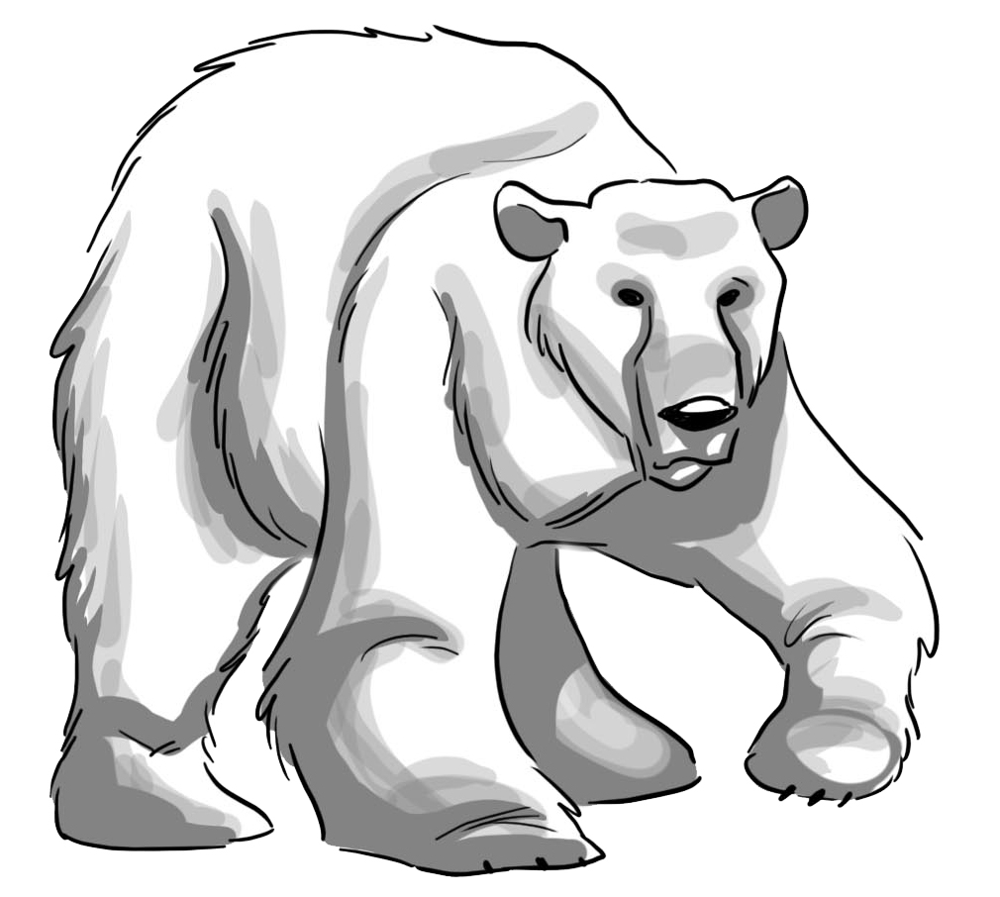 | 15. 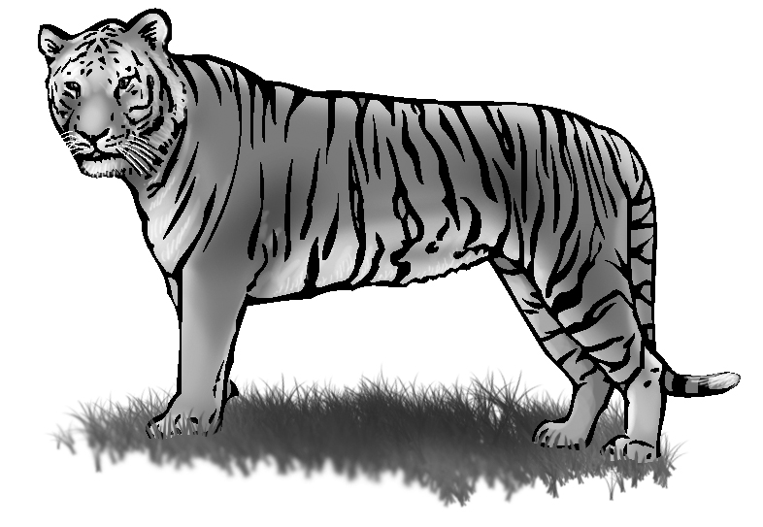

2. Listen and write about the animals. Use these words.

big / trunks black and white/ stripes scary/ big teeth

smart/ long arms long/ no arms or legs fat/ big mouths.

1. Elephants are________.  They have big________. | 2. Zebras __________.  They have ________.
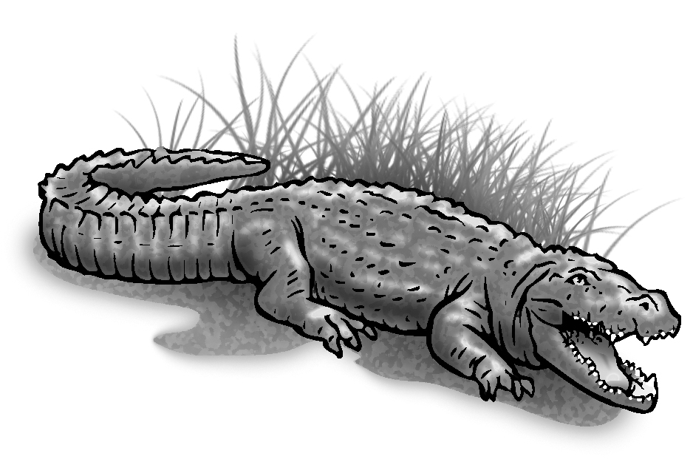  3. Crocodiles are ________.  They have ________. | 4. Chimpanzees are ________. They have __________.
5. Snakes are ________.  They have ____________. | 6. Hippos ________.  They ______________.
3. Read and answer. Check √ YES or NO. Then write.

Can kangaroos jump?  Can kangaroos fly? | YES √ NO  YES NO √
Can crocodiles fly?  Can crocodiles swim? | YES NO √  YES √ NO

Kangaroos can ________ but they __________ .
Crocodiles can ________ but they __________ .

