1st term الفصل الأول
Name : ………………………………………………….………………………………
الاسم: ………………………………………………….………………………………..
الصف: ………………………………………………….………………………………

Units :1-2-3-4

We Can 3

General Revision

General Questions
A. Match "A" with "B":
"A" |  | "B"
1.How are you ? |  |  | Nice to meet you, too.
2.Where do you live ? |  |  | I'm fine, thank you.
3.Nice to meet you |  |  | I feed the fish.
4.What sport do you like? |  |  | I think they are scary.
5. Whose car is this? |  |  | It is his car.
6. What chores do you do? |  |  | I like skydiving.
7.What do you think about sharks? |  |  | I live in Makkah.
B. Choose the correct answer:
1-What’s your name?
A. Thank you. B. Nice to meet you. C. My name is Hana.
2-Whose hat is this?
A. Hello. B. It’s mine. C. Thank you.
3-It is nice to meet you.
A. Nice to meet you, too. B. You are welcome. C. No


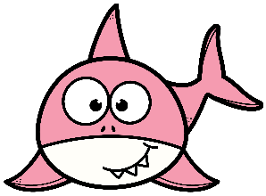
4-What are those?
A. They are fat. B. They are dolphins. C. It is a starfish.
5-How are you?
A. I'm great, thanks. B. It's not mine. C. Hi
6. What chores do you do?
A. I wash the dishes. B. I like pasta. C. Thanks.
C-Answer the following questions :
1.How are you? __________________________________.
2.Nice to meet you . __________________________________.
3.Where do you live? __________________________________.
4.What activity do you want to try? _______________________________.

Controlled Writing
A. Unscramble to make a correct sentence:

is – lunch – Omar – eating - .
………………………………………………………………………………………………………………………..………………………………………
………………………………………………………………………………………………………………………………………..………………………

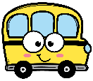
by - going – am – to -. – school – I - bus
………………………………………………………………………………………………………………………..………………………………………
………………………………………………………………………………………………………………………………………..………………………

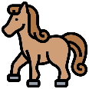
as - It – fast – is -. – as – wind
………………………………………………………………………………………………………………………..………………………………………
………………………………………………………………………………………………………………………………………..………………………

B. Unscramble to make a correct Question:
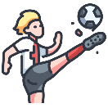
he - Does -? – football- play
………………………………………………………………………………………………………………………………………..………………………
………………………………………………………………………………………………………………………………………..………………………

you- like – game - ? – Do - computer
………………………………………………………………………………………………………………………………………..………………………
………………………………………………………………………………………………………………………………………..………………………

Reading Short Sentences:
A.Choose the correct sentence:
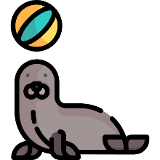  ⃝ I think it is scary.  ⃝ I think it is cute. |   ⃝ He is cooking.  ⃝ He is watching TV. | 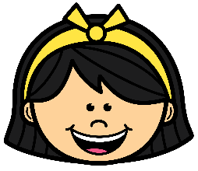  ⃝ My mom is happy.  ⃝ My dad is a doctor .
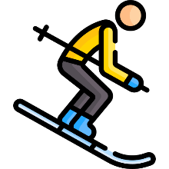  ⃝ I like skiing.  ⃝ I like basketball. |   ⃝ I don’t think it is big.  ⃝ I think it is the biggest. | 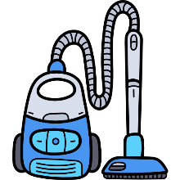  ⃝ He vacuums the floor.  ⃝ He takes out the trash.

B.Choose  or 
1.She washes the dishes. 
2.I want to try tennis. 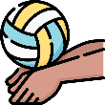
3.As fat as a walrus. 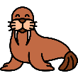
4. I fold the laundry. 

Grammar
A.Choose the correct answer:
- I ( am – is – are ) great, thanks.
- He ( am – is – are ) playing volleyball.
- We ( am – is – are ) superstars.
- ( Where – Who – What ) do you live?
- ( What – Who – Where ) is your name ?
- ( Whose – Where – When ) bag is this?
- It is ( mine – my – he ) .
- This is my mom. ( His – Her - their ) name is Fatimah.
- They are friends. ( Their – His - your ) names are Salim and Hassan.
- I ( have – has – are ) a laptop.
- She ( have – has – am ) a sister.
- We ( have – has – is ) an exam.
- He ( have – has - are ) a car.
- ( This – These - Those ) is a seahorse.
- ( That – Those - This ) are dolphins.
- Ahmad is as ( tall – taller – tallest ) as Hashim.
- Dolphins are ( cute – cuter - cutest ) than sharks.
- A seahorse is the ( small – smaller – smallest ).
- Rock climbing is the ( more – most - less ) dangerous.
- Horse riding is ( more – most - not ) exciting than football.
- ( Do – Does - Is ) you like bungee jumping?
- ( Do – Does – Are ) he play computer game?
- ( Do – Does – Is ) they go to school?
- Yes , I ( do – don’t - isn’t ) .
- No , she ( does – doesn’t – aren’t ) .
- He ( take – takes – taking ) out the trash.
- I ( clean – cleans – cleaning ) the room.
- They ( set – sets – setting ) the table.
B. Correct the mistakes between brackets:
- ( Who ) is your name ? ………………………………………………….
- He ( am) watching TV. ………………………………………………….
- What ( does ) chores you do ? ………………………………………………….
- (Who) hat is this? It's mine. …………………………………………….
- Omar is ( tall ) than Ali. …………………………………………….

Vocabulary
- Write the word under the picture:
walrus l crab l starfish l snake l horse

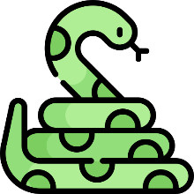  ____________ | 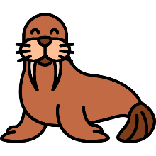  ____________ | 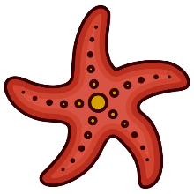  ____________ | 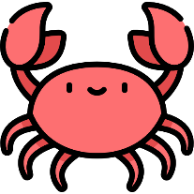  ____________ | 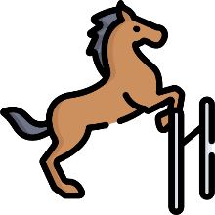  ____________

Hang gliding l horse riding l tennis l scuba diving l snowboarding

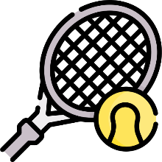  ____________ | 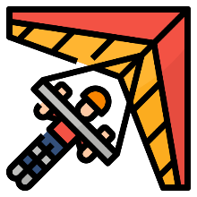  ____________ | 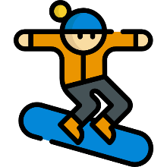  ____________ | 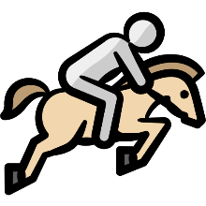  ____________ | 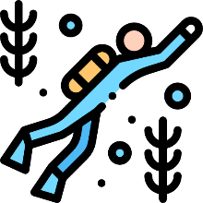  ____________

drink | robot l laundry l shopping l trash

  ___________ |   ___________ |   ___________ |   ___________ |   ___________
Orthography
- Circle the correct missing litters:
  r __ __ d  ea / ee / ay | 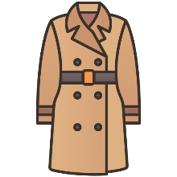  c __ __ t  ow / oa / ou |   cl __ __ n  oa / ee / ow |   pl __ __  ei / ay / ai |   p __ __  ay / ie / oi
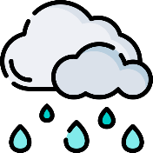  r __ __ n  oi / ay / ai | 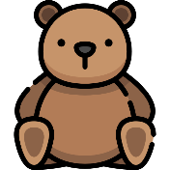  b __ __ __  air / ear / ere | 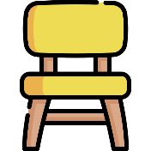  ch __ __ __  ere / air / ere |   wh __ __ __  ear / ere / air |   c __ __ n  ai / oy / oi
  t __ __ s  ai / oy / oi |   teach __ __  ar / er / or |   doct __ __  ar / er / or |   c __ __  ar / er / or |   h __ __ se  ou / ow / oa

- Unscramble :
  iarnt __________ | 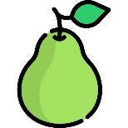  rpae __________ |   ceir __________ |   lewah __________ | 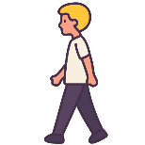  lkwa __________
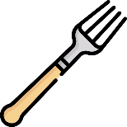  rfok __________ |   emta __________ |   hpoindl __________ |   ady __________ |   tsiser __________

Good luck, Tr. Hanadi Al-Osaimi

