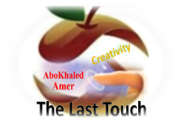

##### 

##### وزارة التعليم

**الإدارة العامة للتعليم بمنطقة -----**

**مجمع ------------------------- ( بنين )**

**اختبارات نهاية الفصل الدراسي الأول 1445 هـ**

|  |  |  |
| --- | --- | --- |
| **المادة:**  **لغة انجليزية** | **الصف: الثالث الثانوي رقم الجلوس : ( )** | **الزمن:**  **ساعتان ونصف** |
| **اسم الطالب: ................................................................................................................................................** |

|  |  |  |  |  |  |  |  |
| --- | --- | --- | --- | --- | --- | --- | --- |
| **Total**  **written** | **5**  **Vocabulary** | **4**  **Grammar** | **3**  **Free Compositio** | **2**  **Guided Composition** | | **1 Comprehension** | **Q. NO.** |
|  |  |  |  |  | |  | **Mark Given** |
| **30** | **6** | **6** | **6** | **6** | | **6** | **Mark** |
| **6** | | | **Reviser** | |  | | **Corrector** |
|  | |

**1)** **Comprehension**

**Read the following passage then answer the questions**

**Sheikh Sulaiman bin Abdul-Aziz Al-Rajhi, the world renowned philanthropist and winner of the 2012 king Faisal International Prize for Services to Islam, in recognition of his outstanding service to Islam, by establishing the world's largest Islamic bank and his contribution to charities and humanitarian projects, has not always been a billionaire.**

**Born in 1920, he spent his youth in Al-Qassim where he and his brother Saleh began their business changing money for pilgrims, on their way to Makkah and Madinah. Their business expanded in the 1970s during the oil bloom in Saudi Arabia. The Al-Rajhi brothers helped migrant workers from Indonesia, Pakistan and other places to send their earnings home. They were granted a permission to establish a bank, the Al-Rajhi Bank, which compiled with religious tenets such as a ban on interest.**

***A)* Answer the following questions*:*  
1. Who is this passage about?-------------------------------------------------------.**

**2. When was he born? -----------------------------------------------------------.**

**3. What did he win in 2012? ----------------------------------------------------------.**

**4. Has he been a billionaire?  --------------------------------------------------------------.**

***B)* Put ( √ ) or ( X ):  
5. Sheikh Sulaiman was born in Najran. ( )**

**6. Sheikh Sulaiman established the world's largest Islamic bank. ( )**

**7. They began their business changing money for pilgrims. ( )**

**8. Their business expanded in the 1960s during the oil bloom. ( )  
*C)* Complete*:*  
9. They were granted a permission to establish a --------------------------------.  
10. He has a contribution to charities and -----------------------------------.**

**D) Choose the correct answer:**

**11. The Bank is compiled with (**social – cultural – religious**) tenets.**

**12. Sheikh Sulaiman is the world renowned and (**poet – teacher – philanthropist**)**

**2) Guided Composition**

**6**

**This is the last week for you in a high school. Next week, you will be considered in the university choosing your major for your future job.**

**Write a short paragraph about " Your Future Job"**

**Guiding words:**

(many jobs – study – choose – work hard …)

-------------------------------------------------------

-------------------------------------------------------------------------------------------------------------------------------------------------------------------------------------------------------------------------------------------------------------------------------------------------------------------------------------------------------------------------------------------------------------------------------------------------------------------------------------------------------------------------------------------------------------------------------------------------------------------------------------------------------------------------------------------------------------------------------------------------------------------------------------------------------------------------------------------------------------------------------------------------------------------------------------------------------------------------------------------------------------------------------------------------------------------------------------------------------------------------------------------------------------------------------------------------------------------------------------------------

**3) Free Composition**

**6**

**Choose one topic from the following to write about.**

**1. Imagine that you are a scientist who is talking about the future predictions and things that will take place in the future.**

**2. Write about a person whom you consider as your example in life**

-------------------------------------------------------

-----------------------------------------------------------------------------------------------------------------------------------------------------------------------------------------------------------------------------------------------------------------------------------------------------------------------------------------------------------------------------------------------------------------------------------------------------------------------------------------------------------------------------------------------------------------------------------------------------------------------------------------------------------------------------------------------------------------------------------------------------------------------------------------------------------------------------------------------------------------------------------------------------------------------------------------------------------------------------------------------------------------------------------------------------------------------------------------------------------------------------------------------------------------------------------------------------------------------------------------------------------------------------------------------------------------------------------------------------------------------------------------------------------------------------------------------------------------------------------------------------------------------------------------------------------------------------

**4) Grammar**

**6**

**A: Choose the correct answer:**

**1. He is so full of burgers, so he couldn't eat (other – others – another – so).**

**2. Ali used to (drives – drive – driving – drove) his car to work.**

**3. By 2026 I will have (completed – completes – completing – complete) my studies.**

**4. Both Ahmed and Khaled (is – are – was – has) good friends.**

**5. They didn't go to school (because – since – now that – because of) the heat.**

**6. He stopped (to smoke – smoke – smoking – smokes). He doesn't smoke now.**

**Do as shown between brackets:**

**1. We go to school. We want to learn. (**Join using: in order to**)**

-------------------------------------------------------------------------------------------------.

**2. Ali can play football. Hassan can play football. (Join using: Either)**

-------------------------------------------------------------------------------------------------.

**3. By 2025, I will have been (study) at Najran University. (Correct the verb)**

-------------------------------------------------------------------------------------------------.

**4. Nora is used to (cook) lunch at home. (Correct the verb)**

-------------------------------------------------------------------------------------------------.

**5. Ali likes eating fish. (Use emphatic do)**

-------------------------------------------------------------------------------------------------.

**6. They used to watch games with their friends. (Make Negative)**

-------------------------------------------------------------------------------------------------.

**5) vocabulary:**

**6**

**A- Match the words with the pictures:**

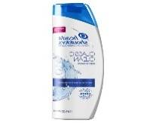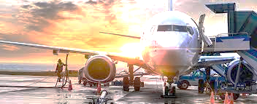**shampoo – traffic – clothing – pigeon – aviation – detective**

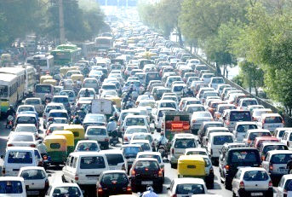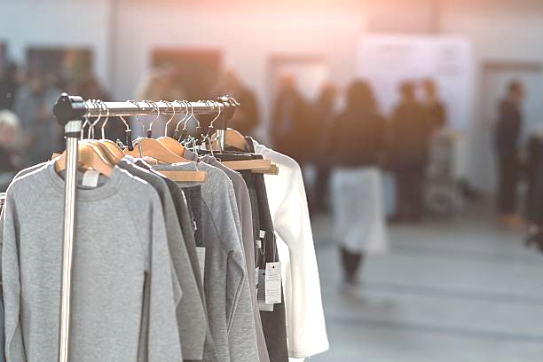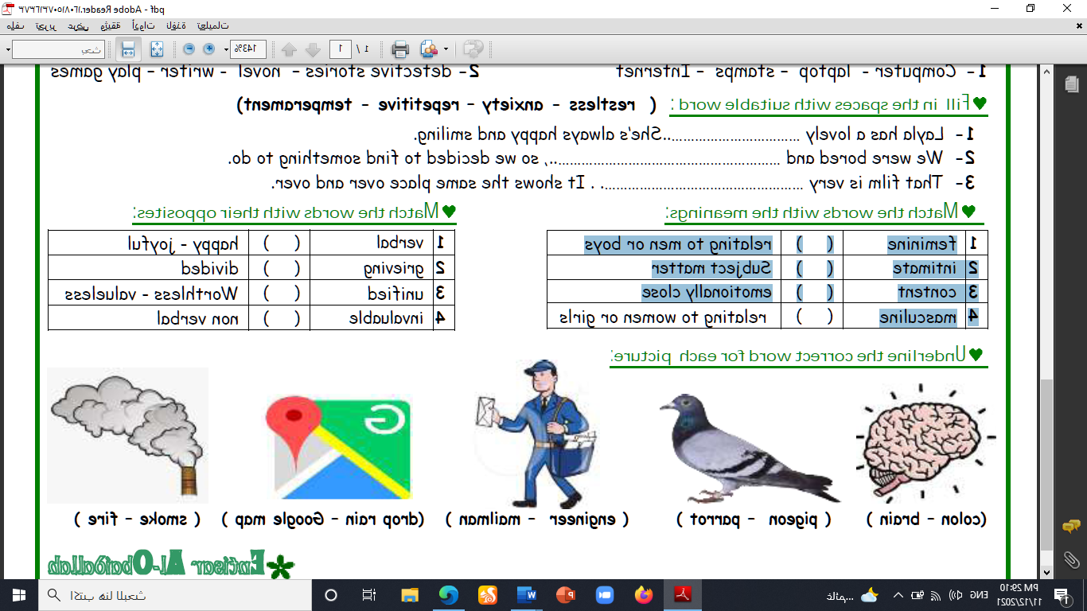

**--------- --------- ---------- -------- ------ -------**

**A) Match to form new words or expressions:**

**1. No sweet ---- a. fall asleep**

**2. cash ---- b. No problem**

**3. doze off ---- c. expensive**

**4. pioneer ---- d. position in an ordered group**

**5. steep ---- e. money**

**6. rank ---- f. a person who first made something**

**End of Questions**

**Best of Luck**



##### 

##### وزارة التعليم

**الإدارة العامة للتعليم بمنطقة -----**

**مجمع ------------------------- ( بنين )**

**اختبارات نهاية الفصل الدراسي الأول 1445 هـ**

|  |  |  |
| --- | --- | --- |
| **المادة:**  **لغة انجليزية** | **الصف: الثالث الثانوي رقم الجلوس : ( )** | **الزمن:**  **ساعتان ونصف** |
| **اسم الطالب: ................................................................................................................................................** |

|  |  |  |  |  |  |  |  |
| --- | --- | --- | --- | --- | --- | --- | --- |
| **Total**  **written** | **5**  **Vocabulary** | **4**  **Grammar** | **3**  **Free Compositio** | **2**  **Guided Composition** | | **1 Comprehension** | **Q. NO.** |
|  |  |  |  |  | |  | **Mark Given** |
| **30** | **6** | **6** | **6** | **6** | | **6** | **Mark** |
| **6** | | | **Reviser** | |  | | **Corrector** |
|  | |

**1)** **Comprehension**

**Read the following passage then answer the questions**

**King Faisal bin Abdul-Aziz was born in Riyadh in 1905. In 1919, he was sent to Paris Peace Conference at the end of World War 1. On the same trip, he visited the UK. There were many important events in Faisal’s life. In 1925, he became viceroy of the Hejaz and Foreign Minister. During the 1930s, he made many trips abroad to present the Arab’s views on Palestine. Then in 1945, *he* took the Kingdom into the United Nations. He became Prime Minister in 1962 and King in 1964. He is remembered for his piety, his intellectual powers and his quick mind. He died in 1975 at the age of 70.**

***A)* Answer the following questions*:*  
1. Who is this passage about?----------------------------------------------------.**

**2. When was he born? -----------------------------------------------------------.**

**3. Where was he sent in 1919? ---------------------------------------------------.**

**4. When did he die?  --------------------------------------------------------------.**

***B)* Put ( √ ) or ( X ):  
5. King Faisal was sent to Paris Peace Conference after the World War I1. ( )**

**6. King Faisal became Foreign Minister in 1962. ( )**

**7. King Faisal is remembered for his piety. ( )**

**8. King Faisal died at the age of seventeen. ( )  
*C)* Complete*:*  
9. King Faisal took the Kingdom into the --------------------------------.  
10. In 1925, he became viceroy of the -----------------------------------.**

**D) Choose the correct answer:**

**11. He presented the Arab’s views on (**Syria – Yemen – Palestine**).**

**12. He became the king of Saudi Arabia in (**1964 – 1975 - 1905**).**

**2) Guided Composition**

**6**

**Some animals can not live alone in the jungle. They have to make partnership with other animals. Write a short paragraph about:**

**" Animal Partners "**

**Guiding words:**

(symbiosis – crocodile / plover bird – lacks – zebra / ostrich **…)**

-------------------------------------------------------

---------------------------------------------------------------------------------------------------------------------------------------------------------------------------------------------------------------------------------------------------------------------------------------------------------------------------------------------------------------------------------------------------------------------------------------------------------------------------------------------------------------------------------------------------------------------------------------------------------------------------------------------------------------------------------------------------------------------------------------------------------------------------------------------------------------------------------------------------------------------------------------------------------------------------------------------------------------------------------------------------------------------------------------------------------------------------------------------------------------------------------------------------------------------------------------------------------------------------------------------------------------------------------------------------------------------------------------------------------------------------------------------------------------------------------------------------------------------------------------------------------

**3) Free Composition**

**6**

**Choose one topic from the following to write about.**

**1. There are some places in Saudi Arabia that are visited by many tourists every year. Choose a place and write a paragraph about it.**

**2. The problem of pollution is widespread all over the world. Writ about it**

-------------------------------------------------------

------------------------------------------------------------------------------------------------------------------------------------------------------------------------------------------------------------------------------------------------------------------------------------------------------------------------------------------------------------------------------------------------------------------------------------------------------------------------------------------------------------------------------------------------------------------------------------------------------------------------------------------------------------------------------------------------------------------------------------------------------------------------------------------------------------------------------------------------------------------------------------------------------------------------------------------------------------------------------------------------------------------------------------------------------------------------------------------------------------------------------------------------------------------------------------------------------------------------------------------------------------------------------------------------------------------------------------------------------

**4) Grammar**

**6**

**A: Choose the correct answer:**

**1. I like tea, but (another – other – others – so) like coffee.**

**2. Nora didn't use to (sleep – sleeps – sleeping – slept) early on the weekends.**

**3. By 2024, they (will be – will have – will has – will can) completed the bridge.**

**4. Neither Sarah (not – or – and – nor) Norah likes fish.**

**5. He sleeps early (so that – because – in order to – if) get up early.**

**6. He regrets (helps – help – helping – helped) that lady.**

**Do as shown between brackets:**

**1. They played football at school. (**Emphatic do**)**

-------------------------------------------------------------------------------------------------.

**2. They (used to) working for late hours. (Correct)**

-------------------------------------------------------------------------------------------------.

**3. She used to help her mom. (Make Yes/No Question)**

-------------------------------------------------------------------------------------------------.

**4. By 2026, we (complete) our projects. (Use: Future Perfect)**

-------------------------------------------------------------------------------------------------.

**5. Ali can swim. Ahmed can swim. (Join using: Both)**

-------------------------------------------------------------------------------------------------.

**6. They didn't go to school. There was rain. (Join using: because of)**

-------------------------------------------------------------------------------------------------.

**5) vocabulary:**

**6**

**A- Match the words with the pictures:**

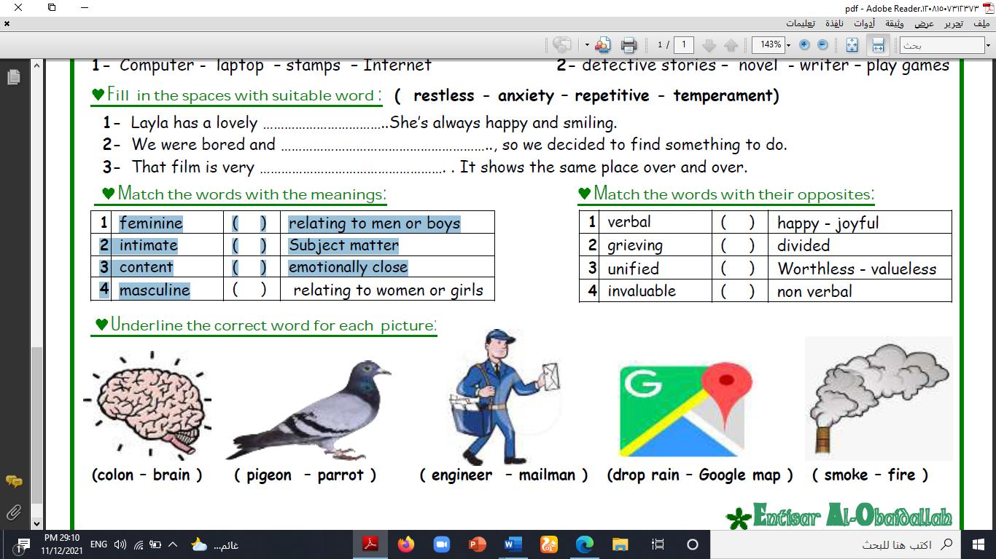**sneakears – prize – Nemo – Language – brain – ostrich**

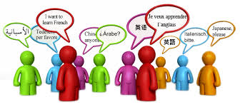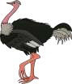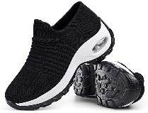

**-------- -------- ---------- ----------- ------ -------**

**A) Match to form new words or expressions:**

**1. fearsome ---- a. accept things**

**2. crucial ---- b. design symbol of a business or product**

**3. logo ---- c. causing great fear**

**4. go with the flow ---- d. extremely important**

**5. broke ---- e. You don't like**

**6. Not my cup of tea ---- f. out of money **

**End of Questions**

**Best of Luck**

|  |  |  |  |  |  |
| --- | --- | --- | --- | --- | --- |
| الدرجة | | | | C:\Documents and Settings\user\Desktop\1444823505lnha01401002015ha0016-800x500.jpgC:\Users\Dar Altarbia\Desktop\شعار مدرستي.jpgنتيجة بحث الصور عن شعار رؤية المملكة 2030  =======================================  اسم الطالب ( ------------------------------------)  رقم الجلوس (------------------------------)  المادة ( اللغة الانجليزية Mega Goal 5 )  زمن الإجابة (ساعاتان ونصف )  التاريخ / / 1445 هـ | المملكة العربية السعودية  **وزارة التعليم**  **ثانوية**    **الفصل الدراسي الاول**  **الدور الأول**  **العام الدراسي**    **1445 / 1444**  **الصف الثالث الثانوي** |
| الدرجة | السؤال | | |
|  | 6 | **قطعة** | 1 |
|  | 6 | **القواعد** | 2 |
|  | 6 | **المفردات** | 3 |
|  | 12 | **كتابة** | 4 |
|  | 30 | 30 | **المجموع** |

وطننا بيتنا...فلنحافظ عليه

Q. 1 (Reading )

6

***Read the following passage and answer the following questions:***

**(Computer)**

**The computer is a double-edge weapon. So some people are with and others are against it. According to people who support, they see that we live at the age of the computer as it breaks through every field in our life, for example medical, educational, engineering, and commercial fields. In addition to many other fields everywhere. These people also see that the computer is far more efficient than human beings. It has much better and can store huge amounts of information and it can do calculations in no time. The computer has a great characteristics as it doesn’t suffer from lack of sleep, so it never feels tired and works efficiently all the time. One of the most important parts of the computer is the internet which is used for fun, paying bills, shopping, paying salaries, reserving seats on planes, learning and having courses in different fields. In addition to telling tomorrow’s weather and many other jobs can do them accurately and quickly.**

**Other people who don’t support the computer see that it is not important to possess a computer at all neither in their homes, nor in their offices. They prefer to depend on simple machines for communications such as calculator, fax, typewriter, telephone,….etc. they think with them everything is done in a relax manner because they are easier and simpler than the computer. As well as they avoid us taking the risk of using computers. These people also refuse to become part of the new internet world as it is a matter of wasting and gaining bad habits. They see that they see that they will never think of buying even if it becomes able to think, able to act on its own, or accept the responsibility for all mistakes it makes.**

***Put ( T ) for true and ( F ) for false ( one mark for each point )***

1. Computer can be used in education. ( )
2. Computer can’t store huge amounts of information. ( )
3. Computer can’t be a source of bad habits. ( )
4. Computer can feel tired and doesn’t work efficiently. ( )
5. Computer can be useful for the students in learning. ( )
6. Computer doesn’t suffer from a lack of sleep. ( )

follow

Q. 2 ( Grammar )

6

**Choose the correct answer** ( half for each one )

1. I just recovered from a cold, and already I’m getting ……………………………………one
2. **bother b) others c) other d) another**
3. I …………………………………..feel tired yesterday.
4. **do b) did c) does d) doing**
5. Ahmed is busy. He ……………………………………..……..an e-mail now.
6. **writes b) write c) is writing d) wrote**
7. He likes his new job, but he isn’t used to ……………………………….…..a suit and tie.
8. **wearing b) wear c) wears d) wore**
9. Hameed has had the same TV…………………………………..……….15 years.
10. **since b) ago c) and d) for**
11. Have you ……………………………….……..met a billionaire?
12. **ever b) never c) since d) for**
13. By 2022, I ……………………………..…………the university.
14. **joined b) join c) will join d) will have joined**
15. He enjoys outdoor activities, and his son does………………………………….………
16. **either b) to c) two d) too**
17. I’d prefer ………………….…………………………at home. I don’t want to spend all my money.
18. **to stay b) stay c) staying d) stayed**
19. They went to the mall …………………….………….…….the sale.
20. **because b) because of c) to d) in order to**
21. Ahmed is ……………………………..…………….…….than Ali.
22. **tall b) taller c) tallest d) tall as**
23. Jeddah is as ……………………………….…………. Taif.
24. **hot b) hotter c) hottest d) hot as**

Q. 3 ( Vocabulary )

6

1. When you have a design symbol of a business or a product, it is a …………………..………..…………
2. **logo b) exposure c) outlandish d) life**
3. “Changed” can be with the meaning of …………………………………………….…….…
4. **defects b) seller c) exotic d) altered**
5. …………………………………….……………is a sea animal.
6. **Goldfish b) Deer c) Camel d) Tiger**
7. ………………………………………….is a path in space followed by a planet, moon, or spacecraft.
8. **Estimated b) Lucrative c) Chain d) Orbit**
9. …………………………..……………….….causing great fear.
10. **Fearsome b) invaluable c) deficiencies d) compensate**
11. ……………………………………..…….animals that live by hunting others
12. **Mammals b) Predators c) Cats d) Cows**
13. When there is something relating to women or girls, it is called…………………………………………
14. **convey b) masculine c) feminine d) content**
15. …………………………………………………is the person who saw an incident.
16. **Witness b) Species c) Literal d) Intimate**
17. Finding sources for an essay can be a time-consuming and …………………..………………….……..task.
18. **pleased b) good c) happy d) tedious**
19. A person who buys things or services, is …………………….………………..……………
20. **seller b) trader c) consumer d) driver**
21. The Noble Prize is the most …………………………………………………..award a scientist can win.
22. **awful b) tedious c) bad d) prestigious**
23. …………………………………………….…….means producing a lot of money.
24. **Steep b) Affluence c) Patent d) Lucrative**

follow

12

1. 4 ( Writing )
2. **Write a paragraph about (Football ). You may use the following words:**

**( sport – healthy – team – player – match – world cup – national team ) (6 marks )**

-------------------------------------------------------------------------------------------------------------------------------------------

-------------------------------------------------------------------------------------------------------------------------------------------

-------------------------------------------------------------------------------------------------------------------------------------------

-------------------------------------------------------------------------------------------------------------------------------------------

-------------------------------------------------------------------------------------------------------------------------------------------

-------------------------------------------------------------------------------------------------------------------------------------------

-------------------------------------------------------------------------------------------------------------------------------------------

-------------------------------------------------------------------------------------------------------------------------------------------

-------------------------------------------------------------------------------------------------------------------------------------------

-------------------------------------------------------------------------------------------------------------------------------------------

-------------------------------------------------------------------------------------------------------------------------------------------

-------------------------------------------------------------------------------------------------------------------------------------------

-------------------------------------------------------------------------------------------------------------------------------------------

-------------------------------------------------------------------------------------------------------------------------------------------

-------------------------------------------------------------------------------------------------------------------------------------------

-------------------------------------------------------------------------------------------------------------------------------

**B) Write a paragraph about one of the following ( My phone ) or ( Facebook ) ( 6 marks)**

-------------------------------------------------------------------------------------------------------------------------------------------

-------------------------------------------------------------------------------------------------------------------------------------------

-------------------------------------------------------------------------------------------------------------------------------------------

-------------------------------------------------------------------------------------------------------------------------------------------

-------------------------------------------------------------------------------------------------------------------------------------------

-------------------------------------------------------------------------------------------------------------------------------------------

-------------------------------------------------------------------------------------------------------------------------------------------

-------------------------------------------------------------------------------------------------------------------------------------------

-------------------------------------------------------------------------------------------------------------------------------------------

-------------------------------------------------------------------------------------------------------------------------------------------

-------------------------------------------------------------------------------------------------------------------------------------------

-------------------------------------------------------------------------------------------------------------------------------------------

-------------------------------------------------------------------------------------------------------------------------------------------

-------------------------------------------------------------------------------------------------------------------------------------------

-------------------------------------------------------------------------------------------------------------------------------------------

-------------------------------------------------------------------------------------------------------------------------------

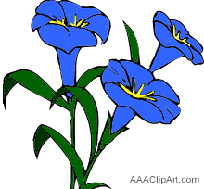

Best Wishes

English Department

End of Questions



##### 

##### وزارة التعليم

**الإدارة العامة للتعليم بمنطقة -----**

**مجمع ------------------------- ( بنين )**

**اختبارات نهاية الفصل الدراسي الأول 1445 هـ**

|  |  |  |
| --- | --- | --- |
| **المادة:**  **لغة انجليزية** | **الصف: الثالث الثانوي رقم الجلوس : ( )** | **الزمن:**  **ساعتان ونصف** |
| **اسم الطالب: ................................................................................................................................................** |

|  |  |  |  |  |  |  |  |
| --- | --- | --- | --- | --- | --- | --- | --- |
| **Total**  **written** | **5**  **Vocabulary** | **4**  **Grammar** | **3**  **Free Compositio** | **2**  **Guided Composition** | | **1 Comprehension** | **Q. NO.** |
|  |  |  |  |  | |  | **Mark Given** |
| **30** | **6** | **6** | **6** | **6** | | **6** | **Mark** |
| **6** | | | **Reviser** | |  | | **Corrector** |
|  | |

**1)** **Comprehension**

**Read the following passage then answer the questions**

**Sheikh Sulaiman bin Abdul-Aziz Al-Rajhi, the world renowned philanthropist and winner of the 2012 king Faisal International Prize for Services to Islam, in recognition of his outstanding service to Islam, by establishing the world's largest Islamic bank and his contribution to charities and humanitarian projects, has not always been a billionaire.**

**Born in 1920, he spent his youth in Al-Qassim where he and his brother Saleh began their business changing money for pilgrims, on their way to Makkah and Madinah. Their business expanded in the 1970s during the oil bloom in Saudi Arabia. The Al-Rajhi brothers helped migrant workers from Indonesia, Pakistan and other places to send their earnings home. They were granted a permission to establish a bank, the Al-Rajhi Bank, which compiled with religious tenets such as a ban on interest.**

***A)* Answer the following questions*:*  
1. Who is this passage about?-------------------------------------------------------.**

**2. When was he born? -----------------------------------------------------------.**

**3. What did he win in 2012? ----------------------------------------------------------.**

**4. Has he been a billionaire?  --------------------------------------------------------------.**

***B)* Put ( √ ) or ( X ):  
5. Sheikh Sulaiman was born in Najran. ( )**

**6. Sheikh Sulaiman established the world's largest Islamic bank. ( )**

**7. They began their business changing money for pilgrims. ( )**

**8. Their business expanded in the 1960s during the oil bloom. ( )  
*C)* Complete*:*  
9. They were granted a permission to establish a --------------------------------.  
10. He has a contribution to charities and -----------------------------------.**

**D) Choose the correct answer:**

**11. The Bank is compiled with (**social – cultural – religious**) tenets.**

**12. Sheikh Sulaiman is the world renowned and (**poet – teacher – philanthropist**)**

**2) Guided Composition**

**6**

**This is the last week for you in a high school. Next week, you will be considered in the university choosing your major for your future job.**

**Write a short paragraph about " Your Future Job"**

**Guiding words:**

(many jobs – study – choose – work hard …)

-------------------------------------------------------

-------------------------------------------------------------------------------------------------------------------------------------------------------------------------------------------------------------------------------------------------------------------------------------------------------------------------------------------------------------------------------------------------------------------------------------------------------------------------------------------------------------------------------------------------------------------------------------------------------------------------------------------------------------------------------------------------------------------------------------------------------------------------------------------------------------------------------------------------------------------------------------------------------------------------------------------------------------------------------------------------------------------------------------------------------------------------------------------------------------------------------------------------------------------------------------------------------------------------------------------------

**3) Free Composition**

**6**

**Choose one topic from the following to write about.**

**1. Imagine that you are a scientist who is talking about the future predictions and things that will take place in the future.**

**2. Write about a person whom you consider as your example in life**

-------------------------------------------------------

-----------------------------------------------------------------------------------------------------------------------------------------------------------------------------------------------------------------------------------------------------------------------------------------------------------------------------------------------------------------------------------------------------------------------------------------------------------------------------------------------------------------------------------------------------------------------------------------------------------------------------------------------------------------------------------------------------------------------------------------------------------------------------------------------------------------------------------------------------------------------------------------------------------------------------------------------------------------------------------------------------------------------------------------------------------------------------------------------------------------------------------------------------------------------------------------------------------------------------------------------------------------------------------------------------------------------------------------------------------------------------------------------------------------------------------------------------------------------------------------------------------------------------------------------------------------------------

**4) Grammar**

**6**

**A: Choose the correct answer:**

**1. He is so full of burgers, so he couldn't eat (other – others – another – so).**

**2. Ali used to (drives – drive – driving – drove) his car to work.**

**3. By 2026 I will have (completed – completes – completing – complete) my studies.**

**4. Both Ahmed and Khaled (is – are – was – has) good friends.**

**5. They didn't go to school (because – since – now that – because of) the heat.**

**6. He stopped (to smoke – smoke – smoking – smokes). He doesn't smoke now.**

**Do as shown between brackets:**

**1. We go to school. We want to learn. (**Join using: in order to**)**

-------------------------------------------------------------------------------------------------.

**2. Ali can play football. Hassan can play football. (Join using: Either)**

-------------------------------------------------------------------------------------------------.

**3. By 2025, I will have been (study) at Najran University. (Correct the verb)**

-------------------------------------------------------------------------------------------------.

**4. Nora is used to (cook) lunch at home. (Correct the verb)**

-------------------------------------------------------------------------------------------------.

**5. Ali likes eating fish. (Use emphatic do)**

-------------------------------------------------------------------------------------------------.

**6. They used to watch games with their friends. (Make Negative)**

-------------------------------------------------------------------------------------------------.

**5) vocabulary:**

**6**

**A- Match the words with the pictures:**

**shampoo – traffic – clothing – pigeon – aviation – detective**



**--------- --------- ---------- -------- ------ -------**

**A) Match to form new words or expressions:**

**1. No sweet ---- a. fall asleep**

**2. cash ---- b. No problem**

**3. doze off ---- c. expensive**

**4. pioneer ---- d. position in an ordered group**

**5. steep ---- e. money**

**6. rank ---- f. a person who first made something**

**End of Questions**

**Best of Luck**