Revision U.1 Date :-

Vocabulary
I - Fill in the missing words ;
photographer – hungry – use – ride – waiter

- Adm can't work as a secretary because he can't ……………………….……..a computer .
- My brother can take really nice picture . He is a ……………………………………….
- I am really ………….……………………………. I can't wait till the lunch .
- Alan can't ………………………………… a motorbike, so he can't work as a delivery person .

II - Cross out the odd word ;

- orange – park – red – black .
- secretary – waiter – gadget – hairdresser .
- hungry – tired – busy – university.
- camera – funny – rude – polite .

III - Write the number under each picture ;

1.thirsty – 2 – bored - 3 . waiter - 4. phone

( ) ( ) ( )



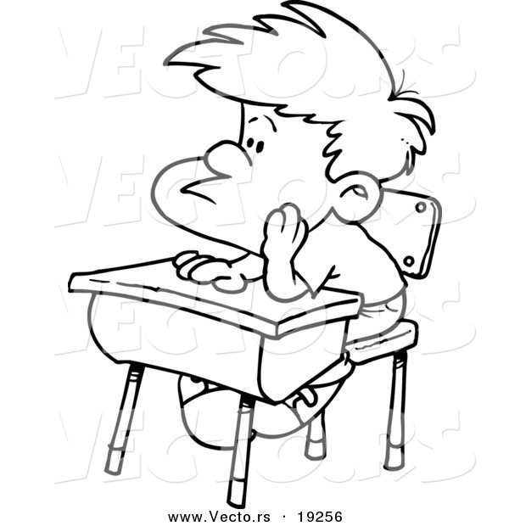

IV- Match the word with its opposite :-
rude
shy
lazy

- active X ……………………………

- polite X …………………………….

- outgoing X ……………………………….

1

Structure
I - Choose the correct answer :-
- He's from China. He is ……………………………………….

a) Chinese b)Chynese c) China

- My ………………………………………car is not black. It's dark blue.

a) friend's b) friends' c) friends

- That is my brother. ……………………………..name is Hassan.

a) Her b)His c) Our

- We can …………………..our neighbor in the garden .

a) see b) saw c ) seen

- ……………………..car is it ? It is my car .
a) Whose b) What c) Where

- Are they your classmates?

a) Yes, you are b) No, they are not c) No, she isn't

- I eat three ………………..……. For breakfast .

a) sandwich b) sandwiches c ) sandwichis

II - Do as shown between brackets :-
- They are football player ( Make Yes – no question )
……………………………………………………………………………………………………..

- You / speak / can / ? / Spanish / ( Rearrange the following questions )
…………………………………………………………………………………………
- My mother is a teacher . ( Change into negative )
……………………………………………………………………..

2

Revision U.2 Date :-

Vocabulary
I - Fill in the missing words ;
message – breakfast – editor – hospital

- Carl is the ……………………………………… of the newspaper .
- What time do you usually have ……………………………………………..?.
- Send me an SMS …………………………………. When you get there .

II – Circle the correct word :-

- His best friend is a ………………………………………. at the Grand Hotel .
a) receptionist b)teacher c) farmer
- He enjoy running on the ……………………………………….
a) bike b) treadmill c) floor
- Jane is a ……………………………. . She works at a hospital .
a) editor b)waiter c) nurse

III - Write the number under each picture ;
1.doctor – 2 – graphic designer - 3 . bellboy - 4. Chef

( ) ( ) ( )



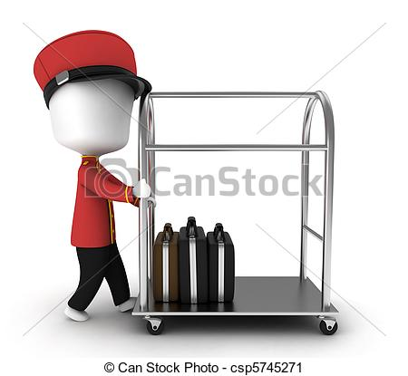

IV - Match to complete the phrases :-
1. hang out
4. mop
2. do
3. take

( ) the floor . ( ) with friends.

( ) karate lessons . ( ) homework .

3
Structure

I - Choose the correct answer :-
- My brother ( go – goes – is going ) to the gym everyday .
- We hate ( watch – to watch – watching ) TV.
- He starts work ( at – in – on ) 8:00 everyday .
- I don't want ( do – doing – to do ) all the house work .
- I never go out with friends ( in – on – at ) Friday .
II - Do as shown between brackets :-
- I go shopping on Friday ( Complete Wh- question )
When ………………. …………………….. ………………… …………………. ?

- every day / Tony / cooks / lunch . ( Rearrange the following sentence )
……………………………………………………………………….…………………………………………
- Mona gets up at 5 o'clock . ( Change into negative )
……………………………………………………………………………………………………………..
- They eat their breakfast on time .
………………………………………………………………………………………………………
- Afaf and Inas talk on phone . ( Use sometimes )
……………………………………………………………………………………………………………………
- Hassan ………………………….( ride ) a motorbike to work . ( Correct the verb )
- They ……………………………….. ( sleeps ) late on Thursday evenings .
- John can't stand ……………………………………( go ) to museums .

4

Revision U.3 Date :-

Vocabulary
I - Fill in the missing words ;
bring
garage
floor
rains interesting

- My brother's new car is in the ……………………………………….
- This documentary is very …………………………………..
- Don't ……………………….. your umbrella . It never …………………………

II – Circle the correct word :-
- Hamid has a ………………………………………. House .
a) lovely b)actually c) exactly
- I have the day ……………………………………….tomorrow .Let's go to the beach .
a) in b) off c) on
- The ……………………………. doesn't work and I hate doing the washing up .
a) fridge b)microwave c) dishwasher

III - Write the number under each picture ;
1.clock – 2 – lamp - 3 . bookcase - 4.Rug

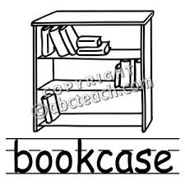



( ) ( ) ( )

IV - Match to complete the phrases :-
1. air
4. bus
2. city
3. living

( ) centre . ( ) driver. ( ) conditioner . ( ) room .

VI - Put the words in the correct category :-
Sofa - museum – hot – cousin – cloudy – bank – fridge -
son – sunny – nephew – bed - bookshop – chilly

family | Furniture | Place in a city | weather

5
Structure

I - Choose the correct answer :-
- ( Whose – What – Who's ) mobile is this ? It is Ali's .
- We are ( go – goes – going ) on holiday next year .
- Tom is playing table tennis ( now – everyday – yesterday ).
- I ( am – is – are ) talking on the phone.
- There ( is – are – be ) a table on the phone .
- Is there ( a – an – the ) dishwasher in your Kitchen .
II - Do as shown between brackets :-
- Hind is working today . ( Ask Yes - No question )
………………. …………………….. ………………… …………………. ?

- I am………………………………… ( visit ) my cousin this week . ( Correct )

- They are watching a football match . ( Change into negative )
……………………………………………………………………………………………………………..
- I have ……………….. Jacket . ( Complete with a\ an \ the )
- He is ……………….. architect .
- He has got a new car . ………………….. car was very expensive

6

Revision U.4 Date :-

Vocabulary
I - Fill in the missing words ;
sell
rash
build
allergic

- No Ice cream for Lary .He is ……………………………………….to chocolate.
- I have a horrible ………………………………….. on my arm .
- My brother wants to ……………………… his car . Do you want to buy it

II – Circle the correct word :-
- They should ………………………………………. a new sports centre in our town .
a) build b) orgnise c) paint
- Naim always buys ………………………………………. clothes .
a) strong b) trendy c) change
- I am a ……………………………. Of an organization called Helping Hand .
a) doctor b) farmer c) volunteer

III - Write the number under each picture ;
- dizzy – 2 – toothache - 3 . peas - 4.kickboxing







( ) ( ) ( ) ( )

IV - Match to complete the phrases :-

a - tea
d - water
b - pizza
c – soup

- A bottle of …………………………….
- A cup of …………………………………
- A slice of ……………………………….
- A bowl of …………………………….
7

Structure

I - Choose the correct answer :-
- Let's make ( some – any – no ) Sandwiches .
- I like cherries ( and – but – so ) I don't like cherry ice cream .
- Is there ( some – no – any ) meat in the fridge ?.
- How ( many – much – little ) carrot do you eat every day ?
- I usually put lot of salt ( but – and – because ) paper on my pasta .
- You ( should – shouldn't - ____ ) eat fast food .
- There is not ( much – some – a little ) salt in the rice .
II - Do as shown between brackets :-
- There is a little lettuce . ( Ask Yes - No question )
………………. …………………….. ………………… …………………. ?

- We should ………………………………… ( going ) to the mall . ( Correct )

- ( How much)students are there in the classroom ?

……………………………..
- Visit / doctor . ( Use should )
……………………………………………………………………………………………………………..
- There is a little cheese . ( Complete Wh - question )
How ………………. ………………….. ……………. …………………….. ?

8

Revision U.5 Date :-

Vocabulary
I - Fill in the missing words ;
safe
age
kill
shocked

- Mazin couldn't speak at the ……………………………………….of two .
- Noor was ………………………………….. when she heard the news .
- It is not ………………………………… to swim in the river! Get out fast

II – Circle the correct word :-
- The young man ………………………………. The woman's bag and started running .
a) made b) forgot c) stole
- I find it ………………………………………. to study for an exam during summer .
a) fast b) difficult c) slow
- Last weekend I decided to go swimming but ……………………………. ,it started raining .
a) unfortunately b) suddenly c) luckily

III - Write the number under each picture ;
- fishing – 2 – camping - 3. burglary - 4.skiing

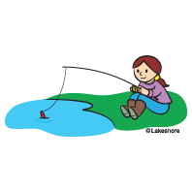
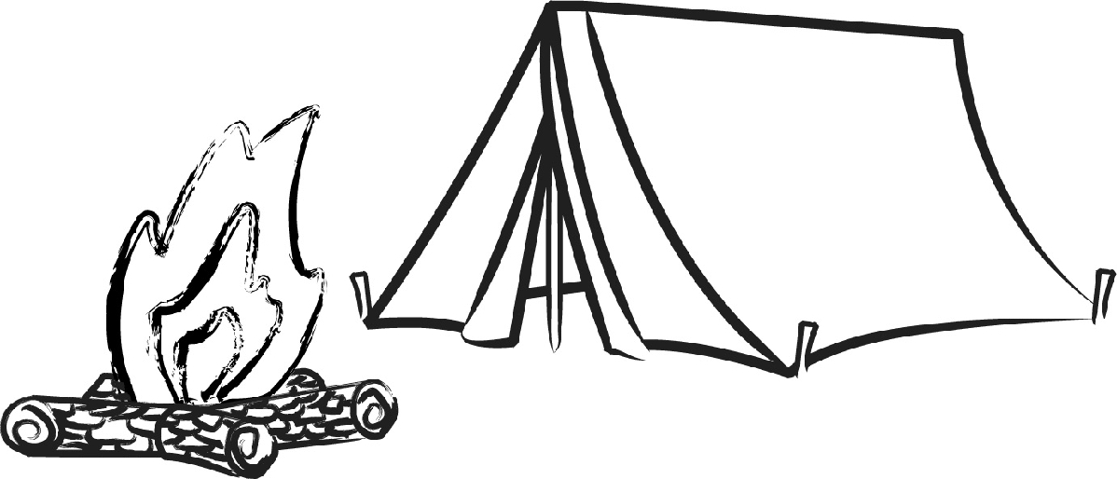
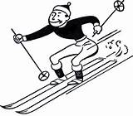


( ) ( ) ( ) ( )

IV - Match to complete the phrases :-

1 - pass
4 - get
2 – pick up
3 – lose

……………… my memory .
……………….. a degree
…………………… the phone
…………………… an exam
9

Structure

I - Choose the correct answer :-
- They ( were – is – was ) in London last year .
- My brother could ( play – playing – played ) tennis when he was seven .
- The internet is very ( slow – slowly – slower ) .
- We ( buy – buying – bought ) our house five years ago .
- This is an easy exercise .I can do it ( easy – easier – easily ) .
II - Do as shown between brackets :-
- I finished school in 2002 . ( complete Wh- question )
When …………… ………………… …………………. …………………………. ?

- He ………………………………… ( sleeps ) early yesterday . ( Correct )

- It was cloudy today . ( make it negative )
……………………………………………………………………………………………………………..
- Ahmed played game last week . ( Ask Wh - question )
………………. ……………. ……………. ………………… ………………………….. ?

10

Revision U.6 Date :-

Vocabulary
I - Fill in the missing words ;
runner - swimmer - borrow - annual

- Can I …………………………………. Your pencil , please ? I don't have one .
- The ………………………………….. event is going to take place at the stadium this year .
- Matt runs really fast . he wants to become a …………………………………

II – Circle the correct word :-
- The event is going to be great . Don't ………………………………. It .
a) miss b) cancel c) lose
- All ………………………………………. To the zoo want to see the shark .
a) visit b) visitors c) people
- The ……………………………. Of the compaction gets $ 2000 .
a) visitor b) loser c) winner

III - Write the number under each picture ;
- Artist 2 – goat 3. festival 4. shark

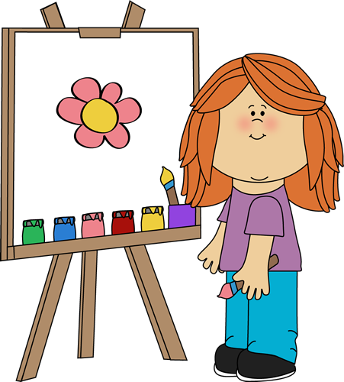


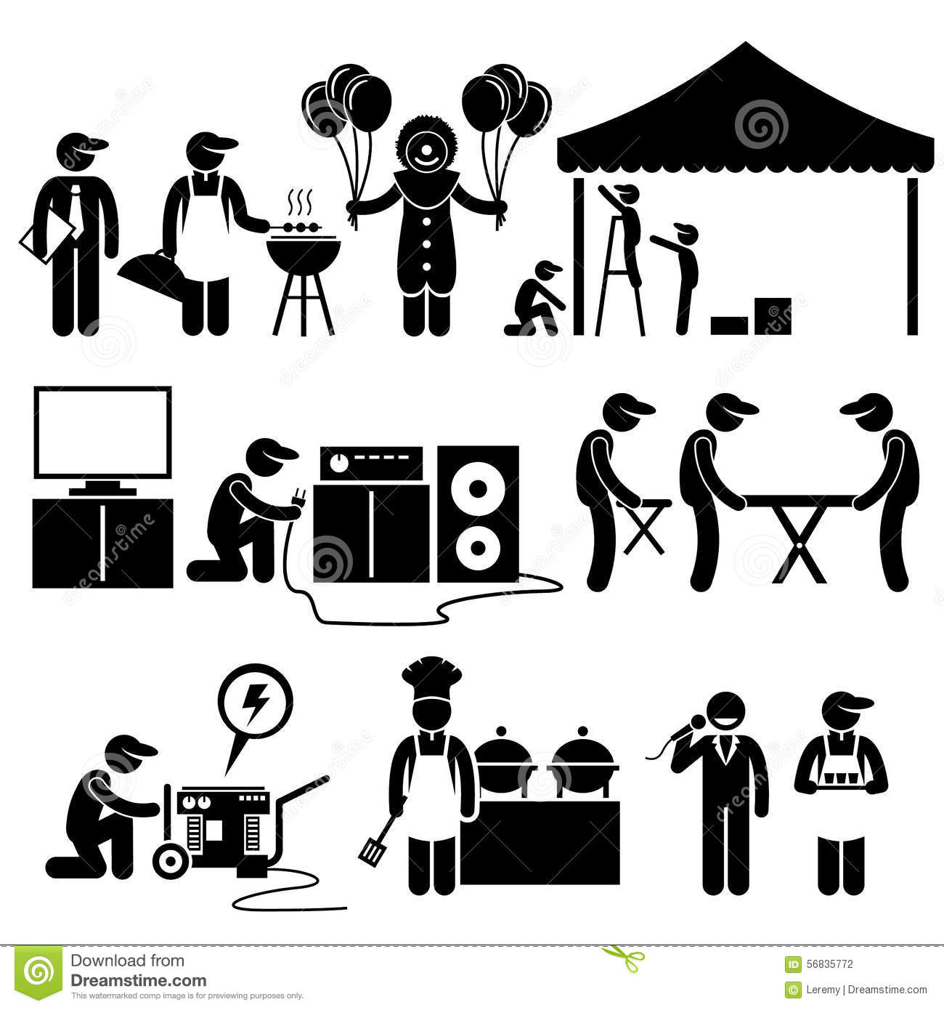

( ) ( ) ( ) ( )

IV - Cross the odd word :-

- Sheep – goat – desk - cow
- Pink – white – red – park
- Chair – history – math – Arabic

11

Structure

I - Choose the correct answer :-
- May I ( use – using – used ) your mobile phone ?
- Tina can't go out . She ( have to – has to – had to ) study ;
- ( Will – can – must ) I borrow your camera ?
- I'm going to ( visit – visited – visiting ) my aunt this week .
- Hennery is ill . How about ( give – giving – gave ) him a call .
- ( Anything – Everything – Something ) was expensive .
II - Do as shown between brackets :-
- go / the doctor / to / Let's . ( re-arrange )
…………………………………………………………………………………..

- I have to ………………………………… ( listening ) to my parents . ( Correct )

- Football player eat healthy food . ( use have to )
……………………………………………………………………………………………………………..
- Why don't we ( stay – staying – stayed ) at home ? . ( Choose )

12

