|  |  |  |  |
| --- | --- | --- | --- |
| **المملكة العربية السعودية**  **وزارة التعليم**  **الإدارة العامة للتعليم بـن مدرسة م ن الابتدائية** | http://tabuk2day.com/wp-content/uploads/IMG_3362.jpgبسم الله الرحمن الرحيم **اختبار الفصل الدراسي الثاني**  **للعام الدراسي 1444 هـ**  **https://t.me/abokhaledamer** | **المادة** | **لغة انجليزية** |
| **الصف** | **السادس** |
| **الزمن** | **ساعة ونصف** |
| **الفصل** | **----- /6** |
| **اسم الطالب رباعيا: .............................................................................................................رقم الجلوس: ------------**   |  |  |  |  |  |  |  |  | | --- | --- | --- | --- | --- | --- | --- | --- | | **السؤال** | **1** | **2** | **3** | **4** | **5** | **6** | **المجموع** | | **الدرجة** |  |  |  |  |  |  |  | | **الدرجة** | 6 | 5 | 4 | 5 | 6 | 4 | 30 | | **المصحح** |  |  |  |  |  |  |  | | | | |

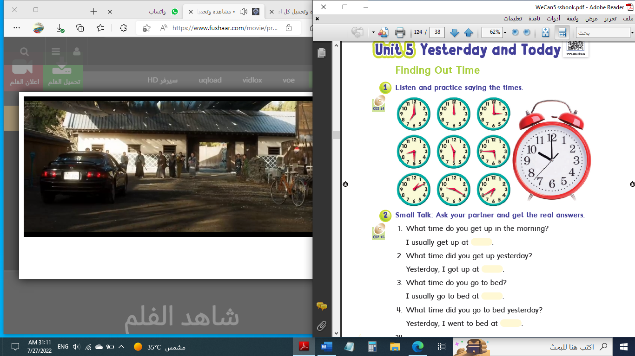

**6**

**I- General Questions:**

**Q1: A. Choose the suitable answer:**

**1. What time is it?**

****( It’s one o’clock. - It’s ten o’clock. - It’s twelve o’clock. )

**2. What do you do?**

( I’m a doctor. – I’m fine, thank you. – I’m Ali. )



**3. Ali cooked a nice ------------.**

( trampoline – sharks - breakfast )

**B. Answer these questions:**

**1.What is the past of “make”? _______________.**

**2. What time do you get up?**  **____________________.**

**3. Where do teachers work? _______________________________.**

**5**

**II- Controlled Writing:**

**Q2: Do as shown between brackets:**

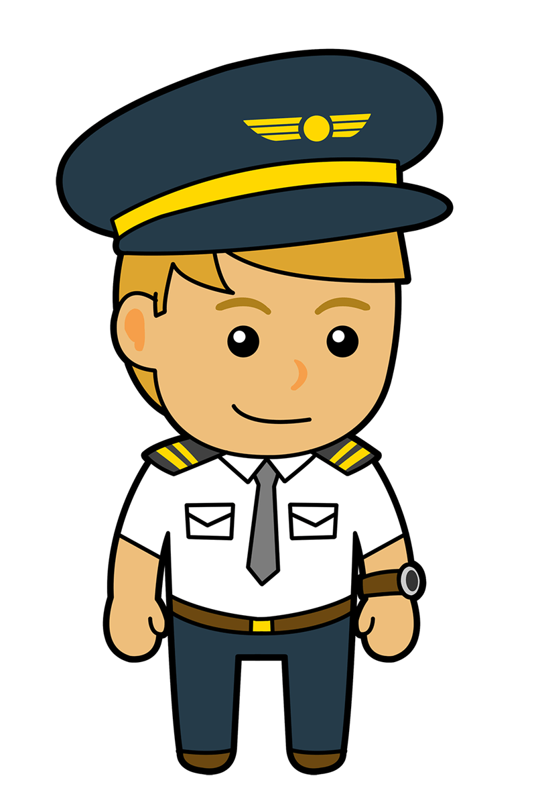**1. I – homework – do – at 4:00. (**Rearrange**) _______________.**

**2. When I grow up, I want to be a _______________.**  **(**Complete**)**

**3. How many tomatoes do we need? (**Answer**) _______________.**

**4. cleaned – my – I – room. (**Rearrange**) _______________.**

**5. went – Khaled – the cupboard. – to (**Rearrange**)__________________.**

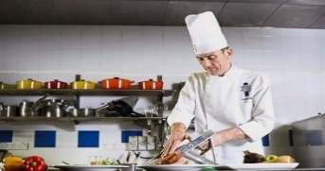**III- Reading Short Sentence:**

**4**

**Q3: Match the sentence with the picture:**

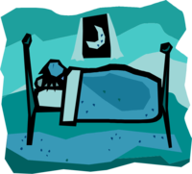**1. I go to bed at 10:00.**

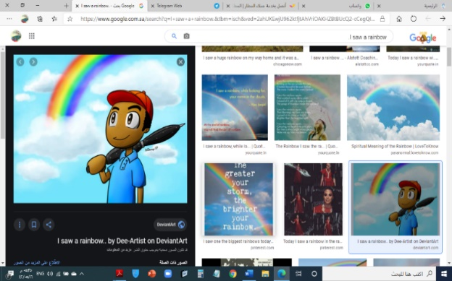**2. The cook works in a restaurant.**

**3. Fahad studied for 6 hours.**

**4. I saw a rainbow.**

**IV- Grammar:**

**5**

**Q4: Choose the correct answer:**

**1. What time (** do – does – did **) you go to bed yesterday?**

**2. I usually (** meet – meets – met **) my friends at the mall.**

**3. (** Where – When – What **) does a nurse work? She works in a hospital.**

**4. (** What – Who – When **) does he do? He is a student.**

**5. How (** many – much – old **) tea do you need?**

**6. We need (** some – any – not **) apples.**

**7. We don’t have (** some – any – no **) tomatoes.**

**8. Yesterday, we (** have – had – has **) some salad.**

**9. Yesterday, we (** don’t – doesn’t – didn’t **) have any ketchup.**

**6**

**10. Sorry (** on – to – about **) that.**

**V- Vocabulary:**

**Q5: Write the correct number under each picture:**

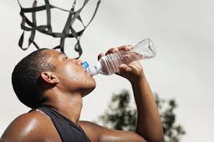 **1**- firefighter **2**- boring **3**- captain **4**- ring **5**- trampoline 6- drink

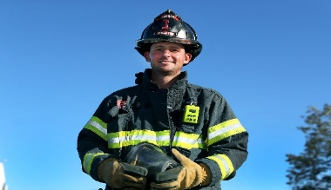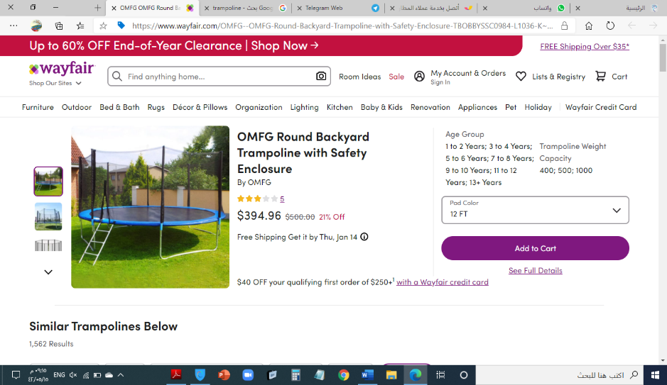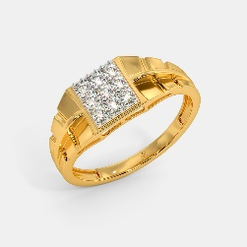

**4**

**( ) ( ) ( ) ( ) ( ) (** )



**VI- Orthography:**

**Q6: Fill in the missing letters: gh / sh / wh / fr / ph / nd / nt / kn**

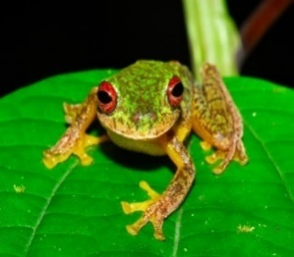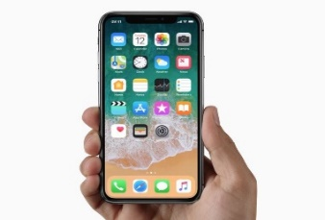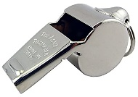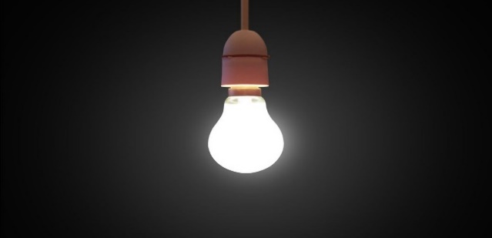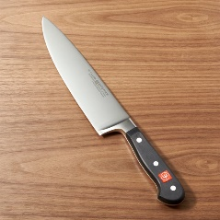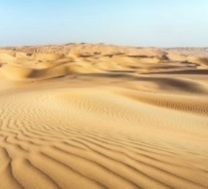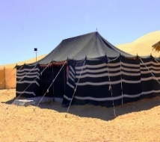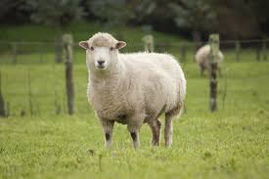

**_ _ eep _ _ istle li _ _ t _ _ ife sa_ _ te_ _ _ _ one _ _ og**

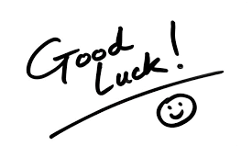

**End of Questions**

**ABOKHALEDAMER**

**0557325813**