Kingdom of Saudi Arabia 4th, 5th & 6th Elementary Grade

Ministry of Education Time: An hour and a half

3rd Elementary School Number of papers: 3 . Final Exam – Third Term – 1446 AH

1. **General Questions:**

**/ 6**

1. **Choose the correct answer:**

|  |  |  |
| --- | --- | --- |
| 1. **What should you do if you have a toothache?** | | |
| 1. Visit the dentist | 1. It’s moving slowly | 1. I work at the zoo |
| 1. **Where do you work?** | | |
| 1. Visit the dentist | 1. It’s moving slowly | 1. I work at the zoo |
| 1. **How is the tortoise moving?** | | |
| 1. Visit the dentist | 1. It’s moving slowly | 1. I work at the zoo |
| 1. **What is the weather like today?** | | |
| 1. It is windy. | 1. I like winter. | 1. Yes, it was. |
| 1. **Was it sunny on Sunday?** | | |
| 1. It is windy. | 1. I like winter. | 1. Yes, it was. |
| 1. **What’s your favorite season?** | | |
| 1. It is windy. | 1. I like winter. | 1. Yes, it was. |

1. **Controlled writing:**

**/ 5**

1. **Rearrange the words to form a sentence:**

animals – are – quiet – Cats

……………………………………………………………………………..

1. **Fill in the missing words:**

**cage – hot – wet – stomach**

|  |  |  |  |
| --- | --- | --- | --- |
| wet weather clipart - Clip Art Library  He is in the ……………. climate. | Cage , Free Transparent Clipart - ClipartKey  In zoos, some birds often live in this. (………………. ) | Digestive System Process Royalty-Free Images, Stock Photos & Pictures ...  The part of your body where food goes. (……………….) | Premium Vector | Boy too hot thirsty from heat of the summer sun  He is in the ……………. climate. |

1. **Reading Short Sentences:**

**/ 4**

1. **Match the sentences with the correct pictures:**
2. I like rabbits. 3- He is ill.
3. He is a vet. 4- I’m going to go skiing.

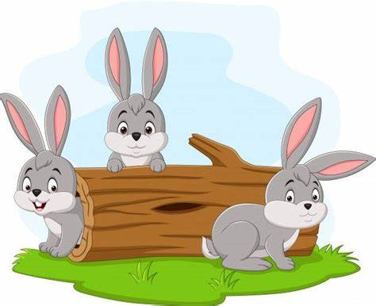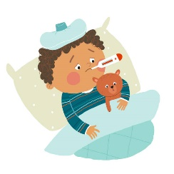

**( ) ( ) ( ) ( )**

**/ 5**

1. **Grammar:**

|  |  |  |
| --- | --- | --- |
| 1. **Choose the correct answer:** | | |
| 1. You …………… shout in the hospital. | | |
| 1. must | 1. mustn’t | 1. have to |
| 1. I think there is …………… at the door. | | |
| 1. someone | 1. everywhere | 1. anything |
| 1. The girl …………… wears pink is my sister. | | |
| 1. who | 1. when | 1. whose |
| 1. The cheetah is the……………animal in the world. | | |
| 1. fast | 1. faster | 1. fastest |
| 1. They are going to …………… swimming next week. | | |
| 1. go | 1. went | 1. going |

1. **Vocabulary:**

**/ 6**

1. **Write the word under the pictures:**

**cough – giraffe – flashlight – medicine – owl – melting**

|  |  |  |  |  |  |
| --- | --- | --- | --- | --- | --- |
| Ice Cube Melting Clipart Free Images At Clker Com Vec - vrogue.co | Flashlight Clipart 1148296 Illustration By Lineartest - vrogue.co | Giraffe Clipart Images – Browse 10,977 Stock Photos, Vectors, and #3703280 | Hinstock Primary School - Owl Class (Year 5 & Year 6) | Cough Clipart | Free download on ClipArtMag | Premium Vector | Pills and liquids medicine for children kawaii doodle ... |
|  |  |  |  |  |  |

1. **Orthography:**

**/ 4**

1. **Choose the correct missing letters:**

|  |  |  |  |  |  |  |  |
| --- | --- | --- | --- | --- | --- | --- | --- |
| Rainbow Clipart Vector Art, Icons, and Graphics for Free Download  rain__ow | | Simple Ice Cube Clipart, Clipart, Ice, Cold PNG Transparent Image and ...  i__e | | Free Cartoon Snow Cliparts, Download Free Cartoon Snow Cliparts png ...  s__ow | | Clipart Tall  t__ll | |
| b | d | s | c | n | m | o | a |
| Premium Vector | Cute boy sleeping in his bed preschool kid daily ...  as__eep | | brave clip art 19 free Cliparts | Download images on Clipground 2025  bra__e | | Blood Finger Test Illustrations, Royalty-Free Vector Graphics & Clip ...  c__t | | 9,543 Cartoon Baby Show Royalty-Free Photos and Stock Images | Shutterstock  c__y | |
| l | i | f | v | k | u | r | i |

**BEST OF LUCK ☺**

**Ms. Tahani Al-Ghamdi**