Lab 15: Welded Assembly of Lofted Features

1. Open a new part file; check that the units are set to mm.

2. Open a sketch on the ‘Top Plane’ and sketch a circle with a Ø100mm centred at the origin.

3. Extrude this sketch to a thickness of 12mm.

4. Select the ‘Top Surface’ of the Flange and add a 3mm fillet.

5. Open a sketch on the ‘Top Surface’ of the Flange and draw a vertical centre line up from the origin. See Figure 1.

Figure 1
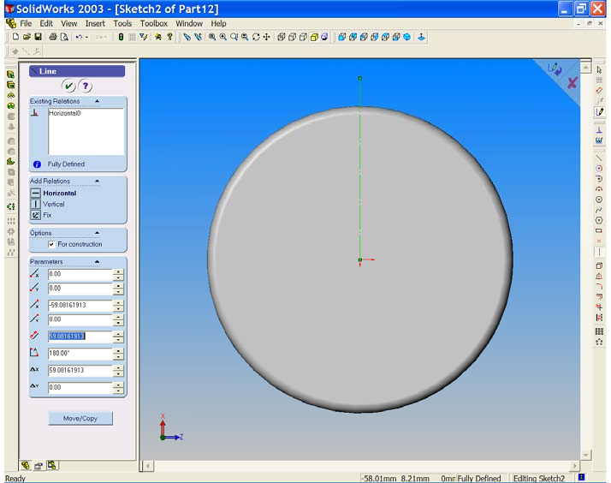

6. Select the ‘Hole Wizard’ from the ‘Features Toolbar’. The ‘Hole
Definition Window’ opens.

• Choose the ‘Countersink Tab’.
• For ‘Standard’ choose ‘ISO’.
• For ‘Screw Type’ choose ‘CTSK Flat Head’.
• For ‘Size’ choose ‘M8’.
• For ‘End Condition & Depth’ choose ‘Through All’.
• Leave all other values as default sizes. See Figure 2.
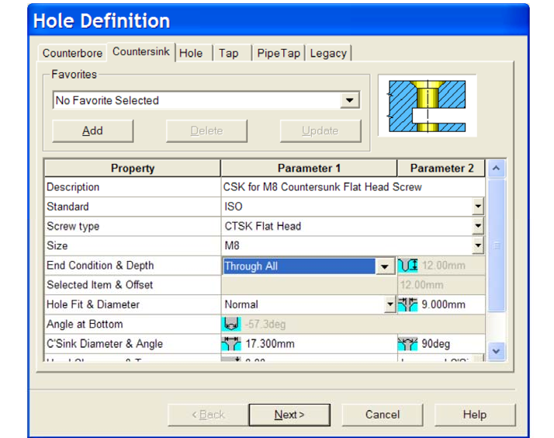
Figure 2

7. Select the ‘Next’ button. The ‘Hole Placement’ window opens.

Note the symbol on the cursor.

Figure 3
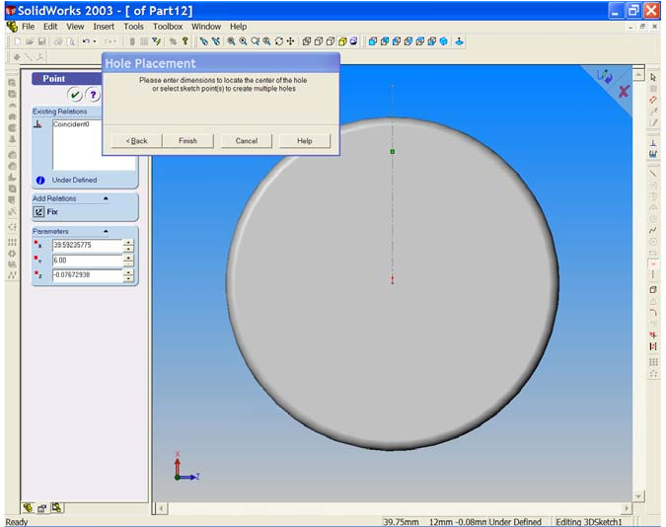

Place the cursor on the centre line as shown in Figure 3.

Notice that the centre line changes to red.
8. Right click and choose ‘Select’. Choose the dimension tool and add the distance from the origin to the hole centre. This distance should be 35mm.

Figure 4
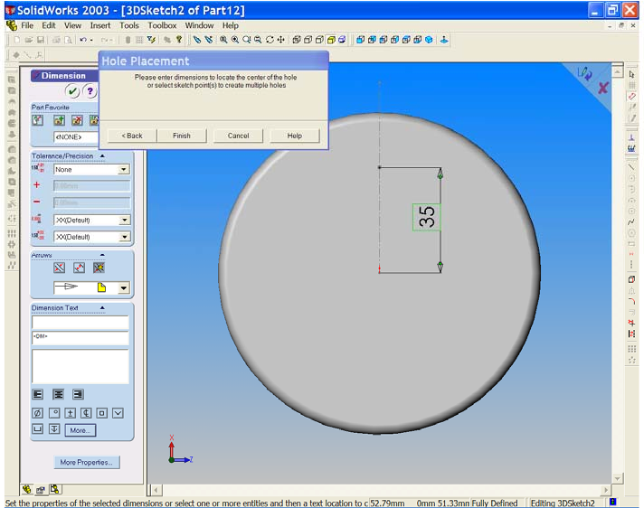

Figure 5
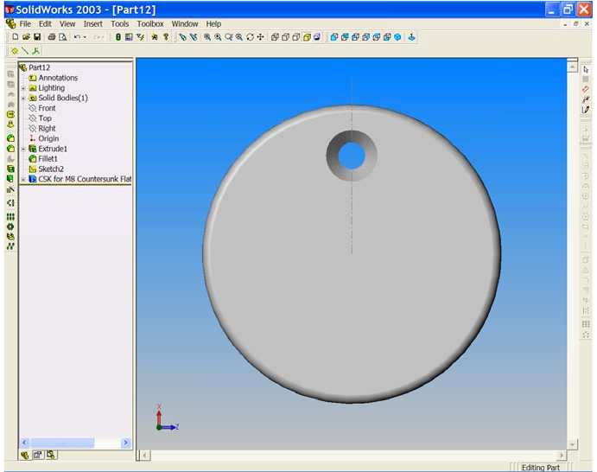

9. Select ‘Finish’ from the ‘Hole Placement’ window. The hole is generated and the feature is added to the design tree. See Figure 4 & 5.

10. We will now add 5 more countersunk holes creating a ‘Circular Pattern’ of the first hole. Choose the ‘Circular Pattern’ button.
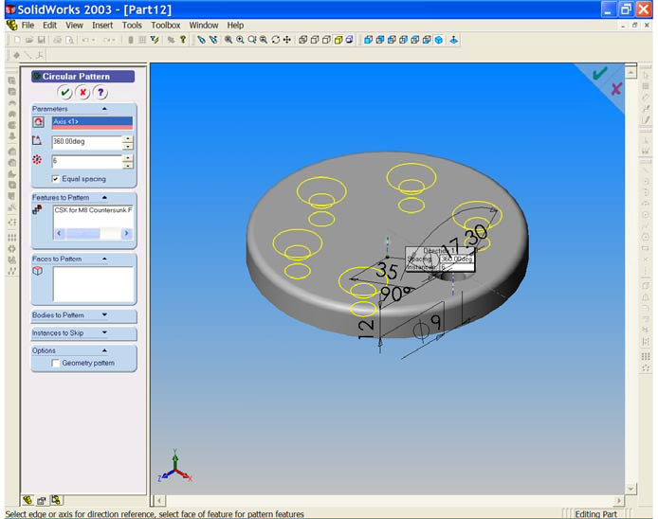
Figure 6

11. The ‘Circular Pattern Property Manager’ opens.

Note that the first hole is already listed in the ‘Features to Pattern’ field.

From the ‘View’ drop down menu select ‘Temporary Axes’. Select
‘Isometric’ to get a better view of these axes. For the ‘Pattern Axis’ field (the pink field) choose the centre line in the middle of the Flange (not the centre line in the middle of the hole). Ensure that the equal spacing box is ticked and that the angle is 360º. Increase the number of instances from 2 to 6. You may use the ‘up’ arrow and watch the yellow preview indicating the
result as more holes are added. When all six holes are shown, select OK to complete the command. The circular pattern of countersunk holes is added to the Flange and listed in the design tree. See Figure 6.

12. Switch off the ‘Temporary Axes'. Right click on the centre line sketch and choose ‘Hide Sketch’. The Base Flange is now complete.

13. Use ‘Save As’ and save the ‘Flange’ for later use. You may close the file.

14. Open a new part and save as ‘Lofted Column’.

15. Activate the ‘Top Plane’ and choose ‘Isometric’ .
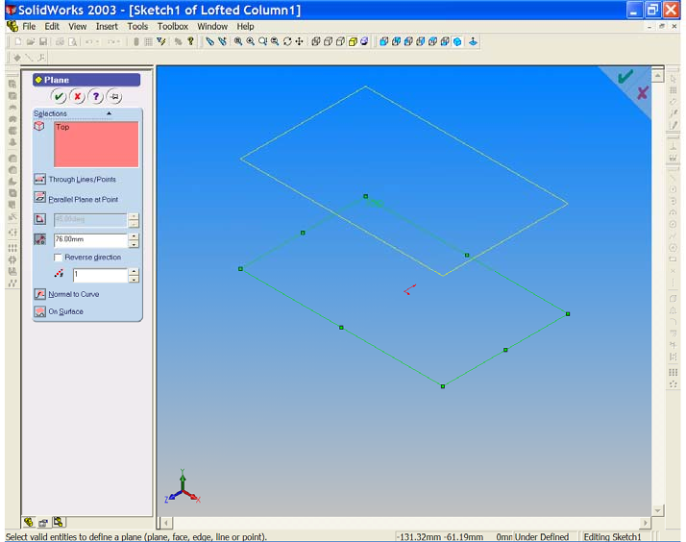
Figure 7

16. Hold down the control key and create a new plane parallel to the Top Plane and at a distance of 76mm above it. See Figure 7.

17. Open a sketch on the Top Plane and sketch a circle of Ø42 centred at the origin.

18. Open a sketch on the upper plane (plane 1) and sketch a circle of Ø32 centred at the origin. See figure 8.

Figure 8
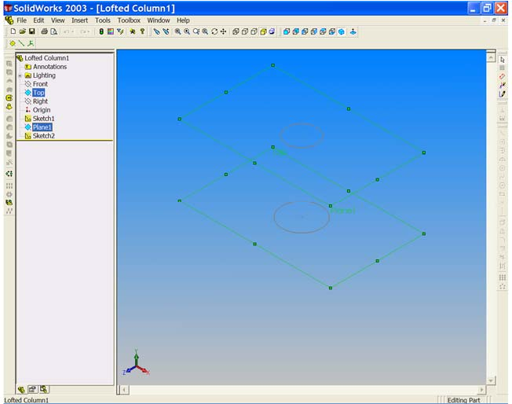

19. Select the ‘Loft’ button from the ‘Features Toolbar’. Ensure that ‘Show Preview’ is checked under options in the ‘Loft Properties Manager’. Select the lower circle at any point on its circumference. The point is highlighted on the sketch and is listed in the pink profiles field of the ‘Loft Properties Manager’.

20. Select the upper circle circumference at approximately the same position as the lower one.

Figure 9
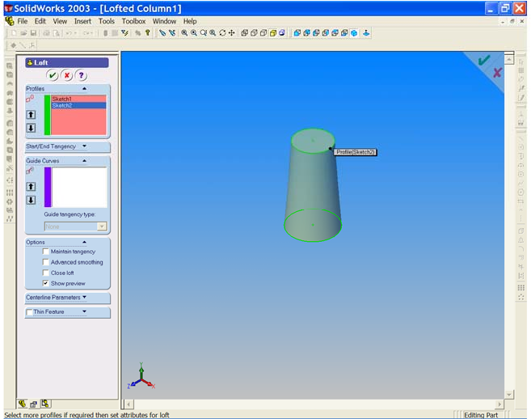

A solid loft is generated between the two sketches and the second sketch is listed in the pink profiles field.

21. Select ‘OK’ to complete the command.

22. SAVE YOUR WORK!!!

23. We can now weld all the parts together. Open the ‘Hand Rail Column Top’, the ‘Flange’ and the ‘Lofted Column’.

24. Choose ‘New’ and select ‘Assy’ . 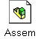

25. From the ‘Window’ drop down menu choose ‘Tile Horizontally’.
See Figure 10.
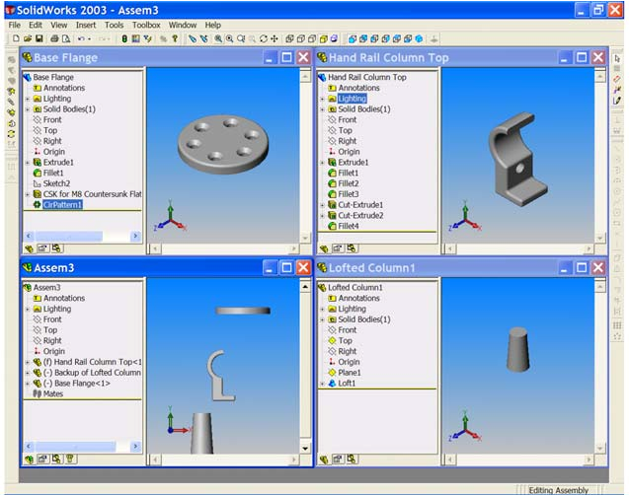
Figure 10

26. We can now begin the procedure for joining these parts together by welding.

Place the ‘Hand Rail Column Top’ into the Assembly first. This first part will be the ‘Anchored Part’ of the assembly. From the top of the design tree drag the ‘Hand Rail Column Top’ icon into the design tree area of the assembly window. Remember to hold the left button down as you drag and drop. Drag the other two parts from the top of their design trees and drop them in the graphics area of the assembly window.

27. Maximise the assembly window. To see the parts more clearly choose
‘Isometric’ . See figure 11.

Figure 11
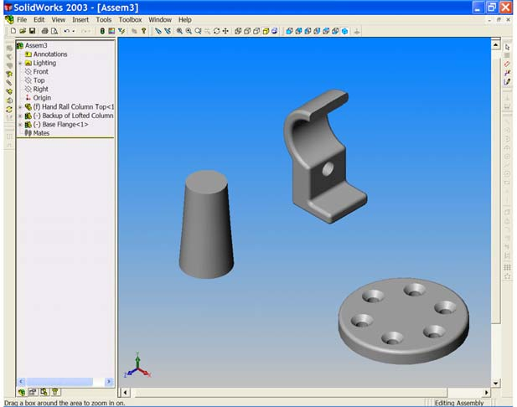

28. We will now mate the base of the lofted feature to the top surface of the
flange. Select ‘Mate’ from the ‘Assembly Toolbar’. Choose the Top Surface of the flange to activate it and to list it in the ‘Entities to Mate’ field of the
‘Mate Properties Manager’.

29. Use the ‘Rotate’ button and choose the bottom of the lofted feature.

Select ‘Coincident’ and ensure that ‘Closest’ is checked.

30. We will now make these two cylindrical parts concentric.

Select the circular base of the Flange. Hold down the control key and select the circular base of the lofted feature. Choose ‘Mate’ once again; note that
the two surfaces are listed and that the concentric mate is now available. Mate these two features to each other.

Figure 12
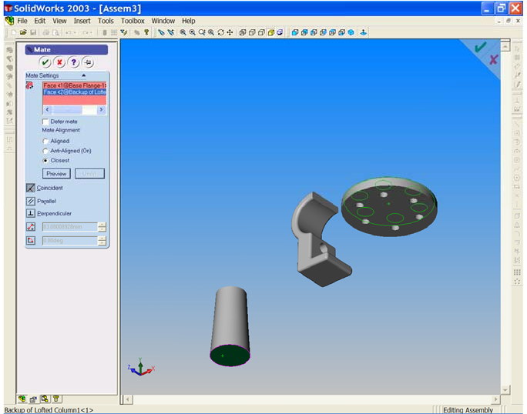

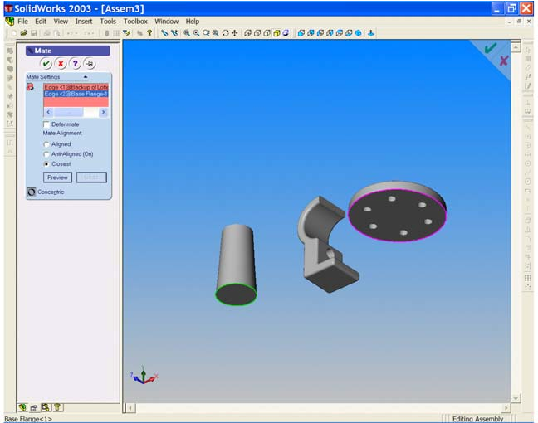
Figure 13

31. We must now mate these two parts to the bottom surface of the final part.

Use ‘Mate’ ‘Coincident’ to align the top surface of the lofted feature with the bottom surface of the final part. See Figure 14.

Figure 14
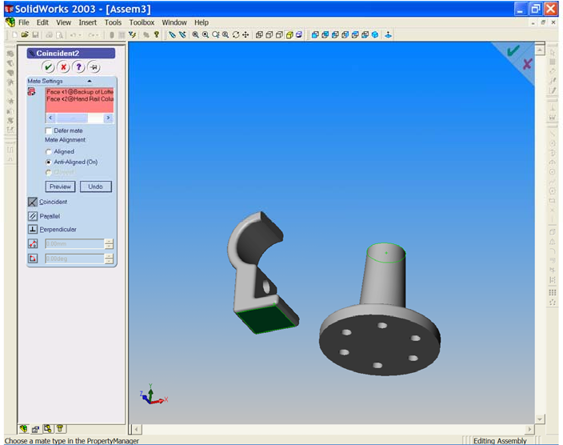

32. In the design tree select the ‘Origin’. From the ‘View’ drop down menu, switch on ‘Temporary Axes’.
33. Select ‘Mates’ note that the origin is already listed in the ‘Entities to Mate’
field. Select the vertical axis through the lofted feature and choose
‘Coincident’ and Preview’ in the ‘Mate Property Manager’. See Figure 15.

Figure 15
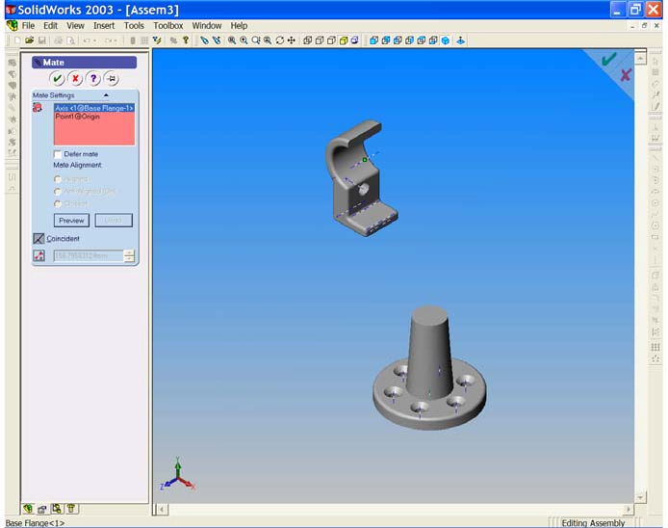

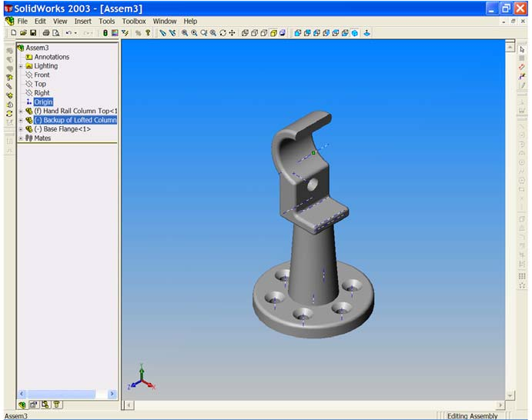
Figure 16

Notice that all parts are now correctly positioned and ready for welding. Figures 15 & 16.

Switch off the temporary axes.

SAVE YOUR WORK!!!

34. From the ‘Insert’ drop down menu navigate to ‘Weld Bead’. See Figure???
The weld bead window opens. The most suitable weld here is the ‘Fillet Weld’. Choose ‘Fillet’ from the ‘ISO’ ‘Weld Types’ offered in the window and choose ‘Next’.

Figure 17
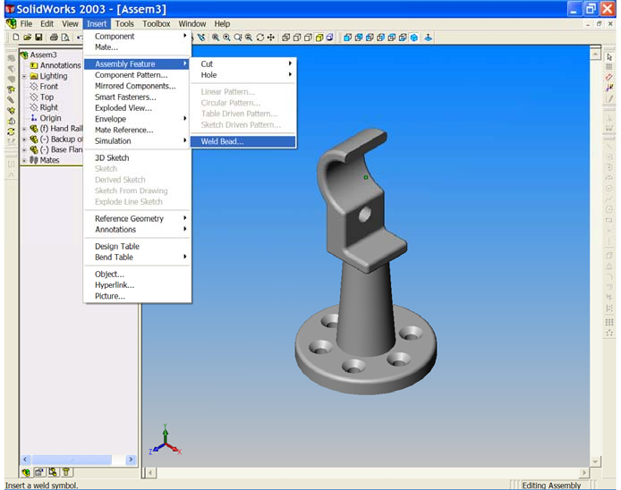

Figure 18
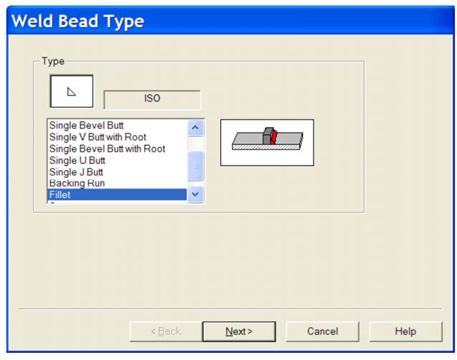

(Note the weld symbol and the pictorial diagram change as you make selections.)
• For ‘Surface Shape’ choose ‘Concave’.
• For ‘Top Surface Delta’ increase the value to 0.75.
• For ‘Radius’ increase the value to 5mm. When the above changes are in place choose ‘Next’.

Figure 19
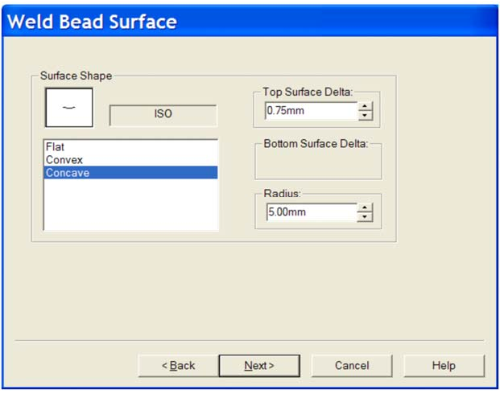

We must now select the surfaces to be welded.

Select the top surface of the Flange and the cylindrical surface of the Lofted Column. These two surfaces are listed in the pink ‘Contact Faces’ window. Choose ‘Next’ and ‘Finish’. The weld is generated between the two parts and is added to the design tree. See Figure 20.

Figure 20
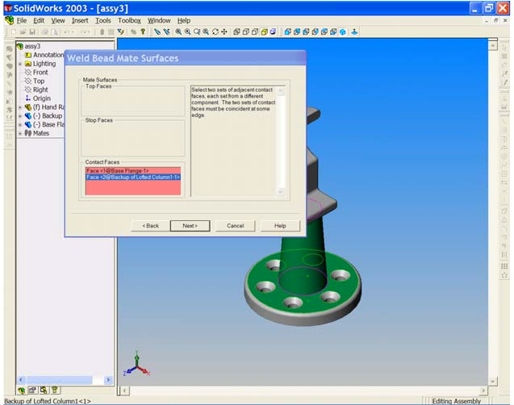

35. With the ‘Rotate’ tool manoeuvre the model so that the under surface of the model is visible and apply the same weld between the Top of the lofted column and the bottom of the other piece.

You will find however that the 5mm radius is too big for a weld at this location.

Use the back button to return to the appropriate window and reduce the radius to 3mm. The weld will now be satisfactory. See Figure 21.

Figure 21
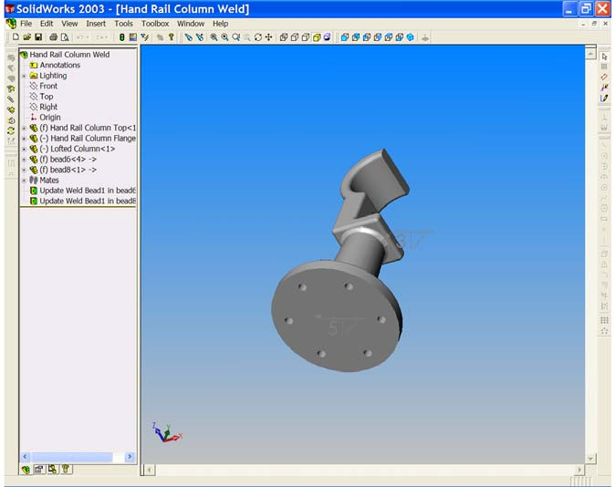

SAVE YOUR WORK!!

