Test 1
20
TOTAL

Name .

1. Write the plural.
1. pancake ________________
2. tomato ________________
3. sandwich ________________
4. strawberry ________________
4
score


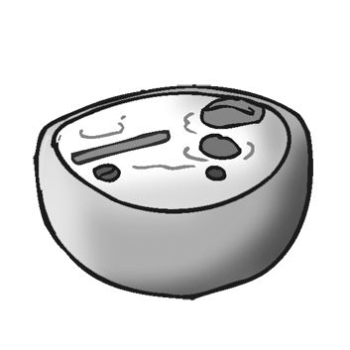
2. Listen and tick (✓).
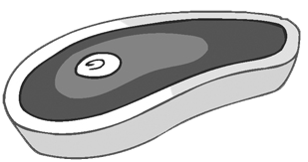
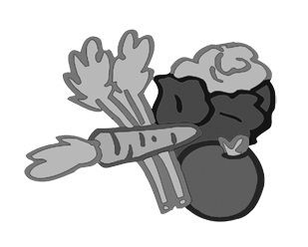
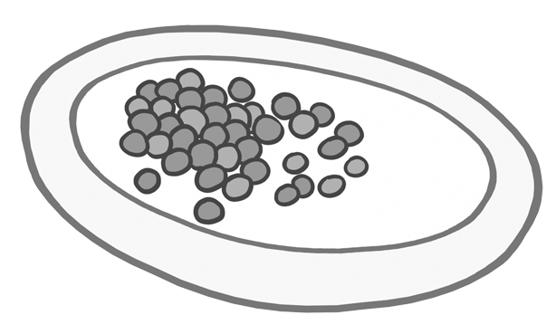
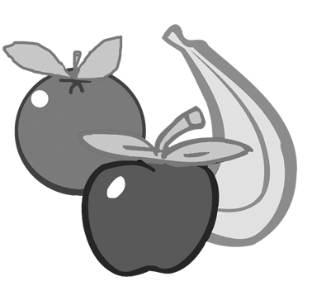


1.
2.
3.
b

a

b

a

b

a

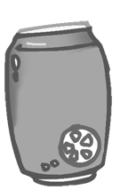
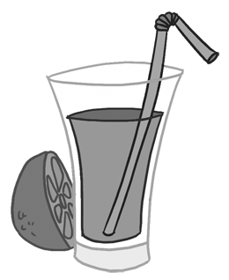
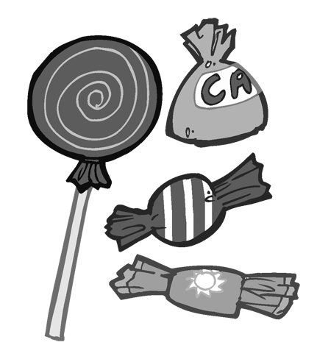

b

a

4.
5.
b

a

5
score

thanks sour don’t like
Do you like sweet good like

3. Read and complete.

1. I (1) this tea. It’s cold.
2. I like banana juice. It’s (2) .
3. (3) milk?
It’s (4) for you.
4. Sami: Do you want water?
Ali: No, (5) . I’m not thirsty.
5. You don’t like omelette. You (6) . chicken with beans. It’s your favourite food.
6. I don’t like this orange juice. It’s (7) .
7
score

- Answer about yourself.
1. What do you have for breakfast?
2. What do you have for lunch?
3. What do you have for dinner?
4. Do you like cheese? .
4
score

