

Department of Biomedical Technology

BASIC MECHANICAL SKILLS
BMT 221 Lab Manual

Lab 4: Extruded Feature; V-Block

2nd Semester 1438-1439

Biomedical Technology
King Saud University
Riyadh, Kingdom of Saudi Arabia

In order to demonstrate how to create extruded features step by step, a V-Block model is used in this tutorial. Its geometry and dimensions are given in Figure. 1.

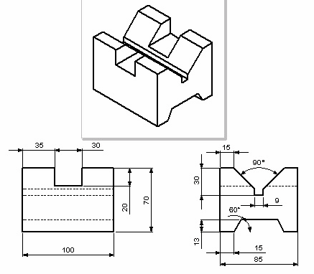

Modeling Procedure

Figure 1. V-Block

Before a model is created, a strategic plan for modeling should be done. The following points should be considered:

• Which view of the part best conveys its shape?
The base feature is usually the most prominent feature in that view.

• What is the most important feature of your part?
Create these features early in the modeling process so you can use them for creating subsequent features.

• Can the origin and coordinate planes be used to modeling advantage?

After the above considerations, the V-Block can be created from the following steps as shown in Figure2.

1) Create a 100mm x 85mm x 70mm block using the Extrude Boss/Base.

2) Cut a 30mm x 20mm x 85mm Rectangular Slot using Extrude Cut.

3) Cut a V-slot using Extrude Cut.

4) Cut a Trapezoid slot using Extrude Cut.

Figure 2 V-Block Modeling steps.

Start Solid Works and Set up Properties

1) Start Solid Works.

2) Click New on the Standard toolbar, or select File, New on the menu bar.

3) Select Part 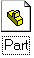 from the Tutorial tab in the dialog box and then click OK.

4) Click File, Properties on menu bar.

5) Fill in the necessary properties in the dialog box, and click OK to accept the properties and close the dialog box.

6) Select Tools, Options on the menu bar to open the Options dialog box.

7) Select the Document Properties tab, and click Unit in the properties tree text box.

8) Select Millimeter and set the decimal places to 2 as shown in Figure 3. The available units are Millimeters, Centimeters, Meters, Inches, Feet, Feet, Inches, etc.

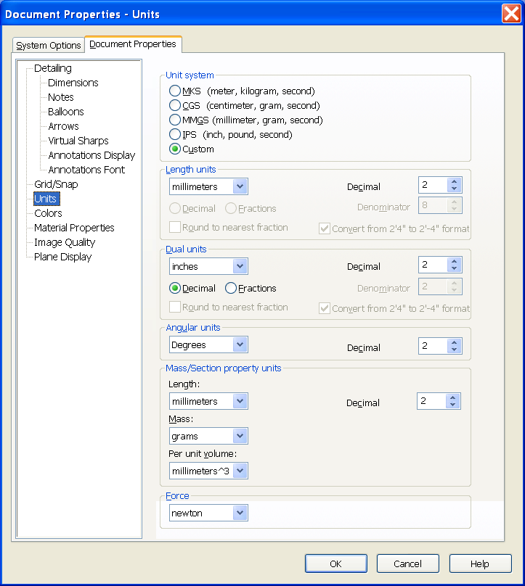

Figure 3 Units selection

9) Click Material Properties in the properties tree box. Change the density to 0.0078 g/mm3 as shown in Figure 4.
-
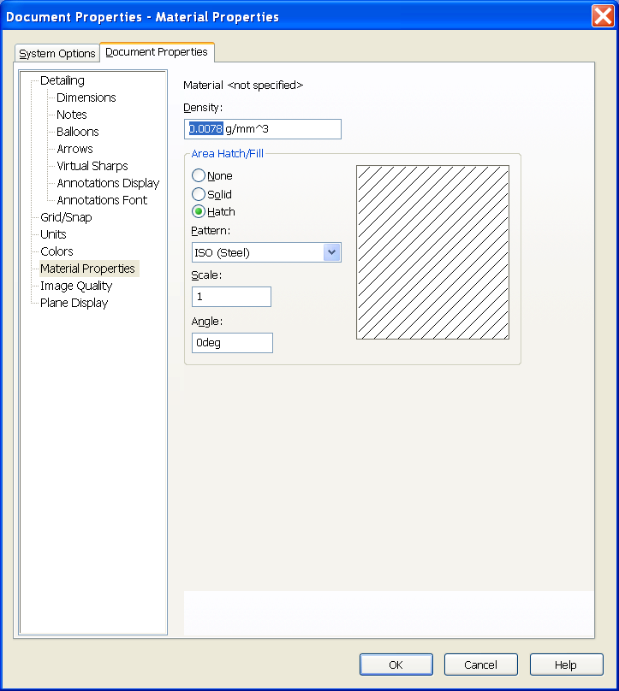

Figure 4 Material properties

10) Click Grid/Snap in the properties tree box. Check the Display grid check box in the grid frame to display the grid in the sketch environment as shown in Figure 5.

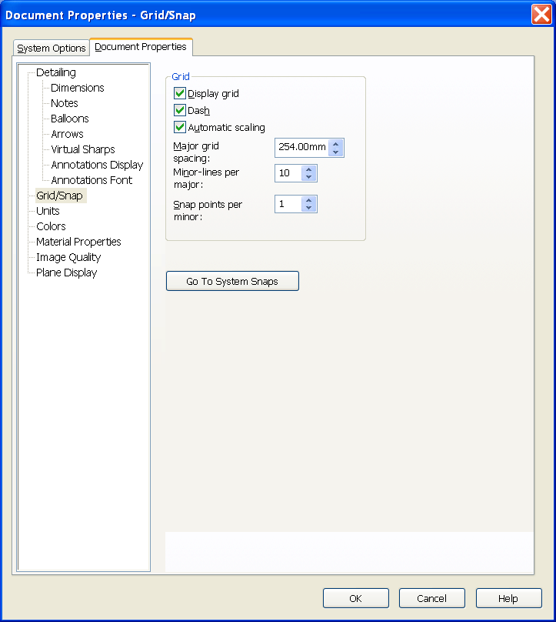

Figure 5 Grid/Snap
11) Click OK to accept the changed properties and close the dialog box.

Create Extruded Base Feature

1) Click Sketch on the Sketch toolbar.

2) Bring cursor closer to Front plane, when highlighted, Click on it to open a new sketch on Front Plane.

3) Select Rectangle on the Sketch

Tools toolbar.

4) Click the origin as one corner of the rectangle.

5) Move the mouse up and right, and click to locate the other corner of the rectangle. A rectangle is created. The left vertical line and the bottom horizontal line change the color to black (black is the default color. It could be a different color) because the left lower corner is coincident

Figure 6 Partially constrained Rectangle

with the origin, and a coincident relation is applied between the origin and the lower left corner automatically as shown in Figure 6. The top horizontal and right vertical lines are blue (default color) because they need some dimensions to define them.

6) Select Dimension on the Sketch
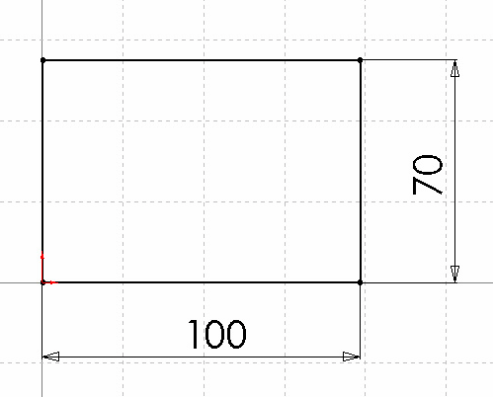

Relation toolbar.

7) Click the bottom line. Move the mouse below the bottom line. Click to place the dimension.

8) Change the dimension to 100 mm.

9) Click the right line. Move the mouse to the right. Click to place the dimension.

10) Change the dimension to 70 mm. The sketch is fully constrained, and turns to black (default color) as shown in Figure 7.

11) Select Extruded Boss/Base on the
Figure 7 Base sketch of the Block

Features toolbar. The profile changes its orientation to isometric. The

PropertyManager appears.

12) Move the mouse to the left side of the sketch, and click to accept the extrude direction.

13) In the Depth text box, type 85 mm as shown in Figure 7. Click OK  to finish the extruded base feature.

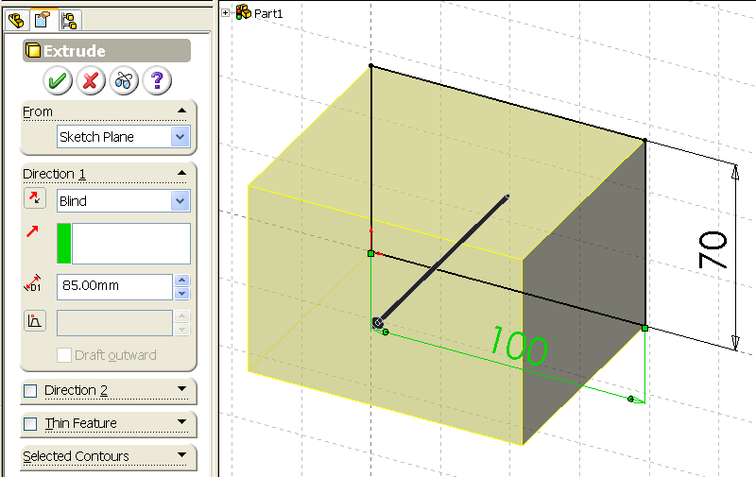

Cut Rectangular Slot
Figure 7 Extruded Base Feature

1) Select the front surface of the base feature as shown in Figure 8.

2) Select Sketch on the Sketch toolbar to open a sketch on the front surface.

3) Select Normal To on the Standard Views toolbar to make the sketch parallel to the screen. (If the Standard Views toolbar is not displayed, select View,

Toolbar, Standard Views on the menu bar to open the Standard Views toolbar.)

Figure 8 Sketch Plane for Rectangular Slot

4) Select Wireframe on the Views toolbar to change the model display to wireframe from the shaded mode.
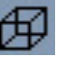

5) Select Line on the Sketch Tools toolbar to draw 3 lines as shown in Figure 9.

6) Select Dimension on the Sketch Relation toolbar.

Figure 9 Rectangular Cut Sketch

7) Dimension the sketch as shown in Figure 10. The sketch is fully constrained and turns to black. if not, apply coincident constraints to the endpoints of the vertical lines with the top edge of the part.

8) Select Extruded Cut on the Feature toolbar.

9) Select Through All from the end condition drop down list box in the Cut-Extrude PropertyManager as shown in Figure 11.

10) Click OK to finish the cut.

11) Click Shaded on the View toolbar to change the model to Shaded mode to check the cut.

Figure 10 Rectangular Slot Dimensions
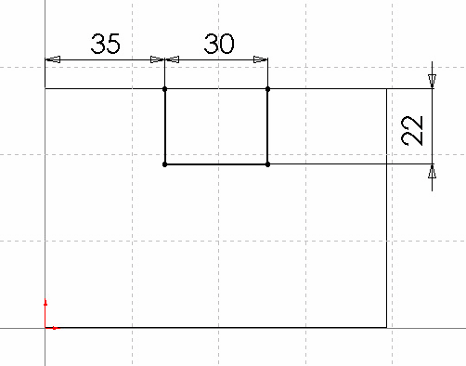

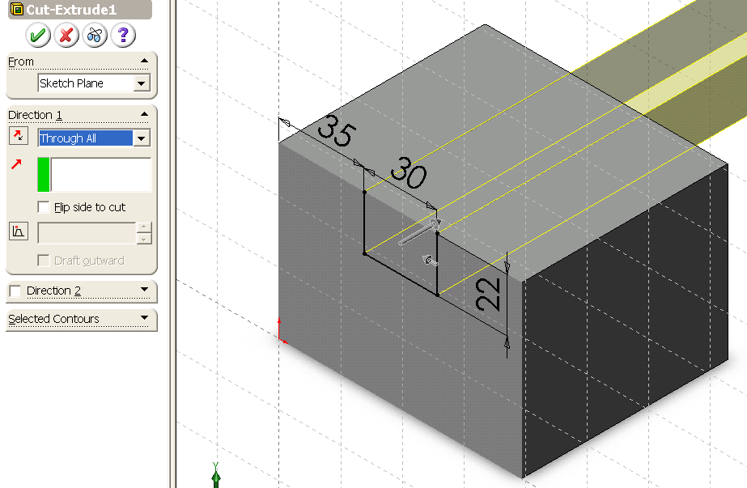

Cut V-Slot

Figure 11 Rectangular Slot Cut

1) Select the right surface of the part as the V-Slot sketch plane as shown in Figure 12.

2) Select Sketch on the Sketch toolbar to open a new sketch.

3) Select Normal To on the Standard Views toolbar to make the sketch parallel to the screen.

4) Select Line on the Sketch Tools toolbar.

5) Draw five lines to form the geometric V-slot shape as shown in Figure 13.

Figure 12 Sketch plane for V-Slot Cut
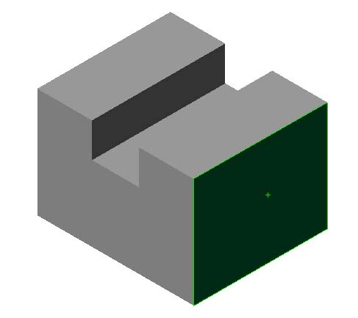

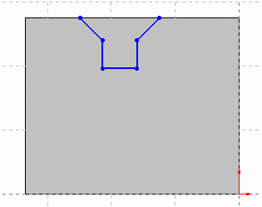
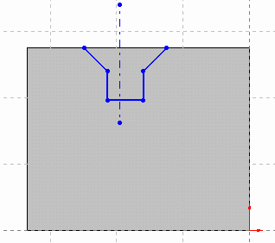

Figure 13 V-Slot Sketch

Figure 14 Centerline for V-Slot Sketch

6) Select Centerline on the Sketch Tools toolbar.

7) Draw a vertical centerline within the V-slot sketch as shown in Figure 14.

8) Select Add Relation on the Sketch Relation toolbar.

9) Select two angled lines and the centerline.

10) Select Symmetric in the Add Relation PropertyManager as in Figure 15 to make two angle lines symmetric about the centerline.

11) Select two vertical lines and the centerline.

12) Select Symmetric in the Add Relation dialog box as shown in Figure 16 to make two vertical lines symmetric about the centerline.

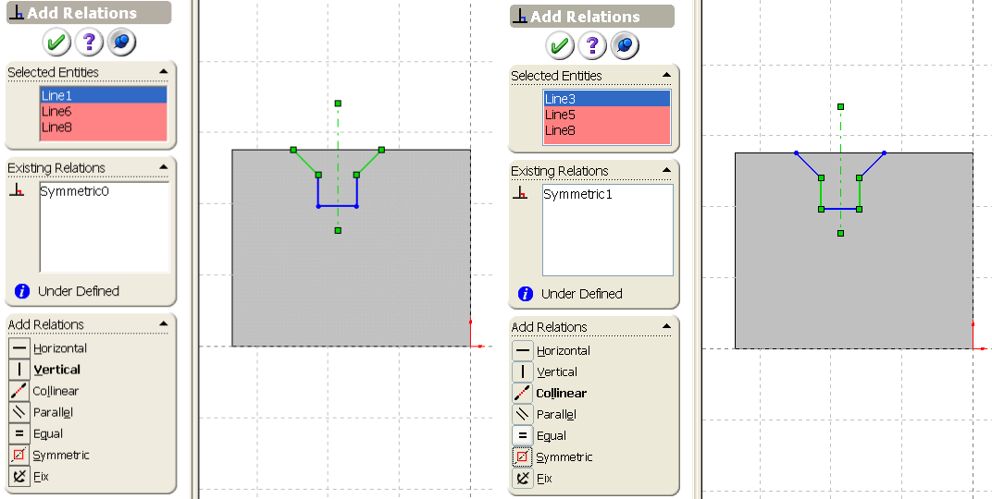

Figure 15 Symmetric Constraints for Two
Angled Lines
Figure 16 Symmetric Constraints for Two Vertical Lines

13) Select two vertical edge lines on the face and the centerline.

14) Select Symmetric in the Add Relation dialog box as shown in Figure 17 to make centerline at the center of face.

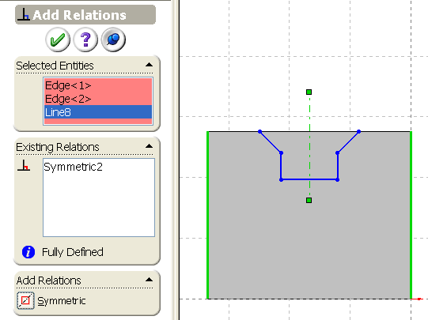

Figure 17 Symmetric Constraints for the centerline at the center of the face

15) Click on the OK button to close the Add Relation PropertyManager.

16) Select Dimension on the Sketch Relation toolbar.

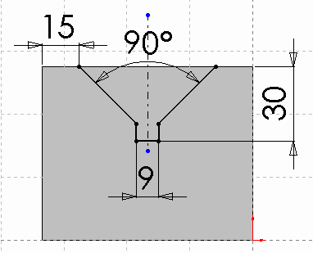

Figure 18 V-Slot dimensions
17) Dimension the sketch as shown in Figure 18. The sketch is fully constrained. If not, apply coincident constraints to the two endpoints of the vertical lines with the top edge of the part. You may also drag the end point of the angled line to make it coincident with the top horizontal edge of the part.

18) Select Extruded Cut on the Features toolbar

19) Select Through All from the end condition drop down list box in the Cut-Extrude
PropertyManger.

20) Uncheck Direction 2 as shown in Figure 19.

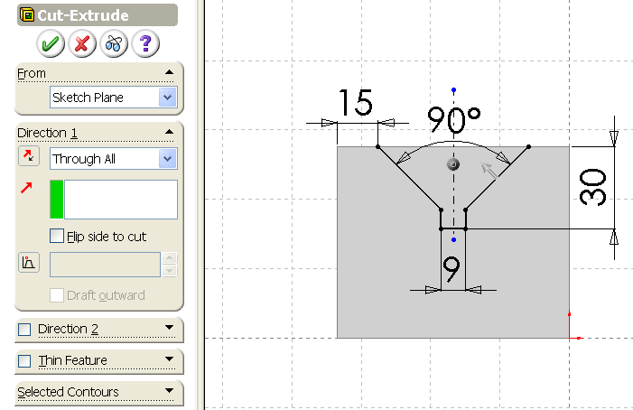

Figure 19 V-Slot Cut.

21) Click OK to finish the cut.

21) Click Rotate View on the View toolbar, and drag the mouse to rotate the model. Right click and select Rotate View from the context menu to end the rotate view command.

22) Select Isometric on the Standard Views toolbar to set the part orientation to Isometric.

Cut a Trapezoid Slot

1) Select the same surface as the V-Slot cut as
the sketch plane for the trapezoid cut as shown in Figure 20.

2) Select Sketch on the Sketch toolbar to open a new sketch.

Figure 20 Sketch plane for

Trapezoid Slot cut

3) Select Normal To on the Standard Views toolbar to make the sketch parallel to the screen.

4) Select Line from the Sketch Tools toolbar.

5) Draw three lines to form the trapezoid slot sketch as shown in Figure 21.
6) Select Centerline on the Sketch Tools toolbar.
7) Draw a vertical centerline starting from

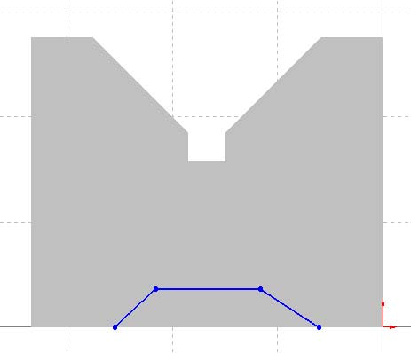

Figure 21 Trapezoid Slot Sketch

the mid-point of the lowest horizontal edge as the symmetric axis for the trapezoid slot.

8) Select Add Relation on the Sketch Relation toolbar.

9) Select the two angled lines and the centerline. Select Symmetric in the
PropertyManager as shown in Figure 22.

10) Click OK to close the PropertyManager.

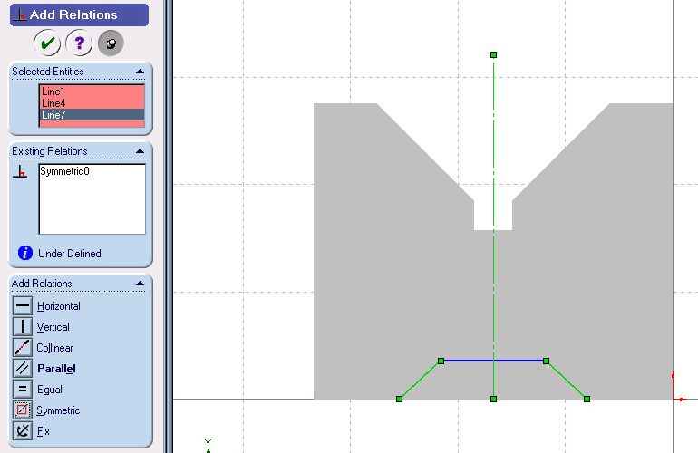

Figure22 Symmetric constraint for Angled lines

11) Select Dimension on the Sketch Relation toolbar.
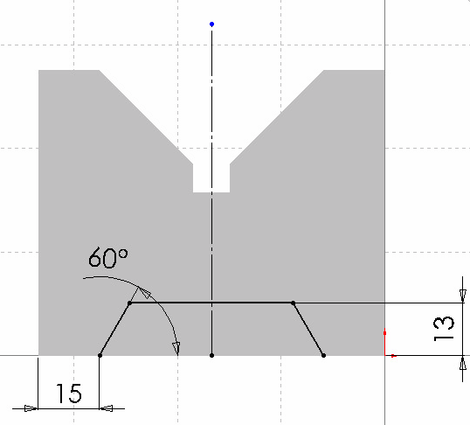

12) Dimension the sketch as shown in Figure 23.

13) Select Extruded Cut on the Features toolbar.

14) Select Through All from the end condition drop down list box in the Cut-Extrude PropertyManger.

15) Check Flip side to cut to change the cut direction toward inside.

16) Uncheck Direction 2 as shown in
Figure 24.

Figure 23 Trapezoid Slot Dimensions

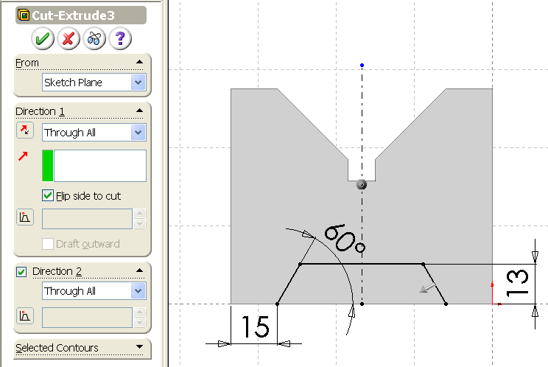

Figure 24 Trapezoid Slot Cut

17) Click OK to finish the cut. The final part is shown as in Figure 25.

Figure 25 V-Block Model

Change Feature Names and Check Model Mass Properties

Once features are created, they are listed in the FeatureManager Design Tree as shown in Figure 25 with default names. You may have slightly different default names. Those names could remain as they are, but, it is recommended to change the default names to make the features recognized easily:

Figure 26 FeatureManager Design Tree

To change the default names:

1) Click Extrude1 twice (not double click) in the FeatureManager Design Tree.

2) Type Block as the new name.

3) Click Cut-Extrude1 twice, and change it to Rectangular-Slot.

4) Click Cut-Extrude2 twice, and change it to V-Slot.

5) Click Cut-Extrude3 twice, and change it to Trapezoid-Slot.

The new FeatureManger Design Tree is as shown in Figure 27.

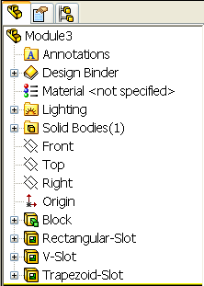

Figure 27 Updated FeatureManager
Design Tree
To check the model mass properties:

1) Select Tools, Mass Properties on the menu bar.

2) The Mass Properties dialog box appears. The Measurement Options dialog box appears, and the mass properties are calculated automatically as in Figure 28. Note: in the dialog box, the mass density is displayed as 0.01 gram per cubic millimeter because the decimal places format is set as 2. It does not influence the mass properties.

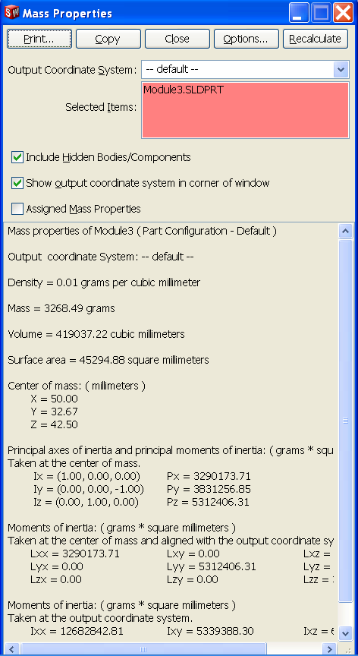

Figure 28 Mass Properties
3) To display the correct value of the mass density, select the Options button. The Mass/Section Property Options dialog box appears as shown in Figure 29. Change the Decimal Places to 4, the mass density is displayed as 0.0078 g/mm3 in the Density text box as shown in Figure 30.

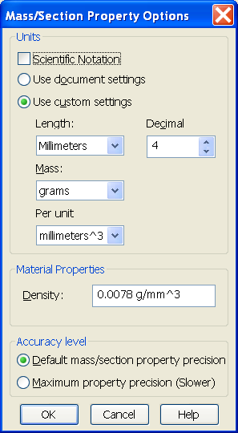
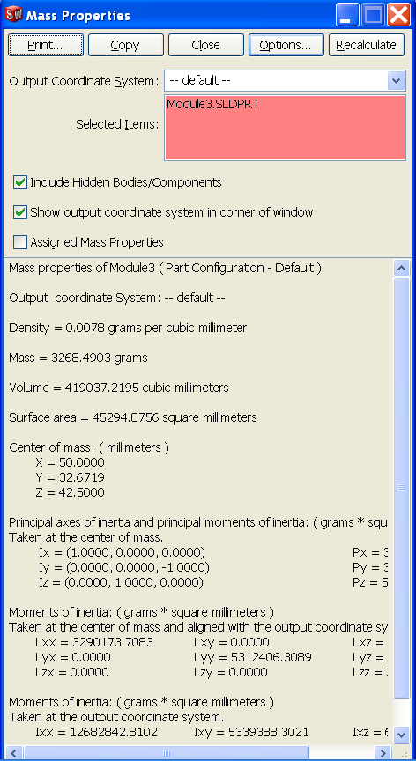

Figure 29 Mass/Section Property
Options

4)
Figure 30 Mass Properties

4) Click the OK button to close the Options dialog box.

5) Click on the Print button to print the mass properties, or click Copy to copy them into the clipboard. Then they can be copied to other programs.

6) Click Close to close the Mass Properties dialog box.

7) Choose the Save button from the Standard toolbar to save the model.

