[](https://www.madty.net/fd3/sf009/exams9/testft9/)Kingdom of Saudi Arabia Name: ……………………………

Ministry of education Class: 3rd Intermediate Grade

**20 /**

Hefar Intermediate School Mid-Term Exam - 1446 Third Term

1. **Comprehension:**

**Read the passage to answer the questions below:**

My best friend’s name is Maha. She is in my class. Her surname is Al-Ali. She is very tall. Her eyes are green and her hair is brown. It is long and straight. She is always smiling and wants everyone to be happy. She is very kind and likes to help other children. I hope Maha will always be in my class.

1. **Choose the correct answer:**
2. Maha’s hair is ………………
3. curly b- wavy c- straight
4. Maha’s eyes are …………….
5. brown b- green c- black
6. **Check ( T ) or ( F ) :**
7. The writer and Maha are in the same class. ( )
8. Maha is a selfish person. ( )
9. **Grammar:**
10. **Choose:**
11. A clown is a person **(who – which – when – where)** makes children laugh.
12. My brother was watching TV while he **(eat – eats – ate – was eating)** dinner.
13. He enjoys **(read – reads – reading – to read)** novels.
14. The meal was **(so – such – so many – so much)** delicious that we ate too much.
15. **Do as shown between brackets:**
16. **(Rewrite the sentence with a two-word verb in two ways**)
17. Turn off the TV.

…………………………………

…………………………………

1. done/the dishes/hasn’t/Jana/yet **(Unscramble the sentences)**

Jana …………………………………………….

1. **Vocabulary:**
2. **Write the words under the pictures:**

**pedal cab – thief – spill – hair dryer – nail polish**

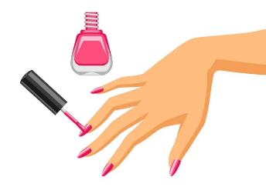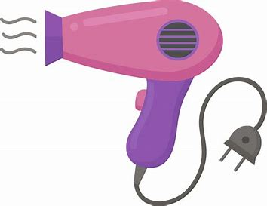[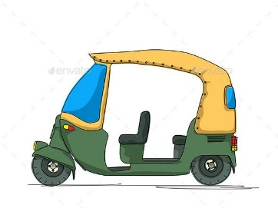](https://t.me/akhtbarnhae)

_____________ _______________ ________________ ______________

1. **Classify the words:**

**polite – rude – honest – pessimistic**

|  |  |
| --- | --- |
| **☺** | **☹** |
|  |  |
|  |  |

1. **Orthography:**
2. **Choose the correct missing letters:**
3. There were two security guards **on d__ty** outside the building.

|  |  |  |
| --- | --- | --- |
| 1. i | 1. o | 1. u |

1. I caught him trying to **s__eal** my bike.

|  |  |  |
| --- | --- | --- |
| 1. b | 1. t | 1. d |

1. Would you **tu__n** down your radio a little?

|  |  |  |
| --- | --- | --- |
| 1. r | 1. s | 1. z |

1. A **n__phew** is a son of one’s brother or sister.

|  |  |  |
| --- | --- | --- |
| 1. a | 1. e | 1. i |

**Good Luck ☺**

**Ms. Tahani Al-Ghamdi**

**[](https://www.madty.net/examf3/)**

**Kingdom of Saudi Arabia**

**Ministry of Education**

**………… Education Directorate............**

**…………..……………….. Intermediate School**

|  |
| --- |
|  |
| **20** |

**Total**

**Midterm Test units 9 & 10**

|  |
| --- |
| Third Intermediate Grade |

**Name ………………………………… Class ………………………………**

__________________________________________________________________________________________

/ 4

**Comprehension**

**Read the following then answer the questions:**

Albert Einstein was born in 1879 in Ulm, Germany. When he was a child he learned things very slowly. Albert didn’t speak until he was three years old. His parents worried about him. The principal of his school told his father. “your son will never make a success of anything. His grades in school were bad. The only thing he liked to do was play violin.

**A- Put (√ ) for true or ( ᵡ ) for false :**

|  |  |
| --- | --- |
| **( )** | 1. Albert Einstein was born in Italy. |
| **( )** | 2**.**  He learned things very slowly when he was a child . |

**B- Choose the right answer:**

|  |  |  |  |  |
| --- | --- | --- | --- | --- |
| **six** | **five** | **three** | **four** | 1- He didn't speak until he was _____ years old. |
| **not bad** | **bad** | **excellent** | **good** | 2- His school grades were ______ . |

_________________________________________________________________

/ 5

**Grammar**

**Choose the right answer:**

|  |  |  |  |
| --- | --- | --- | --- |
| 1- The computer ____________________ I bought does not work well. | | | |
| D. **Where** | C. **How** | B. **Who** | A. **Which** |
| 2 - We were sitting in the café when a thief _____ my bag! | | | |
| D. **was stealing** | C. **stolen** | B. **stole** | A. **steal** |
| 3 - I __________to book a room. | | | |
| D. **may** | C. **could** | B. **would like** | A. **can** |
| 4 - They stop_____ tennis in the winter. . | | | |
| D. **playing** | C. **play** | B. **plays** | A. **played** |
| 5 . Have you _____ the dishes yet? | | | |
| D. **did** | C. **done** | B. **does** | A. **do** |

**Vocabulary**

/ 4

**A- Choose the best answer to fill in the blank:**

|  |  |  |  |
| --- | --- | --- | --- |
| 1.  He was talking on his _____________. | | | |
| D. **brother** | C. **house** | B. **cell phone** | A. **car** |
| 2. The ______that grow in the city garden are very colorful . | | | |
| D. **food** | C. **carpet** | B.  **books** | A. **flowers** |
| 3- You look at yourself in the _______ when you brush your hair. | | | |
| D. **sink** | C. **mirror** | B. **toothpaste** | A. **bed** |
| 4- people using an escalator instead of the _______. | | | |
| D. **stairs** | C. **bus** | B. **train** | A**. cell phone** |

**B- Put the right word under its picture:**

|  |  |  |  |
| --- | --- | --- | --- |
| 💅🏼 Nail Polish: Medium-Light Skin Tone Emoji | ‪Scissors Vector Design Illustration Isolated On White Background Stock  Illustration - Download Image Now - iStock‬‏ | [Talkative Person Talking Too Much, Vector Cartoon Stick, 40% OFF](https://t.me/akhtbarnhae) | Retro cartoon fridge with food | Sticker |
|  |  |  |  |

**scissors , talkative , refrigerator, nail polish**

/ 4

_______________________________________________________________________________

/ 3

**Orthography**

**Choose the correct letter:**

|  |  |  |  |
| --- | --- | --- | --- |
| **a** | **u** | **y** | 1. He was waiting for the b__s. . |
| **r** | **t** | **d** | 2. The artist is talking about his pain_ng . |
| **r** | **h** | **m** | 3. I can’t stand people who throw litte__ in the street. |

Good luck T.

**[](https://www.madty.net/saexam)**

**Kingdom of Saudi Arabia**

**Ministry of Education**

**………… Education Directorate............**

**…………..……………….. Intermediate School**

|  |
| --- |
|  |
| **20** |

**Total**

**Midterm Test units 9 & 10**

|  |
| --- |
| Third Intermediate Grade |

**Model answer**

__________________________________________________________________________________________

/ 4

**Comprehension**

**Read the following then answer the questions:**

Albert Einstein was born in 1879 in Ulm, Germany. When he was a child he learned things very slowly. Albert didn’t speak until he was three years old. His parents worried about him. The principal of his school told his father. “your son will never make a success of anything. His grades in school were bad. The only thing he liked to do was play violin.

**A- Put (√ ) for true or ( ᵡ ) for false :**

|  |  |
| --- | --- |
| **( ᵡ )** | 1. Albert Einstein was born in Italy. |
| **(√ )** | 2**.**  He learned things very slowly when he was a child . |

**B- Choose the right answer:**

|  |  |  |  |  |
| --- | --- | --- | --- | --- |
| **six** | **five** | **three** | **four** | 1- He didn't speak until he was _____ years old. |
| **not bad** | **bad** | **excellent** | **good** | 2- His school grades were ______ . |

_________________________________________________________________

/ 5

**Grammar**

**Choose the right answer:**

|  |  |  |  |
| --- | --- | --- | --- |
| 1- The computer ____________________ I bought does not work well. | | | |
| D. **Where** | C. **How** | B. **Who** | A. **Which** |
| 2 - We were sitting in the café when a thief _____ my bag! | | | |
| D. **was stealing** | C. **stolen** | B. **stole** | A. **steal** |
| 3 - I __________to book a room. | | | |
| D. **may** | C. **could** | B. **would like** | A. **can** |
| 4 - They stop_____ tennis in the winter. . | | | |
| D. **playing** | C. **play** | B. **plays** | A. **played** |
| 5 . Have you _____ the dishes yet? | | | |
| D. **did** | C. **done** | B. **does** | A. **do** |

**Vocabulary**

/ 4

**A- Choose the best answer to fill in the blank:**

|  |  |  |  |
| --- | --- | --- | --- |
| 1.  He was talking on his _____________. | | | |
| D. **brother** | C. **house** | B. **cell phone** | A. **car** |
| 2. The ______that grow in the city garden are very colorful . | | | |
| D. **food** | C. **carpet** | B.  **books** | A. **flowers** |
| 3- You look at yourself in the _______ when you brush your hair. | | | |
| D. **sink** | C. **mirror** | B. **toothpaste** | A. **bed** |
| 4- people using an escalator instead of the _______. | | | |
| D. **stairs** | C. **bus** | B. **train** | A**. cell phone** |

**B- Put the right word under its picture:**

|  |  |  |  |
| --- | --- | --- | --- |
| 💅🏼 Nail Polish: Medium-Light Skin Tone Emoji | ‪Scissors Vector Design Illustration Isolated On White Background Stock  Illustration - Download Image Now - iStock‬‏ | Talkative Person Talking Too Much, Vector Cartoon Stick, 40% OFF | Retro cartoon fridge with food | Sticker |
| **nail polish** | **scissors** | **talkative** | **refrigerator** |

**scissors , talkative , refrigerator, nail polish**

/ 4

_______________________________________________________________________________

/ 3

**Orthography**

**Choose the correct letter:**

|  |  |  |  |
| --- | --- | --- | --- |
| **a** | **u** | **y** | 1. He was waiting for the b__s. . |
| **r** | **t** | **d** | 2. The artist is talking about his pain_ng . |
| **r** | **h** | **m** | 3. I can’t stand people who throw litte__ in the street. |

Good luck T.

[](https://t.me/akhtbarnhae)

English Language

Intermediate Grade 3rd

period Exam

Kingdom of Saudi Arabia

Ministry of Education

……………… intermediate school

Student's Name : class:

|  |
| --- |
|  |
| 5 |

1-Read the following passage and answer the questions below:

My best friend’s name is Marco. He’s 13 years old and he’s tall and smart. Marco has got curly brown hair and blue eyes. Marco is shy but when we hang out together, we always have a lot of fun. Marco is also very clever and helpful, so I like studying with him. We both like sports, and we’re in the same ice-hockey team. Marco is a great player!

**A) choose the correct answer:**

1-Marco is ………………. Years old

a- 15 b- 17 c- 13

2-Marco has got blue ………………………

a-eyes b-hair c-T-shirt

3-I like ……………………… with Marco.

a-swimming b-running c-studying

**B) Put (√ ) or (×):**

1- Marco is very clever and helpful. [ ]

2- We spend all our free time at the mall. [ ]

|  |
| --- |
|  |
| 5 |

**2-choose the correct answer**

1- English is a language ( who – which – where ) is easy to learn.

2- My brother was watching TV ( when – while – that ) he was eating dinner.

3- I would like to ( books – booking – book ) a room.

4- Have you done your H.W ( yet – already – just ) ?

5- It ( must – can - can’t )be rain. There isn’t a cloud in the sky.

6- A talkative person is someone( who- which – where) speaks a lot.

7- There are (so many – so much – such) cars that we couldn’t park

8- He can’t stand ( wait – waits - waiting ) in line.

9- May I ( spoken – spoke – speak) to the manager?

10- it's ( so – such- so many) a great movie that I've watched several times.

.

|  |
| --- |
|  |
| 6 |

**3. Do as shown between brackets.**

A-(Correct)

1-Ahmed was walking in the park **while** he saw Hameed. …………………………

2-The criminal hasn't been arrested **just**. ……….…..

3- Can I **asking** you a question? ……………………….

4- A clever person is someone **which** is intelligent. ……………………..

B**-( Use which )**

1- My father bought a car . It is BMW.

…………………………………………………………………………………………………………………

**C-( reorder)**

2-we\ May\ have \ cookies \ some \? …………………………………………………………………………………………………………………

**B(Rewrite each sentences).**

1- Clean up the mess. ……………………………..………

2- Put away the toys…………………………………………

|  |
| --- |
|  |
| 4 |

|  |  |  |  |
| --- | --- | --- | --- |
| To make less |  | unemployment | 1 |
| Being poor |  | poverty | 2 |
| Lack of jobs |  | loan | 3 |
| Money you borrow |  | To reduce | 4 |

**4- Match**

5-write **the correct word for each picture.**

Pedal cab thief nail polish toothpaste

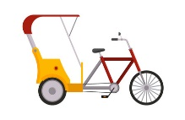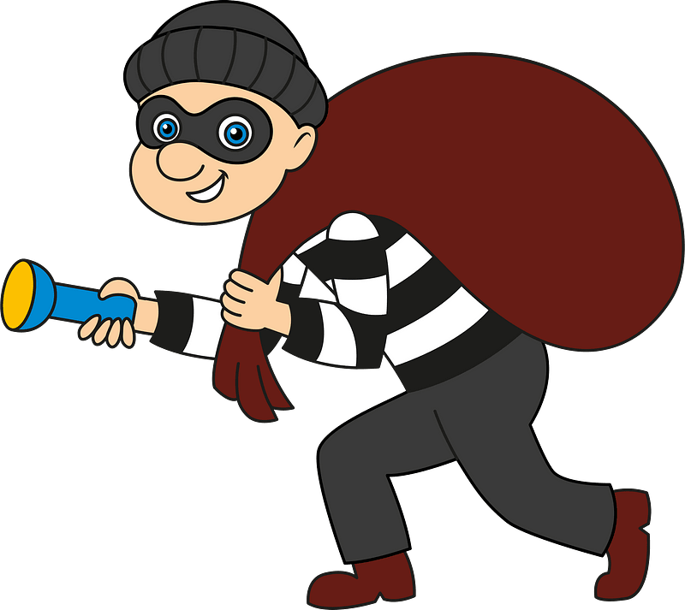

………………..

………………..

………………..

………………..

**6-choose the correct missing letter.**

1-Fa____e ( k - j ) 2- gui__e ( p – d )

3- hair__rush ( b - t ) 4- Sha__poo ( h - m )

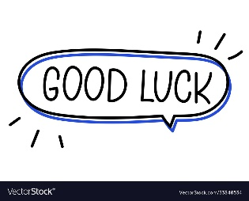



Your teacher



Kingdom of Saudi Arabia

Ministry of Education

………… Education Directorate

……………….. Intermediate School

**Super Goal 3** - **Test** unit 9 & 10

By **Rashed Alsulami** | **Telegram:** https://t.me/iRashed

Name :………………………………………………………………………… Class:…….……….

**Comprehension**

2 Marks

* **Read the text and answer the questions. Write T or F at the end of each question/statement.**

A strange thing happened yesterday. Bob Hampton was in his car workshop with his guard dog, Pal. Bob was working on a car when a fire started in the workshop. Bob and Pal ran outside to safety.

Bob tried to put the fire out. He was spraying the workshop with water when he said, “I need help.” Pal ran away. Bob thought that Pal was hiding from the fire. Bob kept spraying the fire with water. A little while later, Pal came back. Behind him was the city fire department.

The firefighters were working nearby when Pal ran up to them. The firefighters saw the smoke in the distance and followed Pal back to Bob.

Thanks to Pal, the firefighters put the fire out quickly. Pal is now a hero. Bob and his family are very happy to have Pal. They are going to give him a lot of extra treats!

1. Bob was driving his car when the fire started. ( )
2. Pal brought help to Bob. ( )
3. Bob put the fire out. ( )
4. The firefighters were working nearby when Pal found them.( )

**Grammar**

* **Choose the best answer to fill in the blank in each question.**

5 Marks

1. We were sitting in the café when a thief _____ my bag.

**a**. steal **b**. stole **c**. was stealing **d.** stolen

1. I _________ at the monument when someone called my name.

**a**. look **b**. looked  **c**. am looking **d.** was looking

1. I finished reading the book _____ I was riding the bus.

**a**. That **b**. where  **c**. while  **d.** Who

1. Have you ______ finished your homework.

**a**. already **b**. yet **c**. just **d.** already not

1. He has ________books that he can hardly carry them.

**a**. so much **b**. much **c**. so many  **d.** that many

**اقلب الصفحة**



* **Write *who* or *which* to fill in the blank.**

1.5 Marks

1. The clerk_____________________was at the store was very nice.
2. The computer _________________ I bought does not work well.
3. The food _____________________ is in the refrigerator is old.

* **Complete the sentences with can’t or must.**

1.5 Marks

1. Badria couldn’t sleep last night. She________________be tired.
2. Ahmed’s just joking. He _________________________ be serious.
3. You haven’t eaten all day. You ____________________ be hungry.

**Vocabulary**

* **Choose the best answer to fill in the blank in each question.**

5 Marks

1. That diamond is not real. It is ____________________.

**a**. thief **b**. give direction  **c**. fake **d.** steal

1. Some people are always ____________________. They don’t have time to talk and relax.

**a**. pretend **b**. in a hurry  **c**. steal **d.** give direction

1. You use a toothbrush and _______________to brush your teeth.

**a**. toothpaste **b**. hair dryer  **c**. shampoo  **d.** scissors

1. You use ____________________ to wash your hair.

**a**. hairbrush  **b**. scissors **c**. shampoo **d.** toothpaste

1. You look at yourself in the ____________________ when you brush your hair.

**a**. mirror **b**. shampoo **c**. toothpaste  **d.** hair dryer

* **Write the correct word under the picture.**

3 Marks

Dishes – Thief – Police Officer

****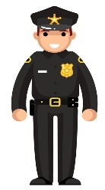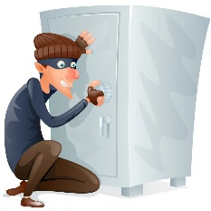

………………………………………….

………………………………………….

………………………………………….

**Orthography**

* **Choose the correct letter.**

2 Marks

* The people who live in the city are always in a hur….y ( c – r – k )
* Have you taken the garbage o…t yet? ( e – h – u )

**انتهت الأسئلة....**

**التوفيق والنجاح دوماً في طريقكم أبنائي.. تذكروا دائماً بأنني فخور بكم فأنتم مستقبل هذا الوطن الغالي إن شاء الله ونجاحكم هو نجاحي..**

**الأستاذ / راشد السلمي**