We Can! Book 4 Unit 2: From Here to There

1. Listen and match pictures and words. Number the words.

___ bicycle | ___ car | ___ truck
___ police car | ___ bus | ___ ambulance
___ motorbike | ___ train | ___ taxi

1.  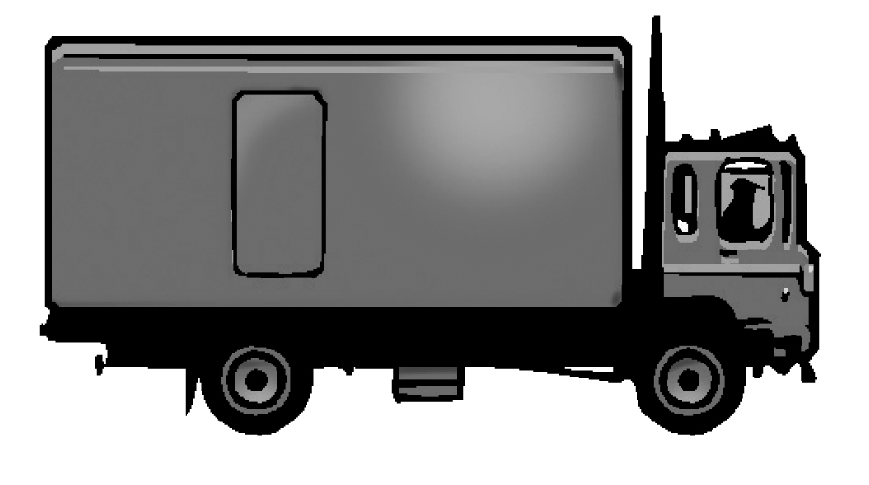 | 2.  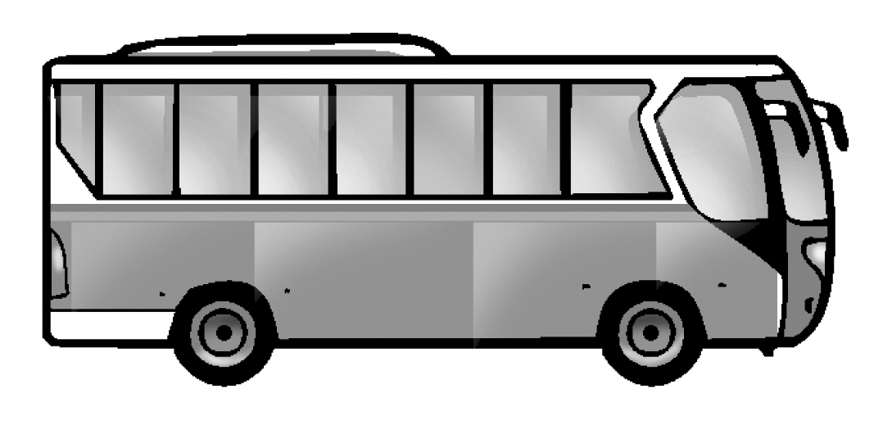 | 3.  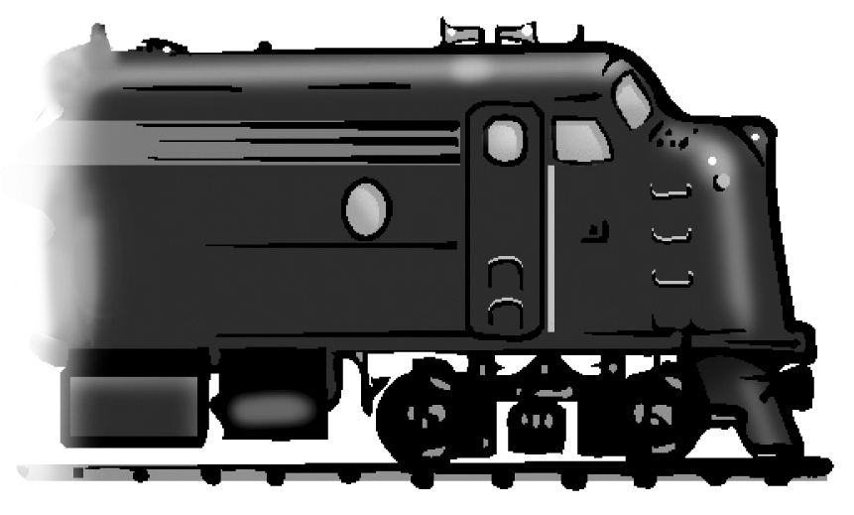
4.  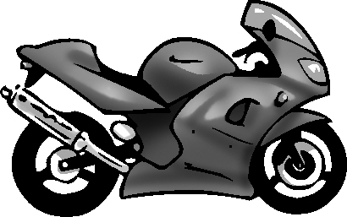 | 5.  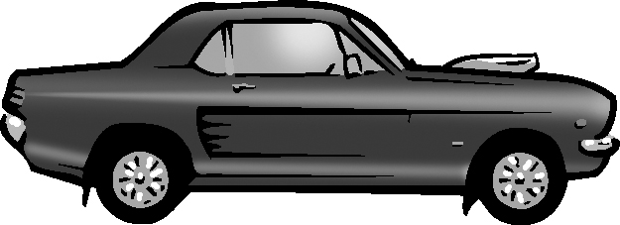 | 6.  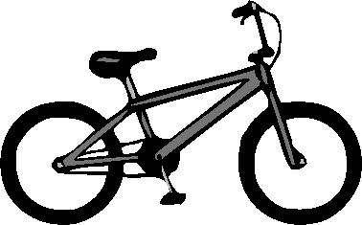
7.  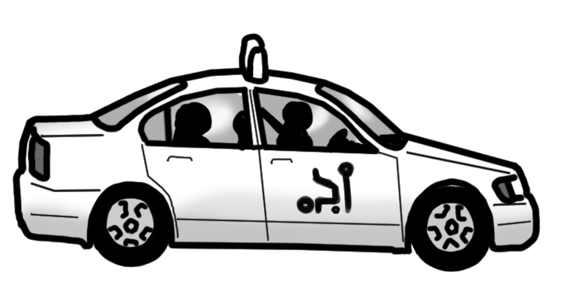 | 8.  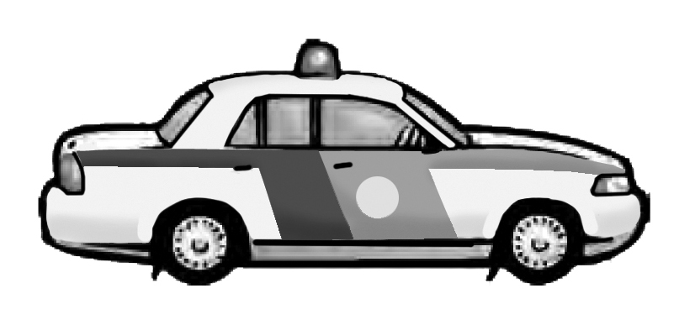 | 9.  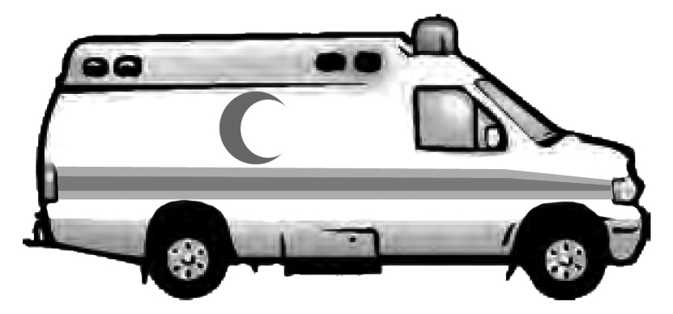

2. Look at the arrow and circle A, B, or C.

1. | 2. | 3.
A. Turn right  B.Turn left  C.Walk straight | A. Turn right  B.Turn left  C.Walk straight | A. Turn right  B.Turn left  C.Walk straight
.

3. Listen and number the missing lines.

___ When you see a green light, go, go, go.
___ When you see a red light, stop, stop, stop.
___ When you see a yellow light, wait, wait, wait.

When you see a red light,  red light, red light.  (1) ___________________ | 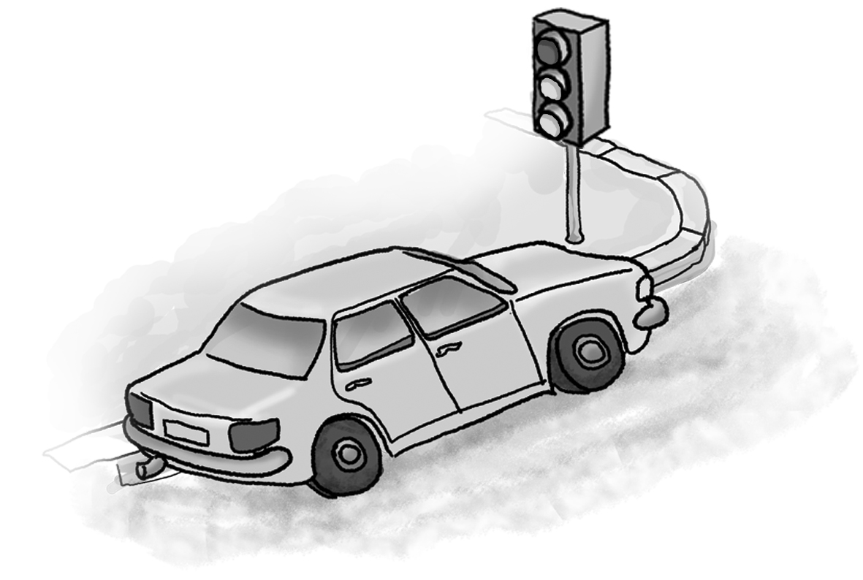
When you see a yellow light,  yellow light, yellow light.  (2) ___________________ | 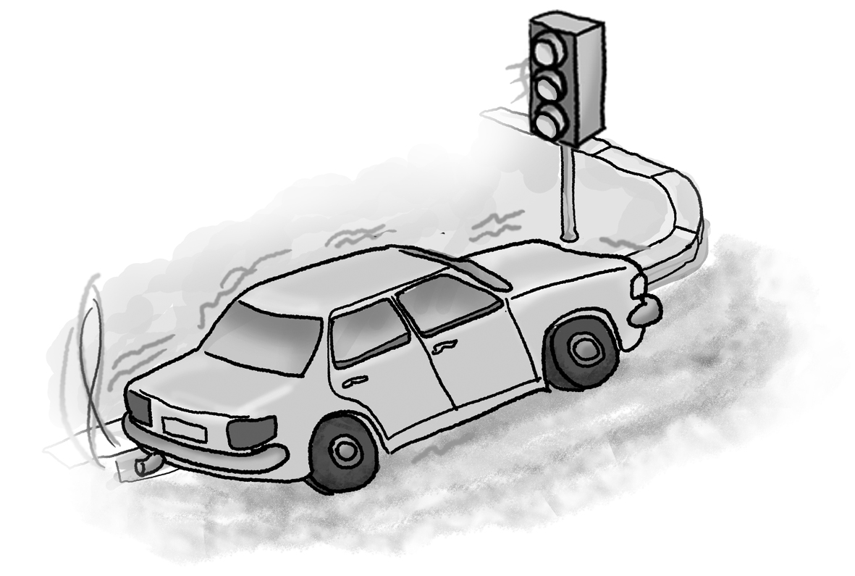
When you see a green light,  green light, green light.  (3) ___________________ | 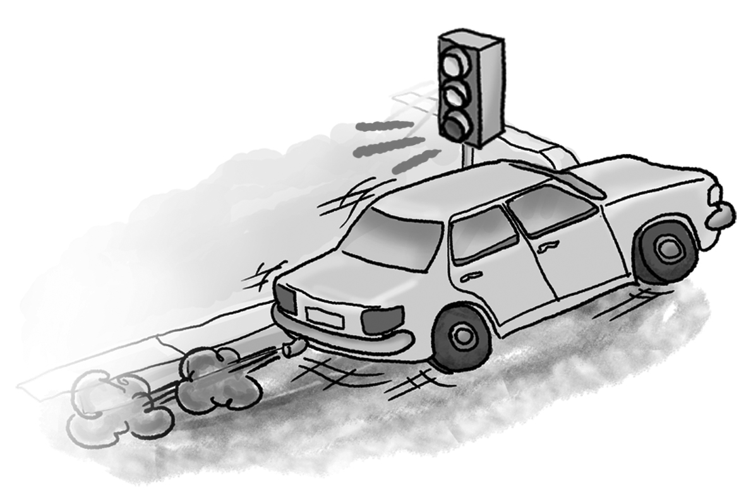

4. Look at the picture and write bl, cl, fl, gl, or pl.

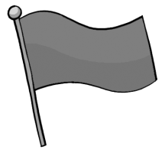 | 1. ___ ag |  | 2. ___ ack
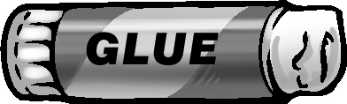 | 3. ___ ue | 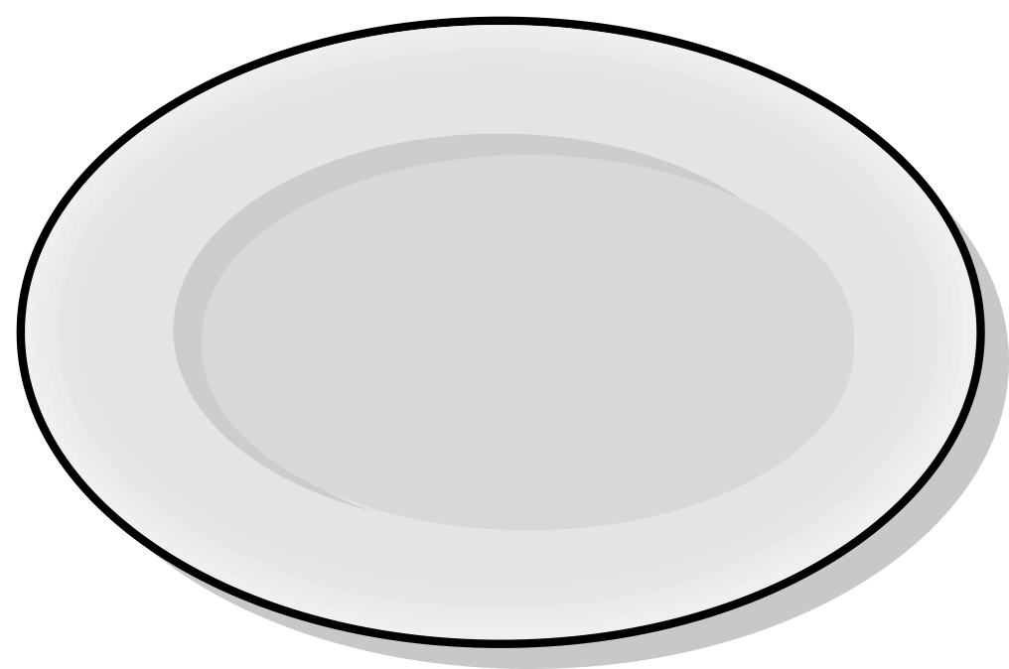 | 4. ___ ate
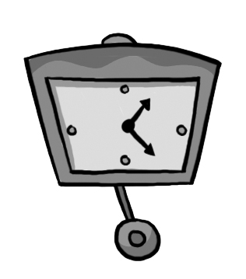 | 5. ___ ock |  | 6. ___ ant
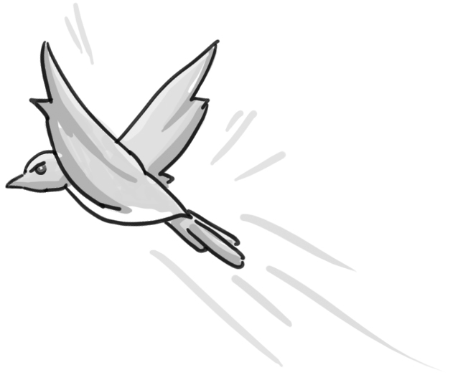 | 7. ___ y | 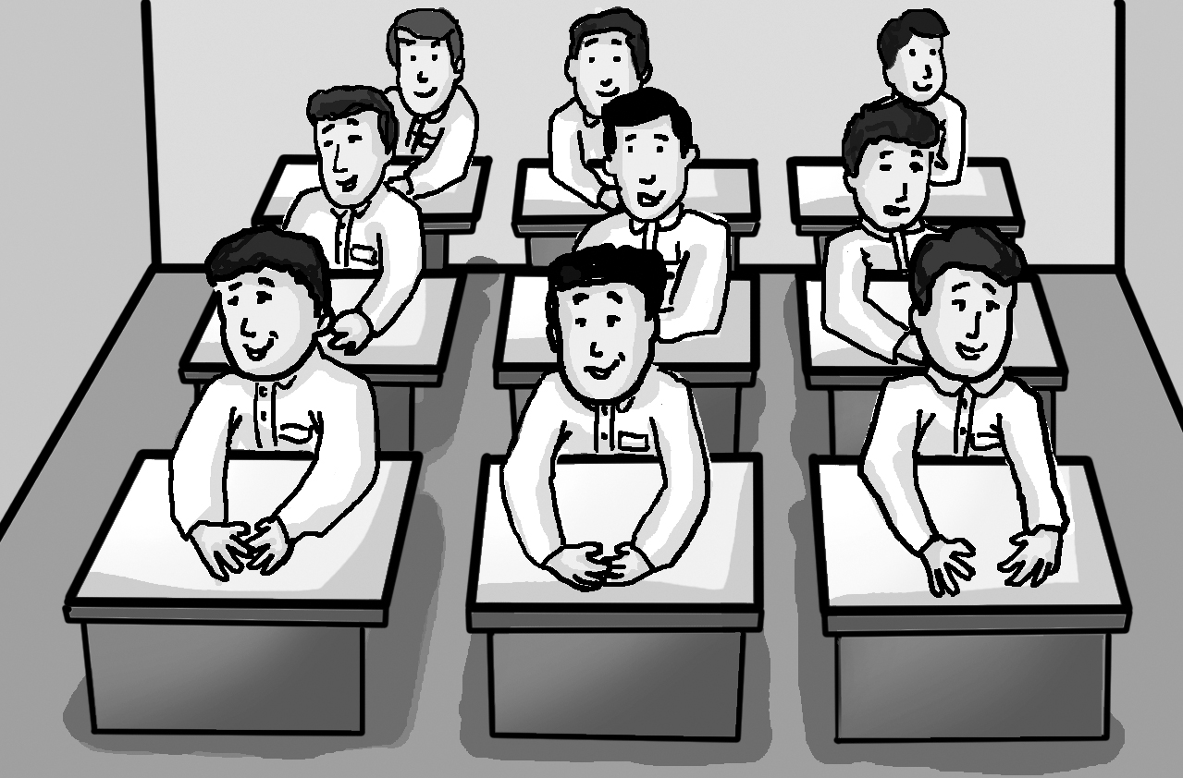 | 8. ___ ass

