**positions**

Name : -------------------------------

**\*Where is the dog?**

MC900417482[1]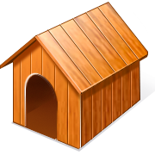MC900417482[1]MC900417482[1]MC900417482[1]MC900417482[1]

Miss:

The dog is --------------- the dog house .

The dog is ------------- the dog house .

The dog is --------- the dog house .

The dog is --------- the dog house .

The dog is -------------- the dog houses .