
Kingdom of Saudi Arabia
Ministry of Education
………………… School
English Language
Intermediate Grade 3rd
2nd period Exam
……….\20

Student's Name : class:

……\ 5 marks
1-Read the following passage and answer the questions below:
Saad went to the supermarket with his mother on Saturday. They wanted to buy fruit, bread, and milk. Saad pushed the shopping cart while his mother chose the items. At the end, they paid at the cashier and carried the bags home. Saad enjoyed the trip because he loves helping his mother shop.
c-park | b-museum | a-supermarket | 1- Where did Saad go?
c- on Monday | b- on Sunday | a- on Saturday | 2-When did Saad go to the supermarket?
c-his friend | b- his family | a- his mother | 3- Who went with Saad?
c- bread | b-cereal | a-salmon | 4- They wanted to buy fruit, …, and milk
c-in the cart | b-on chair | a-on floor | 5-Where did they keep the things they chose?
A.Choose the correct answer.

2-Choose the correct answer.
……\ 4 marks
c- raining | b-rain | a-rains | 1- It will ……..soon
c- write | b- writing | a- writes | 2- Ali is …….the lesson.
c-many | b- old | a-much | 3- How… milk do we need to make a cake?
c-many | b-few | a- little | 4- You need to drink a ….. lemon juice.
c- cooks | b- cook | a- cooked | 5- I’ll go shopping while you …… dinner.
c- does | b- do | a- doing | 6- He’s going to play football after he ….his HW.
c-more | b- because | a- so | 7- I went home early ….. I was tired.
c- yourself | b- myself | a- herself | 8- She is old enough to take care of ….now.

……\ 3 marks
3-Do as shown between brackets.
(Give the negative)
1- Sara is going to sleep early.
……………………………………………………………………………….….
( use How much )
you / add / salt
………………………………………………………………………………….?
(correct)
1-I will get herself a cup of coffee. ……………………..

……\ 4 marks
4- write the correct word under each picture (suitcase – pineapple - shrimp – pilot )

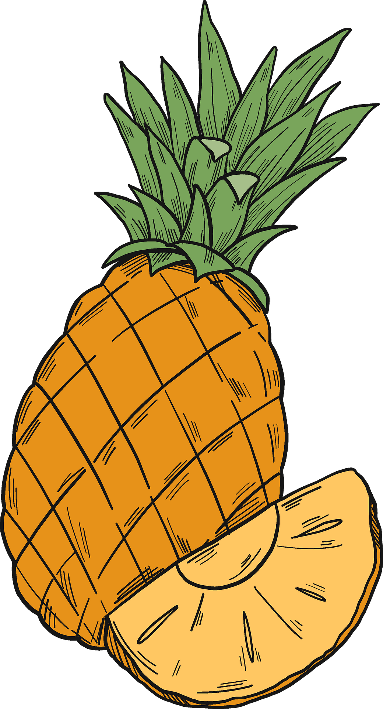
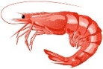
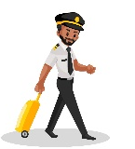
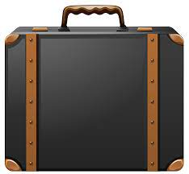

………………………
………………………
………………………
………………………

……\ 2 marks
5- Choose the correct answer.
1- Buzzing means : (very hot – very cold - busy and lively)
2- I ( bake – boil – fry ) an orange cake.

6.Choose the missing letter.
1- The main ingredient of guacamole is a…ocado.( d - x - v ).
2- I'm ….lying to Japan tomorrow morning. ( f – k – s )

……\ 2 marks

7- write the missing letter
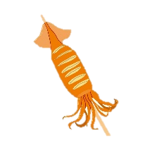
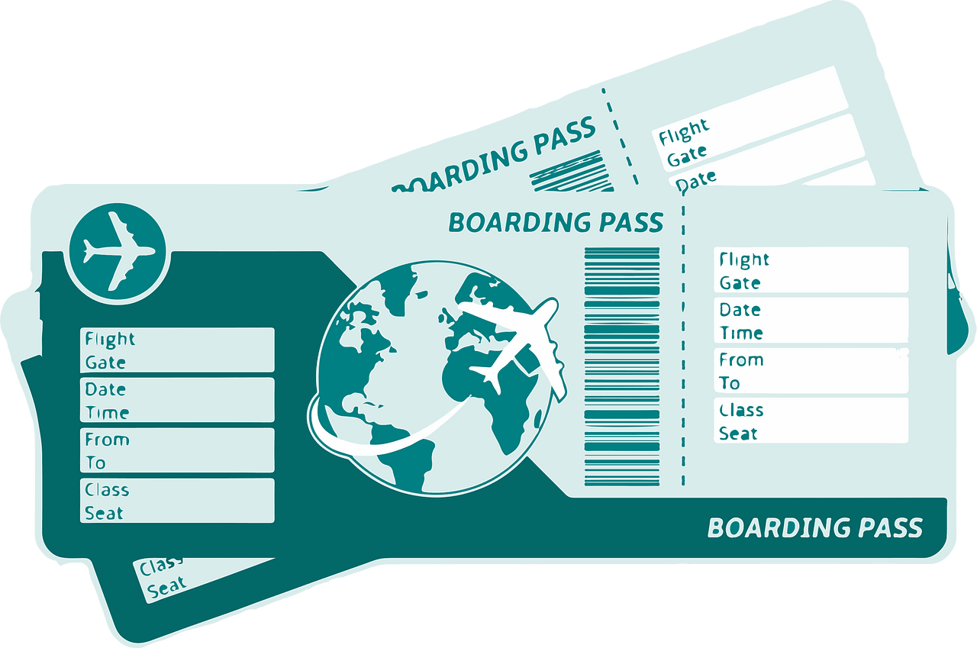

s….uid
Tic….ets

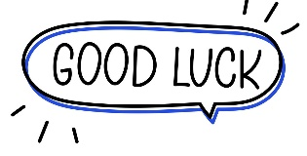

Your teacher:

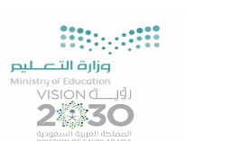
Kingdom of Saudi Arabia Name: ……………………………
Ministry of education Class: 3rd Intermediate Grade
10 /
…….. Intermediate School Second Exam - 1447 First Term
- Grammar:
- Choose:
- I am going to (travelling – travel – travelled) to London next week.
- Muslims walk (through – across – around) the Kabah.
- There are (a little – a few – much) monkeys at the zoo.
- He cut (myself – himself – herself) yesterday.

- Do as shown between brackets:
- Farah probably (send) a gift to her friend tomorrow. (Correct the verb)
………………………………………………………………
- I am too busy, ………. I can’t go to the cinema. (Use ‘so’ or ‘because’)
…………………………………………………………

- Vocabulary:
- Write the words under the pictures:
condiment – vaccination – liquid – containers – watermelon
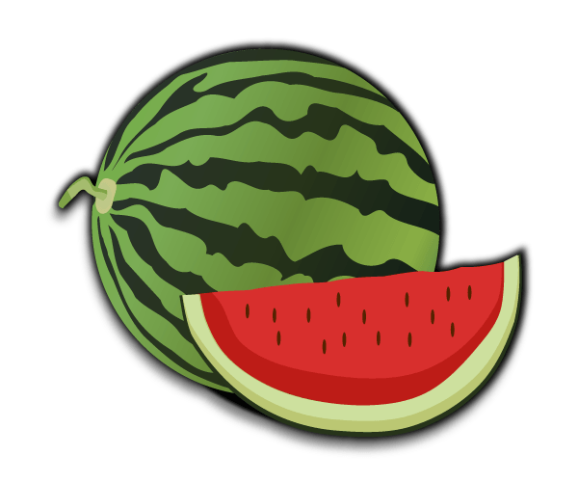
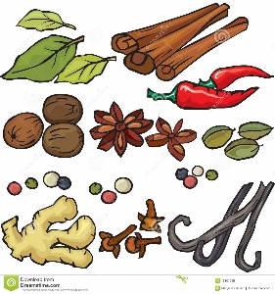
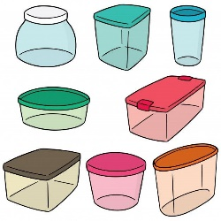


_____________ _______________ ________________ ______________

- Fill in the blank with the correct words in the box:
crab – boil – check

- I ……………… my mailbox every five days.
- The water is beginning to ……………

- Circle the odd word:
- milk – cheese – butter – cookie
- ticket – passport – stranger – boarding pass

- Orthography:
- Fill in the missing letters:
- Sara speaks with an American acc__nt.
- Rana packed a small suitc__se for the weekend.
- This book has 50 delicious reci__es.
- I need a tea__poon to stir my tea.

Good Luck
Ms. Tahani Al-Ghamdi


Kingdom of Saudi Arabia
Ministry of Education
………… Education Directorate............
…………..……………….. Intermediate School

Total

المجموع | تحريري | شفهي
20 | 10 | 10

Second Period Exam

Third Intermediate Grade

Name ………………………………… Class ………………………………
__________________________________________________________________________________________
Comprehension

/ 2

Read the following then answer the questions:

Saudi Arabia is the is the largest country in West Asia and the thirteenth largest in the world. It's population is about 27 million and the official language is Arabic. Riyadh is the capital city and it's the largest city in Saudi Arabia. The kingdom tower is the tallest skyscraper in Riyadh and the 26th tallest building in the world. Jeddah is the largest city on the red sea.
A- Put (√ ) for true or ( ᵡ ) for false :

( ) | 1. The official language is Arabic.
( ) | 2. The kingdom tower is the smallest skyscraper in Jeddah .

B- Choose the right answer:

east | north | west | south | 1- Saudi Arabia located in ______ Asia.
Riyadh | Jeddah | Makkah | Dammam | 2- __________ is the capital city .
___________________________________________________________________
/ 2.5
Grammar

Choose the right answer:

1- I eat _____ vegetables.
A. many B. little C. much D. nothing
2 - _________milk do you drink?
A. How many B. How much C. How often D. How old
3 - I ____ there two years ago.
A . am B. were C. have D. was
4 - He ______ studied English since third grade
A. was B. have C. is D. has
5 - Trains are ______ than buses
A. fasts B. fastest C. faster D. fast

/ 2
Vocabulary

A- Choose the best answer to fill in the blank:
1. We use water to _____ our crops.
D. put out | C. cool | B. drink | A. irrigate
.2. She cooked the pizza on the ________
D. washer | C. stove | B. printer | A. shower
3- ___________ succeed in doing something
D. accomplish | C. innovation | B. interrupt | A. miniature
4- An area on the edge of a large town or city _______ .
D. continent | C. sea | B. ocean | A. suburb
B- Put the right word under its picture:
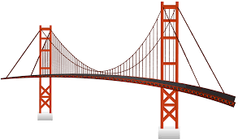 |  |  |  | 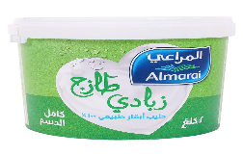
skyscrapers - bridge - printer - yogurt - microwave
/ 2.5

_______________________________________________________________________________
/ 1
Orthography

Choose the correct letter:
d | t | v | 1. lap_ops have become smaller and lighter.
n | r | m | 2. Saudi Arabia has many natural resou__ces .

Good luck T.

