Kingdom of Saudi Arabia  Ministry of Education  …………… Intermediate  School in ……………….. | English Language  3rd Intermediate Grade  2nd Term Exam 1443 -2022  Time: 2 hours  The first session
Name/ …………………………………………………………… | Seat No./ ………………………

( اللهم لا سهل إلا ماجعلته سهلا وأنت تجعل الحزن إذا شئت سهلا )

Student’s Mark Written | Student’s Mark Number | Question |  | Number
 |  | Mark | Question
 |  | 6 | Writing | Q1
 |  | 6 | Reading Comprehension | Q2
 |  | 7 | Grammar | Q3
 |  | 7 | Vocabulary | Q4
 |  | 4 | Orthography | Q5
 |  | 30 | Total Written Tasks

عدد الصفحات : 4 صفحات

اسم المصحح وتوقيعه :
اسم المراجع وتوقيعه :
اسم المدقق وتوقيعه :

1

Q : 1 ( Writing )

6
Write a paragraph about ( your best friend ) not less than 3 lines using the following words .
( name – age – favorite subject – colour – character )
…………………………………………………………………………………………………………………………………………………………………………………………………………………………………………………………………………………………………………………………………………………………………………………………………………………………………………………………………………………………………………………………………………………………………………………………………………………...

6
Q : 2 ( Reading )
Read the following passage then answer the questions :
Prophet Mohammad (PBUH ) was born in Makkah in 571AD. He was an orphan. His father , Abdullah, died before he was born. His mother ,Amena, died when he was achild of six . He lived with his grandfather, Abdulmuttaleb. Prophet Mohammad died in Al-Madina in 11 Hijra( 633AD).
A – Where was prophet Mohammad born ?
………………………………………………………………………………………………………………………….
B – Choose the correct answer :
1 – Prophet Mohammad was born in ( 571AD – 434AD – 999AD )
2 – His father`s name is ( Khaled – Ahmad – Abdullah )
3 – His mother died when he was (a child – a young – an adult ) of six.
4 – He lived with his ( aunt – uncle – grandfather )
C – Put ( T ) or ( F ):
1 – His mother is Amena . ( )
2 – Prophet Mohammad died in Tabouk . ( )
Q : 3 ( Grammar )

7
A – Choose the correct answers for the following questions:
1 – How long have you played football ?
a- I have played football for 3 years.
b- I played football 3 years ago.
2
c- I`m playing football now
2 – How does he drive ?
a – He is driving slowly. b - He drives slowly. c - He is drive slowly.
B – Complete :
1 – Your name is Khaled, ( is it – isn`t it ).
2 – You ( must – should ) stop at the traffic lights when it`s red.
3 – She ( must – should ) have a rest.
4 – Ahmad works ( good – well ) .
5 – I drive ( careful – carefully ) .
6 – They should ( drink – drinking ) warm liquid .
7 – Khalifa tower is the ( tall – tallest ) tower in the world .
8 – Cheetahs are ( fast – faster ) than rabbits .
C – Write the correct answer :
( for – since )
1 – Hameed has had the same TV ……………… 15 years.
2 – I`ve had my laptop ………….. last June.
Q : 4 ( Vocabulary )

7
A – Match :
a – a bit ( ) 1 – Three children born at the same time.
b – triplets ( ) 2 – a little .
c – Orphan ( ) 3 – I am driving 60 .
d – I am doing 60 ( ) 4 – a child who has lost his parents.
B – Choose :
1 – inventions are like ( computers – gold – gas ) .
2 – The complexed word of steering ( mirror – wheel – board )
3 – Technique means ( a way of doing things – actions and events )
4 – Miniature means ( stop in the middle – a small model )
3

C – Put the correct word under its picture :
( cups – spoons – rearview mirror – hose )
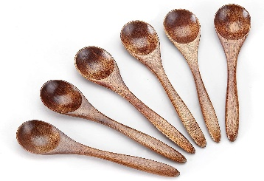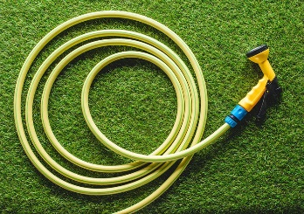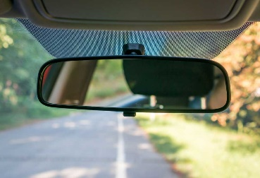
…………………………… ………………………………. ………………………… ……………………….
------------------------------------------------------------------------------------------------------------------------------
D – Write the command under its sign :
( Speed limit – No parking – Stop )
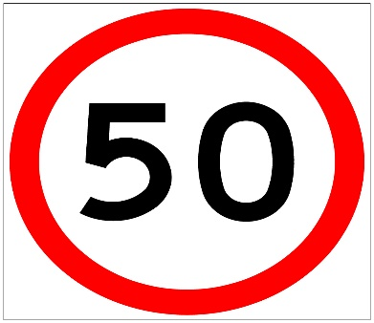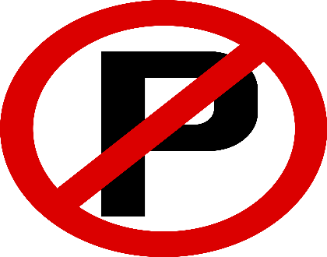
…………………………………….. ……………………………………
--------------------------------------------------------------------------------------------------------------------------------

4

Q : 5 ( Orthography )
A – Write the missing letter :
1 - …….top.( r – d – s ) 2 – Fa…… ( e – n – i )
3 – Tou…… ( ch – th – ph ) 4 – Kni……e ( f – r – d )
B – copy :
1 – Ali knows what career he will follow.
……………………………………………………………………………………………………..
2 – The man is leaving the store .
………………………………………………………………………………………………………
Good luck….
T.
(إجعل دقائق الإنتظار مليئة بالإستغفار )
4

