الملكة العربية السعودية العام الدراسي 1444 هـ
وزارة التعليم الفصل الدراسي : الأول
الادارة العامة للتعليم بالمدينة المنورة الزمن : ساعتان

متوسطة وثانوية البظاظة

أسئلة اختبار مادة اللغة الإنجليزية للصف الثالث المتوسط
اسـم الطالبة : ................................................................. الصف:.................
اليوم :..................... التاريخ :....../....../........

رقم الجلوس : ................

رقم القاعة :.............................. الدور : ( ..............) عدد الأوراق : ..............

رقم السؤال  Questions | الدرجة  Mark | الدرجة المكتسبة للطالبة  Student’s Mark |  | corrector | Signature | Scrutinizer | Signature
 |  | Number | Written
Composition | 6
Reading comprehension | 6
Grammar | 7
Vocabulary | 7
Orthography | 4
Total | 30
Final Written Mark

-استعيني بالله و قولي
( بسم الله ، اللهم لا سهل إلا ما جعلته سهلاً و أنت تجعل الحَزَنَ إن شئت سهلا ).

الختم

6
1. Composition

A- Write a paragraph about your favorite dish :
-What do you think about food and why we need it ?
-What some things that you can cook ?
-What do you usually have for break fast ?
-What is your favorite dish ?why ?
………………………………………………………………………………………………………………………………………………………………………………………………………………………………………………………………………………….………………………………………………………………………………………………………………………………………………………………………………………………………………………………………………………………………………………………………………………………………………………………………………………………………………………………………………………………………………………………………………………………………………..………………………………………………………………………………………………………………………………………………………………………………………………..……

6
2. Reading Comprehension

A-Read the following passage then answer the questions
Prophet Mohammad (PBUH) was born in Makkah in 571AD . He was an orphan . His father, Abdul Allah , dbefore he was born .His mother , Amana, died when he was a child of six . He live with his grandfather, Abdul Muttaleb . Prophet Mohammad died in AL_Madina in 11 Hijra ( 633AD) .
Answer :
1.when was Prophet Mohammad born ? …………………………………………………………
2.Where was prophet Mohammad born ? ..........................................................
choose the right answer:
1.His mother died when he was a child of ( 8 - 6 - 3 ) .
2.prophet Mohammad died in ( jeddah - Al-madina )
Put ( true ) or (false ):
1.His grandfather was Abdul Allah . ( )
2.he lives with his brother. ( )

3. GRAMMAR

7

- Choose the correct words:

1- she always (drink - drank - drinks ) tea in the morning .
2- (neither - all - both ). Of them is a teacher .
3-she used to (plays - played - play ) with toys .
4- it will (raining - rain - rains ) soon .
5-How (many - much - is ) bananas do you have?
6- I eat ( few - little - much ) carrots.
7- Nawal cut ( her self - my self - ourselves) while she was peeling the potatoes.

7
4. Vocabulary
A- Mach :

1 | Infant |  | Some one who exercise a lot
2 | Unique |  | Special
3 | Exercise freak |  | a baby

B-Match the word with the suitable picture:( baggage - pineapple - herbal - cheese )

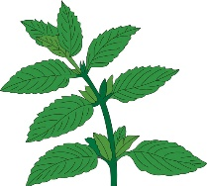
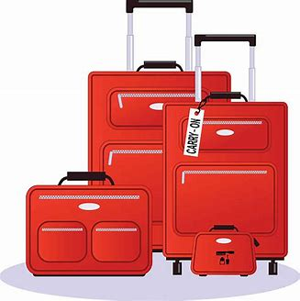
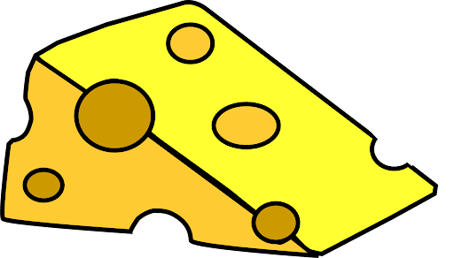

………………..….. …………………………. …………………….. …………………….

5. orthography
A-Write the missing letters :

4
1-suitca...e ( e - s ) 2- fligh….. ( t - k )
3- b….arding pass. ( o - f ) 4- ri…h ( b - c )

Good luck..
إعداد موقع منهجي التعليمي
https://www.mnhaji.com

