اختبار فتري – الصف الثالث /
الاسم ثلاثي: |  | الفصل | / | الدرجة | 20 /
Midterm Exam

2
I. CHOOSE
- What is your name ?
- I am 13 . | - My name is Ali .



- What is that?
- It's a seal. | - It's a whale.

3
222
II. CHOOSE OR

This is a computer. | The whale is small. | This is a dolphin.
 |  | 

2

III. DO AS SHOWN BETWEEN BRACKETS

where | whose | who | 1- ______ skirt is this? It's mine . ( Choose )
slow | scary | fast | 2. Seahorse is ___________ . ( choose)

your | my | his | 1 – I am a teacher , _____ name is Nora .
have | has | is | 2. I _____ a box
IV. CHOOSE
2

V. CHOOSE

6

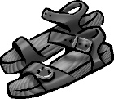 |  | 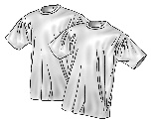 | 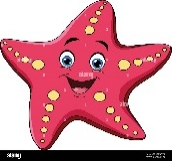 | 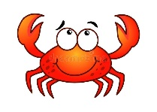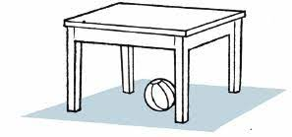 | 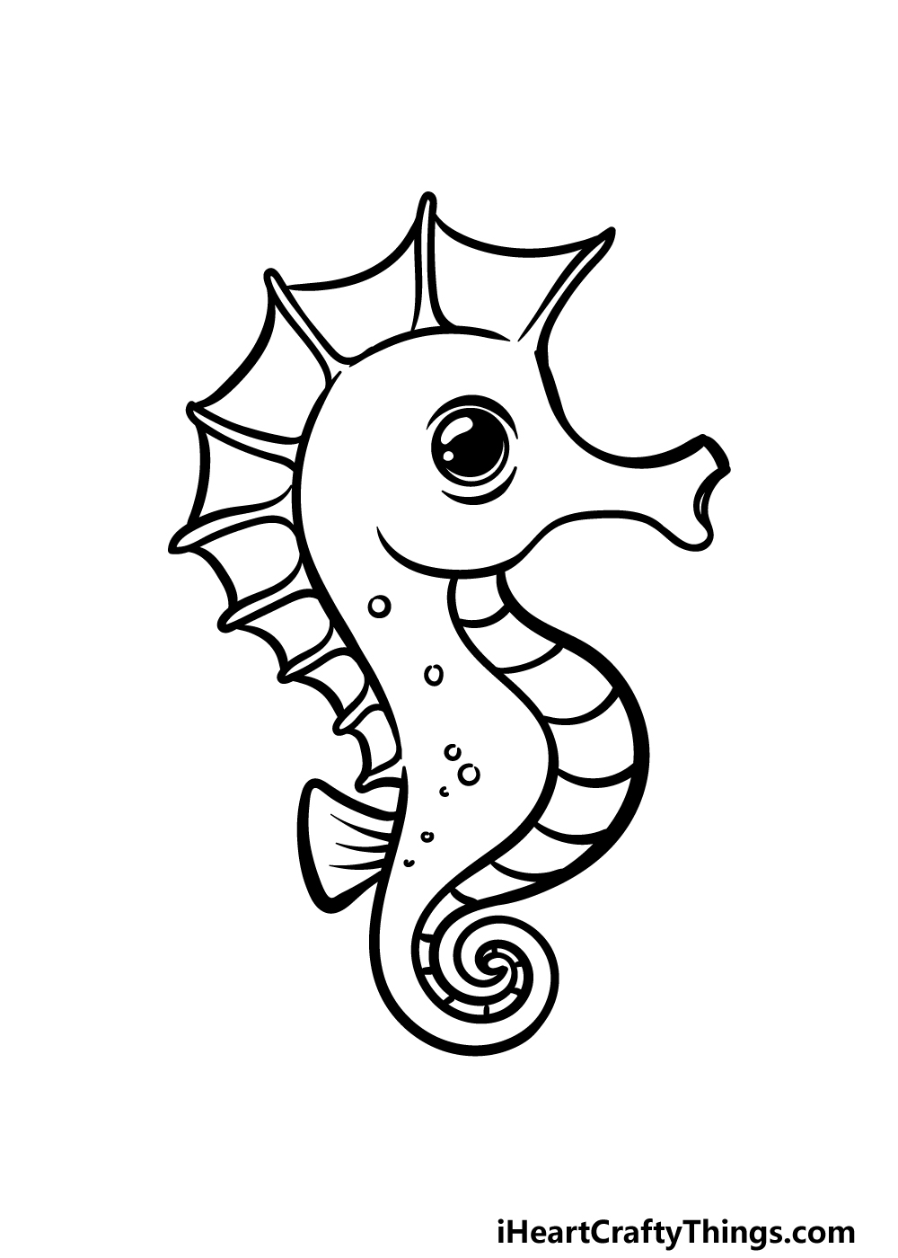
sandals | Thobe | T-shirts | starfish | fish | Seahorse
jacket | cap | Hat | cat | crab | whale

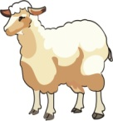  sh_ _ p | 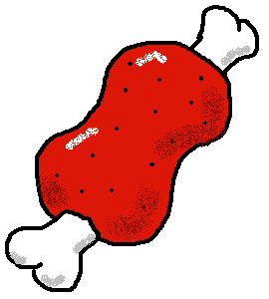  m_ _t |   Pl_ _ |   c_ _ | 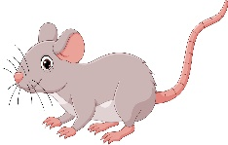  m_ _se
ea | ea | ay | ow | ow
ee | ee | ea | ou | ou
VI. CHOOSE THE CORRECT LTTER
5

TEACHER :


English Language
elementary Grade …..
1st period Exam
…………….\20
Kingdom of Saudi Arabia
Ministry of Education
………………… School
Student's Name : class:

5

A-Choose the correct answer.

her | my | his | This is our little brother. ……..name is Ahmad. | 1
she | I | mine | Whose shoes are these? - They're ………….. | 2
has | are | have | He …………. a new bag. | 3
cutest | cuter | cute | A dolphin is ………………………... | 4
slowest | slower | slow | A snail is the …………………… | 5

2

B- reorder.

1- cook \ you \ Can \ ?
………………………………………………………………………………………….………
2- have \ Thay \ a car.
……………………………………………….………………………………………………….

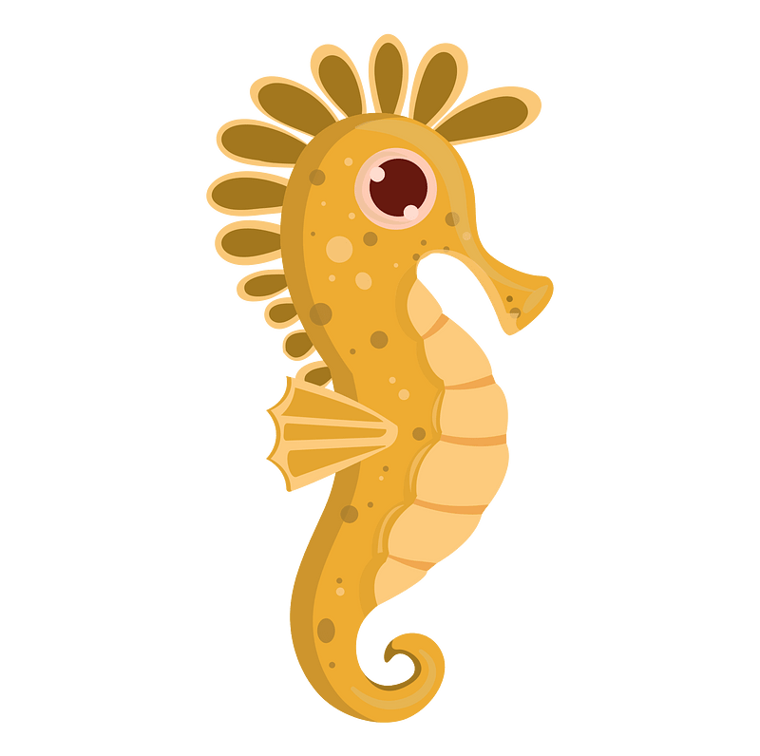
C-Answer the question.
1-what's that ?
3
It's a ( seahorse - fish - sharks ).


2-What are those?
Those are ( crocodile – seagull - baby seals).


3-What‘s that?
it's a ( squid – crab – squid ).
3

D.Match
Nice to meet you, too . |  | What's your name? | 1
I live in Jeddah. |  | Nice to meet you . | 2
My name is Ali. |  | Where do you live? | 3

4

E. Write the correct words under each picture
Sleep goat rice turtle

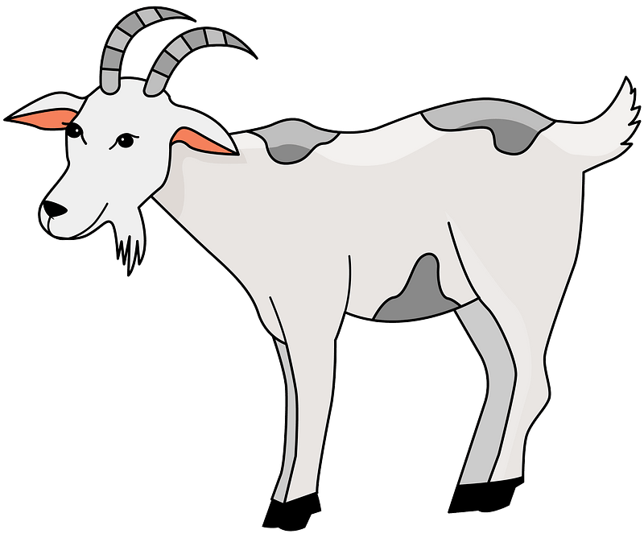
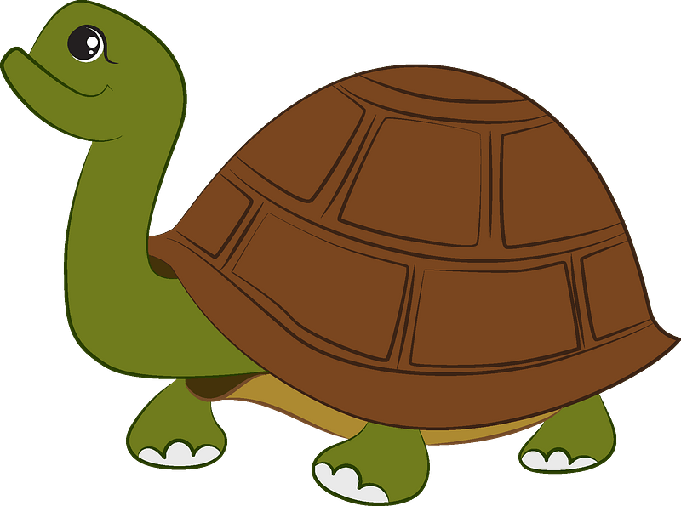


……………………….ر
……………………….ر
……………………….ر
……………………….ر

F.Complete the missing letters.
ee ay ou oa
4



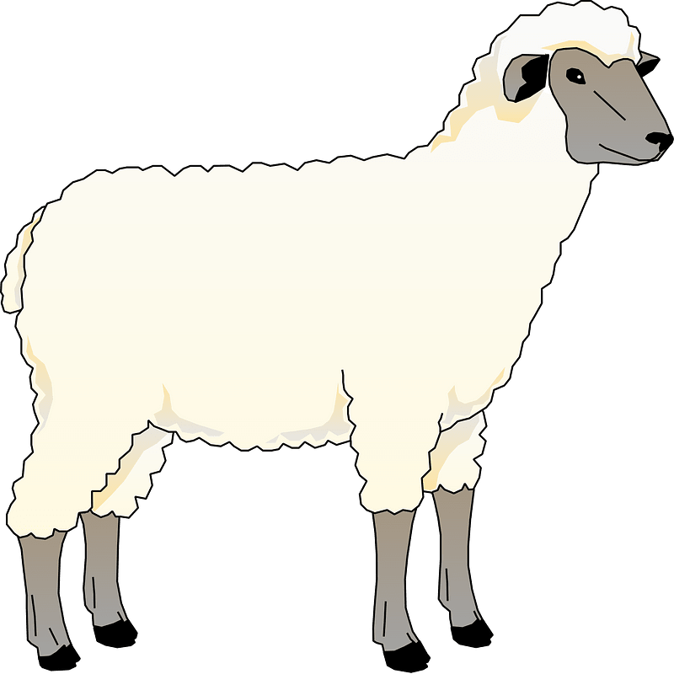


H…….se
Pl………
Sh……..p
C…….t


Your teacher:

3
I. CHOOSE
المملكة العربية السعودية |  | اسم الطالب/ ......................................
وزارة التعليم |  | اسم الطالب/ ......................................
إدارة التعليم بمنطقة |  | المادة : انجليزي
مكتب التعليم |  | الزمن :
مدرسة : |  | الصف : فصل ( )
 |  | / 20
اختبار الفترة للفصل الأول - للعام الدراسي 1446– لغة انجليزية –– للصف ...................
اسم الطالب / هـ الفصل /

1 – What is that?
A . It's a seahorse. B . It's a seal.
2 – where do you live ?
A. I like some juice. B. I live in Riyadh .
3 – What is your name ?
A . I am 13 . B. My name is Nora .
4 – Which of the following is a sea animal ?
A . seahorse . B. horse .

II. CHOOSE OR
3

1. He can swim.

This is a computer. .2
3. The whale is small.







3

___________________ |  |  |  | 1– to - nice – you – meet . ( rearrange )
where | whose | who |  | 2- ______ skirt is this? It's mine. ( choose )
slow | scary |  | fast | 3. Seahorse is ___________ . ( choose)

2
IV. CHOOSE
your | my | his | 1 – I am a teacher , _____ name is Nora .
has | as | is | . As fast ___ a dolphin .2

______________________________________________________________________________________________________________________________________________________________________________________________________
V. CHOOSE
5

Sandals - T-shirts – cap -computer - seal - seahorse – crab -starfish

 | 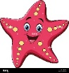 | 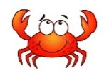 |  | 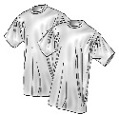


4

Choose the correct letter: ( ai - ea - ow - ee - oa - ou ) )

m_ _t | sh_ _ p | m_ _se | c_ _

___________________________________________________________________________________________________________________________________________________________________________________________________________________________________
Controlled writing

4
III. DO AS SHOWN BETWEEN BRACKETS

Good luck
III. DO AS SHOWN BETWEEN BRACKETS

المملكة العربية السعودية |  | اسم الطالب/ ......................................
وزارة التعليم |  | اسم الطالب/ ......................................
إدارة التعليم بمنطقة |  | المادة : انجليزي
مكتب التعليم |  | الزمن :
مدرسة : |  | الصف : فصل ( )
 |  | / 20
اختبار الفترة للفصل الأول - للعام الدراسي 1446– لغة انجليزية –– للصف ...................
I. CHOOSE
1 – How old are you ?
A . I am 11 years old . B . I am fine .
2 – where do you live ?
A. I like some juice. B. I live in Riyadh .
3 – What is your name ?
A . I am 13 . B. My name is Ali .
6

4
________________________________________________________________________________________________________________________________________________________________________________________________________
II. CHOOSE
your | my | his | 1 – I am a teache , _____ name is .
have | has | is | 2. I _____ a box

______________________________________________________________________________________________________________________________________________________________________________________________________
ه III. PUT THE WORD UNDER ITS PICTURE
8

 |  |  | 
---------- | ---------- | --------- | ---------
Tie - T-shirts – cap -computer

___________________________________________________________________________________________________________________________________________________________________________________________________
IV. CHOOSE THE CORRECT LTTER
8
( ai - ea - ay - ee )

 |  |  | 
r_ _n | r_ _d | sh_ _ p | pl_ _

4


اختبار: اللغة الإنجليزية
الفصل الدراسي: الأول
السنة الدراسية: 1446هـ
الفترة: منتصف الفصل
المملكة العربية السعودية
وزارة التعليم
إدارة التعليم بـ .........................
مدرسة ..............................
اسم الطالب:__________________________________ الصف:____

I. CHOOSE
5 /
1- What is your name?

A- I am elven years old. B- My name is Salem.
2- How are you ?

B- Nice to meet you. A- I am fine. Thank you.
3- How old are you?

A- I am elven years old. B- I live in Jeddah.
4- Where do you live?

A- I live in Jeddah. B- I am elven years old.
5- Nice to meet you.

A- I am fine. Thank you. B- Nice to meet you too.


II. CHOOSE ( ) TRUE OR ( ) FALSE
5 /
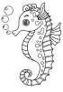
1- A seahorse is slow.
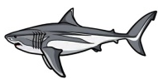
2- Sharks are scary.

3- A starfish is big.


4- Whales are faster than a dolphin.

5- A baby seal is the cutest.
اقلب الصفحة Turn the page
III. MATCE
5 /
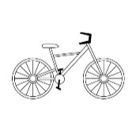
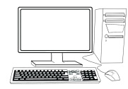
1- I have a bicycle.
2- He has a pen.


3- This is a computer.
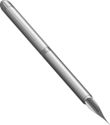
4- They are playing .
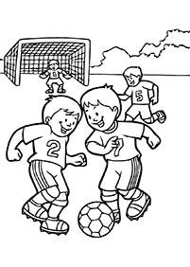
5- She has a cat.

IV. FILL IN
3 /
a e o i u

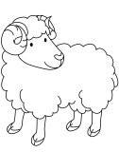
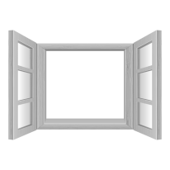
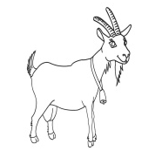

1- wind__w 2- she__p 3- go__t

V. WRITE
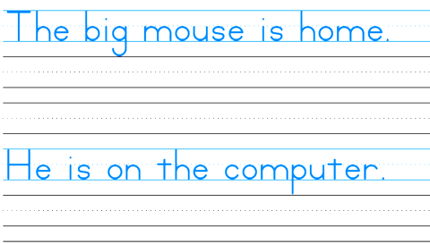
I live in Saudi Arabia
2 /
Good luck

