Quiz number 1 ------------- Unit number 1

2 ………………………………………………………………………………………………………………………………………..
3 ………………………………………………………………………………………………………………………………………..
4 ………………………………………………………………………………………………………………………………………..
5 ………………………………………………………………………………………………………………………………………..
6 ………………………………………………………………………………………………………………………………………..

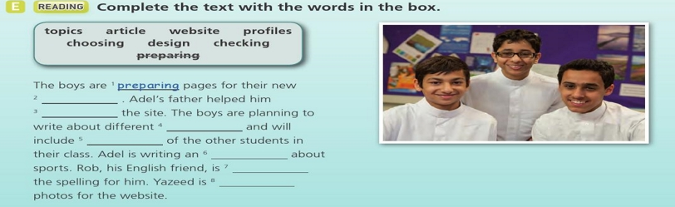
Your name please …………………………………………………………..................... your class ………………
Signature …………………………………………………..

