

English Language

Intermediate Grade 1st

period Exam

Kingdom of Saudi Arabia

Ministry of Education

……………… intermediate school

Student's Name : class:

|  |
| --- |
|  |
| 5 |

1-Read the following passage and answer the questions below:

My favorite mall is Al-Othem shopping Centre . It is in Riyadh .It is very big and it has two floors. There are many shops . It also has a large supermarket . There are many places that sell tasty food. Shopping in Al-Othem is easy .

**A-Choose the correct answer:**

1-Al-Otheim shopping Centre is in …………………………..

a- Riyadh b-Jeddah c- Abha

2-There is a large ………….. in AL-Otheim shopping Centre .

a-bookstore b-bank c-supermarket

3- It is very big it has ………………………. floors.

a- two b-five c-three

**B) Put (√ ) or (×):**

1- Shopping in AL-Othem is easy . ( )

2- There aren't any restaurant . ( )

|  |
| --- |
|  |
| 5 |

**2-choose the correct answer**

1- We like to ( goes – going – go) shopping.

2- I'm going to ( wear – wearing – wears ) jeans.

3-( Are – Am – Is ) you going to go to Dubai?

4- I can ( play – plays – playing ) chess.

5- Amal is( book – books – booking) the restaurant tonight.

6- They enjoy ( swim – swims – swimming) in the summer.

7- He’s going to ( taking – takes – take) light clothes.

8- John ( isn't – don't – doesn't ) like to ride horses.

9- We are (watch - watching – watched )a film on TV this evening.

10- She can't stand ( cook – cooking – cooks ).

|  |
| --- |
|  |
| 6 |

**3. Do as shown between brackets.**

**A-(Correct)**

1-You can **speaks** English. …………………….

2- He is **wash** his car on Wednesday. ……………………

3- I would like to **buying** a new laptop. …………………

4- I’m going to **meeting** my friends. ………………..……

**B-(answer )**

a- Can Fred drive a bus?

No, …………………………………………………….

**C- ( Give the negative ).**

a-Omar likes to fish.

…………………………………………………………

**D-(reorder)**

a- She / going / a new dress / is / to buy

………………………………………………………………………………………………………………..…….

b- -Ali wears a ( lovely , leather , black ) shoes .

……………………………………………………………………………………………………………………….

|  |
| --- |
|  |
| 4 |

4- **choose the correct answer.**

a- a place you can fly to places. ( airport - bus station – park)

b- Saudi men wear ( thobe- suit – tie ).

**5-Write the missing letters.**

1- mu…….eum 2- restaura……t.

6-**write the correct word for each picture.**

pants boots socks skirt

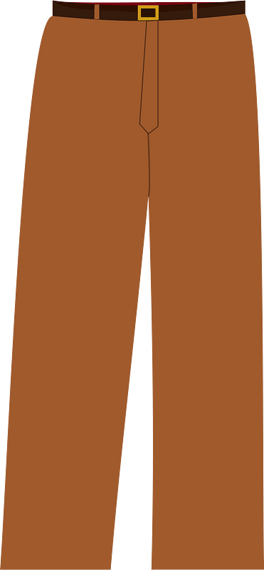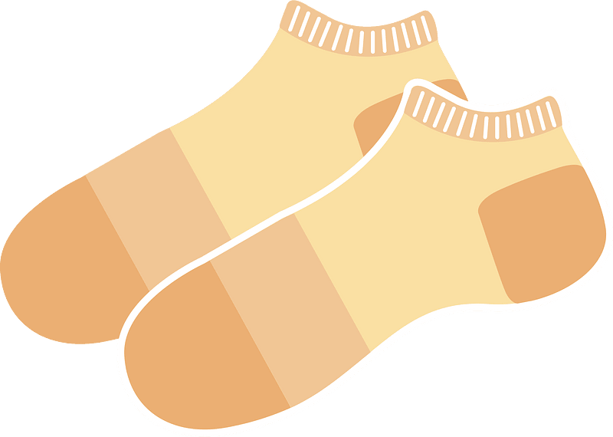

………………..

………………..

………………..

………………..

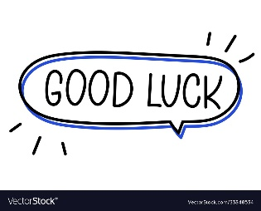

Your teacher



Kingdom of Saudi Arabia

Ministry of Education

………… Education Directorate

……………….. Intermediate School

**Super Goal 1** - **Test** unit 12 & 13

By **Rashed Alsulami** | **Telegram:** https://t.me/iRashed

Name :………………………………………………………………………… Class:…….……….

**Comprehension**

2 Marks

* **Read the text and answer the questions. Write T or F at the end of each question/statement.**

I like to go to the sports center. I go there every weekend. At the sports center, you can do many things. For example, you can play golf or tennis. There is a pool, so you can also swim or relax by the pool. There is a beach next to the sports center. You can swim, water-ski, or windsurf in the ocean. You can also sail on windy days. There aren’t any fish near the beach, so you can’t snorkel. When I go to the sports center, I like to play volleyball on the beach. I also like to jog on the beach. I can’t swim well, so I don’t like to water-ski or windsurf.

1. The writer likes the sports center. ( )
2. You can swim in the pool or in the ocean. ( )
3. People can windsurf in the pool. ( )
4. You can’t use a boat in the ocean.( )

**Grammar**

* **Choose the best answer to fill in the blank in each question.**

5 Marks

1. He can’t surf, but he _____ water-ski.

**a**. can’t **b**. can  **c**. not can **d.** don’t can

1. **Jill:** Does she like to cook? **Kate:** No, _____.

**a**. she does **b**. she don’t  **c**. she doesn’t **d.** doesn’t she

1. I’d like _____ a new laptop, but I can’t afford one. (buy)

**a**. to buy **b**. buy  **c**. buy to  **d.** bought

1. I’m not going to buy jeans. ____________ pants.

**a**. I buying **b**. I’m going to buy **c**. I’m going buying **d.** I going to buy

1. He ____________ a big wedding.

**a**. is have **b**. having **c**. going to have **d.** is going to have

**اقلب الصفحة**



* **Write the gerund or infinitive of the verb in parentheses to fill in the blank.**

1. I’d like _________ a new laptop, but I can’t afford one. (buy(

1.5 Marks

1. Hameed enjoys ____________ volleyball at the beach. (play)
2. Amal spends her free time _________________ books. (read)

* **Write the correct answer to fill in the blank.**

1.5 Marks

1. **Mei:** _______________ you going buy a new dress? **Lisa:** No, I’m not.
2. **Ella:** _____________ are you going to wear?  **Laura:** A black skirt.
3. **Tim:** Are they going to wear jackets? **Harry:** Yes, ______.

**Vocabulary**

* **Choose the best answer to fill in the blank in each question.**

5 Marks

1. You can _____ at the pool.

**a**. swim **b**. surf  **c**. rollerblade **d.** sail

1. I sometimes _____ my bike to work.

**a**. ride **b**. drive  **c**. go **d.** get up

1. Do you need to buy new ____________ to play basketball.

**a**. suit **b**. shirt  **c**. sneakers  **d.** blouses

1. It’s hot. Are you going to wear ____________?

**a**. jeans  **b**. shorts **c**. coat **d.** jacket

1. Women should wear a formal _______to a wedding.

**a**. tie **b**. suit **c**. thobe  **d.** dress

* **Write the correct word under the picture.**

3 Marks

Skirt – Boots – Gym



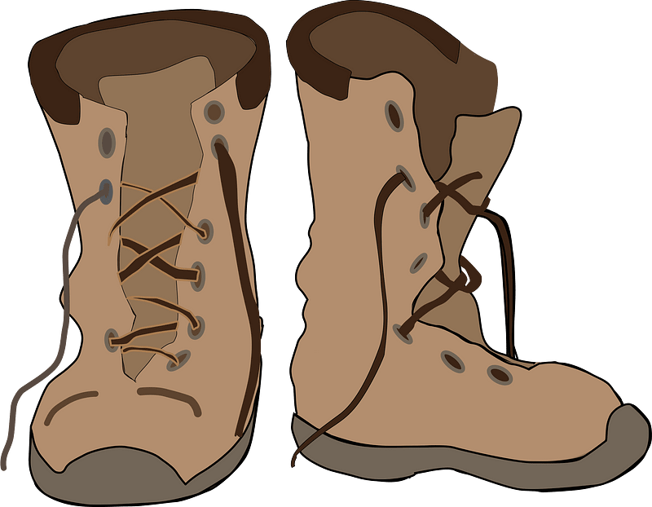

………………………………………….

………………………………………….

………………………………………….

**Orthography**

* **Choose the correct letter.**

2 Marks

* You can go sho…..ping and meet friends. ( v – p – r)
* You need warm clothes it’s …..old in Abha ( n – o – c)

**انتهت الأسئلة....**

**التوفيق والنجاح دوماً في طريقكم أبنائي.. تذكروا دائماً بأنني فخور بكم فأنتم مستقبل هذا الوطن الغالي إن شاء الله ونجاحكم هو نجاحي..**

**الأستاذ / راشد السلمي**