We Can! Book 4 Unit 3: My House

1. Listen, unscramble the letters, and write the words.

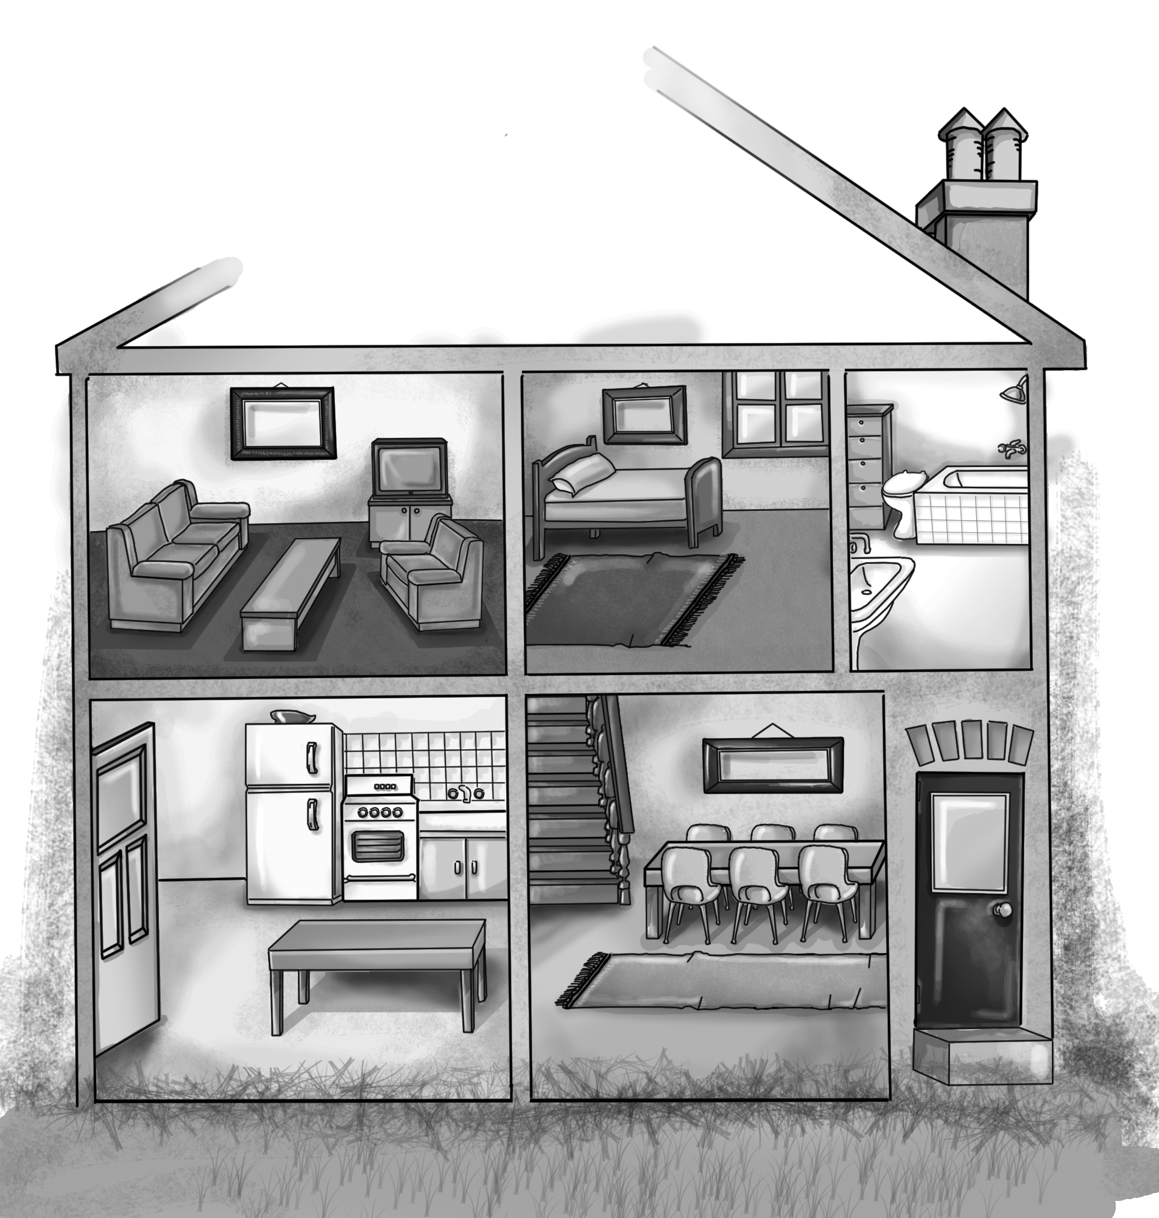 | 1.trofn rodo  ___________  2. nindig mroo  ___________  3. ntiheck  ___________  4. rbohotam  ___________  5. erobdom  ___________  6. ngviil moro  ___________
2. Read and circle Y(Yes) or N(No) for each sentence.
1. There is a TV between the sofa and the armchair. Y N
2. There is a rug under the bed. Y N
3. There is an armchair opposite the sofa. Y N
4. There is a rug in front of the bed. Y N
5. There is a fridge behind the door. Y N
3. Listen and number the pictures. Then write.

Mom | Joe | the boy | Joe
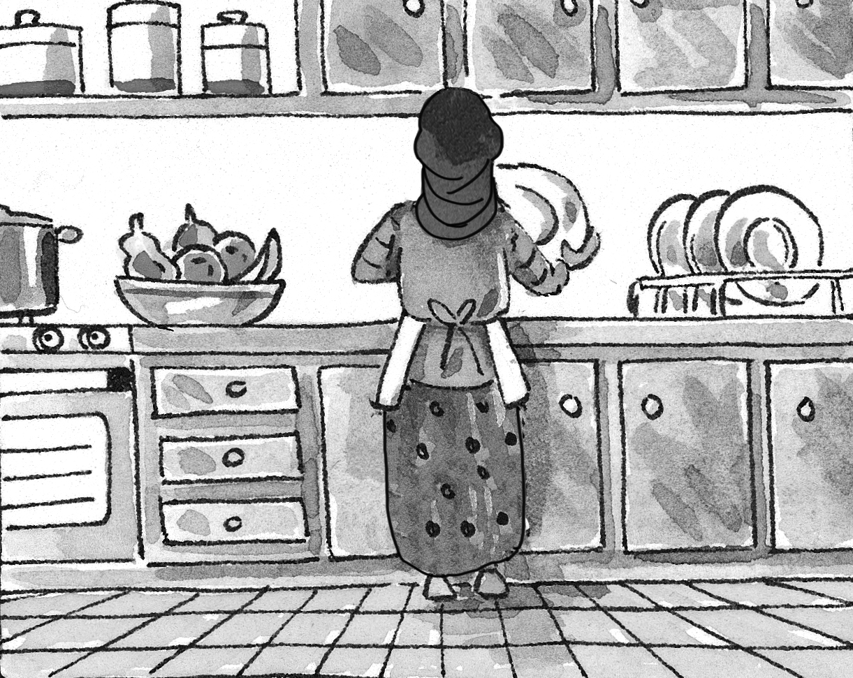 | 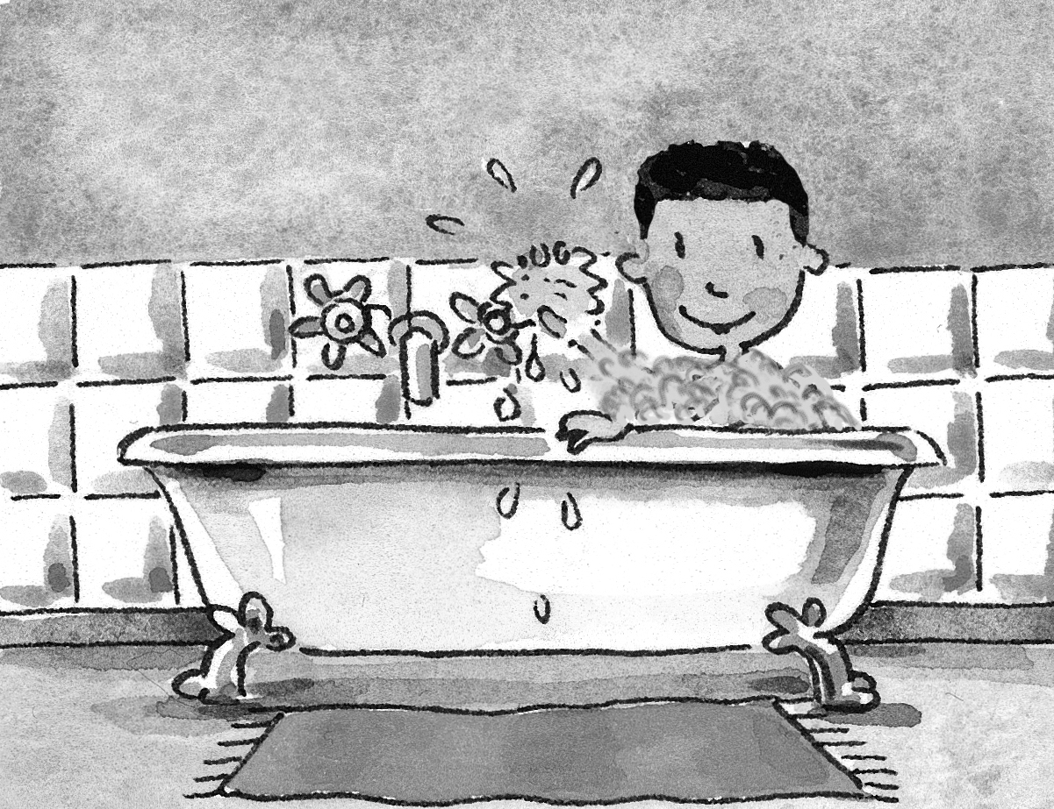 | 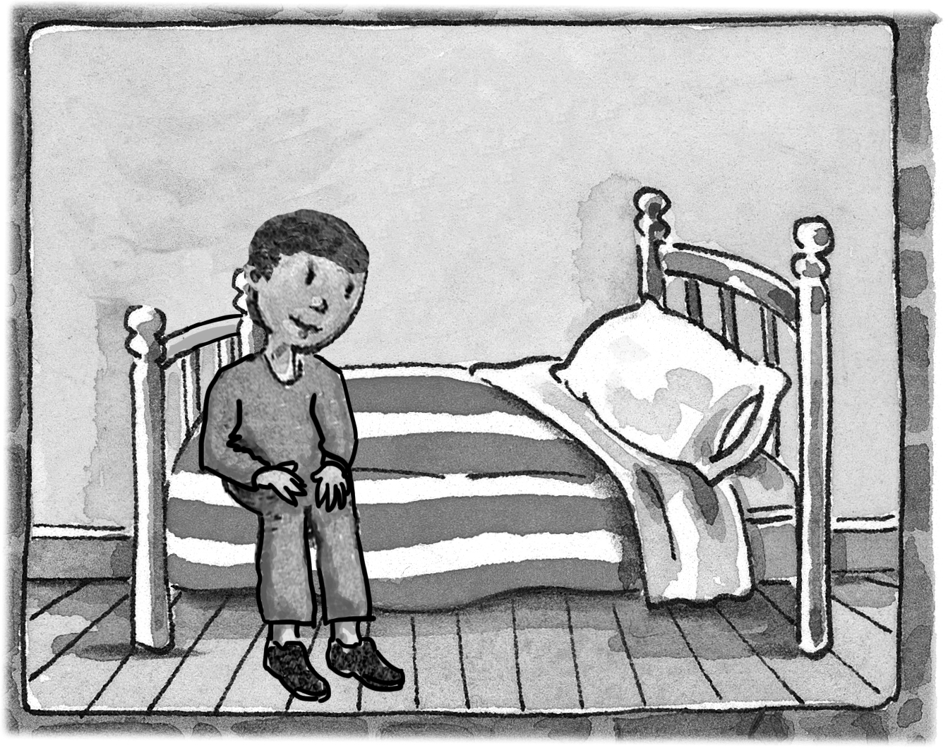 | 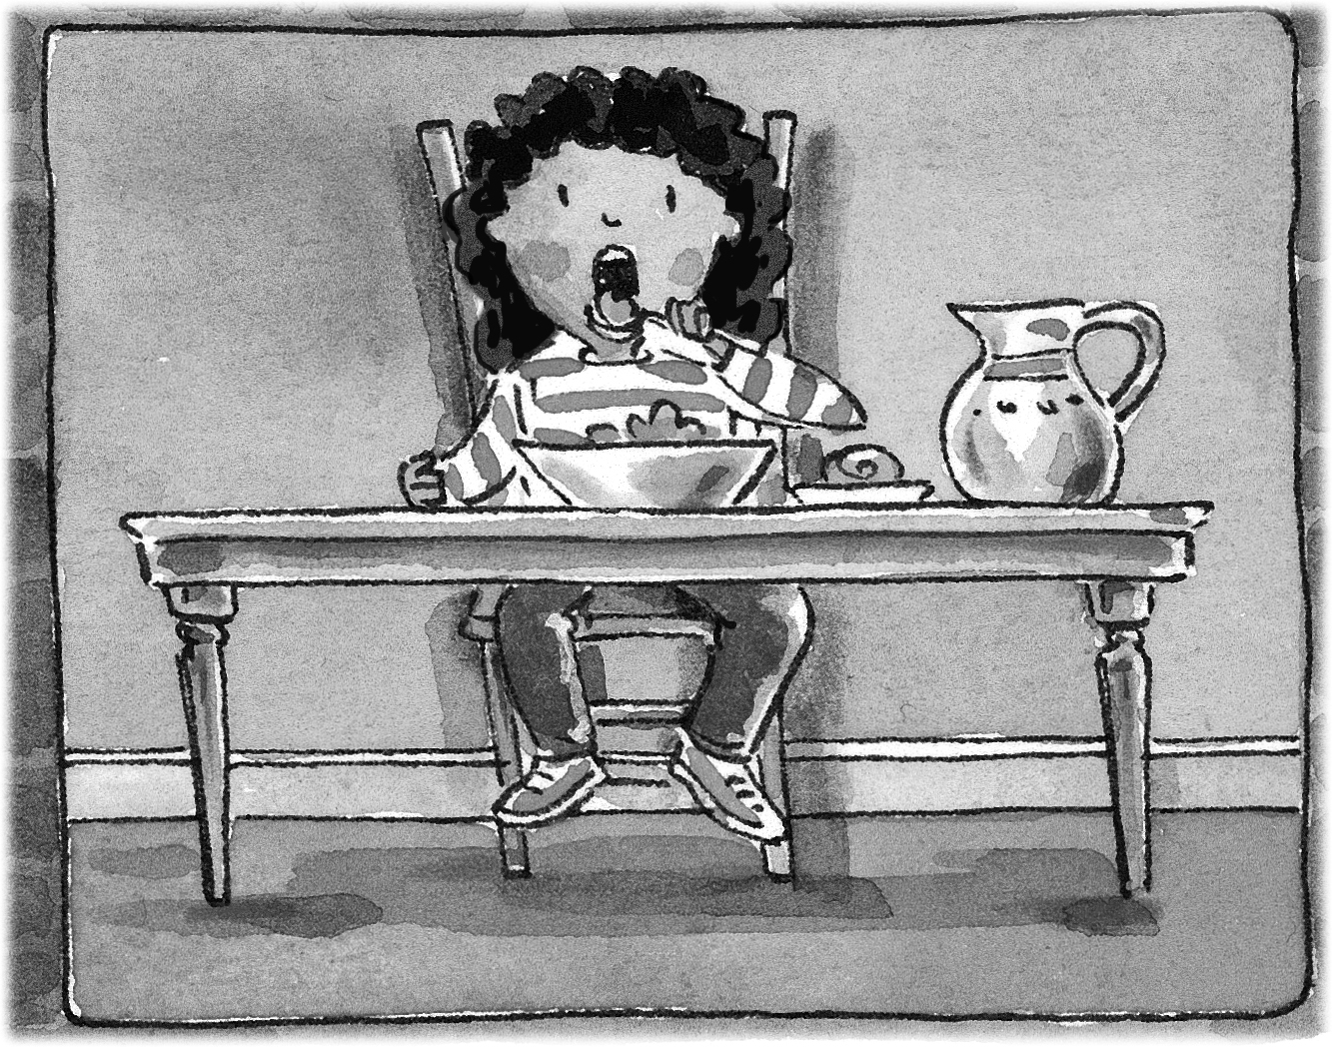
___ | ___ | ___ | ___
1. Where’s Joe? He’s in the_______________.
2. Where’s Mom? She ____________________.
3. Where’s Joe? ____________________ room.
4. Where’s the boy? _______________________.
4. Match the words with the pictures. Then write.

do my homework __ eat lunch __ get up __ play __
go to bed __ go to school __

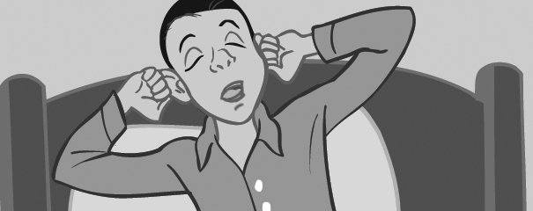  I _________ at 7 o’clock. | Then I ____________.
I _________ at 2 o’clock. | 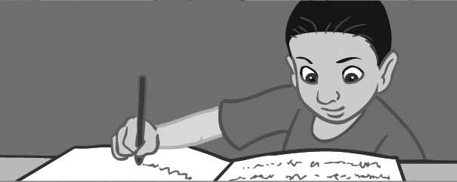  Then I ____________.
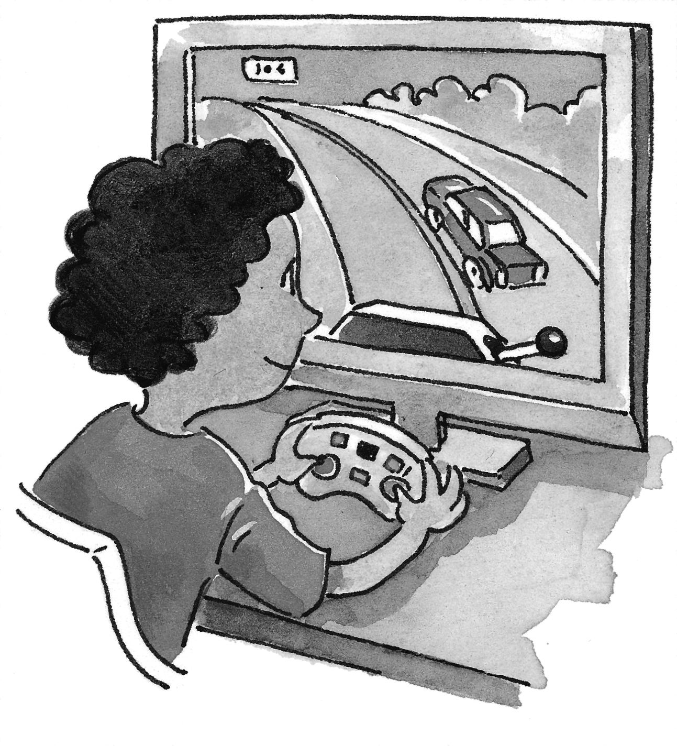  I ______computer games and watch TV. | At night I ___________.

