|  |  |  |  |
| --- | --- | --- | --- |
| **المملكة العربية السعودية**  **وزارة التعليم**  **الإدارة العامة للتعليم بـن مدرسة مستقبل ن الابتدائية** | **http://tabuk2day.com/wp-content/uploads/IMG_3362.jpgبسم الله الرحمن الرحيم**  **اختبار الفصل الدراسي الثالث**  **للعام الدراسي 1444 هـ** | **المادة** | **لغة انجليزية** |
| **الصف** | **السادس** |
| **الزمن** | **ساعة ونصف** |
| **الفصل** | **----- /6** |
| **اسم الطالب رباعيا: .............................................................................................................**   |  |  |  |  |  |  |  |  | | --- | --- | --- | --- | --- | --- | --- | --- | | **السؤال** | **1** | **2** | **3** | **4** | **5** | **6** | **المجموع** | | **الدرجة** |  |  |  |  |  |  |  | | **الدرجة** | 4 | 5 | 6 | 6 | 5 | 4 | 30 | | **المصحح** |  |  |  |  |  |  |  | | | | |

**match: General Questions**

**4**

**1. How many students are there in your school? ------------------------------------.**

**2. What would you like to drink? ------------------------------------.**

**3. What time does your school start? ------------------------------------.**

**4. Can I help you? ------------------------------------.**

**match: Controlled Writing**

**5**

**1. This year, I am in the 6th _______. a. much**

**2. Speak ____in class. b. grade**

**3. How ____is it? It's 160 SR. c. English**

**Rearrange:**

**1. Riyadh – in – I – live -------------------------------.**

**2. going – I'm – to – store – candy - the ---------------------------.**

**Choose: Grammar**

**6**

**1.Last year, I (**is – was – am**) in the 5th grade.**

**2. This year, I (**like – liked - likes**) English.**

**3. The past of "drink" is (**drank – drinking – drinks**).**

**4. The past of "get up" is (**get up – got up – gets up**).**

**5. I (**is – are – am**) going to the doctor.**

**6. (**There is – There are – Is there**) two floors.**

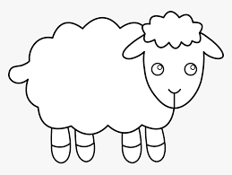**match: Vocabulary**

**6**

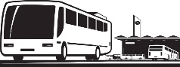**math**

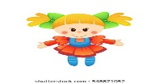 **sky diving**

**lamb**

**globe**

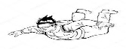 **bus stop**

**doll**

**5**

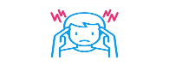**match: Reading**

 **1. I have an earache.**

**2. I want a sweater.**

** 3. I should get up early.**

** 4. Don't make too much noise.**

**5. I have a headache.**

**match: Orthography**

**4**

**1. _ _ arf u-e**

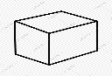**2. c _ b _ ir**

**3. b _ _ d sq**

**4. _ _ uare sc**

**End of Question**