Test 4
20
TOTAL

Name .

1. Read, look and write a-h.
1. trainers 2. jeans 3. glasses 4. gloves
5. scarf 6. jacket 7. abaya 8. sandals
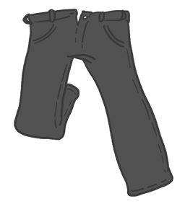
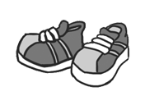
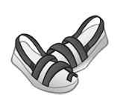
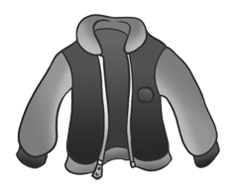
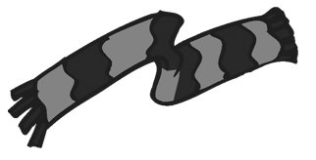
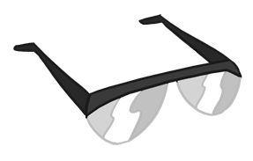
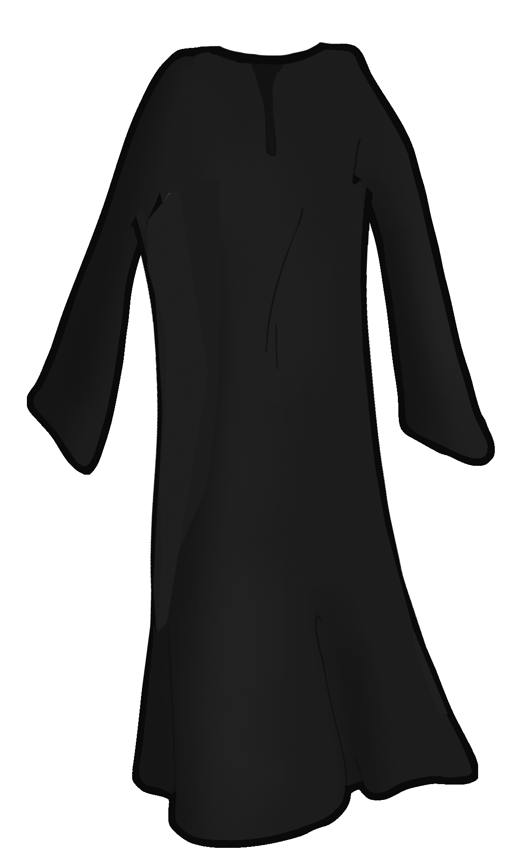
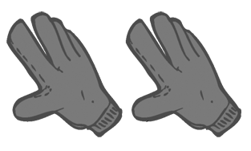
a.
b.
c.
d.
e.
f.
g.
h.
4
score

table tennis basketball volleyball football

2. Look, read and complete.
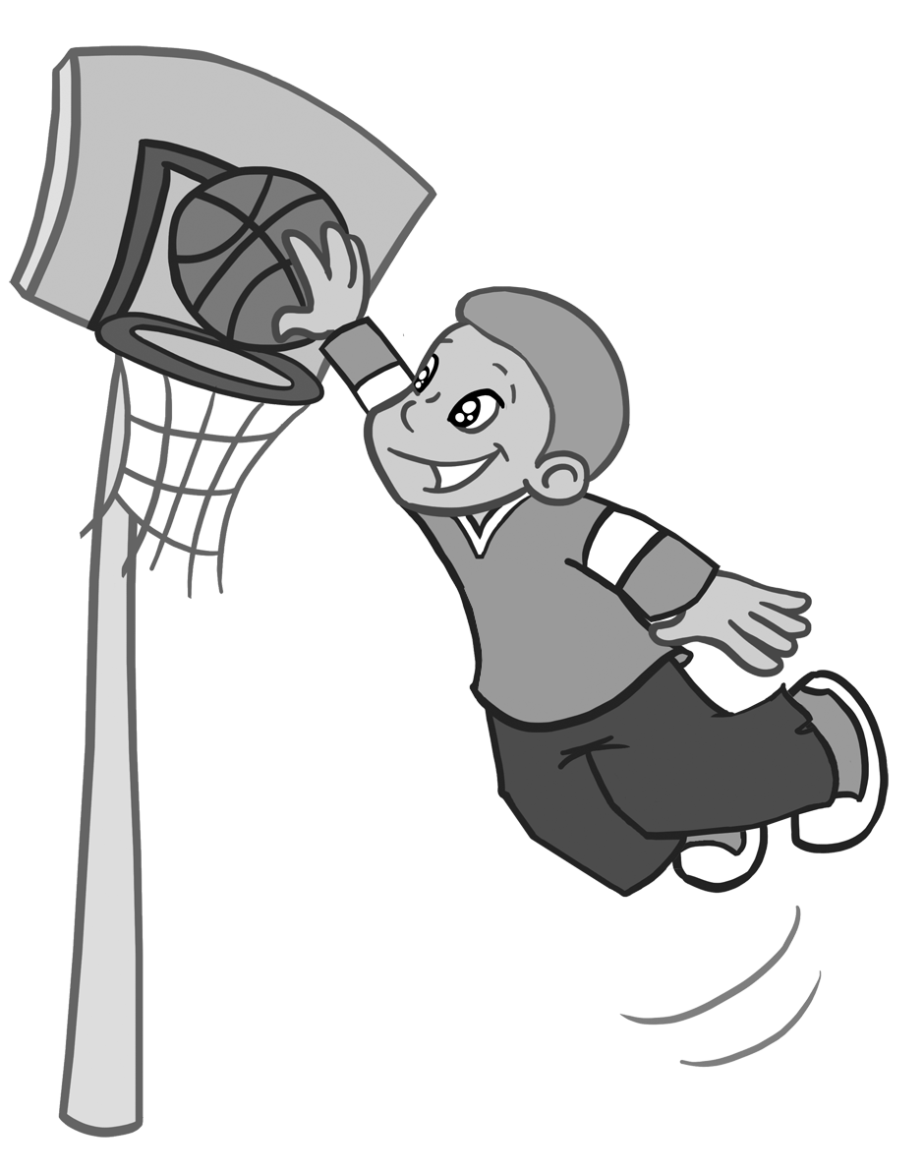
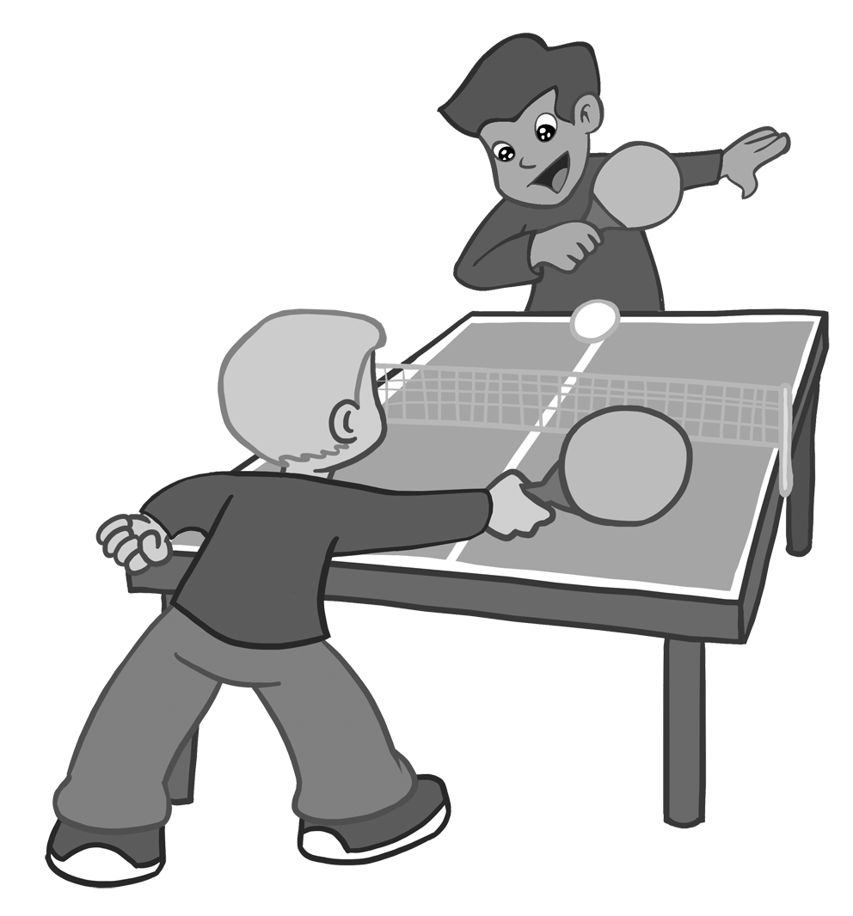
3. They are .
.

4. They .
.
1. He is playing
.
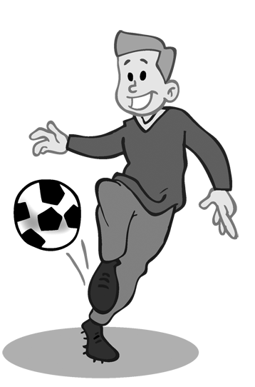
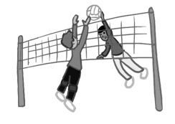
2. He .
.
4
score

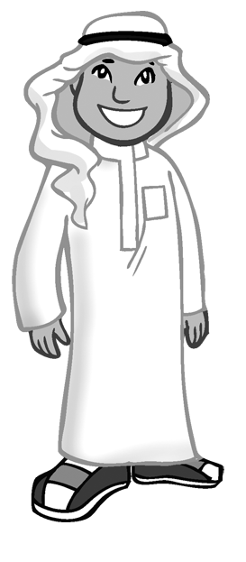
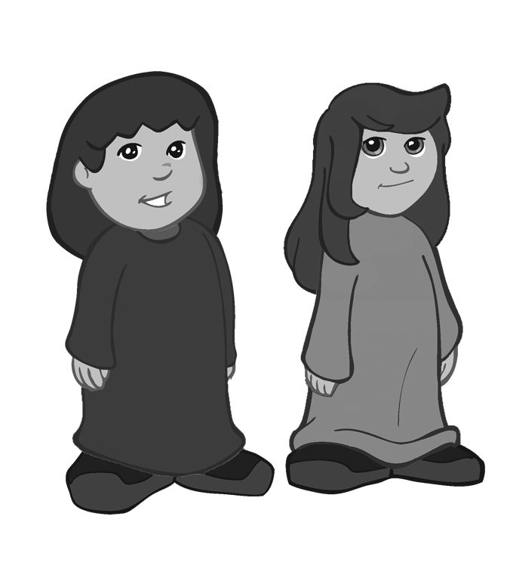

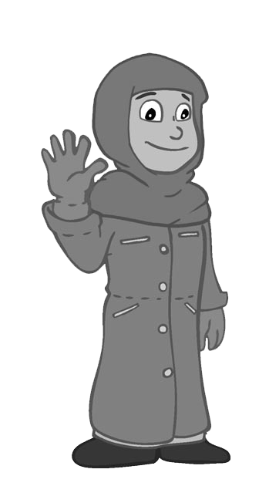

3. Listen and tick (✓).
3. Yes, they are.
No, they aren’t.

4. Yes, he is.
No, he isn’t.
1. Yes, she is.
No, she isn’t.

2. Yes, he is.
No, he isn’t.
4
score

4. Put in the correct order.
1. is playing football not Omar .
2. Ali Is pyjamas wearing ?
3. They reading are book a .
4. aren’t wearing They socks .
4
score

5. Read, look and answer.
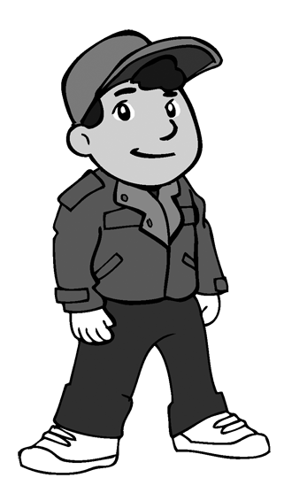
1. Whose jacket is this? It’s .
1
4
2. Whose trainers are these? They’re .
3. Whose coat is this? .
2
3
4. Whose gloves are these? .
Ashraf

Reema

4
score

