We Can! Book 6 Unit 2: Life’s Ups and Downs

1. Look at the pictures and fill in the missing words.

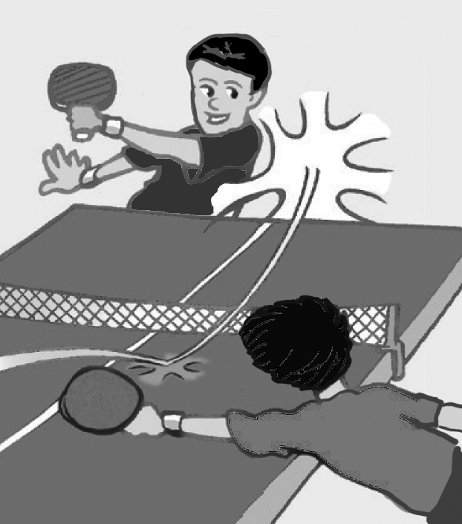  1 | 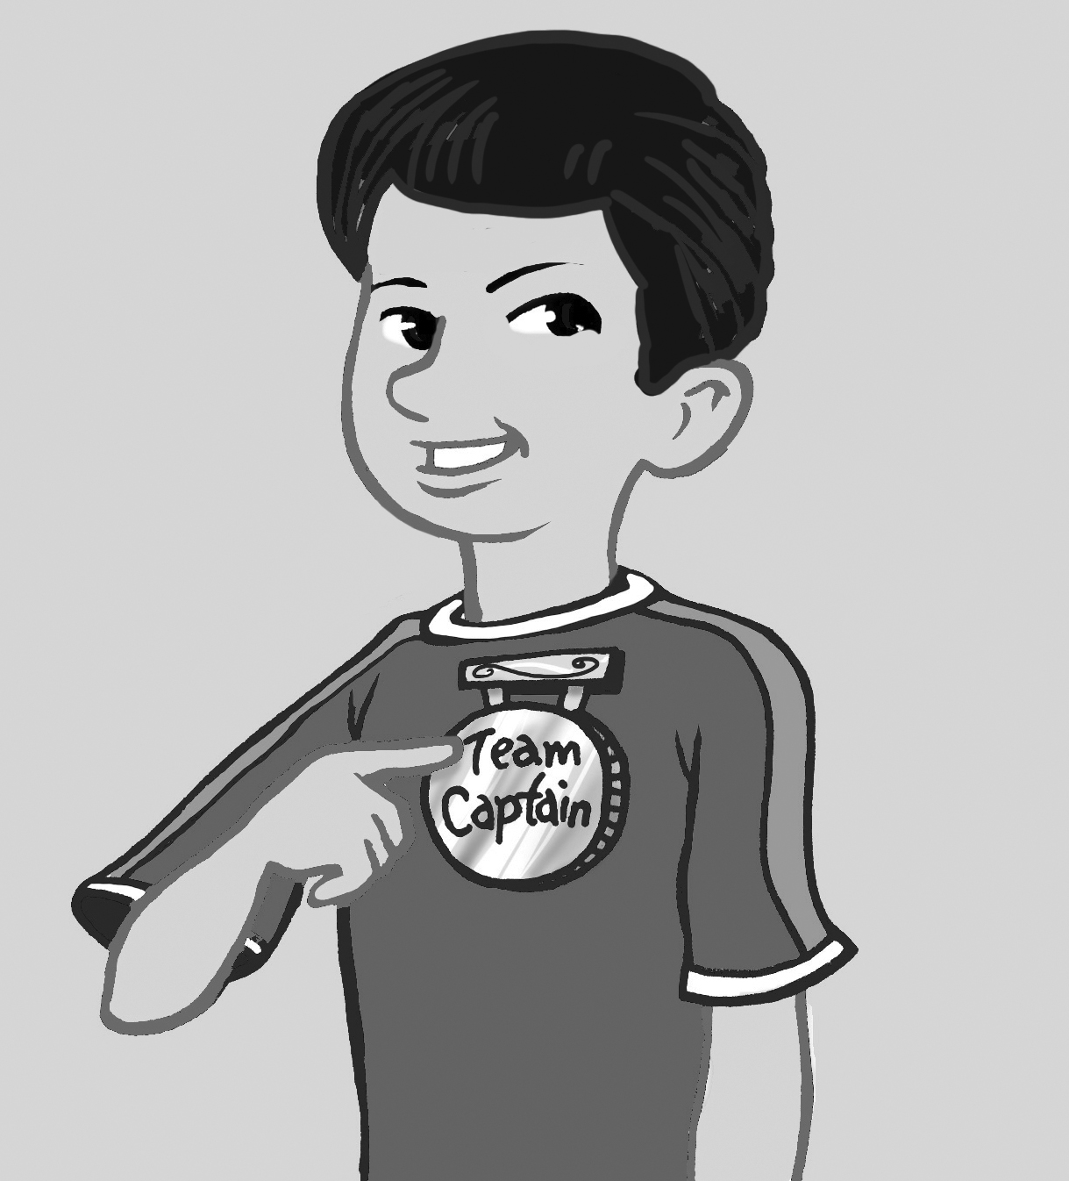  2 | 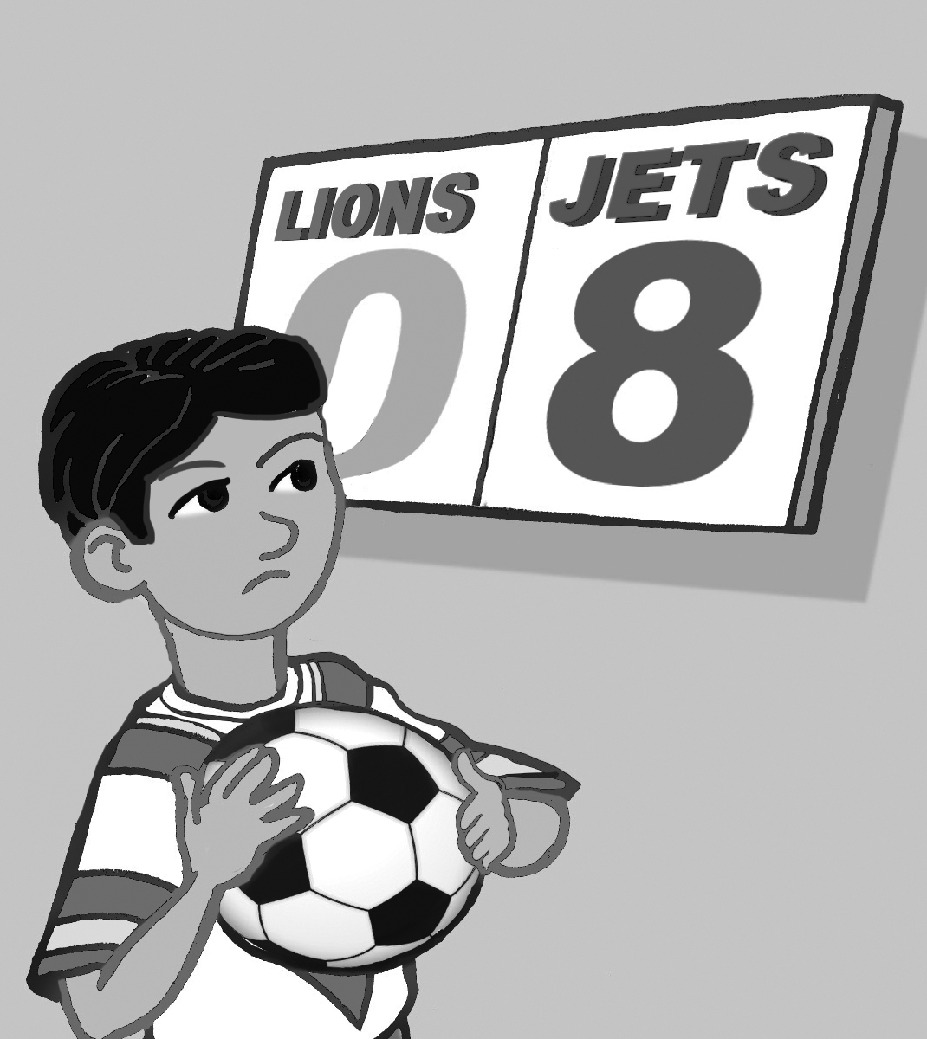  3 | 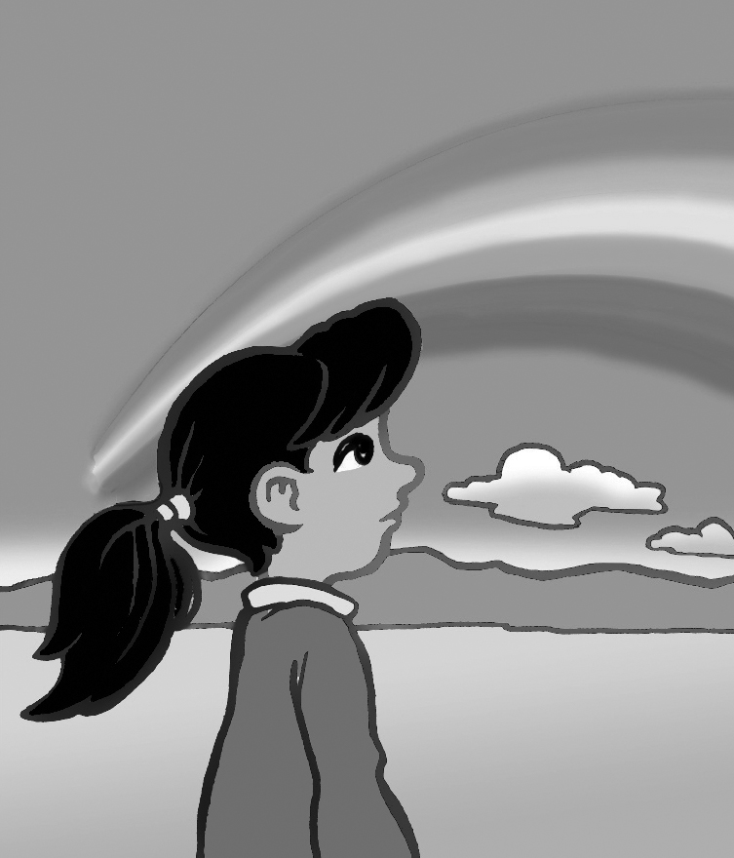  4
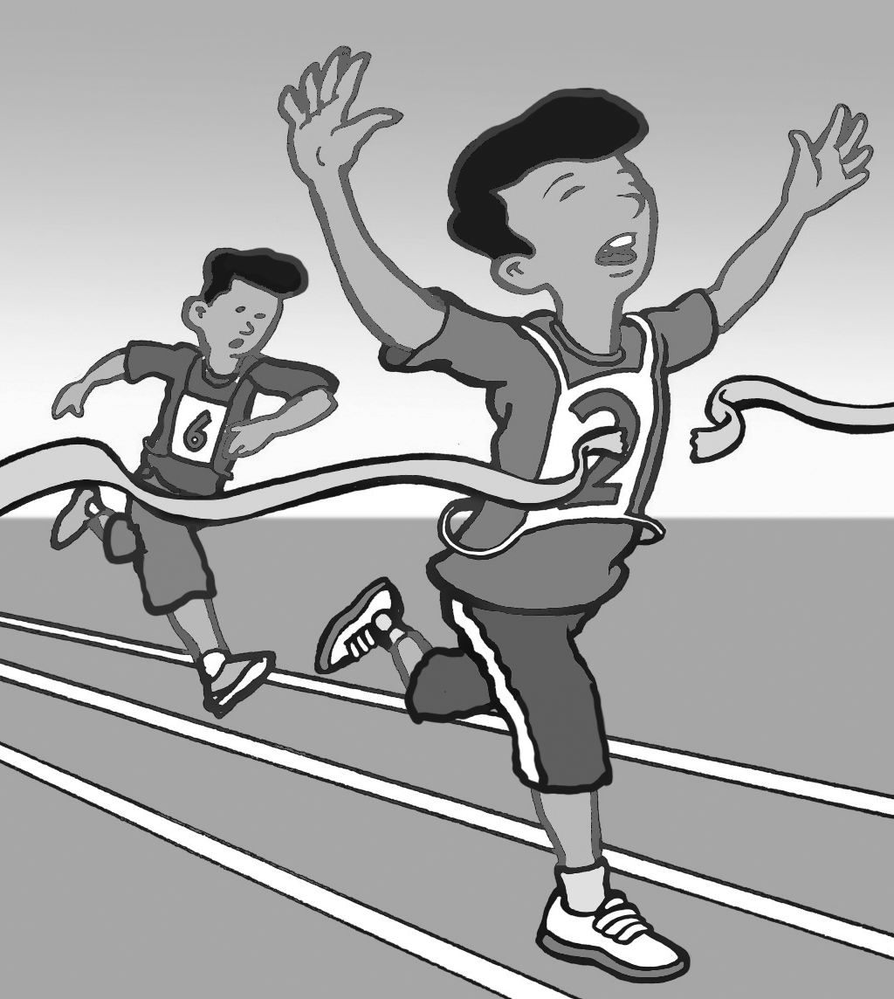  5 | 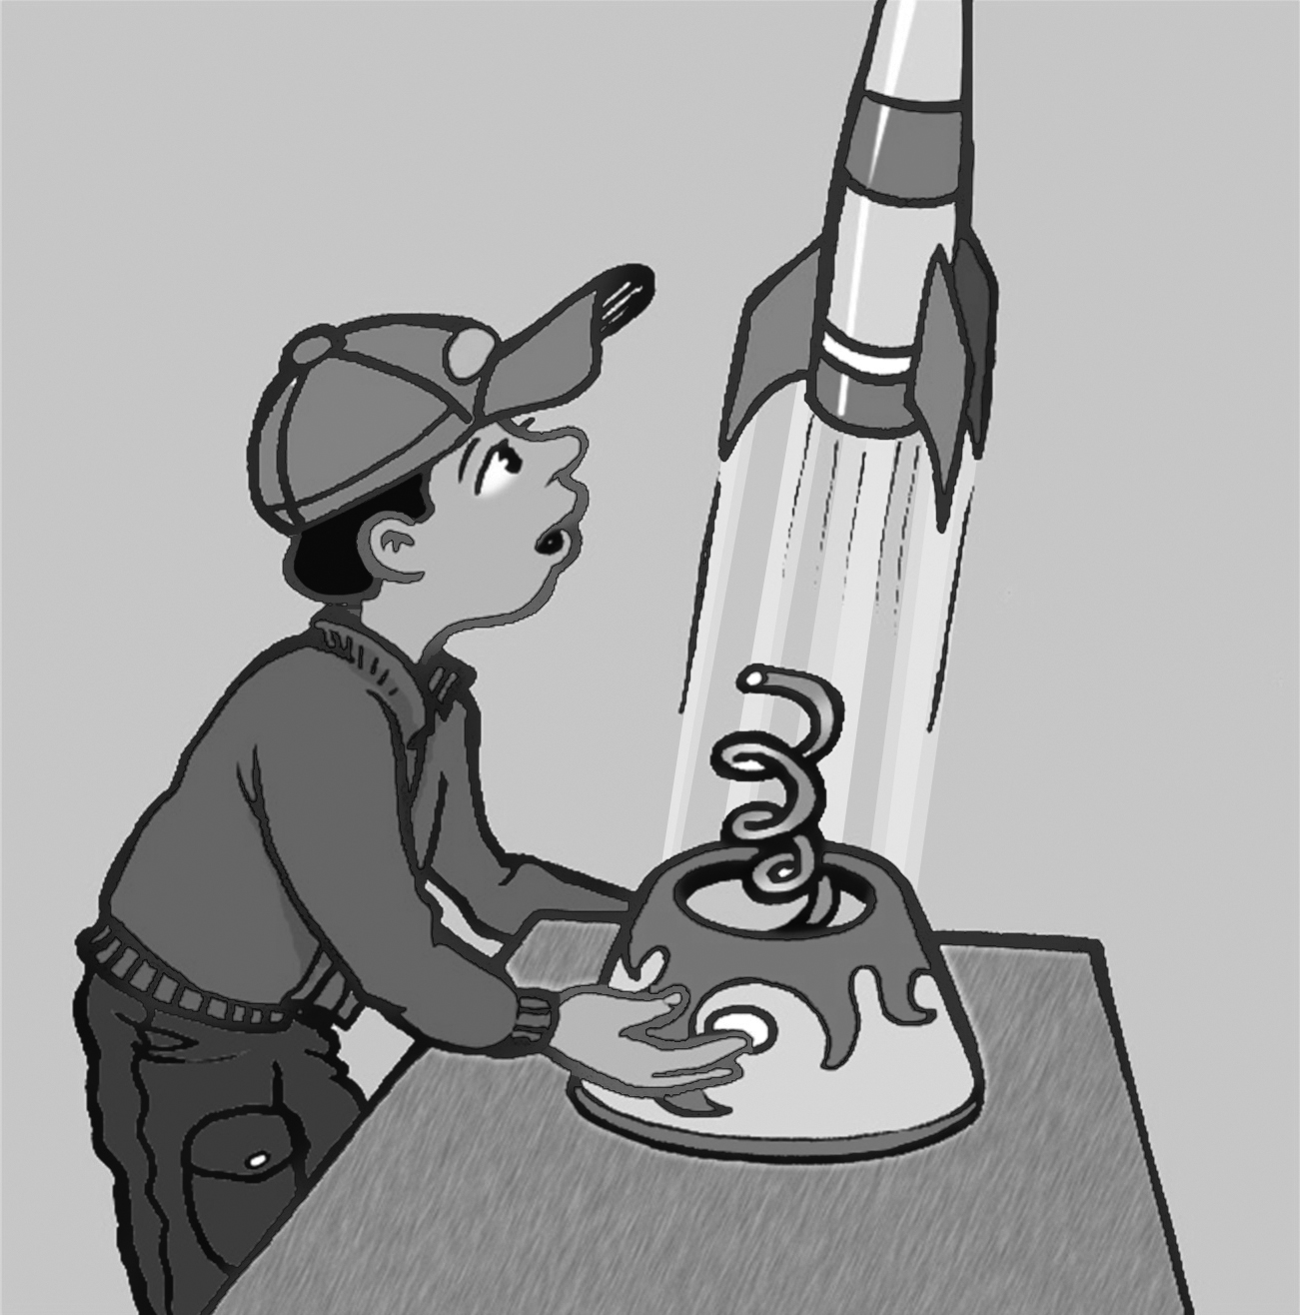  6 | 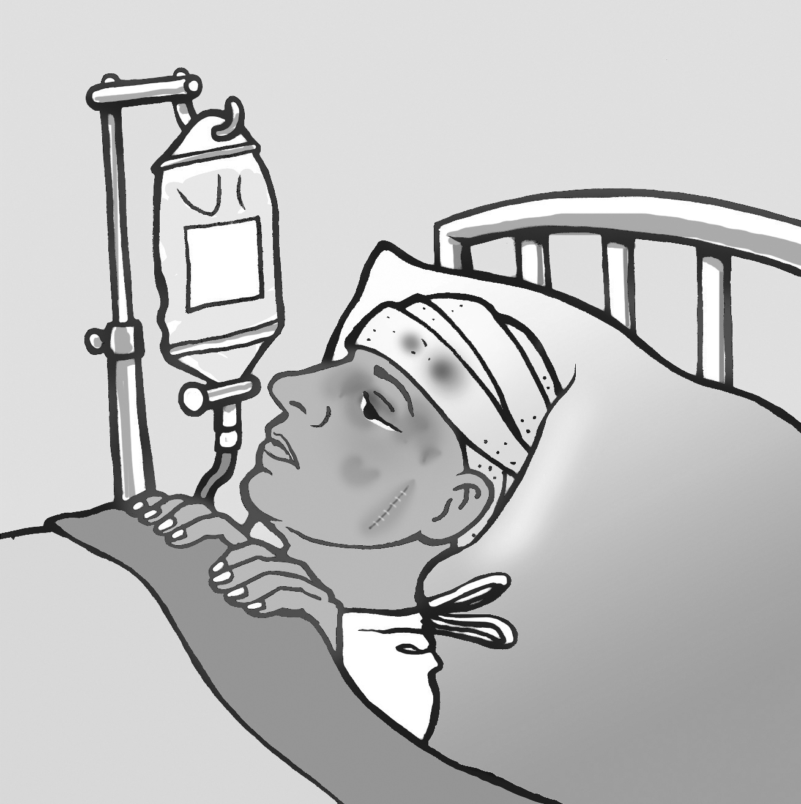  7 | 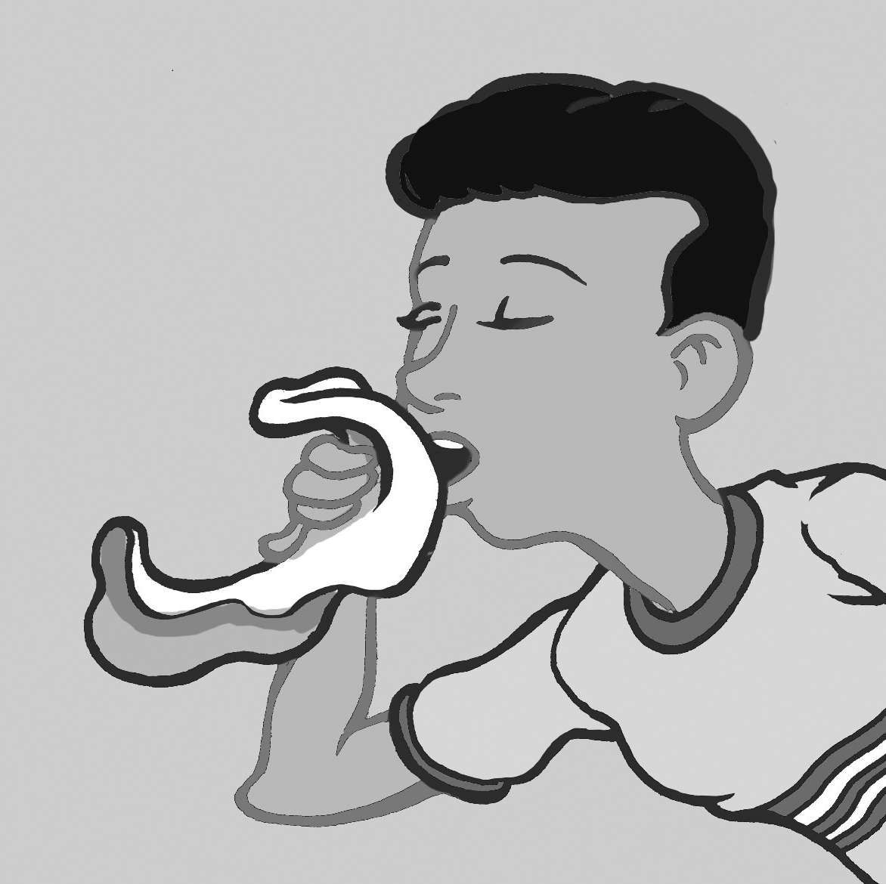  8
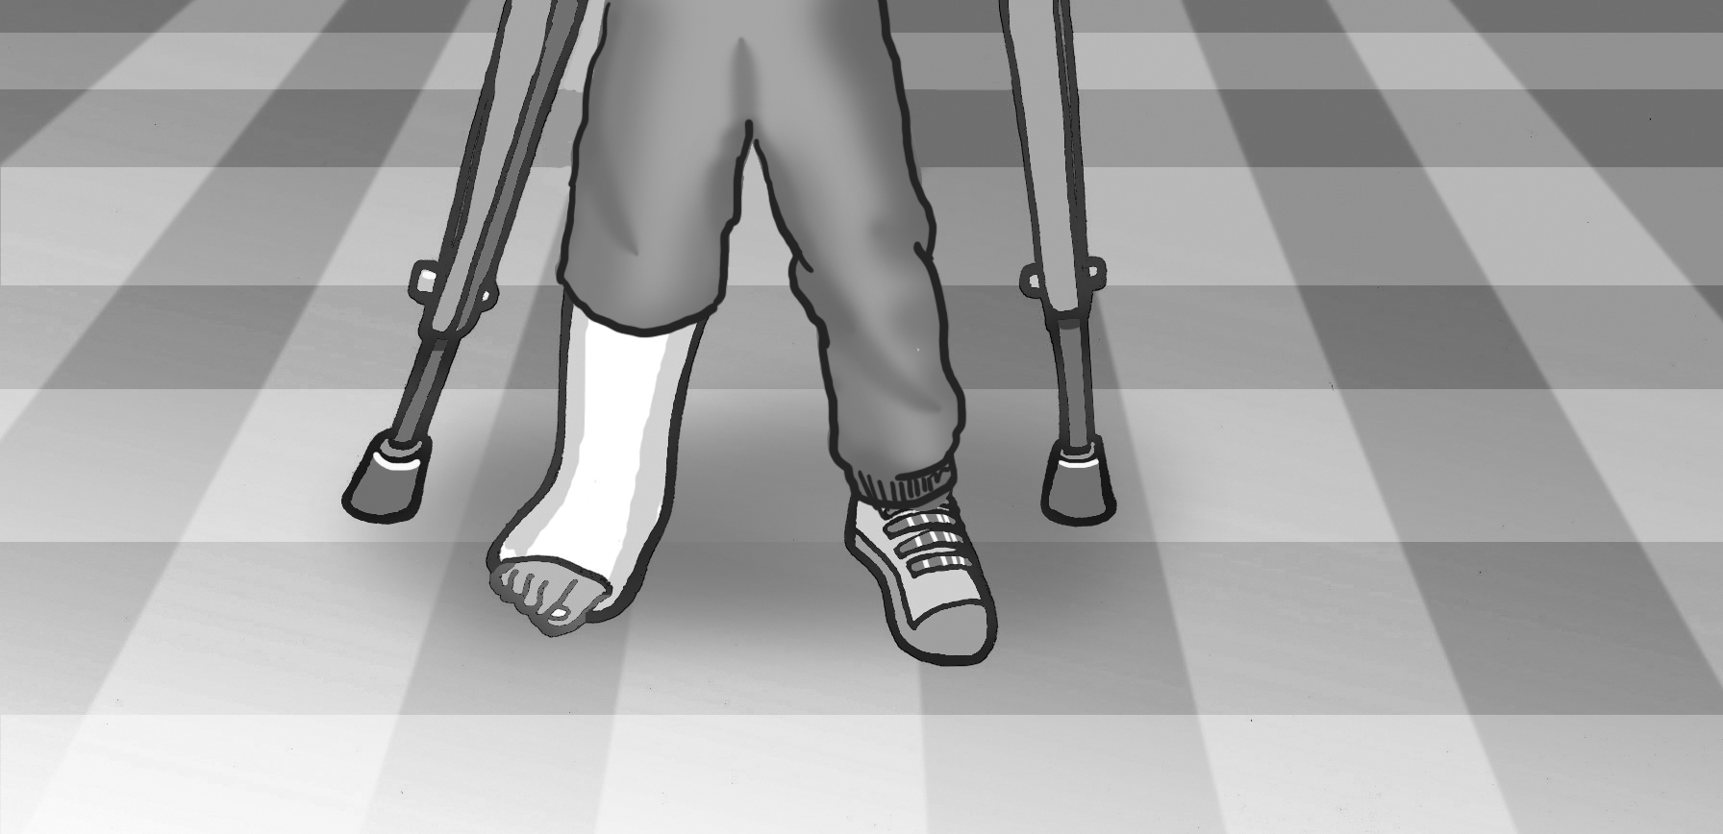  9 |  | 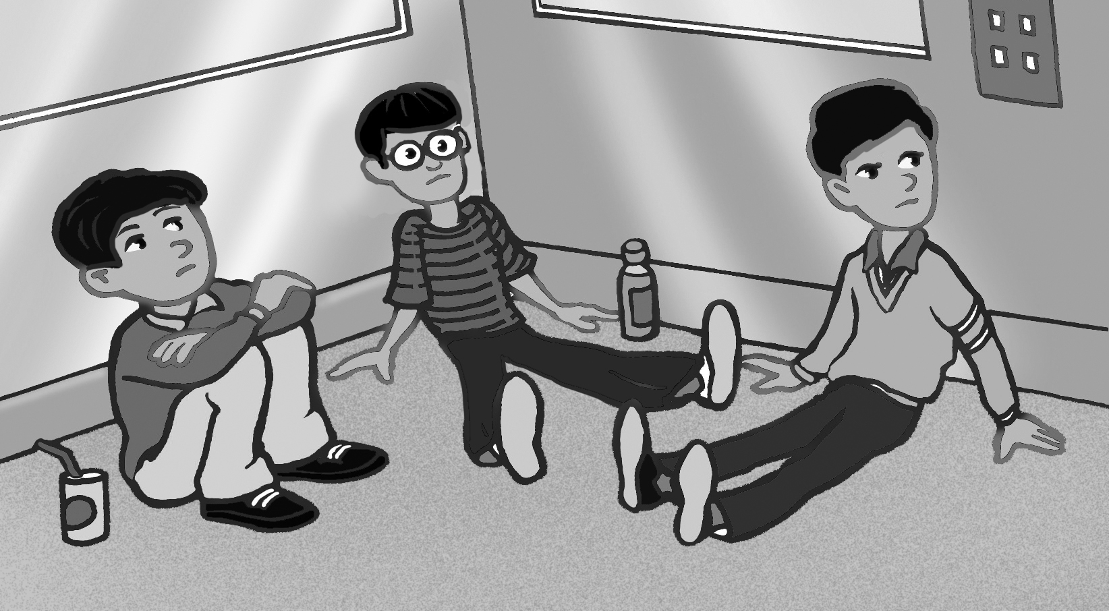  10

saw were broke had got lost was won made caught

1. I won a table tennis game.
2. I was team captain.
3. We lost a football game.
4. I saw a rainbow.
5. I got first place in the race.
6. I made a rocket.
7. My dad had an operation.
8. I caught a cold.
9. I broke my leg.
10. We were stuck in an elevator.
2. Read and match comments with pictures.

1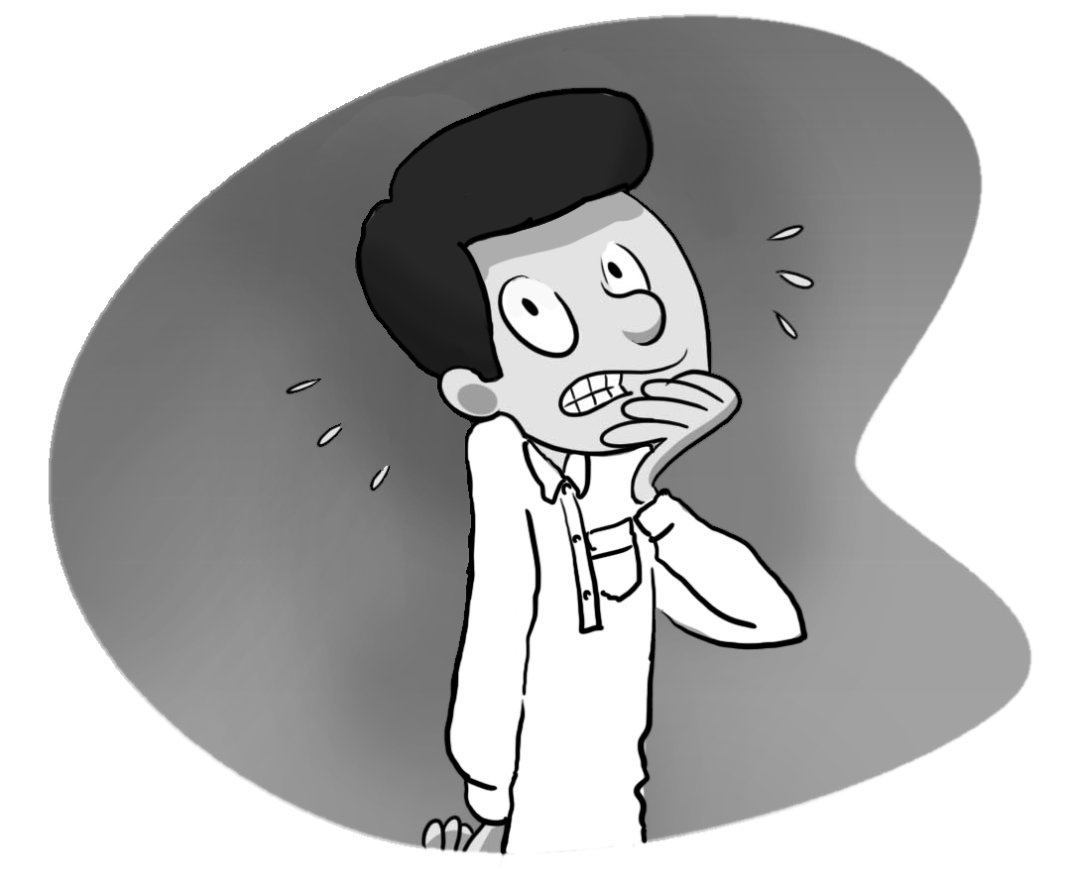 | 2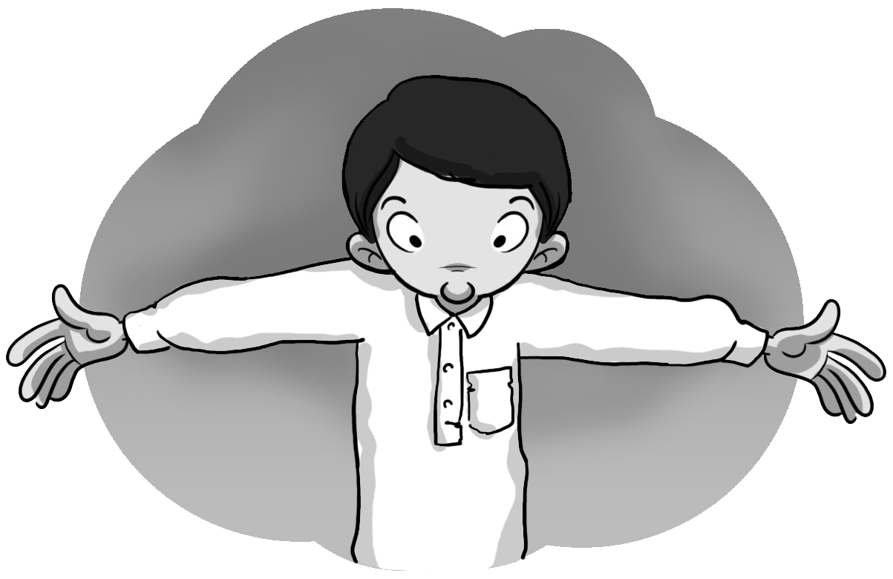 |  | 3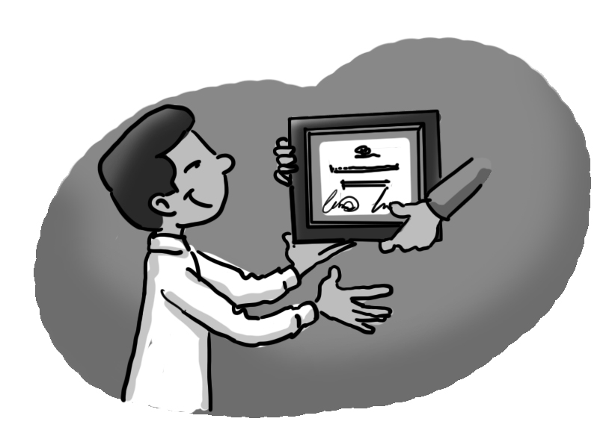
4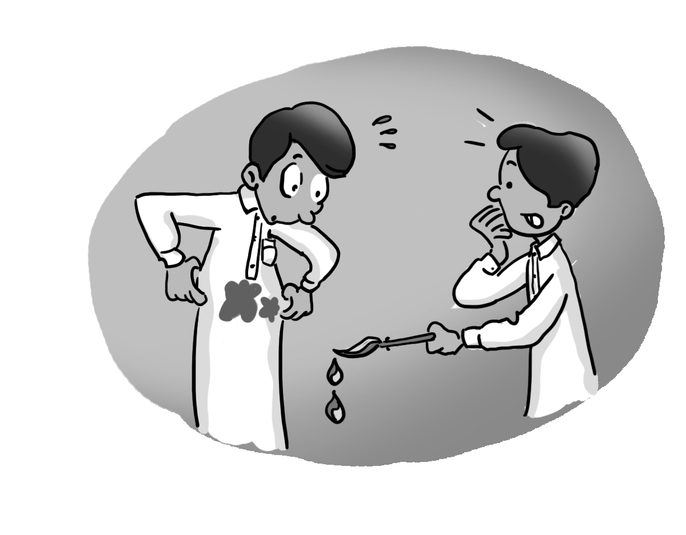 | 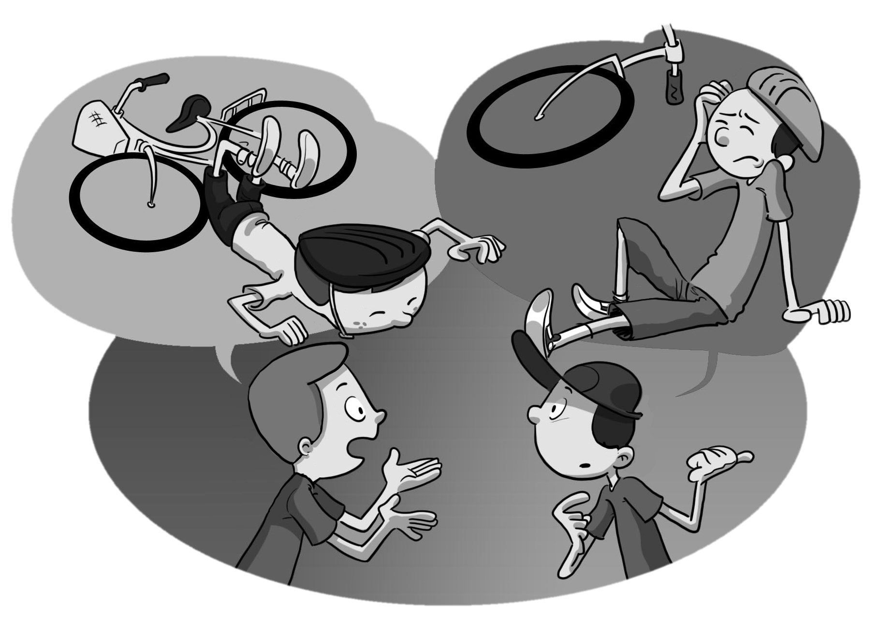  5
Congratulations 3 |  | How scary! 1
How strange! 2 |  | So did I. 5
Sorry about that. 4
3. Read and write your comment.

1. I saw a beautiful parrot in the garden.

That’s great! / So did I.
2. I broke my leg in the race.

Sorry! / I’m sorry about that./ That’s scary.
4. Listen and fill in the missing words.
[Play CD3 14 or read.]

had got went came was

My Brother Richard

My brother Richard
went to the cupboard,
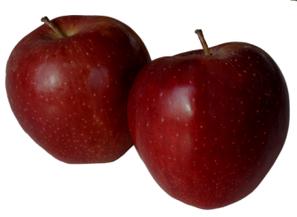
To find something to eat.
But when he got there,
The cupboard was bare,
And so he had nothing to eat.
He went to the grocer’s,
To buy some fruit and milk.
But when he came back,
He was holding and empty brown bag.
Poor Richard!

5. Write about a good event and a bad event, that happened to you last week, last month, last weekend, or last year.

