المملكة العربية السعودية

وزارة التعليم

إدارة التعليـــــــــــــــــــــــــــــــــــم بجدة

متوسطة ابن تيمه



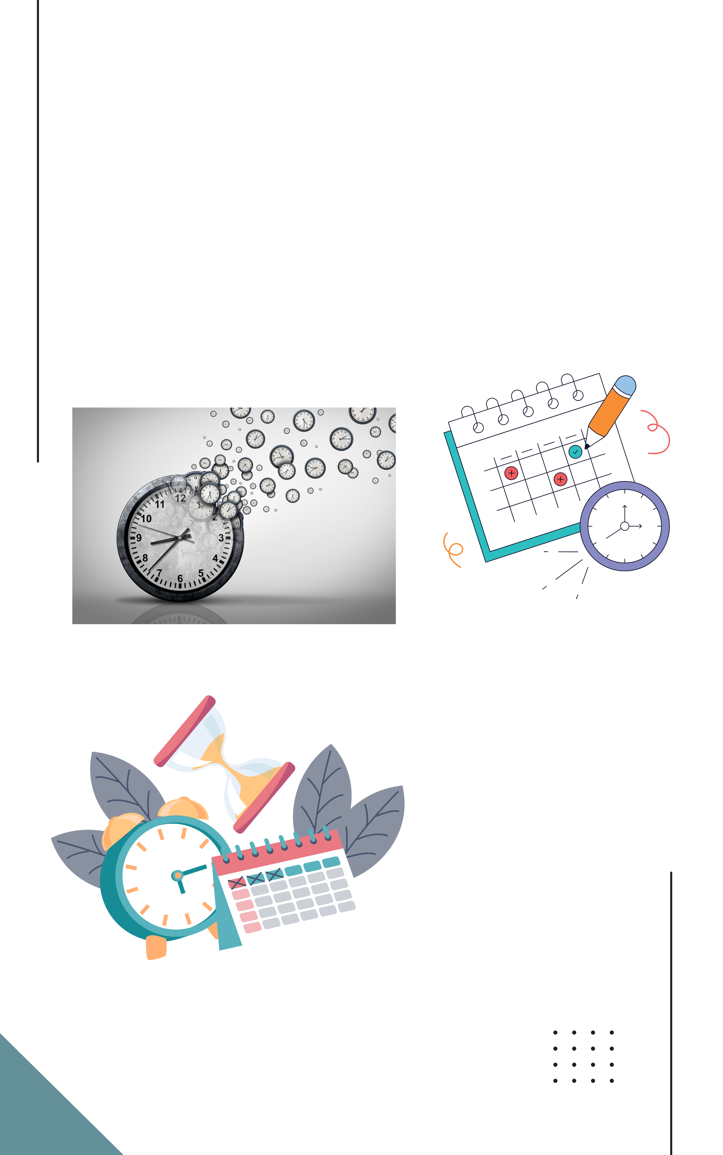

**سجل متابعة ورصد درجات أعمال السنة**

**لمــــادة المهــــــــارات الرقـــــــــــــــــــــــــــمية**

**الفصل الدراسي الأول**

**للعام الدراسي 1446 هـ**

مدير المدرسة: بركات القرني

معلم المادة: ماجد المطيري

سجل متابعة طلاب الصف أول متوسط ( 1 )

|  |  |  |  |  |  |  |  |  |  |  |  |  |  |  |  |  |  |  |  |  |  |  |  |  |  |  |  |  |  |
| --- | --- | --- | --- | --- | --- | --- | --- | --- | --- | --- | --- | --- | --- | --- | --- | --- | --- | --- | --- | --- | --- | --- | --- | --- | --- | --- | --- | --- | --- |
|  | اسم الطالب |  | | | | | | | | | | | | | | | | | | | | | | | | | | | المشاركة |
| 1 |  |  |  |  |  |  |  |  |  |  |  |  |  |  |  |  |  |  |  |  |  |  |  |  |  |  |  |  |  |
| 2 |  |  |  |  |  |  |  |  |  |  |  |  |  |  |  |  |  |  |  |  |  |  |  |  |  |  |  |  |  |
| 3 |  |  |  |  |  |  |  |  |  |  |  |  |  |  |  |  |  |  |  |  |  |  |  |  |  |  |  |  |  |
| 4 |  |  |  |  |  |  |  |  |  |  |  |  |  |  |  |  |  |  |  |  |  |  |  |  |  |  |  |  |  |
| 5 |  |  |  |  |  |  |  |  |  |  |  |  |  |  |  |  |  |  |  |  |  |  |  |  |  |  |  |  |  |
| 6 |  |  |  |  |  |  |  |  |  |  |  |  |  |  |  |  |  |  |  |  |  |  |  |  |  |  |  |  |  |
| 7 |  |  |  |  |  |  |  |  |  |  |  |  |  |  |  |  |  |  |  |  |  |  |  |  |  |  |  |  |  |
| 8 |  |  |  |  |  |  |  |  |  |  |  |  |  |  |  |  |  |  |  |  |  |  |  |  |  |  |  |  |  |
| 9 |  |  |  |  |  |  |  |  |  |  |  |  |  |  |  |  |  |  |  |  |  |  |  |  |  |  |  |  |  |
| 10 |  |  |  |  |  |  |  |  |  |  |  |  |  |  |  |  |  |  |  |  |  |  |  |  |  |  |  |  |  |
| 11 |  |  |  |  |  |  |  |  |  |  |  |  |  |  |  |  |  |  |  |  |  |  |  |  |  |  |  |  |  |
| 12 |  |  |  |  |  |  |  |  |  |  |  |  |  |  |  |  |  |  |  |  |  |  |  |  |  |  |  |  |  |
| 13 |  |  |  |  |  |  |  |  |  |  |  |  |  |  |  |  |  |  |  |  |  |  |  |  |  |  |  |  |  |
| 14 |  |  |  |  |  |  |  |  |  |  |  |  |  |  |  |  |  |  |  |  |  |  |  |  |  |  |  |  |  |
| 15 |  |  |  |  |  |  |  |  |  |  |  |  |  |  |  |  |  |  |  |  |  |  |  |  |  |  |  |  |  |
| 16 |  |  |  |  |  |  |  |  |  |  |  |  |  |  |  |  |  |  |  |  |  |  |  |  |  |  |  |  |  |
| 17 |  |  |  |  |  |  |  |  |  |  |  |  |  |  |  |  |  |  |  |  |  |  |  |  |  |  |  |  |  |
| 18 |  |  |  |  |  |  |  |  |  |  |  |  |  |  |  |  |  |  |  |  |  |  |  |  |  |  |  |  |  |
| 19 |  |  |  |  |  |  |  |  |  |  |  |  |  |  |  |  |  |  |  |  |  |  |  |  |  |  |  |  |  |
| 20 |  |  |  |  |  |  |  |  |  |  |  |  |  |  |  |  |  |  |  |  |  |  |  |  |  |  |  |  |  |
| 21 |  |  |  |  |  |  |  |  |  |  |  |  |  |  |  |  |  |  |  |  |  |  |  |  |  |  |  |  |  |
| 22 |  |  |  |  |  |  |  |  |  |  |  |  |  |  |  |  |  |  |  |  |  |  |  |  |  |  |  |  |  |
| 23 |  |  |  |  |  |  |  |  |  |  |  |  |  |  |  |  |  |  |  |  |  |  |  |  |  |  |  |  |  |
| 24 |  |  |  |  |  |  |  |  |  |  |  |  |  |  |  |  |  |  |  |  |  |  |  |  |  |  |  |  |  |
| 25 |  |  |  |  |  |  |  |  |  |  |  |  |  |  |  |  |  |  |  |  |  |  |  |  |  |  |  |  |  |
| 26 |  |  |  |  |  |  |  |  |  |  |  |  |  |  |  |  |  |  |  |  |  |  |  |  |  |  |  |  |  |
| 27 |  |  |  |  |  |  |  |  |  |  |  |  |  |  |  |  |  |  |  |  |  |  |  |  |  |  |  |  |  |
| 28 |  |  |  |  |  |  |  |  |  |  |  |  |  |  |  |  |  |  |  |  |  |  |  |  |  |  |  |  |  |
| 29 |  |  |  |  |  |  |  |  |  |  |  |  |  |  |  |  |  |  |  |  |  |  |  |  |  |  |  |  |  |
| 30 |  |  |  |  |  |  |  |  |  |  |  |  |  |  |  |  |  |  |  |  |  |  |  |  |  |  |  |  |  |

 مشاركة  سوء سلوك  تأخير  تنبيه

سجل رصد درجات أعمال السنة لصف: أول متوسط ( 1 )

|  |  |  |  |  |  |  |  |
| --- | --- | --- | --- | --- | --- | --- | --- |
| **اسم الطالب** | | **واجبات 10** | **مشروع 20** | **مشاركة 10** | **اختبار عملي 12** | **اختبار تحريري 8** | **المجموع** |
| 1 |  |  |  |  |  |  |  |
| 2 |  |  |  |  |  |  |  |
| 3 |  |  |  |  |  |  |  |
| 4 |  |  |  |  |  |  |  |
| 5 |  |  |  |  |  |  |  |
| 6 |  |  |  |  |  |  |  |
| 7 |  |  |  |  |  |  |  |
| 8 |  |  |  |  |  |  |  |
| 9 |  |  |  |  |  |  |  |
| 10 |  |  |  |  |  |  |  |
| 11 |  |  |  |  |  |  |  |
| 12 |  |  |  |  |  |  |  |
| 13 |  |  |  |  |  |  |  |
| 14 |  |  |  |  |  |  |  |
| 15 |  |  |  |  |  |  |  |
| 16 |  |  |  |  |  |  |  |
| 17 |  |  |  |  |  |  |  |
| 18 |  |  |  |  |  |  |  |
| 19 |  |  |  |  |  |  |  |
| 20 |  |  |  |  |  |  |  |
| 21 |  |  |  |  |  |  |  |
| 22 |  |  |  |  |  |  |  |
| 23 |  |  |  |  |  |  |  |
| 24 |  |  |  |  |  |  |  |
| 25 |  |  |  |  |  |  |  |
| 26 |  |  |  |  |  |  |  |
| 27 |  |  |  |  |  |  |  |
| 28 |  |  |  |  |  |  |  |
| 29 |  |  |  |  |  |  |  |
| 30 |  |  |  |  |  |  |  |

كشف تسليم الواجبات و المشاريع لصف أول متوسط ( 1 )

|  |  |  |  |  |  |  |  |  |  |  |  |  |  |  |  |  |  |  |  |
| --- | --- | --- | --- | --- | --- | --- | --- | --- | --- | --- | --- | --- | --- | --- | --- | --- | --- | --- | --- |
| اسم الطالب | | الواجبات | | | | | الدرجة | المشاريع | | | | | | | | | | الدرجة | ملاحظات |
| 1 |  |  |  |  |  |  |  |  |  |  |  |  |  |  |  |  |  |  |  |
| 2 |  |  |  |  |  |  |  |  |  |  |  |  |  |  |  |  |  |  |  |
| 3 |  |  |  |  |  |  |  |  |  |  |  |  |  |  |  |  |  |  |  |
| 4 |  |  |  |  |  |  |  |  |  |  |  |  |  |  |  |  |  |  |  |
| 5 |  |  |  |  |  |  |  |  |  |  |  |  |  |  |  |  |  |  |  |
| 6 |  |  |  |  |  |  |  |  |  |  |  |  |  |  |  |  |  |  |  |
| 7 |  |  |  |  |  |  |  |  |  |  |  |  |  |  |  |  |  |  |  |
| 8 |  |  |  |  |  |  |  |  |  |  |  |  |  |  |  |  |  |  |  |
| 9 |  |  |  |  |  |  |  |  |  |  |  |  |  |  |  |  |  |  |  |
| 10 |  |  |  |  |  |  |  |  |  |  |  |  |  |  |  |  |  |  |  |
| 11 |  |  |  |  |  |  |  |  |  |  |  |  |  |  |  |  |  |  |  |
| 12 |  |  |  |  |  |  |  |  |  |  |  |  |  |  |  |  |  |  |  |
| 13 |  |  |  |  |  |  |  |  |  |  |  |  |  |  |  |  |  |  |  |
| 14 |  |  |  |  |  |  |  |  |  |  |  |  |  |  |  |  |  |  |  |
| 15 |  |  |  |  |  |  |  |  |  |  |  |  |  |  |  |  |  |  |  |
| 16 |  |  |  |  |  |  |  |  |  |  |  |  |  |  |  |  |  |  |  |
| 17 |  |  |  |  |  |  |  |  |  |  |  |  |  |  |  |  |  |  |  |
| 18 |  |  |  |  |  |  |  |  |  |  |  |  |  |  |  |  |  |  |  |
| 19 |  |  |  |  |  |  |  |  |  |  |  |  |  |  |  |  |  |  |  |
| 20 |  |  |  |  |  |  |  |  |  |  |  |  |  |  |  |  |  |  |  |
| 21 |  |  |  |  |  |  |  |  |  |  |  |  |  |  |  |  |  |  |  |
| 22 |  |  |  |  |  |  |  |  |  |  |  |  |  |  |  |  |  |  |  |
| 23 |  |  |  |  |  |  |  |  |  |  |  |  |  |  |  |  |  |  |  |
| 24 |  |  |  |  |  |  |  |  |  |  |  |  |  |  |  |  |  |  |  |
| 25 |  |  |  |  |  |  |  |  |  |  |  |  |  |  |  |  |  |  |  |
| 26 |  |  |  |  |  |  |  |  |  |  |  |  |  |  |  |  |  |  |  |
| 27 |  |  |  |  |  |  |  |  |  |  |  |  |  |  |  |  |  |  |  |
| 28 |  |  |  |  |  |  |  |  |  |  |  |  |  |  |  |  |  |  |  |
| 29 |  |  |  |  |  |  |  |  |  |  |  |  |  |  |  |  |  |  |  |
| 30 |  |  |  |  |  |  |  |  |  |  |  |  |  |  |  |  |  |  |  |

|  |  |  |  |  |  |  |  |
| --- | --- | --- | --- | --- | --- | --- | --- |
|  | **تم التسليم** |  | **متأخر في التسليم** |  | **لم يسلم** |  | **غير مكتمل** |