Test 3
20
TOTAL

Name .

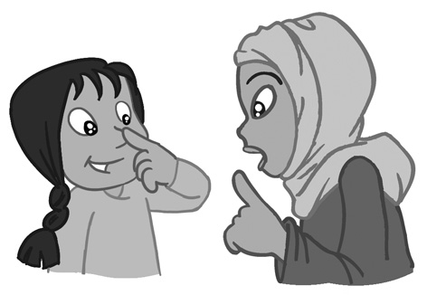
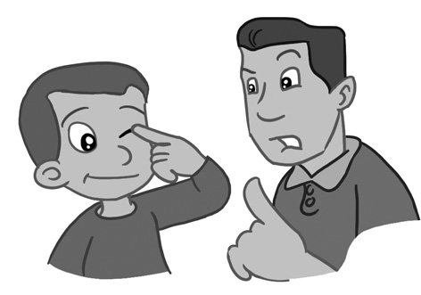
1. Listen and number (1-4).
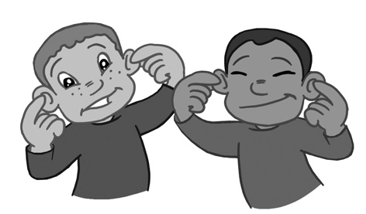
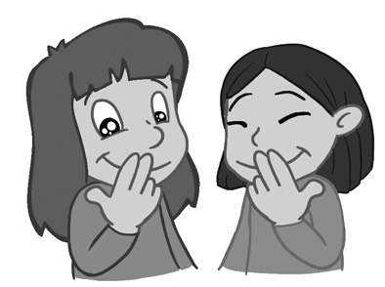

4
score

a

c

d

b

leg toes head fingers hand arm

2. Look and write.
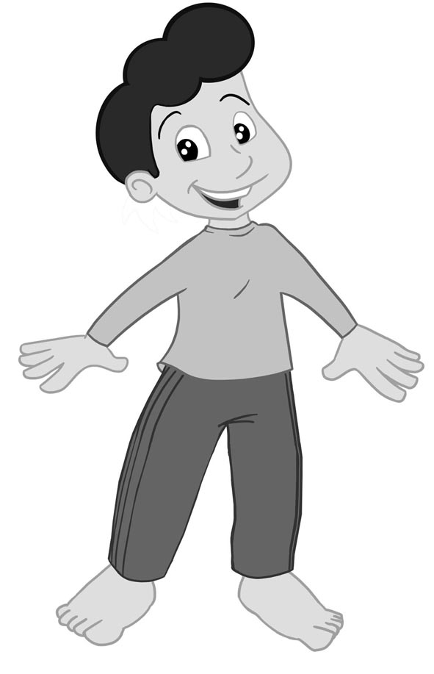
6.

1.

5.

2.

4.

3.

12
score

Yes, it has. No, it hasn’t.

3. Look and write.
1. Has it got big teeth?
.
2. Has it got a short tail?
.
3. Has it got small feet?
.
4. Has it got long ears?
4
score

.

