******المملكة العربية السعودية**

**Kingdom of Saudi Arabia**

**Ministry of Education**

**------- Educational Directorate**

**------- Future Educational Schools**

**2nd Grade High School 2022**

**3rd Term – Final Exam**

**وزارة التعليم**

**الإدارة العامة للتعليم بن**

**مدارس م ن التعليمية**

**الصف الثاني الثانوي**

**الاختبار النهائي للفصل الدراسي الثالث1443**

|  |  |  |  |  |  |  |  |
| --- | --- | --- | --- | --- | --- | --- | --- |
| **Total**  **written** | **5**  **Vocabulary** | **4**  **Grammar** | **3**  **Free Composition** | **2**  **Guided Composition** | | **1 Comprehension** | **Q. NO.** |
|  |  |  |  |  | |  | **Mark Given** |
| **30** | **6** | **6** | **6** | **6** | | **6** | **Mark** |
| **6** | | | **Reviser** | |  | | **Corrector** |
|  | |

**زمن الاختبار: 3 ساعات**

**اسم الطالب: ------------------------------------ رقم الجلوس: ------------- الصف الثاني الثانوي**

**1)** **Comprehension**

**Read the following passage then answer the questions**

**One night, Pilar was in a deep sleep when she was woken by her cat Inti. Inti was meowing wildly outside Pilar's bedroom and throwing himself against the closed bedroom door. When Pilar opened her eyes, she saw that her bedroom was filling with smoke. As she escaped her house with Inti in her arms, she saw that a fire was blazing in her kitchen. Pilar could easily have lost consciousness from breathing in the smoke, but Inti wouldn't let that happen. Even though Inti could have escaped the house through a cat door, he wouldn't leave Pilar. A fireman at the scene said, " Without question, that cat is responsible for saving his owner's life.  He should be honored as a hero."**

***A)* Answer the following questions*:*  
1. How could Pilar have lost consciousness?-----------------------------------------------------.**

**2. When was he in a deep sleep? ----------------------------------------------------------.**

**3. Where was Pilar sleeping? ----------------------------------------------------------.**

**4. Who put out the fire?  -----------------------------------------------------------.**

***B)* Put ( √ ) or ( X ):  
5. Inti was meowing wildly outside Pilar's bedroom.  ( )**

**6. Even though Inti could have escaped the house, he wouldn't leave Pilar. ( )**

**7. Pilar left Inti inside the house and escaped. ( )**

**8. The cat is responsible for saving his owner's life. ( )  
*C)* Complete*:*  
9. Pilar saw that her bedroom was filling with --------------------------------.  
10. The cat should be honored as a -----------------------------------.**

**D) Choose the correct answer:**

**11. The best title for the paragraph is: (**Animal Hero – Firemen – The Kitchen**)**

**12. The cat could have escaped the house through a (**window – balcony – cat door**).**

**2) Guided Composition**

**6**

**Studying online and studying face to face are two ways of learning**

**Write an essay about the two kinds, using the following guide words:**

**Guiding words:**

**inside class – contact – expression – active – go anywhere – computer – internet – limit – time – age (**Write not less than 150 word **(**

-------------------------------------------------------

--------------------------------------------------------------------------------------------------------------------------------------------------------------------------------------------------------------------------------------------------------------------------------------------------------------------------------------------------------------------------------------------------------------------------------------------------------------------------------------------------------------------------------------------------------------------------------------------------------------------------------------------------------------------------------------------------------------------------------------------------------------------------------------------------------------------------------------------------------------------------------------------------------------------------------------------------------------------------------------------------------------------------------------------------------------------------------------------------------------------------------------------------------------------------------------------------------------------------------------------------------------------------------------------------------------------------------------

**3) Free Composition**

**6**

**Choose one topic from the following to write about.**

**1. Imagine that you are invited to a famous restaurant in your city.**

**Writ a paragraph about "Your Favorite Dish".**

**2. Write a paragraph about "Your Dream House" in which you describe which kind of you want to live in, where, who live with, …**

**(**Write not less than 100 word**).**

-------------------------------------------------------

--------------------------------------------------------------------------------------------------------------------------------------------------------------------------------------------------------------------------------------------------------------------------------------------------------------------------------------------------------------------------------------------------------------------------------------------------------------------------------------------------------------------------------------------------------------------------------------------------------------------------------------------------------------------------------------------------------------------------------------------------------------------------------------------------------------------------------------------------------------------------------------------------------------------------------------------------------------------------------------------------------------------------------------------------------------------------------------------------------------------------------------------------------------------------------------------------------------------------------------------------------------------------------------------------------------------------------------

**4) Grammar**

**6**

**A: Choose the correct answer:**

**1. If we (played – had played – play – playing) well, we would have won.**

**2. My car (has – is – will – does) be repaired tomorrow.**

**3. I turn off the TV. I (turn off it – turn it off – it turn off – off it turn).**

**4. Nora is (interest – interesting – interests – interested) in watching TV.**

**5. (Not Warming – Not warm – Not warms – Not warmed) up is bad.**

**6. She is not (enough tall – tall enough – tall too – tall so) to reach the shelf.**

**Do as shown between brackets:**

**1. I bought (yellow – big – Japanese – expensive) car. (**Reorder the adjectives)

-------------------------------------------------------------------------------------------------.

**2. Ali is the tallest boy I (see). (Correct the adjective)**

-------------------------------------------------------------------------------------------------.

**3. The book was very (bore). I didn’t enjoy it. (**Correct**)**

-------------------------------------------------------------------------------------------------.

**4. The chef cut the steak up into small pieces. (Decide if it is** Separable or Nonseparable**)**

-------------------------------------------------------------------------------------------------.

**5. Ali can help the boys. (**Make Passive**)**

-------------------------------------------------------------------------------------------------.

**6. If she had had time, she (visit) her friends. (**Correct**)**

-------------------------------------------------------------------------------------------------.

**5) vocabulary:**

**6**

**A- Match the words with the pictures:**

**medal – popscile – gorilla – dilemma – centipede – canyon**

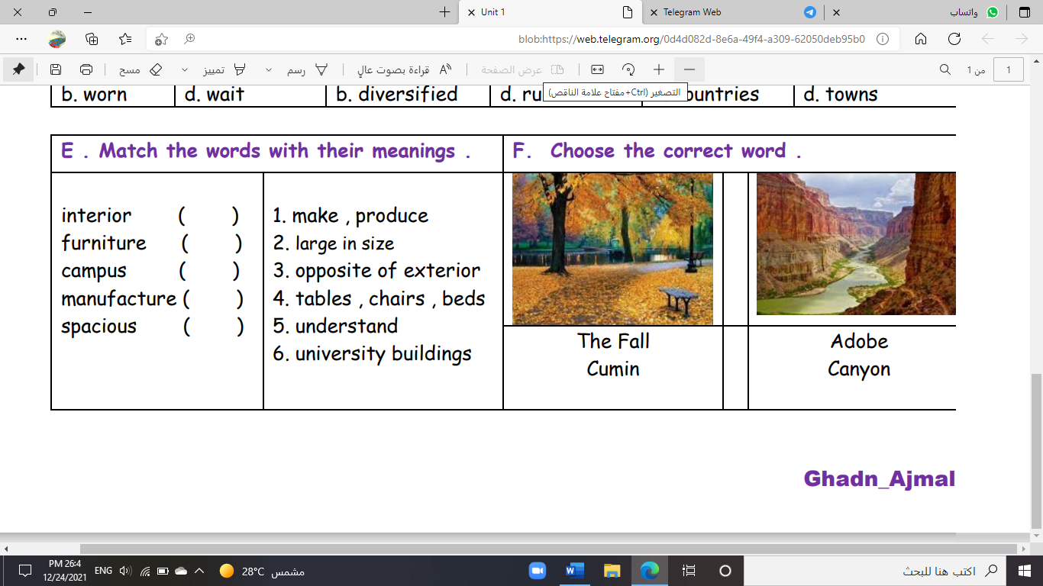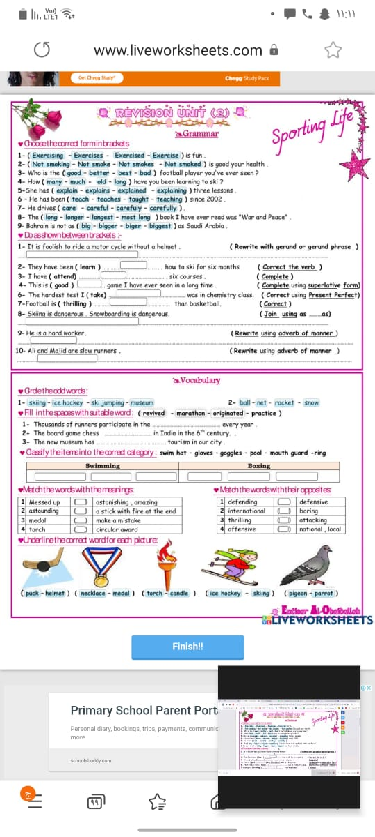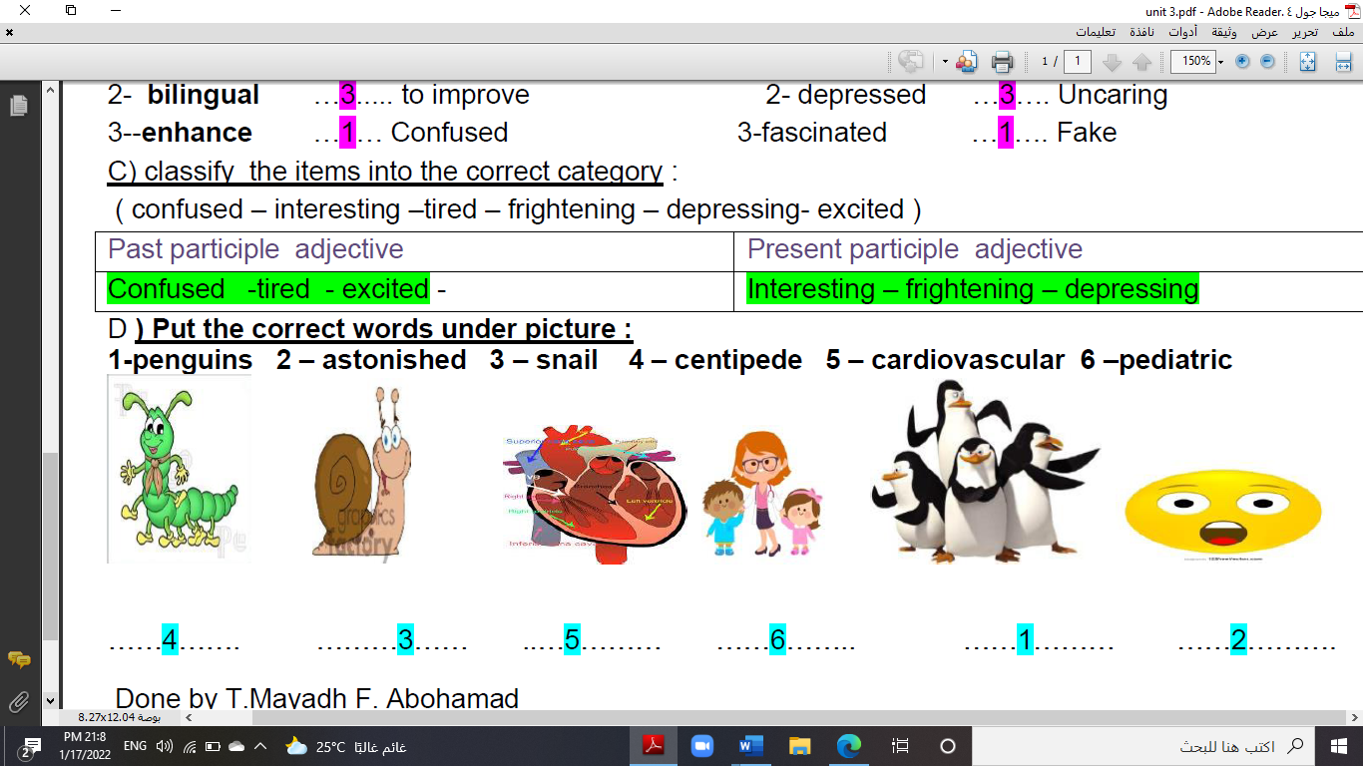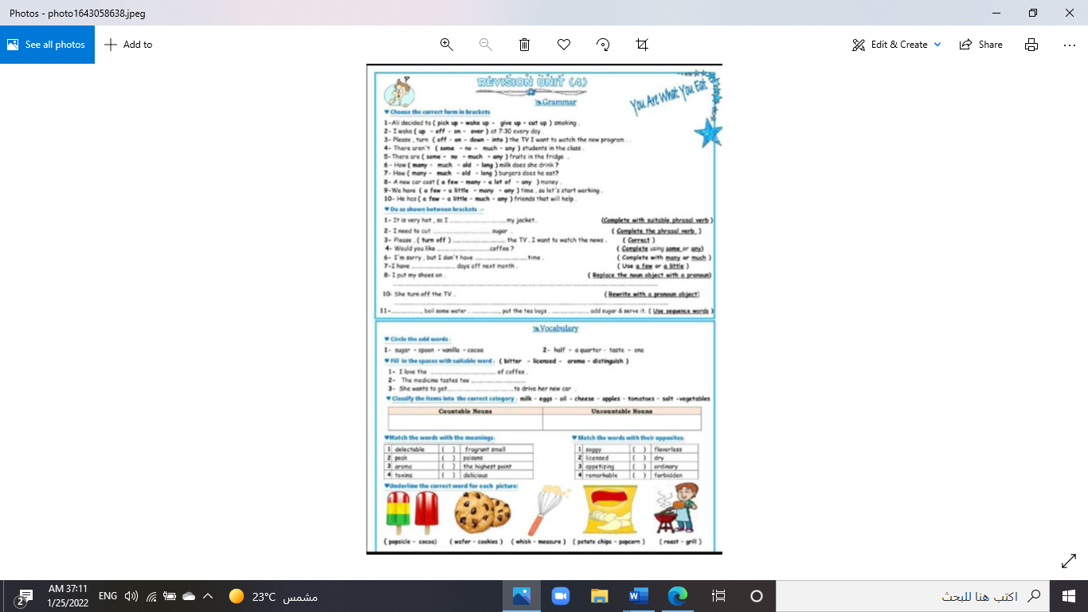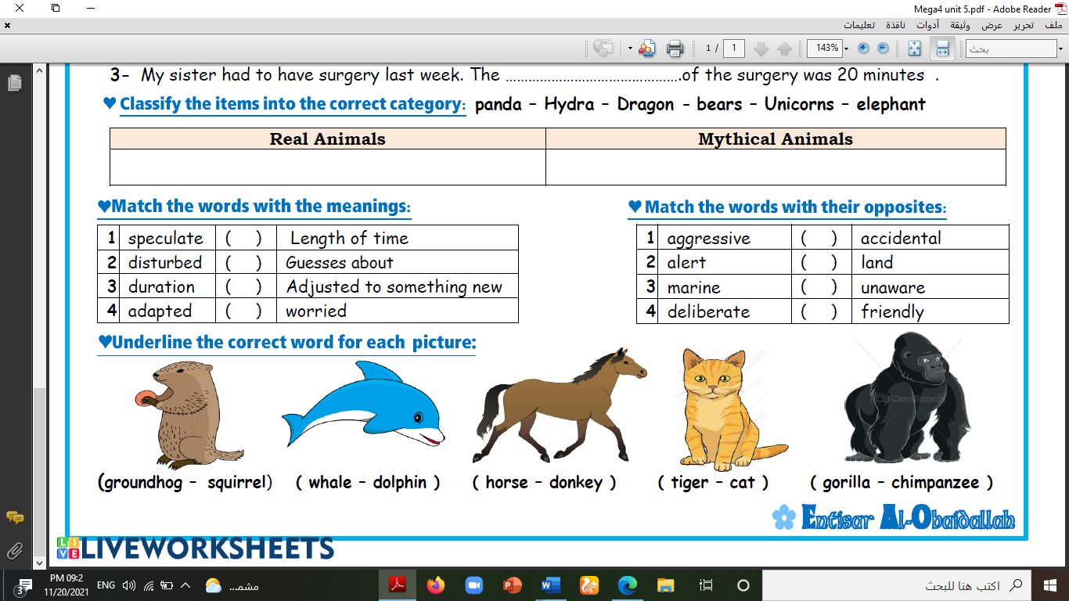

**--------- ------- -------- --------- -------- -----------**

**A) Match to form new words or expressions:**

**1. rotten ---- a. very good**

**2. pampered ---- b. bad**

**3. Hang in there ---- c. indulged**

**4. quite the ---- d. someone who sells something**

**5. vendor ---- e. annoying or bothering**

**6. getting to ---- f. Don't give up**

**End of Questions**

**Best of Luck** [**https://t.me/abokhaledamer**](https://t.me/abokhaledamer)

******المملكة العربية السعودية**

**Kingdom of Saudi Arabia**

**Ministry of Education**

**------- Educational Directorate**

**------- Future Educational Schools**

**2nd Grade High School 2022**

**3rd Term – Final Exam**

**وزارة التعليم**

**الإدارة العامة للتعليم بن**

**مدارس م ن التعليمية**

**الصف الثاني الثانوي**

**الاختبار النهائي للفصل الدراسي الثالث1443**

|  |  |  |  |  |  |  |  |
| --- | --- | --- | --- | --- | --- | --- | --- |
| **Total**  **written** | **5**  **Vocabulary** | **4**  **Grammar** | **3**  **Free Composition** | **2**  **Guided Composition** | | **1 Comprehension** | **Q. NO.** |
|  |  |  |  |  | |  | **Mark Given** |
| **30** | **6** | **6** | **6** | **6** | | **6** | **Mark** |
| **6** | | | **Reviser** | |  | | **Corrector** |
|  | |

**زمن الاختبار: 3 ساعات**

**اسم الطالب: ------------------------------------ رقم الجلوس: ------------- الصف الثاني الثانوي**

**1)** **Comprehension**

**Read the following passage then answer the questions**

**Water**

**Water is life and the lack of water means death. Any living thing cannot go on living without water. Plants need water to grow. Animals need water to drink. People need water to drink and to use in cleaning, cooking, farming and irrigating their lands. We can get water from rivers and lakes. But the main source of water is the rain.  In the desert, people dig deep wells to get water. For keeping water from being wasted, people build dams for storing water in reservoirs that form behind the dams. Water is stored in water towers that supply all the houses with pure water. Our government has set up desalination plants for treating seawater and removing the salt. Thanks be to God, the Merciful, who has created water for us. We don't need to pay for it as it is neither sold nor bought.**

***A)* Answer the following questions*:*  
1. What does the lack of water mean?-------------------------------------------------------.**

**2. Why do people need water? -----------------------------------------------------------.**

**3. What is the main source of water? ----------------------------------------------------------.**

**4. Who has created water for us?  --------------------------------------------------------------.**

***B)* Put ( √ ) or ( X ):  
5. Any living thing can go on living without water. ( )**

**6 Plants and animals need water to grow and drink. ( )**

**7. In the mountains, people dig deep wells to get water. ( )**

**8. We don't need to pay for water. ( )  
*C)* Complete*:*  
9. Our government has set up desalination plants for --------------------------------.  
10. We can get water from -----------------------------------.**

**D) Choose the correct answer:**

**11. Farmers need water for farming and irrigating their (**houses – lands – rooms**)**

**12. To restore water, people build (**dams – schools – farms**)**

**2) Guided Composition**

**6**

**You read a book about some life threating situations that man can hardly survive. Write about a situation you passed or heard about.**

**(**Write not less than 150 word **(**

**Guiding words:**

(fire – smoke – burning – collapsed – call fire department – fire engines – rescue …)

-------------------------------------------------------

--------------------------------------------------------------------------------------------------------------------------------------------------------------------------------------------------------------------------------------------------------------------------------------------------------------------------------------------------------------------------------------------------------------------------------------------------------------------------------------------------------------------------------------------------------------------------------------------------------------------------------------------------------------------------------------------------------------------------------------------------------------------------------------------------------------------------------------------------------------------------------------------------------------------------------------------------------------------------------------------------------------------------------------------------------------------------------------------------------------------------------------------------------------------------------------------------------------------------------------------------------------------------------------------------------------------------------------

**3) Free Composition**

**6**

**Choose one topic from the following to write about.**

**1. Imagine that you are going to buy a new house for your new family. Write a short paragraph describing your new home.**

**2. Sports are spread around the world. All nations have their favorite sport. Write about your favorite sport.**

**(**Write not less than 100 word**).**

-------------------------------------------------------

--------------------------------------------------------------------------------------------------------------------------------------------------------------------------------------------------------------------------------------------------------------------------------------------------------------------------------------------------------------------------------------------------------------------------------------------------------------------------------------------------------------------------------------------------------------------------------------------------------------------------------------------------------------------------------------------------------------------------------------------------------------------------------------------------------------------------------------------------------------------------------------------------------------------------------------------------------------------------------------------------------------------------------------------------------------------------------------------------------------------------------------------------------------------------------------------------------------------------------------------------------------------------------------------------------------------------------------

**4) Grammar**

**6**

**A: Choose the correct answer:**

**1. You are not well (too – so – enough – just) to work today.**

**2. (Watching – Watched – Watches – Watch) sports is my favorite hobby.**

**3. My grandfather's stories about his childhood are (amuse – amusing – amused).**

**4. I take off my shoes. I (take them off – take off them – take it off – take off it).**

**5. The tiger will be (releasing – releases – release – released) into the wild.**

**6. If they had slept early, they would have (be – been – bees – are) on time.**

**Do as shown between brackets:**

**1. If Hassan (visit) me, I would have told him the whole story. (**Correct**)**

-------------------------------------------------------------------------------------------------.

**2. You should clean the bird's cage weekly. (**Make Passive**)**

-------------------------------------------------------------------------------------------------.

**3. I never tire of chocolate. (**Decide if it is Separable or Nonseparable**)**

-------------------------------------------------------------------------------------------------.

**4. Hassan was (disgust) by the news report. (**Correct**)**

-------------------------------------------------------------------------------------------------.

**5. Nora is the (beautiful) girl I have ever seen. (**Correct the adjective**)**

-------------------------------------------------------------------------------------------------.

**6. Ali is wearing a ( white , beautiful , linen , small ) jacket. (**Reorder the adj.)

-------------------------------------------------------------------------------------------------.

**5) vocabulary:**

**6**

**A- Match the words with the pictures:**

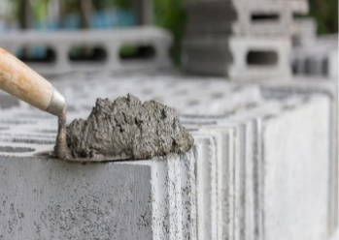**parrot – groundhog – mortar - chocolate – torch – lifeboat**

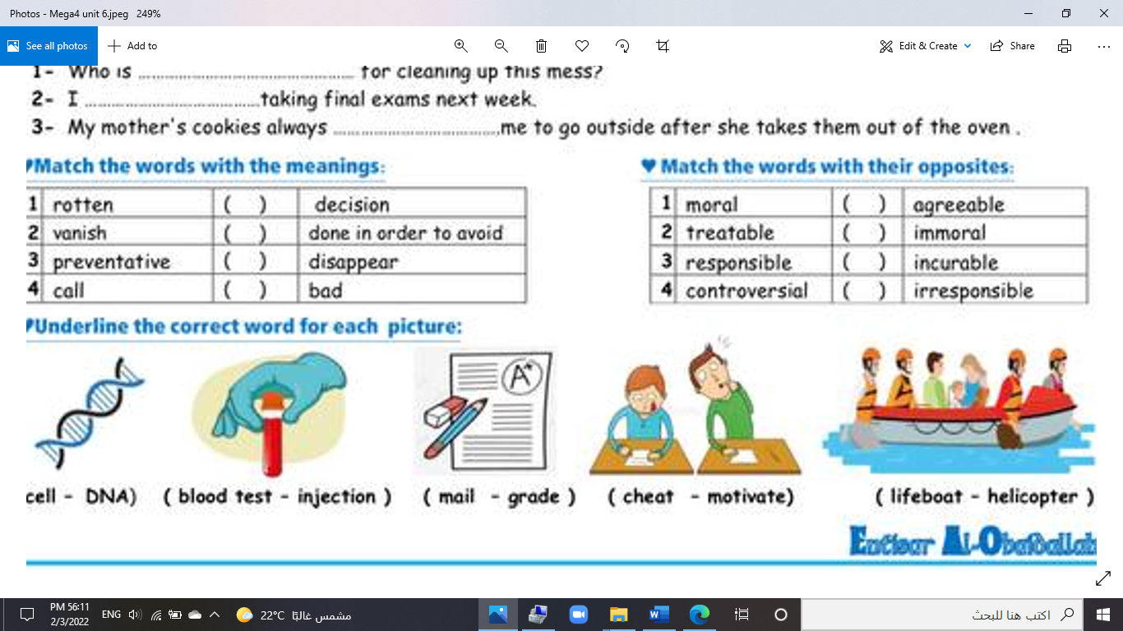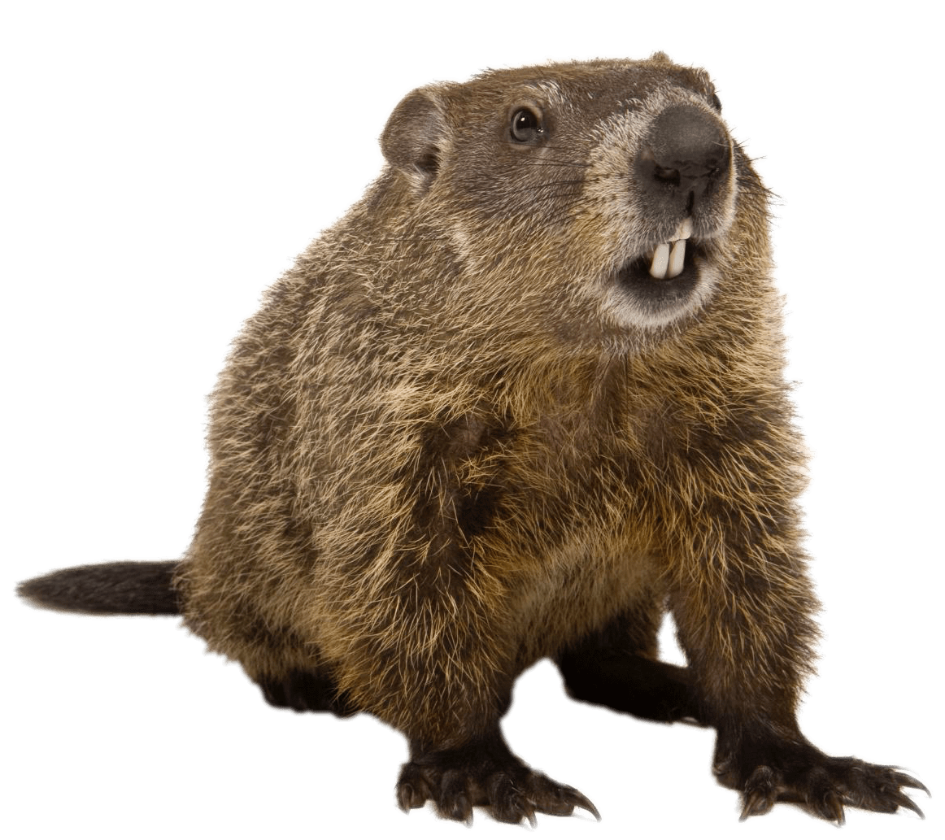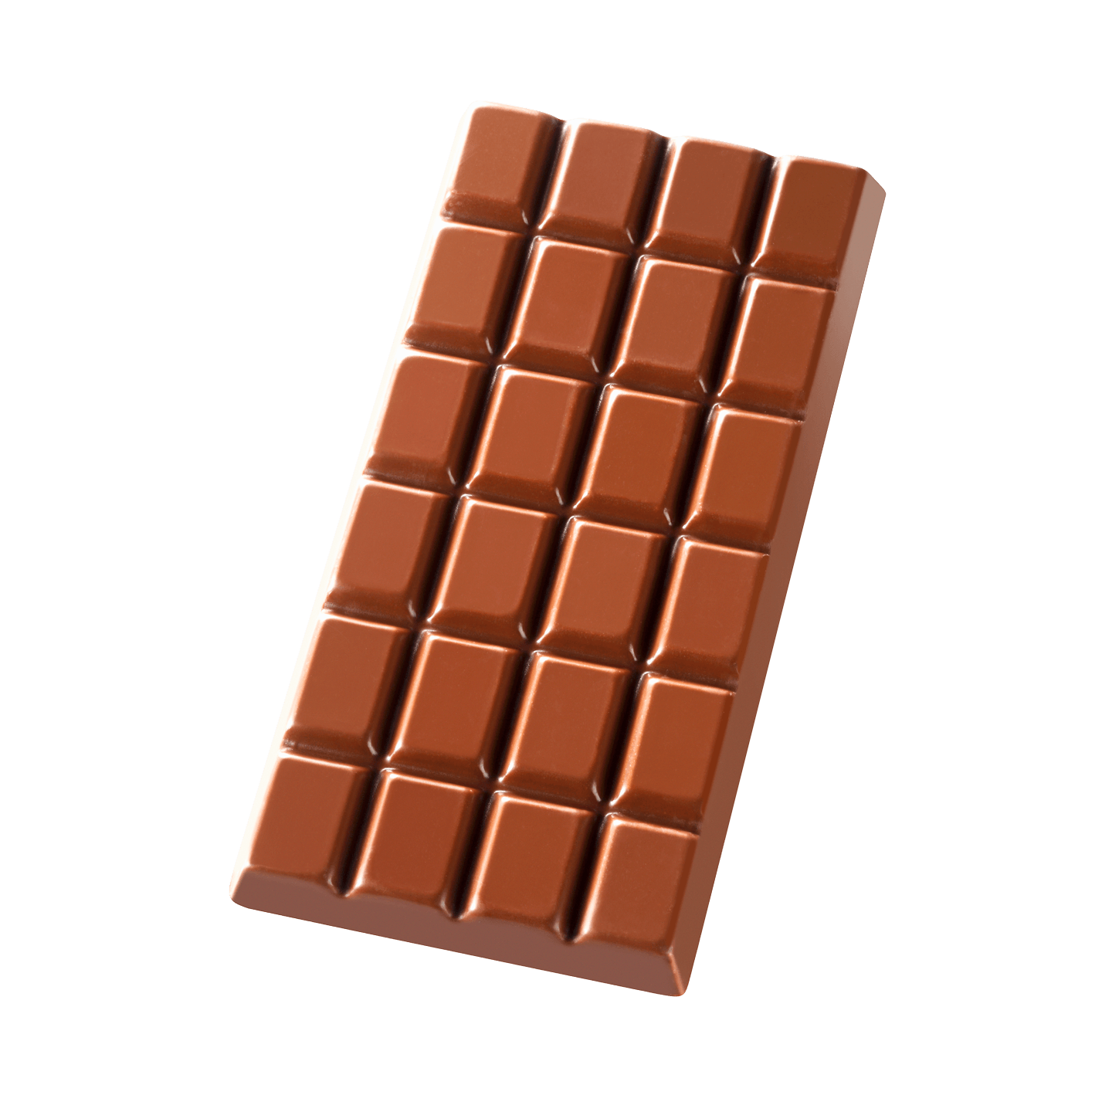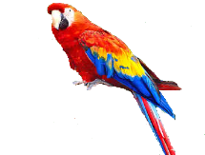

**--------- ------- -------- --------- -------- -----------**

**A) Match to form new words or expressions:**

**1. killer ---- a. very quickly**

**2. genuine ---- b. great**

**3. alert ---- c. real**

**4. bond ---- d. aware**

**5. call ---- e. connection**

**6. in no time ---- f. decision**

**End of Questions**

**Best of Luck** [**https://t.me/abokhaledamer**](https://t.me/abokhaledamer)