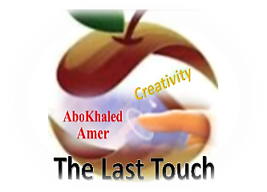

المملكة العربية السعودية
وزارة التعليم
الادارة العامة للتعليم بمنطقة ----------------
مدرسة ------------------ الثانوية
Second Term- Second Session Test
Name: ------------------------------------------------------ Grade: 3rd Sec.
ABOKHALEDAMER
0557325813
1. Write the correct number under its picture: (6M)
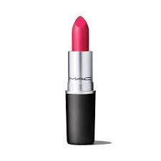


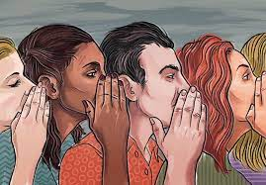

1.bell 2.fault 3.lip stick 4.perfume 5.gossip 6.hairbrush
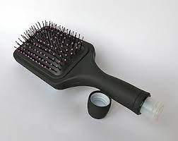

( ) ( ) ( ) ( ) ( ) ( )
2. Match the following: (4M)
1. ---- on the house a. by very much; obviously
2. ---- by far b. free
3. ---- ideal c. stopped being friends
4. ---- split up d. idea of perfection
3. Choose the correct answer: (6M)
1. She says that she ( likes / liked – like ) her classes.
2. Is he able to ( discovers – discovered – discover ) who started the rumor?
3. They said that they ( might – might have – may have ) join us later.
4. ( Can – May – Should) you keep a secret? Yes, I can.
5. We ( had – should – ought) better vote for someone else.
6. The zip on my handbag needs to be (replaced – replaces – replacing).
7. I noticed ( this – then – that ) she didn’t put any make-up on today.
Supply the missing letters: (3M) ( u – a – t – m – t – r )
1. plu__b 2. faul__ 3. pe__fume
4. cap__ain 5. Ar__bic 6. acq__ire
(2) Top Goal - YouTube End of Questions https://t.me/abokhaledamer

