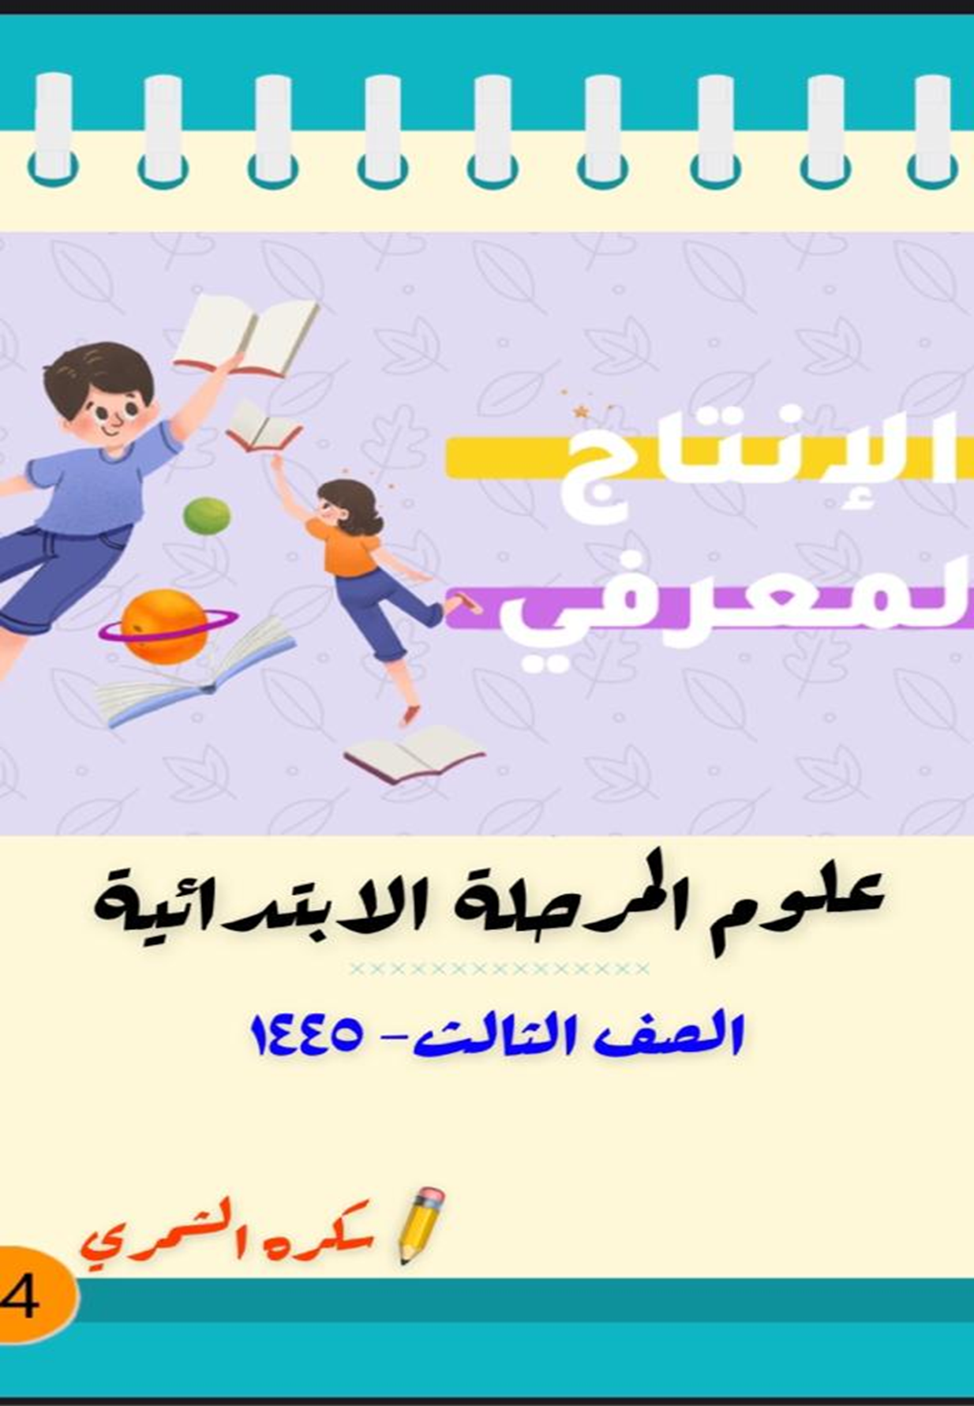

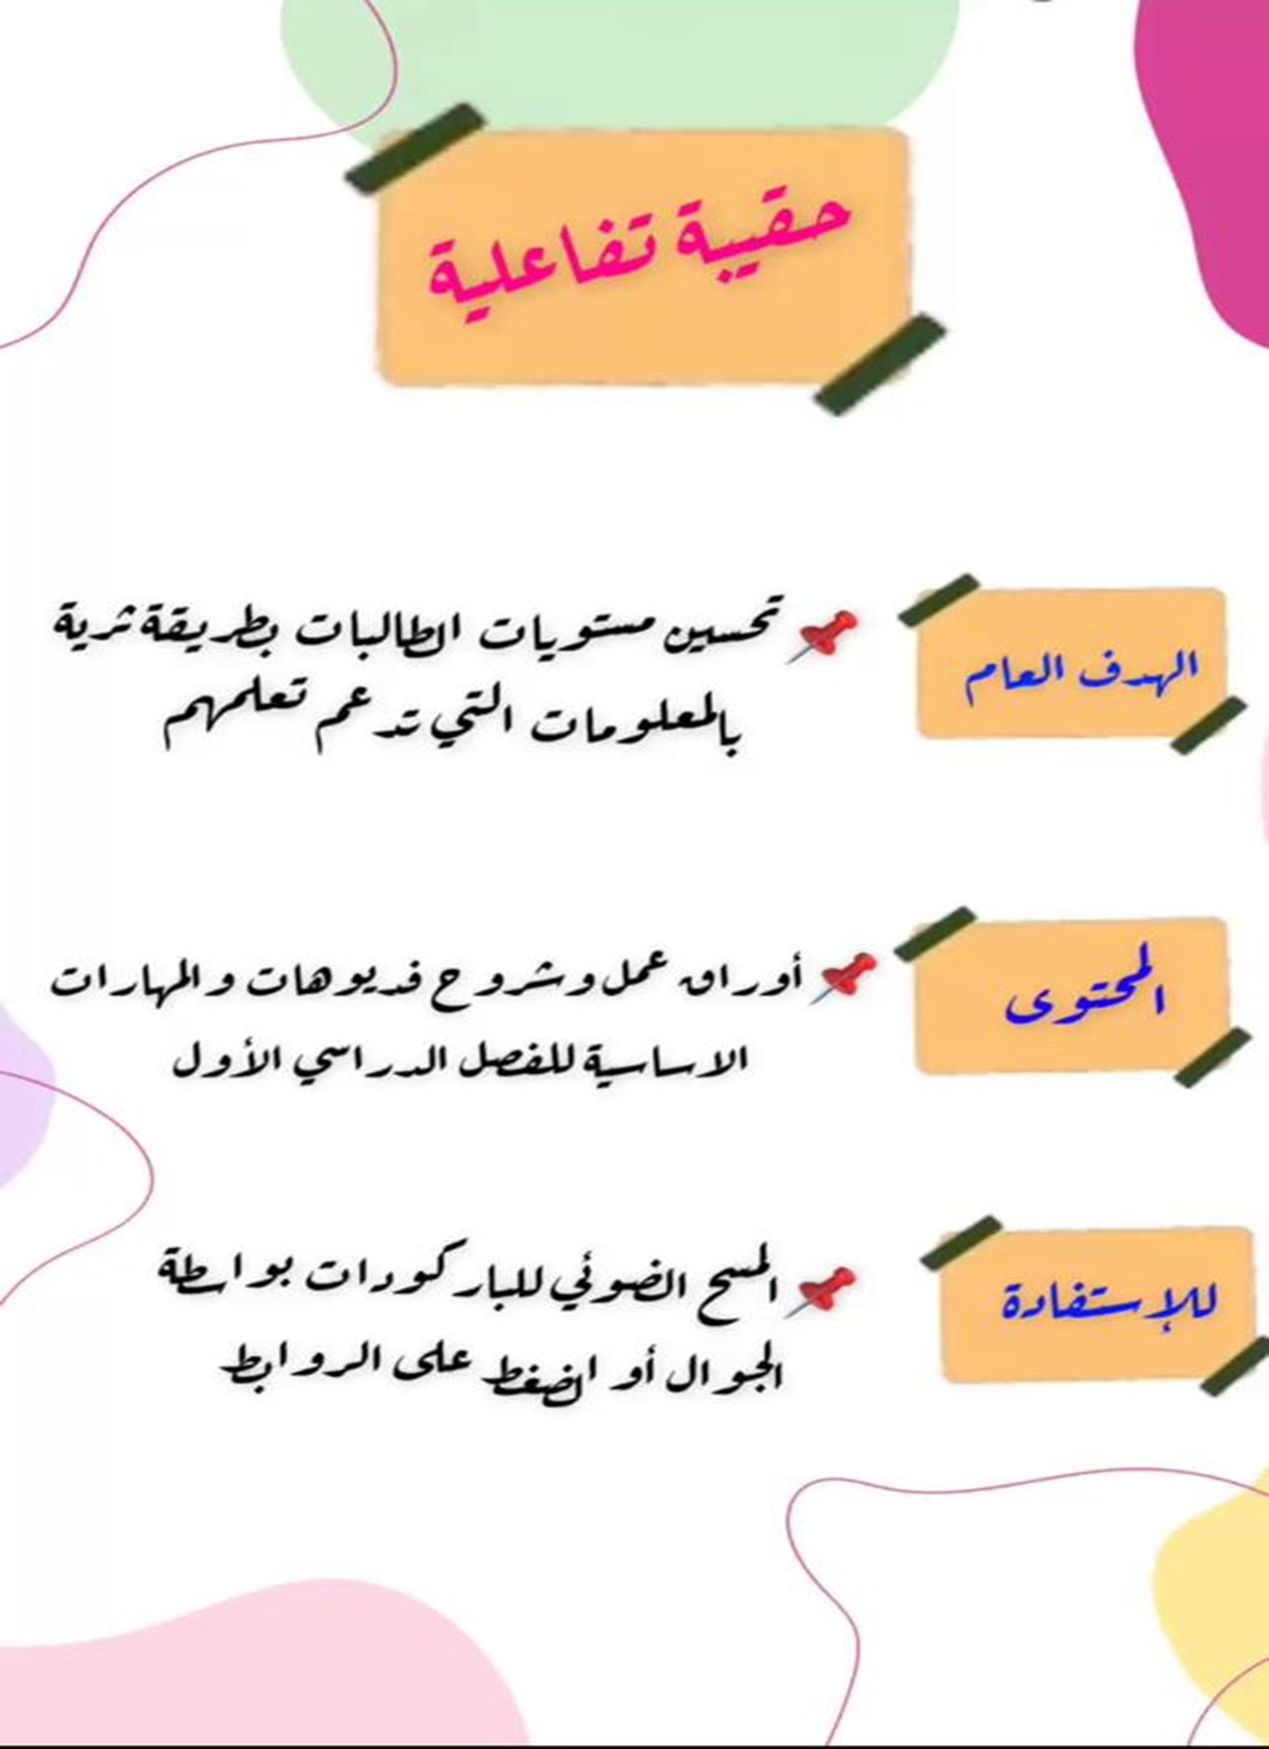



**علوم الصف الثالث الفصل الدراسي الأول**





[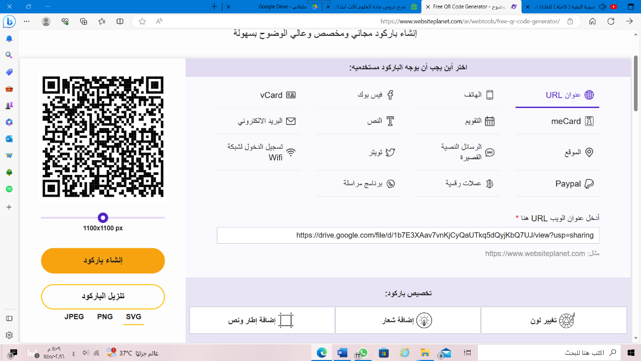](https://drive.google.com/file/d/1b7E3XAav7vnKjCyQaUTkq5dQyjKbQ7UJ/view?usp=sharing)[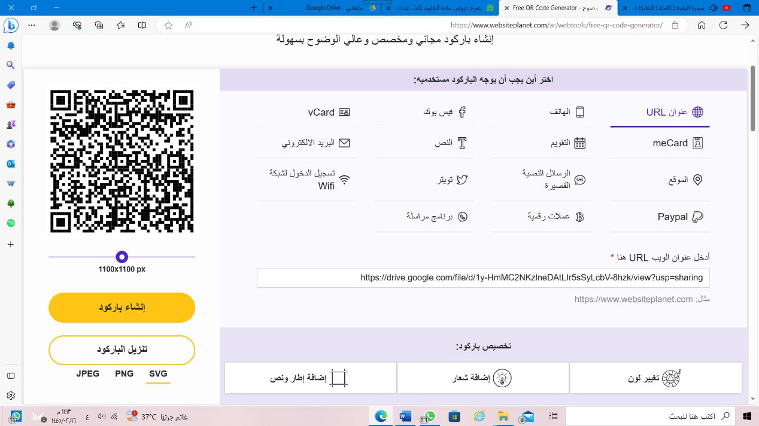](https://drive.google.com/file/d/1y-HmMC2NKzlneDAtLIr5sSyLcbV-8hzk/view?usp=sharing)

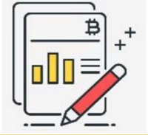

[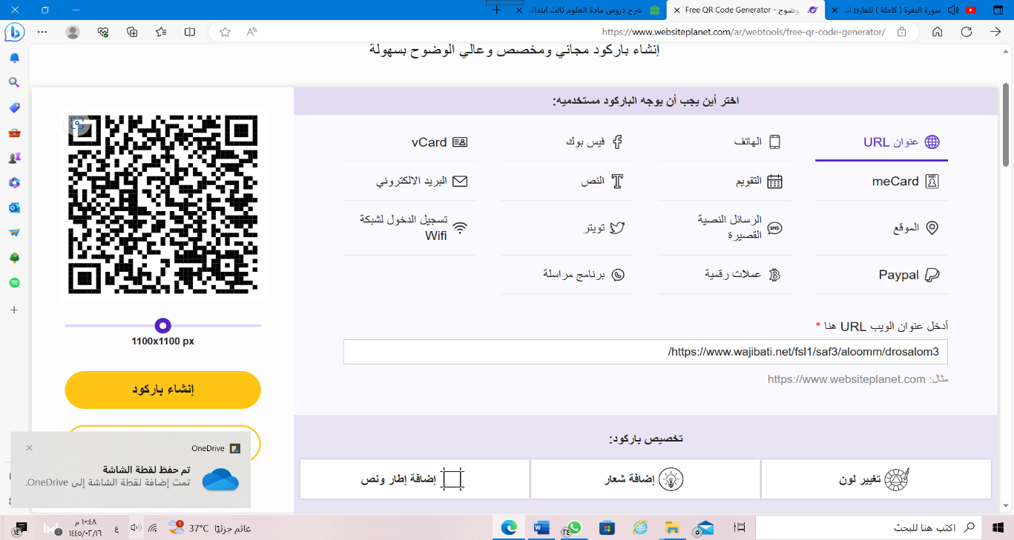](https://www.wajibati.net/fsl1/saf3/aloomm/drosalom3/)

[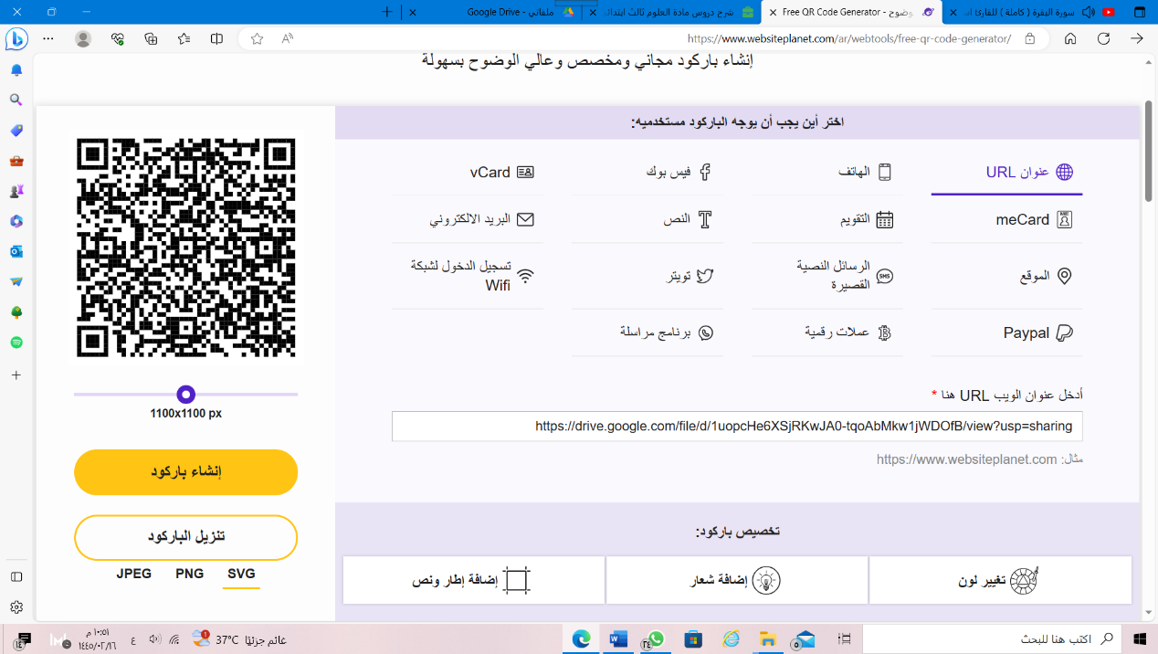](https://drive.google.com/file/d/1uopcHe6XSjRKwJA0-tqoAbMkw1jWDOfB/view?usp=sharing)