1
I. CHOOSE
المملكة العربية السعودية |  |  | اسم الطالب/ ......................................
وزارة التعليم
إدارة التعليم بمنطقة |  |  | المادة : انجليزي
مدرسة : |  |  | الزمن :
 |  |  | الصف : فصل ( )
شفهي | تحريري |  |  | المجموع
10 / | 10 / |  |  | 20 /
اختبار الفترة الثانية للفصل الأول - للعام الدراسي 1447– لغة انجليزية –– للصف الثالث الابتدائي
اسم الطالب / هـ الفصل /


1 – What sport do you like?
A . I like painting. B . I like football .
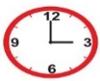
2 – What time is it ?
A. It is three o'clock. B. It is four o'clock.

2. CHOOSE OR
1.5


1. I do painting .

I feed the fish. .2
3. I eat my lunch .





3. DO AS SHOWN BETWEEN BRACKETS
1.5

_______________________ |  |  | 1– horse - I – riding – like. ( rearrange )
feed | fold | play |   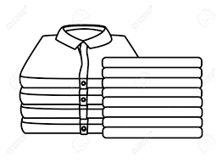  2- I ____ the laundry . ( choose )
4. CHOOSE
1

go | do | play | 1 – I ____ golf .
going | get | got | 2. I usually ____ up at 5:00 .

3
4. CHOOSE
brush - robot - hang gliding

   | 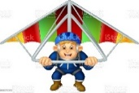 | 


2

Choose the correct letter:

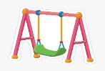  swi_ _ | 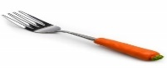  f_ _rk |   c_ _ | 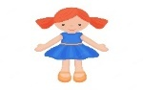  t_ _
ng | ur | ar | oy
nk | or | ur | oi

Controlled writing

4

______________________________________________________________________________________

Good luck



Kingdom of Saudi Arabia
Ministry of Education
……..Education Directorate
………………… School
English Language
elementary Grade 3rd
2nd period Exam
…………….\20
الاسم: الصف:

……\ 4 marks

General questions

A.Answer the questions
I want to try scuba diving |  | What chores do you do? | 1
I feed the fish. |  | What is she doing now? | 2
She's eating a snack. |  | What sport or activity do you want to try? | 3
Yes, he does. |  | Does he vacuum the floor? | 4

Controlled Writing
……\ 1 marks
A-reorder.
1-is -Pottery - boring
a-boring is pottery b-Pottery is boring
……\ 4 marks

Reading short sentence
 | 1- He folds the laundry ( )
 | 2- Rock climbing is the most difficult ( )
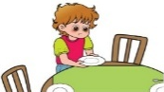 | 3- He Sets the table.( )
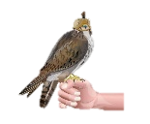 | 4- Many people in Saudi Arabia like falconry ( )
A-Put ( ✔ ) or ( X )

……\ 4 marks

Grammar
A-Choose the correct answer.
c-does | b- do | a-play | 1- I ……… tennis.
c- feeding | b- feeds | a- feed | 2- He is ……the fish.
c- set | b- sets | a- setting | 3- I cook and ………the table.
c-most exciting | b-more exciting | a- exciting | 4- Horse riding is……. than cycling.

Vocabulary

A.Choose the correct word under each picture
……\ 5 marks

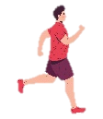 |  |  | 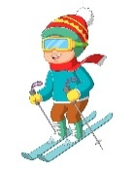 | 
jog | drink | fan | ski | smile
bear | ski | car | pottery | robot
……\ 2 marks

Orthography
A. Fill in the missing letters


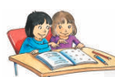

1-gol…..
(u – o – f )
3-sist…..
ar -ai -er))
4-doct….
or– er- ar))
2-h……r
(oy- ai – ee)

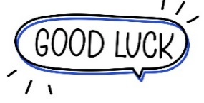
Your teacher:

Your teacher …..:…………………………….


Kingdom of Saudi Arabia Third Elementary Grade
Ministry of Education First Term

10
……………Elementary School . . Second Exam - 1447 AH
Name: ………………………………………………………….………………. Class : …………..
- General Questions:
- Choose the correct answer:
1- What sport does he like?
a- He likes tennis. |  |  |  |  |  | b- He likes dolphins.
2- How do you spell teacher?
a- t – e – a – c – h – e – r |  |  |  |  |  | b- He is Ali.
3- What is he doing now?
a- It is a book. |  |  |  |  |  | b- He is watching TV.
- Controlled Writing:
- Rearrange the words to form a sentence:
the |  |  | feed |  |  | I |  |  |  | fish
- Reading short sentence:
- Read the sentences then choose the correct sentence for each picture:
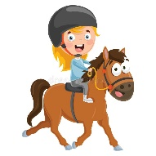 | 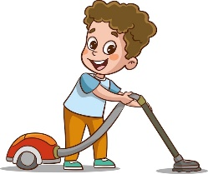 | 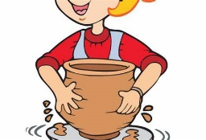 | 
a. He likes riding horse.  b. He likes volleyball. | a. He cleans up the room.  b. He vacuums the floor. | a. I do pottery.  b. I do painting. | a. I wash the dishes.  b. I set the table.

- Grammar:
- Choose the correct answer:
- ……… she play golf?
- Do |  |  |  | - Does |  |  |  |  | - Are
- He ………… the table.
- set |  |  |  | - setting |  |  |  |  | - sets
- Sky diving is the ………… sport.
- exciting |  |  |  | - more exciting |  |  |  |  | - most exciting
- Vocabulary:
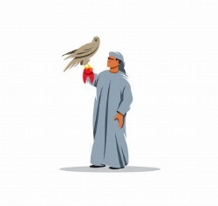
- Choose the correct answer:
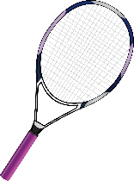 |  |  |  |  |  |  |  |  |  |  | 
- racket  - football |  | - tennis  - falconry |  |  |  |  | - fire  - smile |  |  |  | - bread  - house
- Orthography:
- Choose the correct missing letters:
  b __ __ |  | 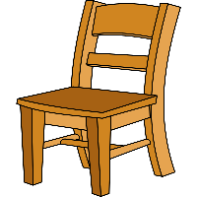  ch __ __ __ |  |  |  |  |   c __ __ |  |  |  |   doct __ __
oy | oi | air |  |  | ere |  | or | ar |  |  | er | or

BEST OF LUCK
Ms. Tahani Al-Ghamdi



اختبار الفترة الثانية – الصف الثالث الابتدائي/
الاسم | الفصل | شفهي | تحريري | المجموع
 | / | 10 / | 10 / | 20 /
Second Period Exam

1

1. CHOOSE
- What sport do you like?
- I like painting. | - I like football

- What time is it ?
- It is three o'clock. | B. It is five o'clock.

1.5
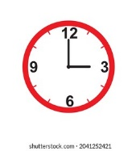
222
2. CHOOSE OR

I do painting. | I feed the fish. | I eat my lunch.
 |  | 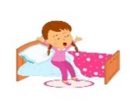

1.5

3. DO AS SHOWN BETWEEN BRACKETS

1- horse - I – riding – like. ( Rearrage ) ………………………………………………………………………………………………….
feed | fold | play | 2. I ____ the laundry . ( choose)

go | do | play | 1 – I ____ golf .
going | get | got | 2. I usually ____ up at 5:00 .
4. CHOOSE
1

5. CHOOSE

3

 |  | 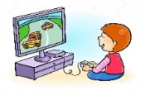 |  | 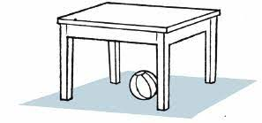 | 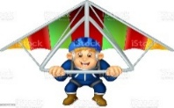
look | brush | Computer games | smile | trash | Hang gliding
clock | catch | Volley ball | cry | robot | Scuba diving

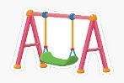  swi_ _ | 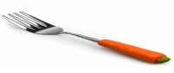  f_ _rk | c_ _ | 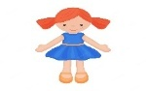  t_ _
ng | ur | ar | oy
nk | or | ur | oi
6. CHOOSE THE CORRECT LTTER
2

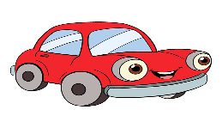

TEACHER :

