The 3rd Grade midterm exam
الأسم ثلاثي: |  | الفصل

- Match
1-Can I have some candy ? |  |  | There are 3 books .
2-How many books are there ? |  |  | Yes , sure .
3-where's mom? |  |  | She is in the kitchen .

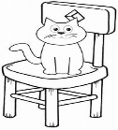
- Choose
- The cat is ( on _ in _under ) the chair .
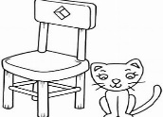
- The cat is ( on _ in _ next to ) the chair .

- She ( is _ are _ am ) my mom .

- He ( is _ are _ am ) my Dad .

- Match numbers with pictures:

1-kitchen | 2- bed room | 3- bathroom | 4- dining room

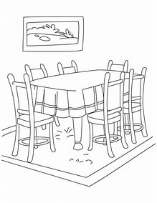
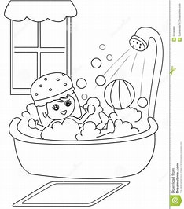
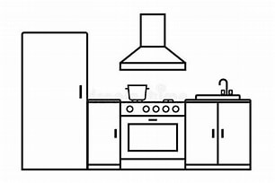
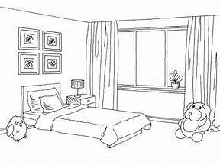

……………………… …………………………… ………………………. ………………………..

- complete the missing numbers:

1 , 2 , …………, 4 , …………… , 6 , 7 , ………… , ………… , 10 , …………,

12 , ………………, 14 , 15 .

- Choose true or false :
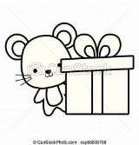 | The mouse in the box |  | House |  | 4 pens

F – choose the odd word:
dot , not , sun , hot

G – copy the sentence:
This is my house

...............................................................................................................................................................................................

H _ choose the missing letter :
( pr / fr )

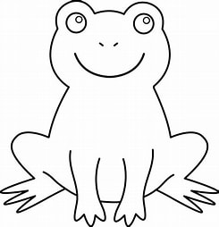

…..ize
….. og

) oo – ou – ie )

cl….d

اختبار الصف الثالث منتصف الفصل الدراسي الثالث

/25 | الدرجة | / 3 | الفصل |  | األسم ثالثي:

- Choose : 6 /
- Rearrange :
He's / the bathroom / in
………………………………………………………………………………………………………
3 /
controlled Writing
Grammar
1- What are ? | these | this | that
2 – ………………….. is Ali ? | Who | What | Where
3- She …………….. in the bedroom . | am | are | is
- Circle :
Reading
1-A sofa in the living room . 4 /
2-The mouse is next to the fridge.
#.Write :
Vocabulary
1-This is the …………………………………….. 2 /
2-This is the ……………………………………

#. Match :

Fill in :

Vocabulary
house 4 /
tree candy ox
Orthography
3 /

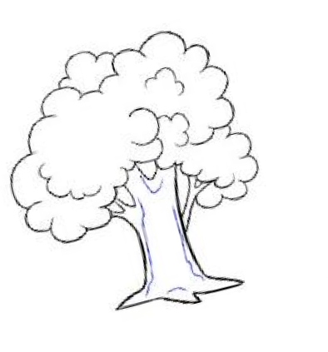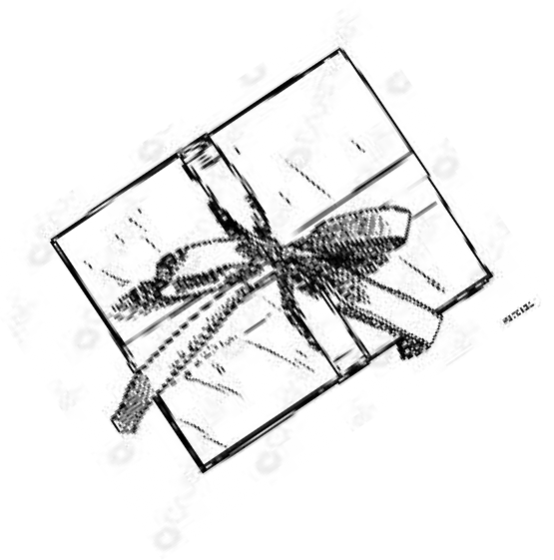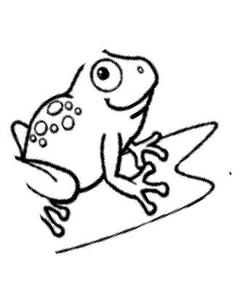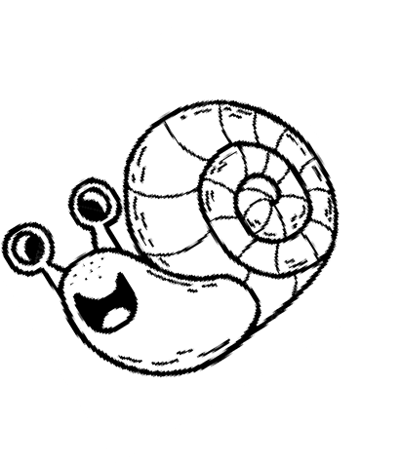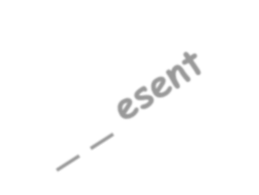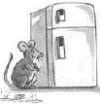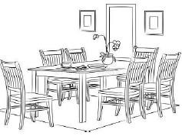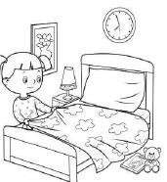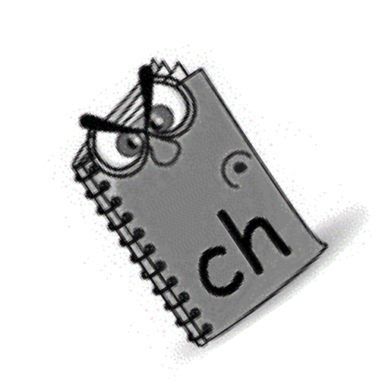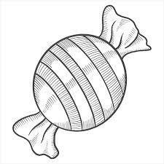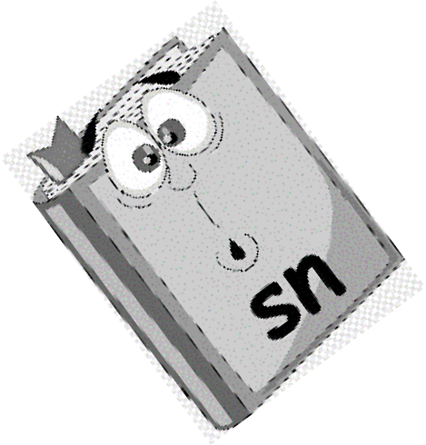
- Match :
1 – Where’s Hashim?
2- Can I have some candy ? 3- How do you spell box?
3 /
b-o-x .
He’s in the bathroom. Sure. Here you go.
General Questions

Good luck… Fekry Bosubaih

