Revision Sheet for Grade 5, 3rd Semester

General Questions
Underline the correct answer :

The bed is in the ……… ( bathroom – kitchen – bedroom )

My mom cooks in the ……… ( bathroom – kitchen – bedroom)

12 + 13 = ……… ( 24 – 25 – 26 )

Can ostriches fly ? ( yes – no )

In summer , the weather is ……… ( hot – cold – freezing )

He works in a hospital , he is a ……… ( doctor – engineer – pilot )

The Astronaut work in ……………………… (hospital - space)

Answer these Questions.
1. Welcome to our house. | 6 | I get up at six o‘clock
2. Where is he? | 5 | Yes. I do
3. What’s this? | 4 | Sure! Here you go.
4. Can I have some candy? | 3 | It is a comic book.
5. Do you watch TV in the evening? | 2 | He is in the bathroom.
6. What time do you get up? | 1 | Thanks

Complete the sentences. Use the words in the box.

sunny kitchen homework How

- You can find fridge in the ____kitchen________________

- ____________How___________many are there?

- He does his ________homework____________.

- It‘s ____sunny________ and hot, Sit in the shade and tall.

Choose Tor F (1point)
1. The mouse is next to the fridge. 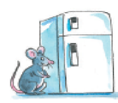 | T | F
2. It’s a watch. | T | F
3. Kangaroo can jump but it can’t fly. 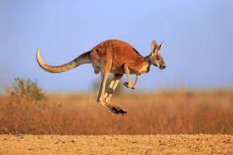 | T | F
4. It’s sunny | T | F

Grammar:

Choose the correct answer

- Where ( is – and ) Ali ?

- 2.Where’s Mom? ( She – He ) is in the Kitchen.

- 3.What ( are – no ) these?

- I ( eat - eating ) my lunch at 2 o'clock.

- ( Does – I am ) he work in an office?

- He is ( in – on) the living room .

- I eat 3 (egg - eggs)

- Can I (read – have) some candy ?

- It's ( an – a) comic book .

- These ( is - are) glasses

- That ( is - are) a pencil.

- This is a ( tooth - teeth)

- I have one (child - children)

- I bought 2 (watches - watchs)

- We baked 3 ( pizza - pizzas)
- The cat is (front of - behind) the box.

Answer the questions:
- What is that?
It is a ……………………tooth…………..

- What are those?
They are …………………feet………… .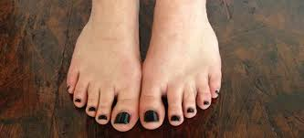

3. Vocabulary and spelling:
A. Write the correct word under the picture (1 point)
head doctor table candy
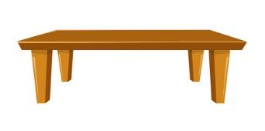
table | candy | doctor | head

B. Choose the correct answer (1 point)
1. This is my _____________wallet_______
A | wallet | B | pens
2. He is a ________________doctor_________
A | teacher | B | pilot

C. Choose the correct letter: (1 point)
 | 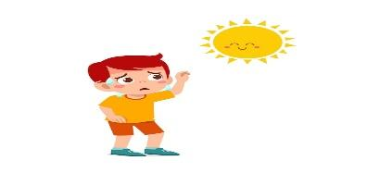
__ries  ( F – V – P) | __ot  ( K – H -G) | MP3 __layer  ( B- P – D) | Me__t  ( e – a – i)

Complete:
H – F – S - P
 | 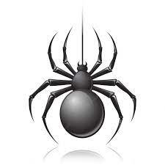 |  | 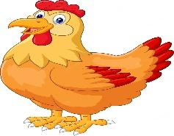
Prize | Spider | Flag | Hen
Write each word under the suitable picture :
Chair – door – scissors – watch – teacher – cook

 | 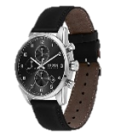 |  | 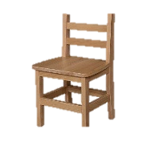 |  | 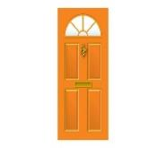
teacher | watch | cook | chair | scissors | door

Reading Short Sentences
Read and fill in the missing words :

hen – bug – cat – fox
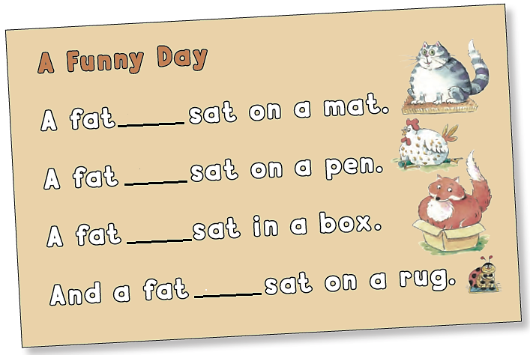

Control Writing
Rewrite the sentence on the lines correctly :

You can buy a house but not a home
-------------------------------------------------------------------------------------------------------------------------------------------------------------------------------------------------------------------------
Rearrange the letters correctly :
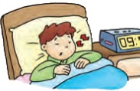
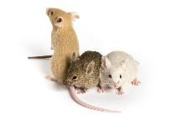
s / e / p / e / l h / a / d / e m / c / i/ e
___sleep_____ ___haed___ ___mice_

Complete the dialogue:
A: Tell me about your day? 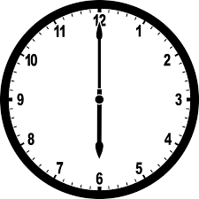
B: I get up at ………6:00 O’clock……
A: What time do you eat lunch?
B: at ……2:00 O’clock…….. then I ……do my homework…………
A: Do you watch TV in the evening?
B: No, ……I do not…….

Describe the girl:
She is a short girl. She has black …………………(short - long) hair. She has brown ( skin - eyes). She is wearing a (red - purple) dress.

Best wishes
Ms. Etedal Alrashed

