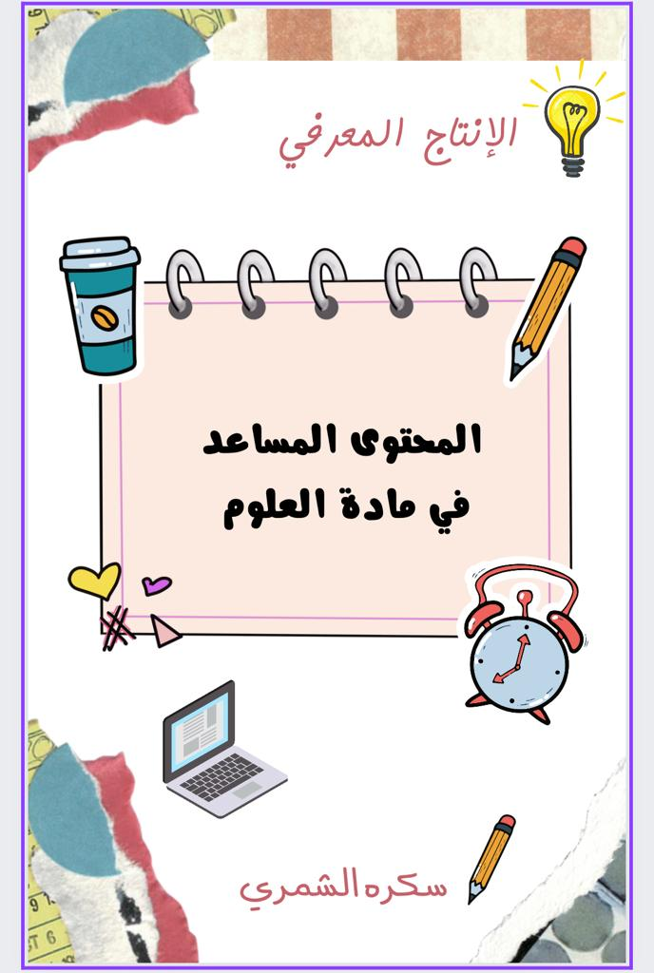

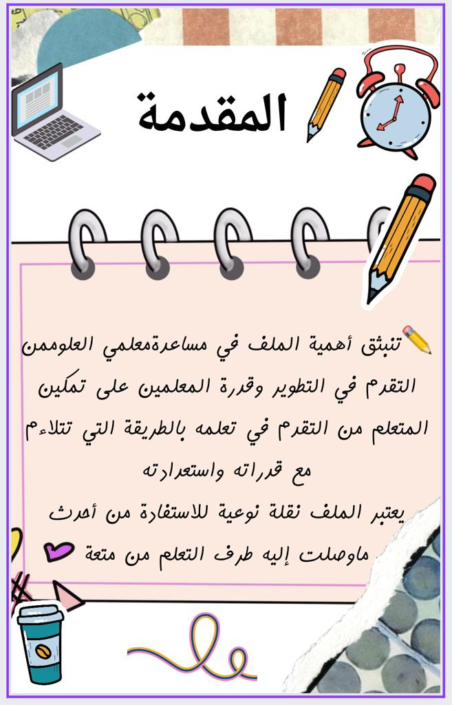

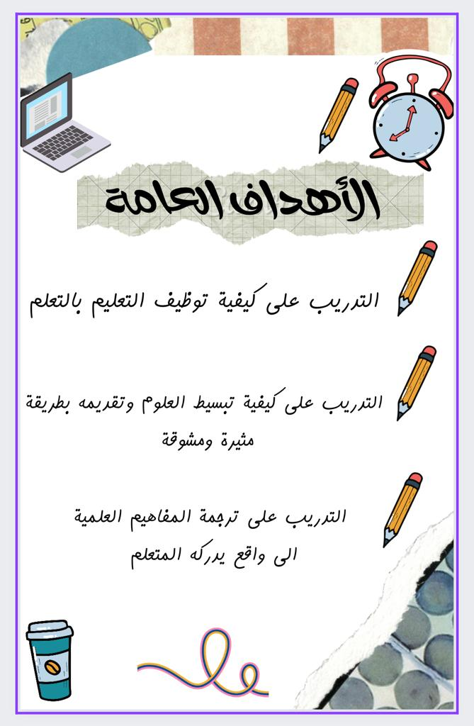

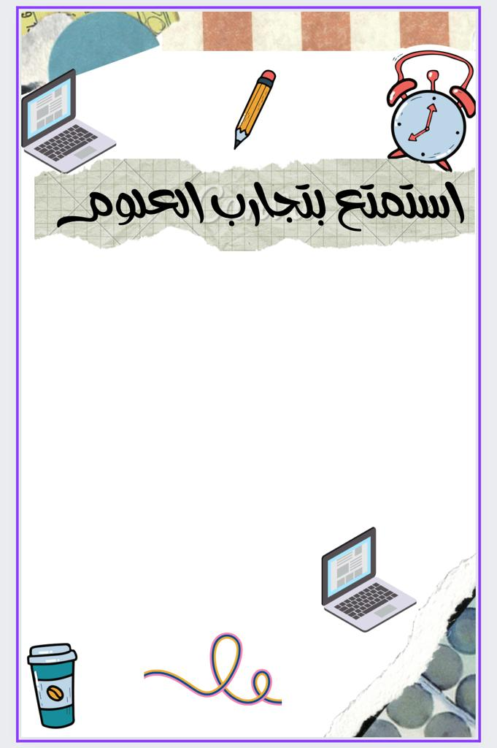

[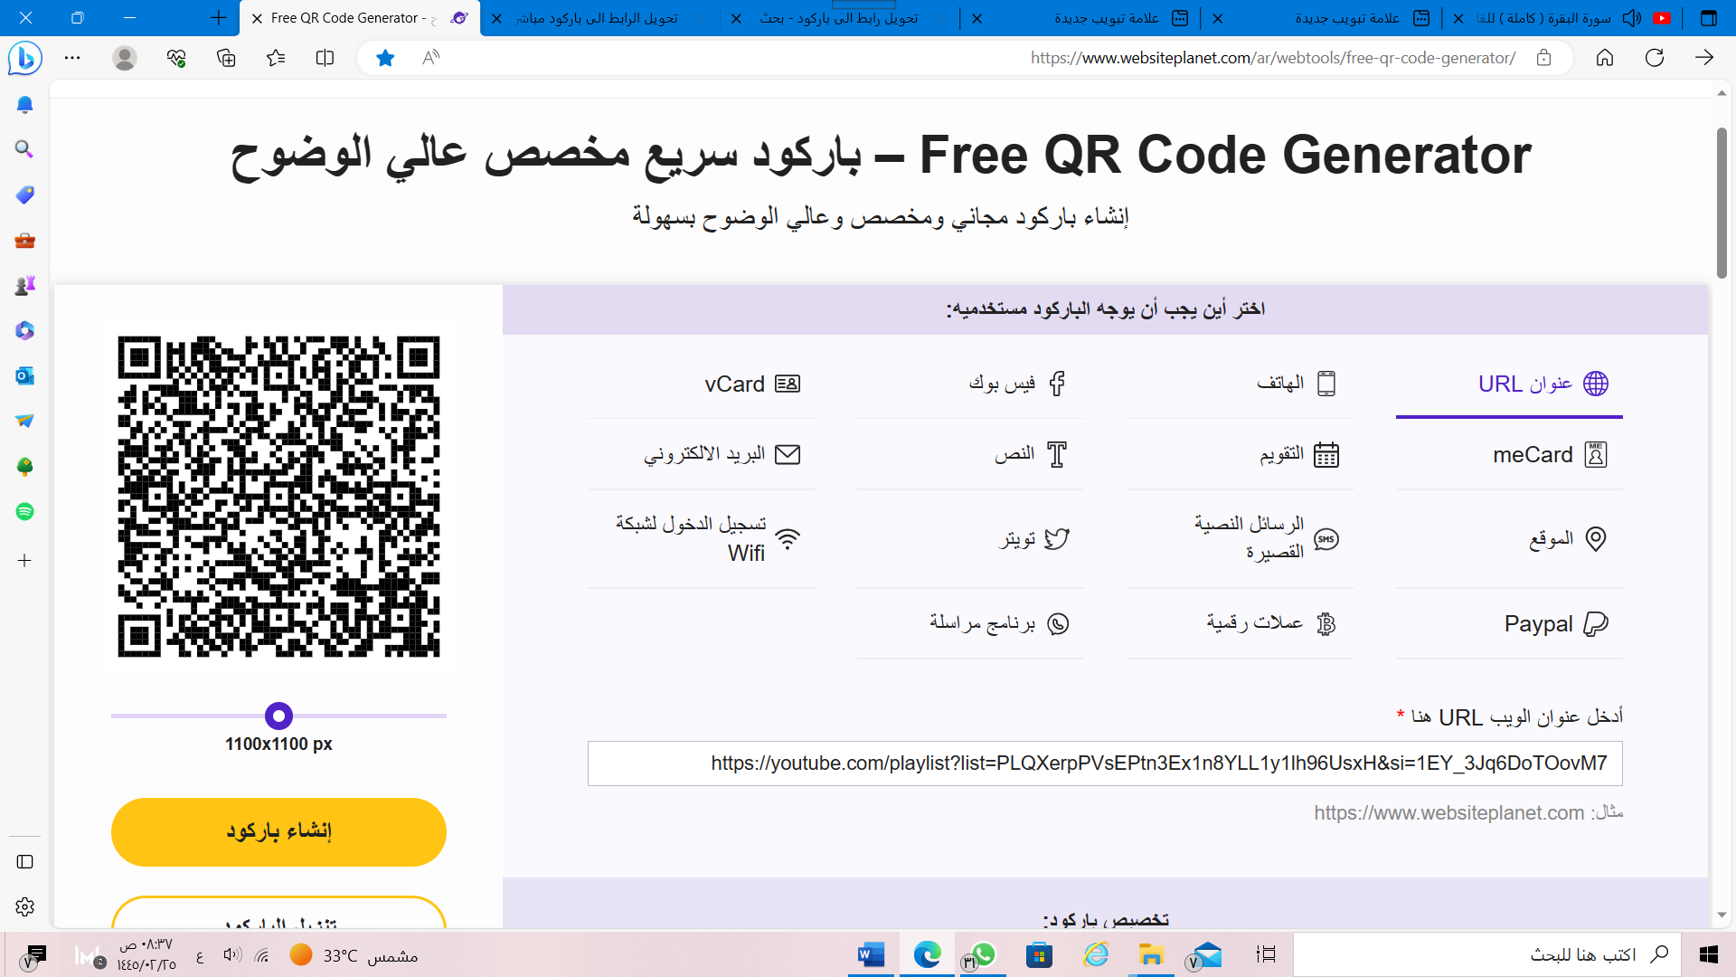](https://youtube.com/playlist?list=PLQXerpPVsEPtn3Ex1n8YLL1y1lh96UsxH&si=1EY_3Jq6DoTOovM7)

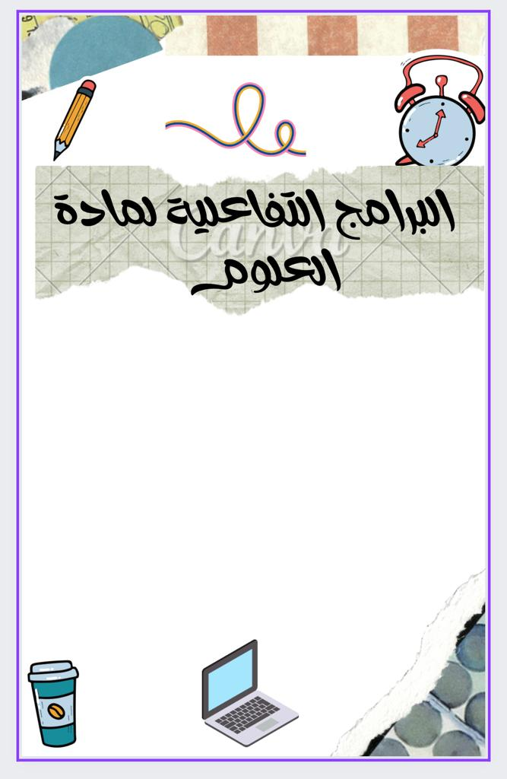

[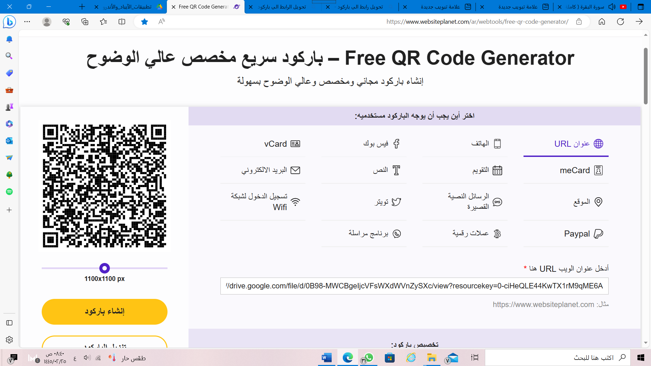](https://drive.google.com/file/d/0B98-MWCBgeIjcVFsWXdWVnZySXc/view?resourcekey=0-ciHeQLE44KwTX1rM9qME6A)

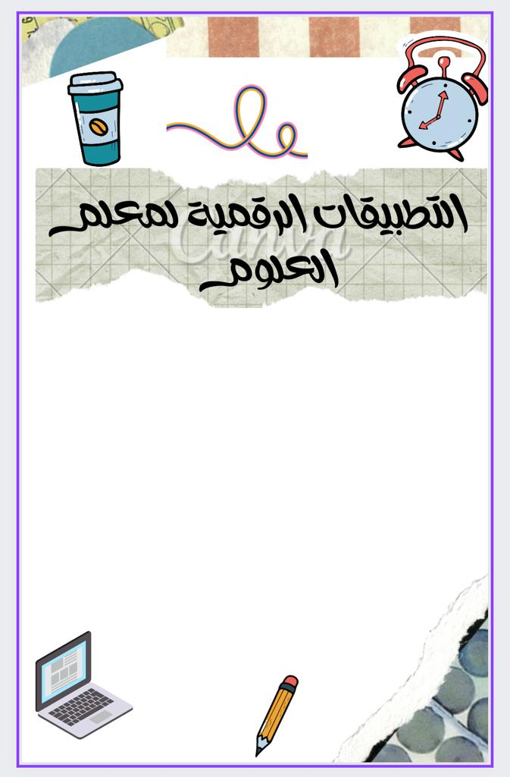

[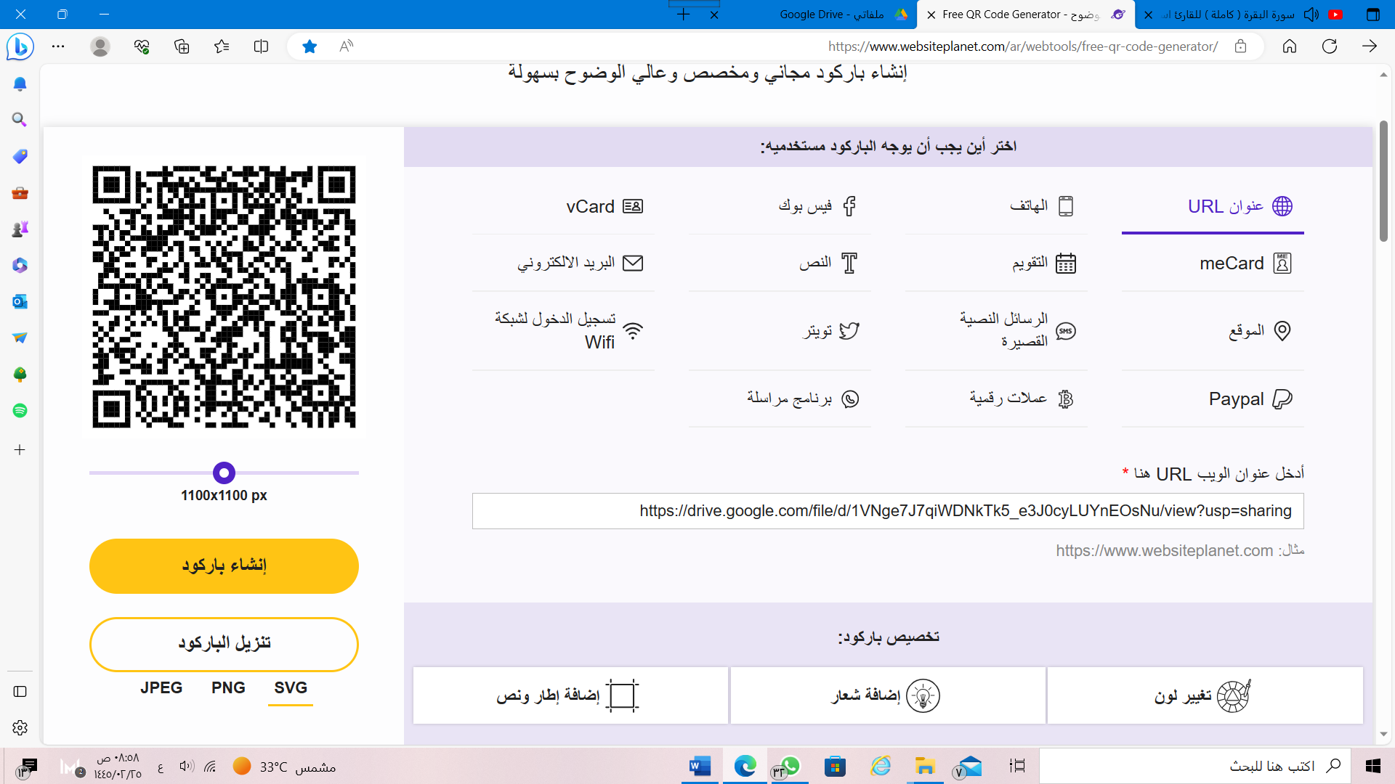](https://drive.google.com/file/d/1VNge7J7qiWDNkTk5_e3J0cyLUYnEOsNu/view?usp=sharing)

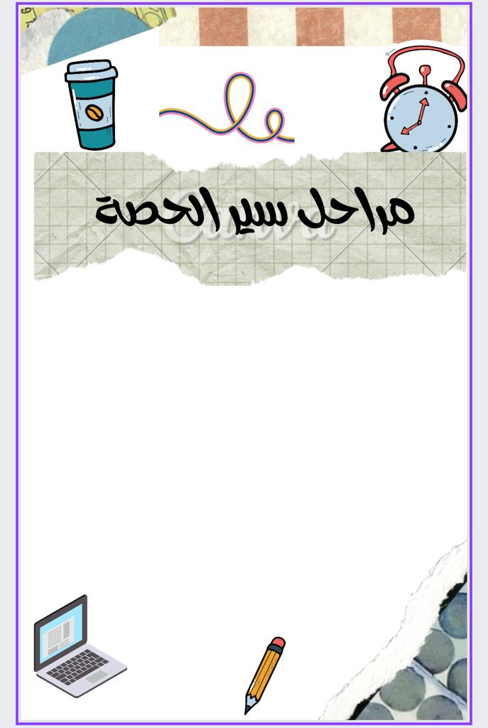

[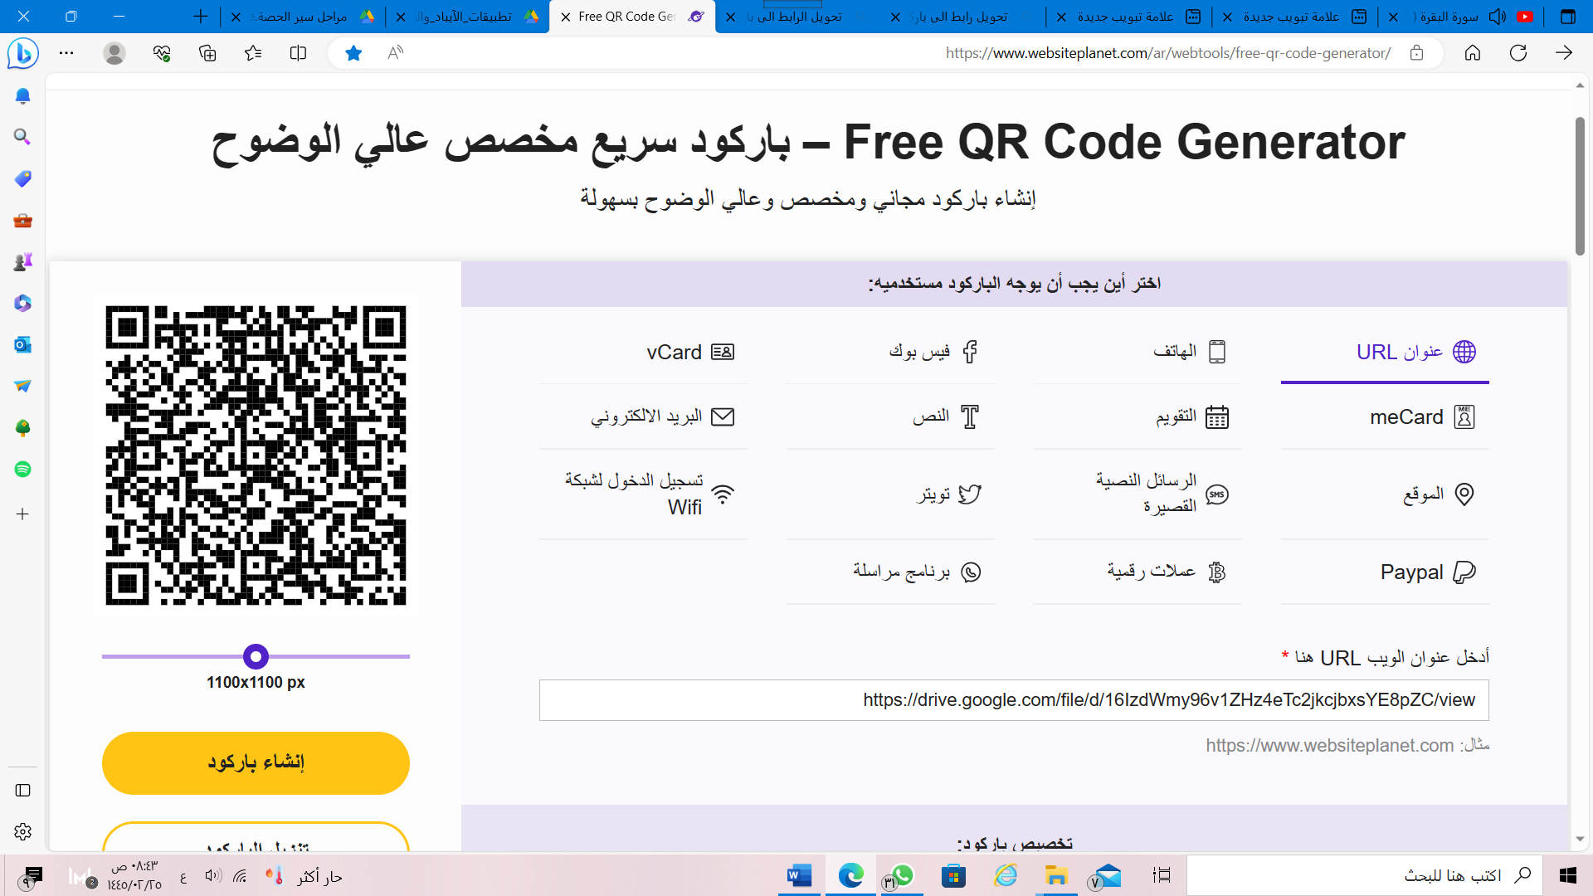](https://drive.google.com/file/d/16IzdWmy96v1ZHz4eTc2jkcjbxsYE8pZC/view)

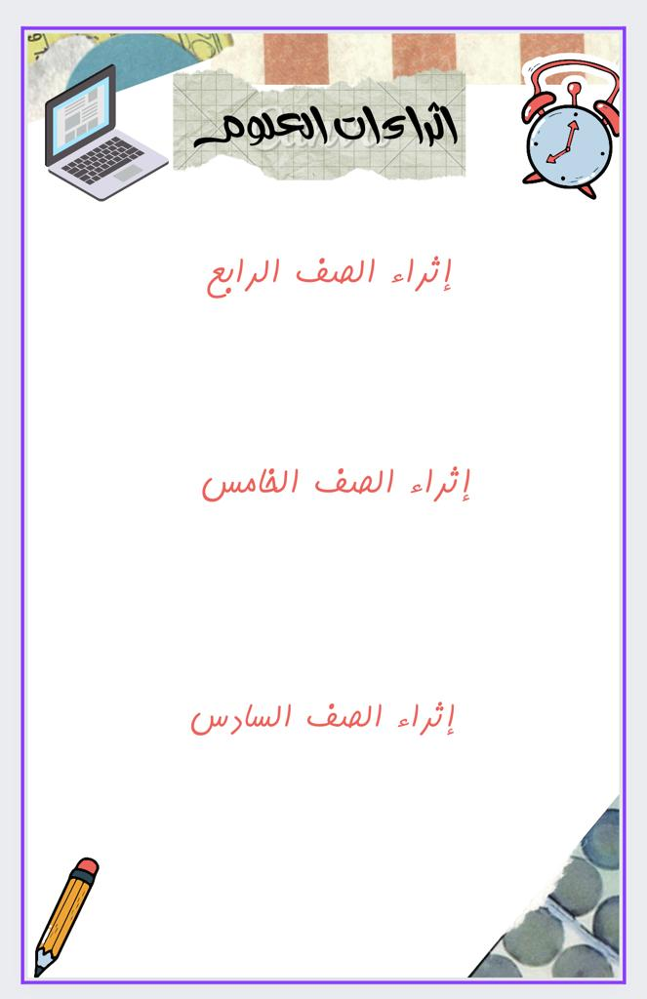

[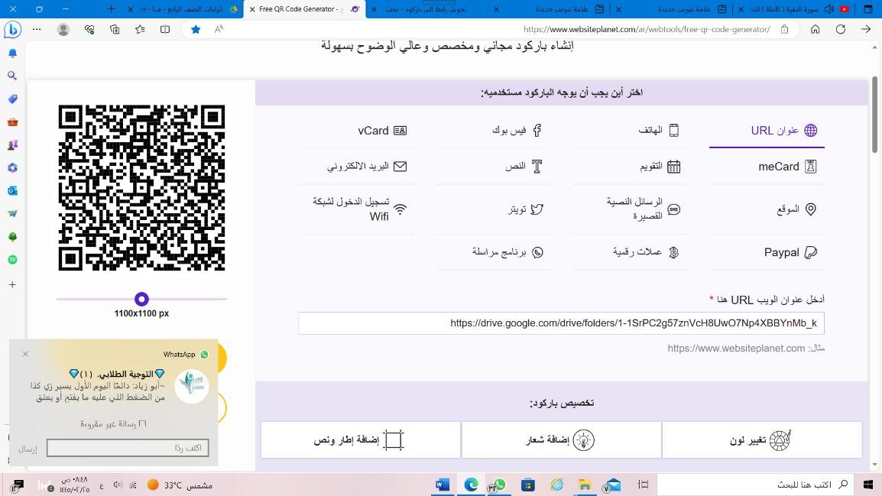](https://drive.google.com/drive/folders/1-1SrPC2g57znVcH8UwO7Np4XBBYnMb_k)

[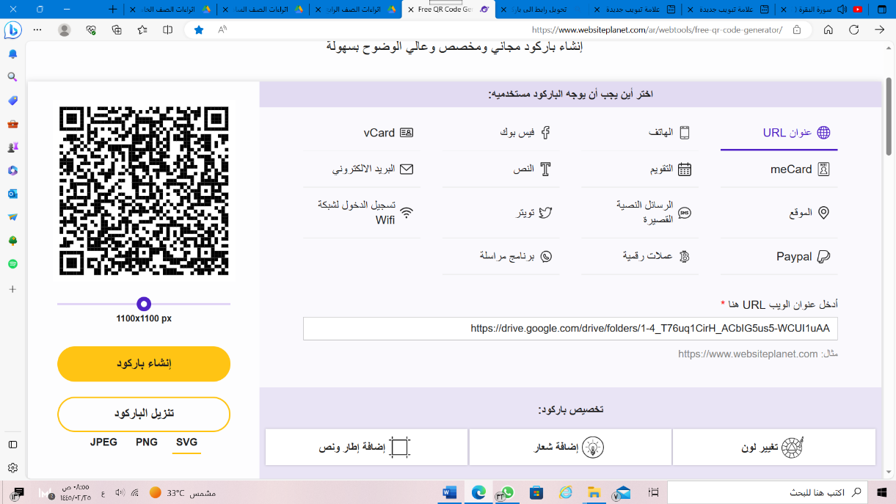](https://drive.google.com/drive/folders/1-4_T76uq1CirH_ACbIG5us5-WCUI1uAA)

[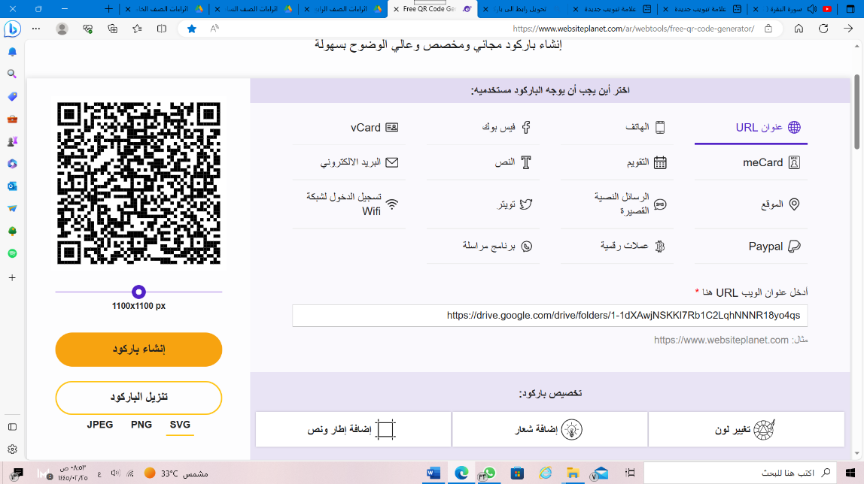](https://drive.google.com/drive/folders/1-1dXAwjNSKKI7Rb1C2LqhNNNR18yo4qs)

