المملكة العربية السعودية  وزارة التربية والتعليم  إدارة تعليم الاحساء |  | الفترة : First period  الصف : اول ثانوي  الزمن : 25 minutes  اختبار :units 1-2
الدرجات | 10 | ..........................

Name:……………………………………………………………………………………………………………………………………..
A-Choose the correct answer :
1-He…………………..( play - plays ) basketball everyday.
2-Salem is…………………….( write - writing ) the letter now .
3- I ……………………( read - reads ) the holy Quran every night.
4-she………………( was - were ) studying math yesterday.
5-They were …………………….( watch - watching ) the series last night .
B- Match the words with their meaning :
a-to provide place for |  | 1-to launch
b- to set up start |  | 2- to host
c- to send into space |  | 3- to establish

c- write the correct word under the picture below .
( TV reporter - pollution - food scientist - traffic )
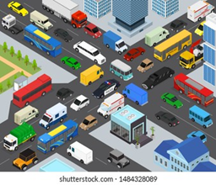
........................................... .....................................................
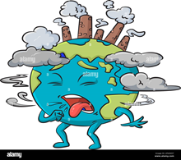
........................................... ....................................................
Unit 1-2 Exam Mega 1.1
Name:………………………………………………… Class :…………
A) Match the word with its meaning Vocabulary
- vibrant ( ) a- center
- established ( ) b- be part of
- fit in ( ) c- set up – start
- hub ( ) d- active & strong
B- Choose the correct answers :
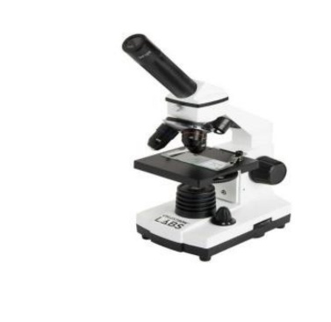
( traffic - sculptor - economy - microscope )

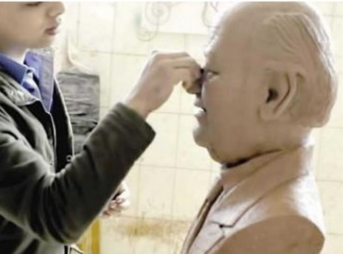
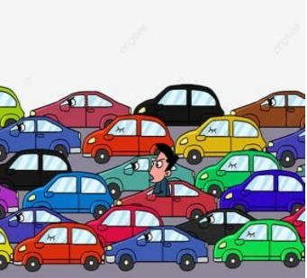

…………….
…………….. ……………….. ………………..
Grammar A ) Choose :
1-It is ( rain – rained – raining ) right now .
2-This is the boy ( who - which – when ) had an accident .
3-He is interested in ( read - reading – reads ) novels .
4- ( How long – How much – How many ) lessons has she explained ?
5-She ( clean - cleaned - cleaning ) her house yesterday .
6-Ahmed has ( eat - eats - eaten ) three burger .
B - Rewrite using capitals :
1- jack decided to fly to new york next monday.…………..………………………………………………….
2-my brother has never been to dubai . ……………………..……………………………………………………
3-riyadh is the capital of saudi arabia . …………………….………………………………………………………

GOOD LOOK
Sara Madkhali .

