We Can! Book 6 Unit 1: Fun on the Weekend

1. Read and match sentences and pictures.

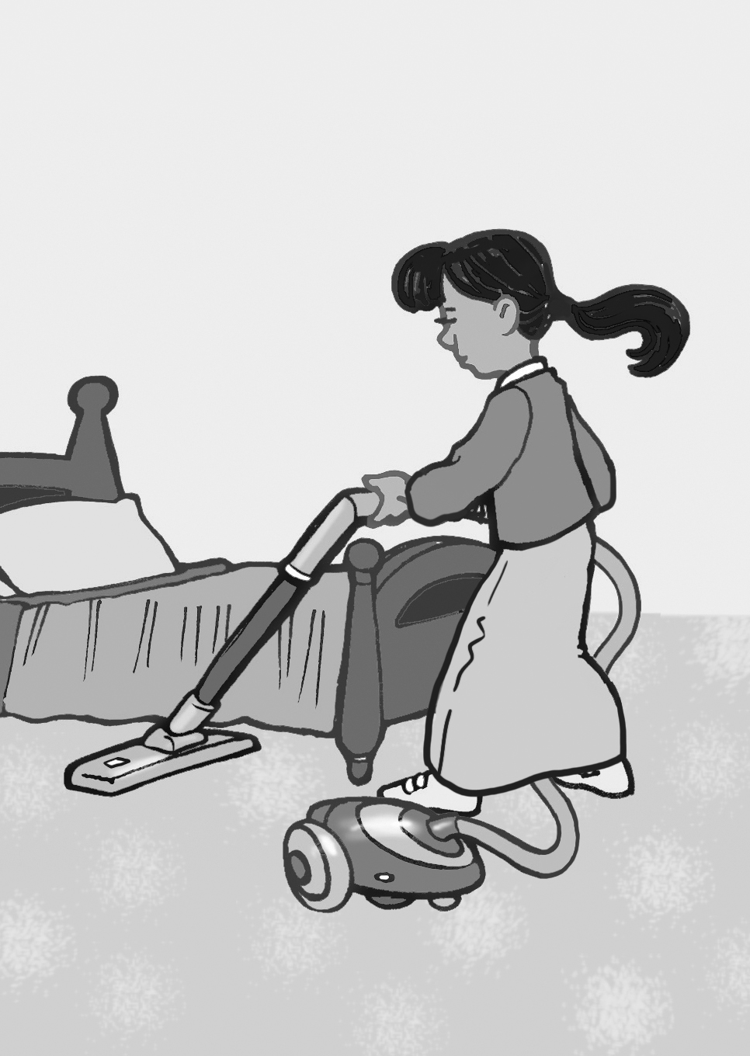 | 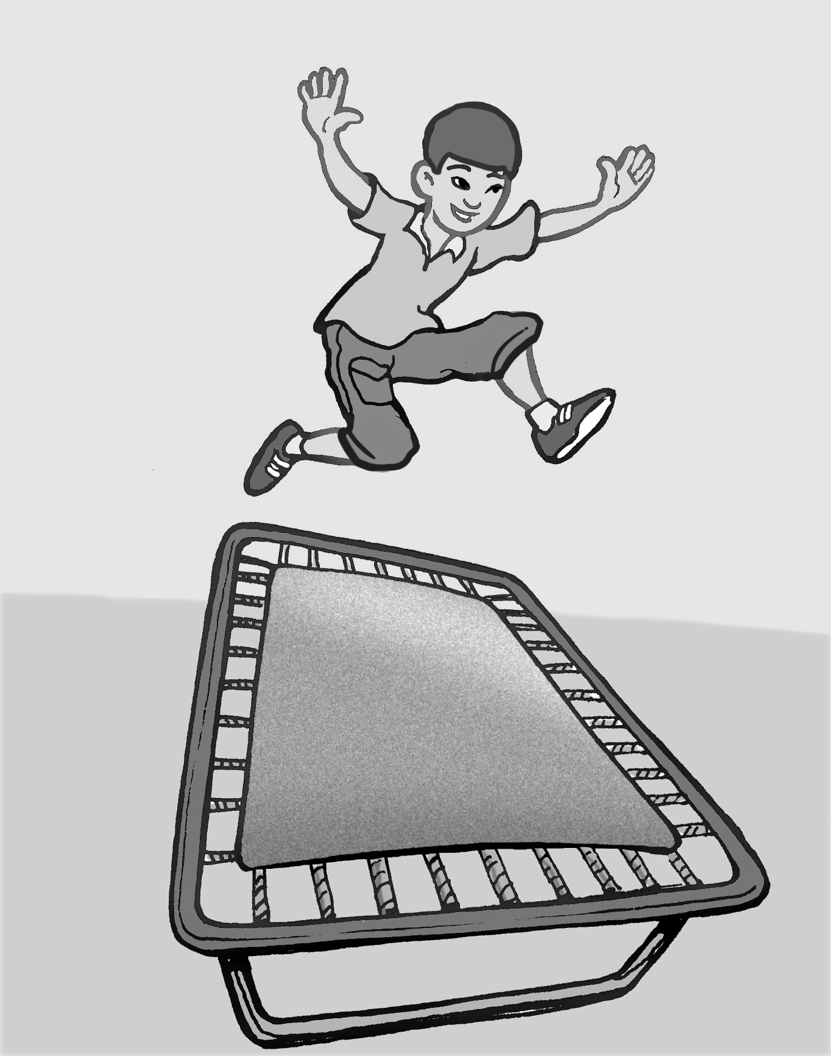 | 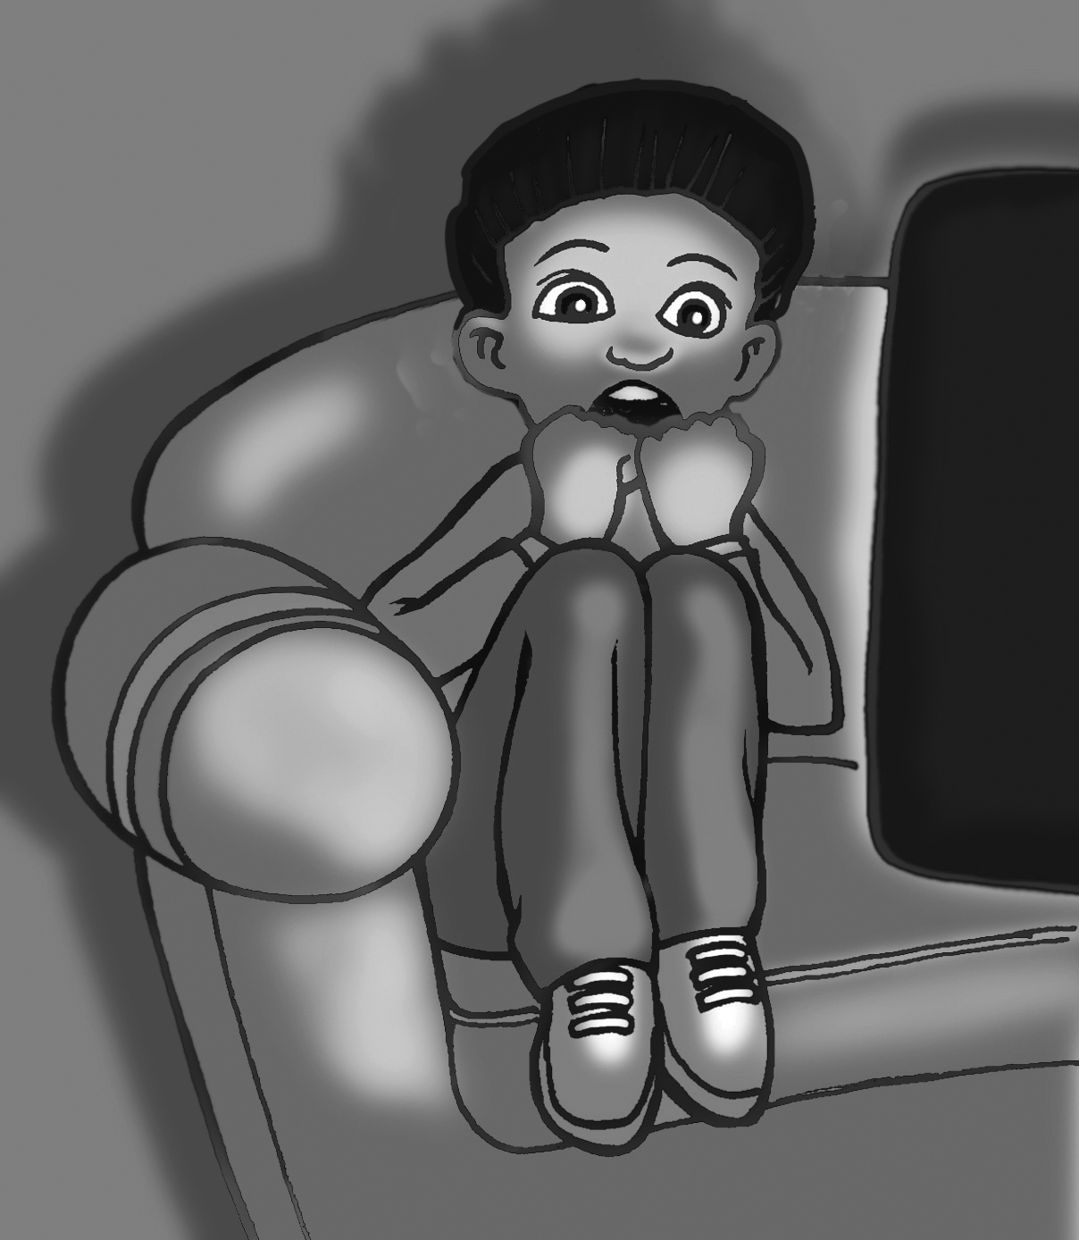 | 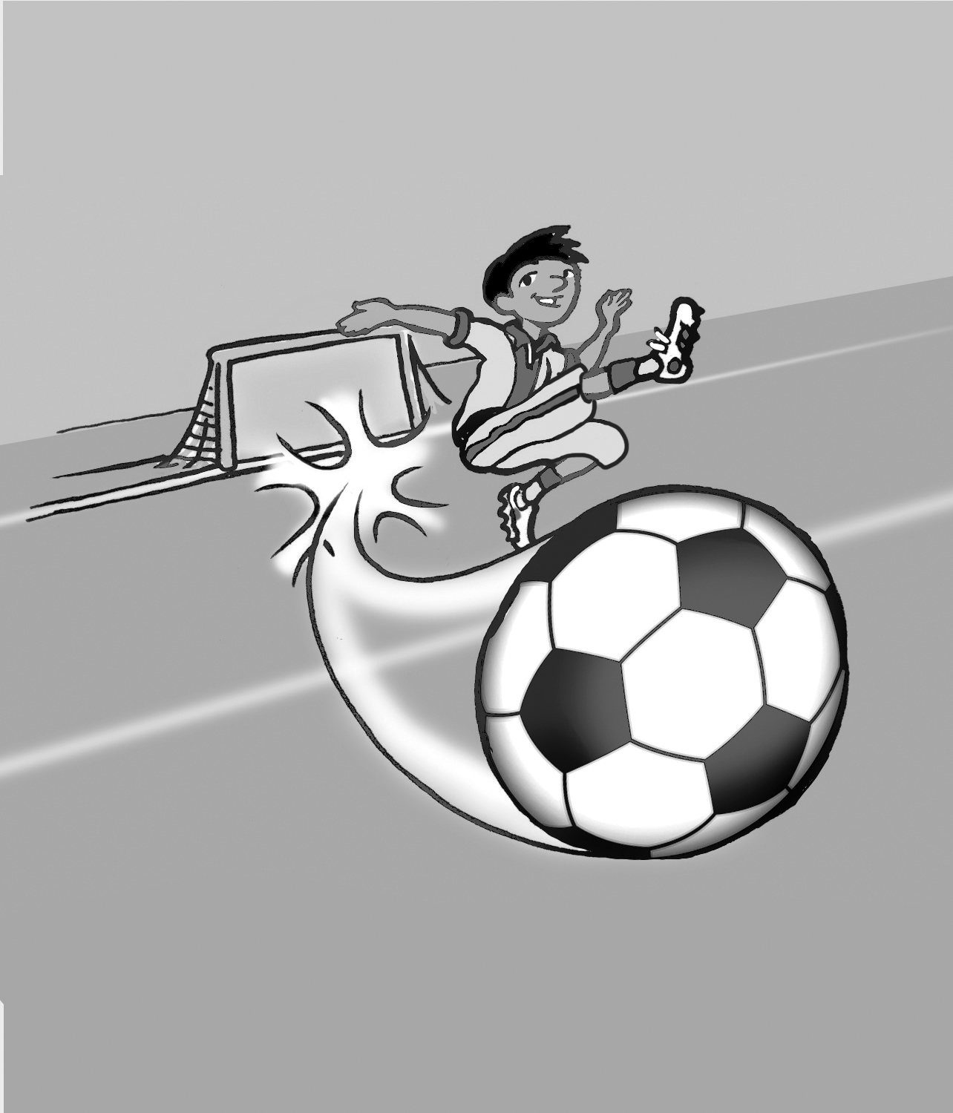
1 | 2 | 3 | 4
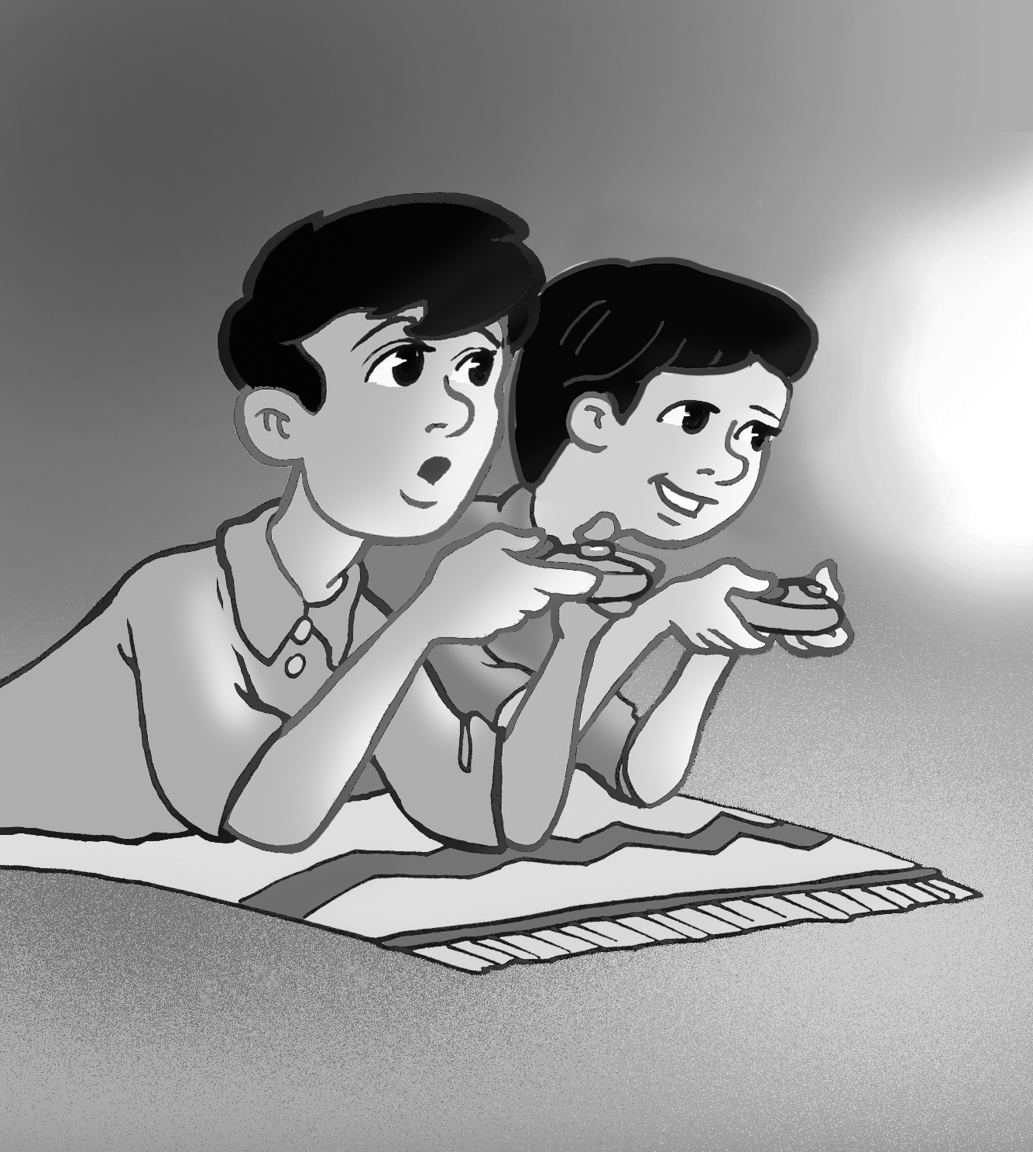 | 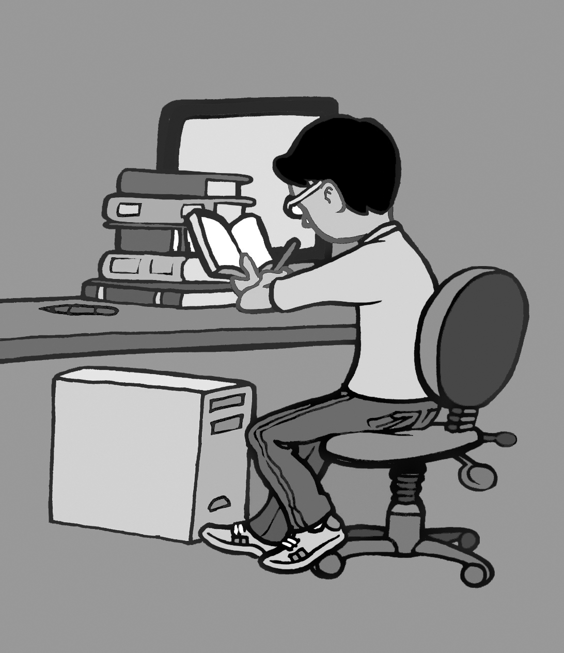 | 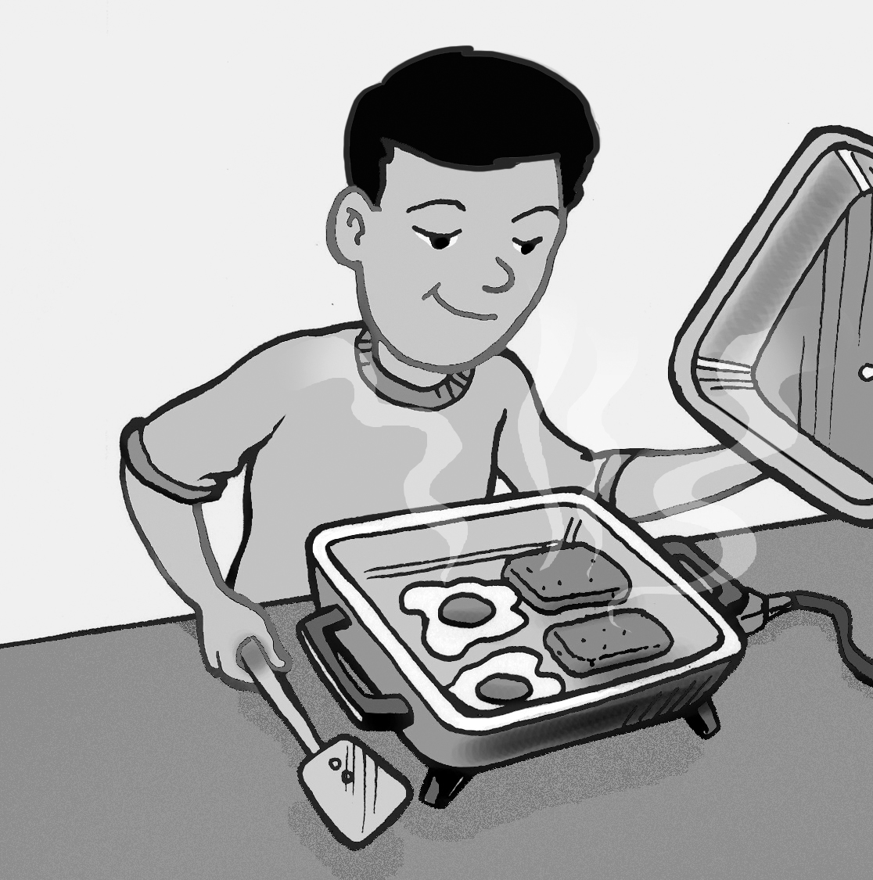 | 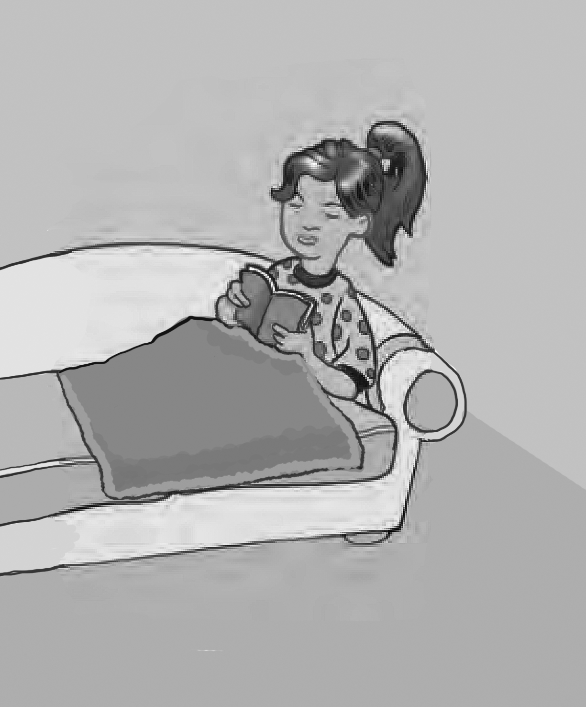
5 | 6 | 7 | 8

___ Nura stayed home.
___ Fahad studied for six hours.
___ Ali practiced on the trampoline.
___ He cooked breakfast.
___ You watched a scary DVD.
___ Saeed kicked the ball.
___ Nura cleaned her room.
___ They played computer games.

What did you do yesterday afternoon?

____________________________________________________
2. Listen and fill in with much or many. Then listen again and circle the right answer.

1. How _____ flour do we need to make a cake?
a. 3 cups b. 4 cups
2. How _____ eggs do we need? I think we need …
a. 5 eggs b. 4 eggs
3. How _____ tomatoes are there in the fridge?
a. 7 tomatoes b. 6 tomatoes
4. How _____ milk do you drink in the morning?
a. About 2 cups b. About 10 cups
5. How _____ apples do we need for the apple pie?
a. I don’t need any. b. I don’t know.

Now listen and fill in with some or any.

6. We have _____ sugar, but we don’t have ____ milk.
7. We have ____ apples, but we don’t have ____ bananas.
8. There is _____ orange juice in the kitchen.
9. There isn’t _____ oil in the bottle.
10. There are _____ chocolates in the box.

3. Read and write about things in your bag. Use some or any.
pencils/ cookies
There are some pencils in my bag, but there aren’t any cookies.

pens/ flowers
_____________________________________________________

books/ toys
_____________________________________________________

Now write your own sentences.

_____________________________________________________

_____________________________________________________

