Lab 13: Sweep Features I; Cranking Lever

The cranking lever details are shown in Figure 1.

Figure 1 Cranking lever

It can be modeled by the following steps as shown in Figure 2.

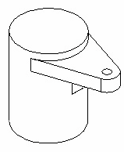

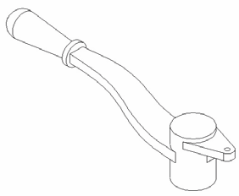

Figure 2 Cranking lever modeling process.

1. Create a cranking lever head using a revolved boss/base feature.

2. Create a crank lever head with an extruded boss/base and revolved cut

3. Add a handle to the handle body using the revolved boss/base.

4. Create two ribs fillets on the crank lever.
Create a Cranking Lever Head

1. Start SolidWorks.

2. Select New on the Standard toolbar, or click File, New on the menu bar.

3. Select Part 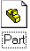 from the Template tab in the dialog box, and click OK.

4. Click File, Properties on the menu bar.

5. Fill in the necessary properties in the dialog box, and click OK to accept the properties and close the dialog box.

6. Click Tools, Options on the menu bar to open the option dialog box.

7. Select the Document Properties tab.

8. Click Unit in the properties tree text box.

9. Select Millimeter and set the decimal places to 2.

10. Click OK to close the Properties dialog box.

11. Select Sketch on the Sketch toolbar to open a new sketch on the Front Plane.

12. Select Centerline on the Sketch Tools toolbar to draw a vertical centerline through the origin as the axis of the revolution.

13. Select Line on Sketch Tools toolbar, and draw and dimension a profile of the cranking lever head as shown in Figure 3.

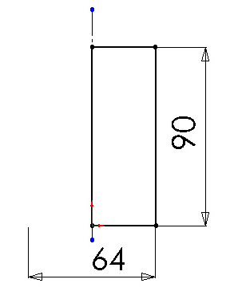

Figure 3 Cranking Lever Head Sketch

14. Select Revolved Boss/Base on the Features toolbar, and click OK .

15. Select the Front plane on the FeatureManager design tree.

16. Select Sketch on the Sketch toolbar to open a new sketch for the lever head rib.

17. Click Normal To on the Standard Views toolbar to make the sketch plane parallel to the screen.

18. Sketch and dimension the lever head rib as shown in Figure 3.
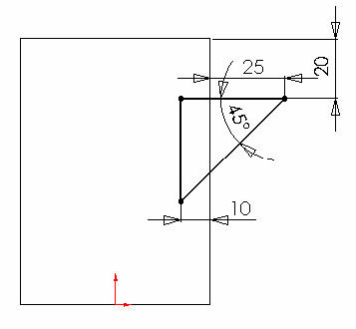

Figure 3 Lever head rib sketch.

19. Select Extruded Boss/Base on the Features toolbar.

20. Select Mid Plane on the End Condition drop down list box.

21. Type 10mm in the depth box under Direction 1, and click OK .

22. Select the top surface of the rib as shown in Figure 4, and open a sketch.

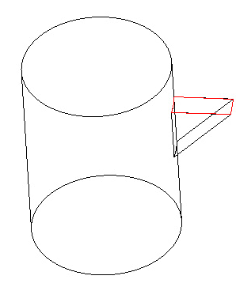

Figure 4 Sketch plane for lever head ear.

23. Sketch and dimension the lever head ear as shown in Figure 5.

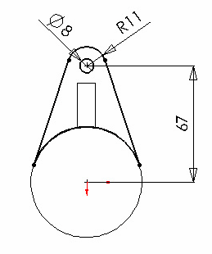

Figure 5 Lever Head Ear Profile

24. Select Extruded Boss/Base on the Features toolbar.

25. Enter 13 mm in the depth box under Direction 1 as in Figure 6.

26. Click OK .

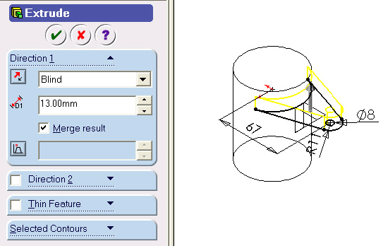

Figure 6 Lever Head Ear Extrusion

Create a Handle Body using Sweep

1. Select the Front on the FeatureManager design tree.

2. Select Sketch on the Sketch toolbar to open a new sketch for the sweep guide curve.

3. Sketch and dimension the sweep guide curve as shown in Figure 7.

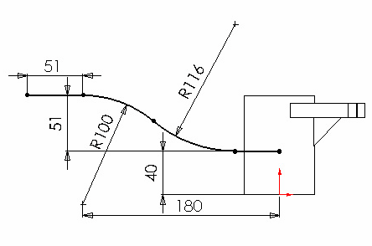

Figure 7 Sweep path

4. Click Confirmation Corneror select Rebuild on the Standard toolbar to exit the sketch.

5. Select Front on the FeatureManager design tree.

6. Select Sketch on the Sketch toolbar to open a new sketch for the sweep guide curve.

7. Sketch and dimension the sweep guide curve as shown in Figure 8.
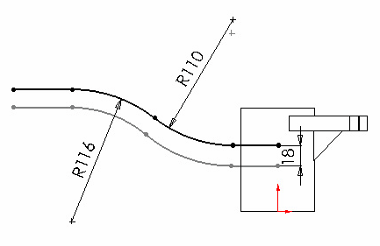

Figure 8 Sweep guide curve.

8. Click Confirmation Corneror select Rebuild on the Standard toolbar to exit the sketch.

9. Select Insert, Reference Geometry, Plane on the menu bar or Click Plane on
Reference Geometry Toolbar.

10. Click the Offset Distance button.

11. Select the Right plane on the FeatureManager design tree, and enter 230 mm in the
Distance box.

12. Check the Reverse direction check box as shown in Figure 9.

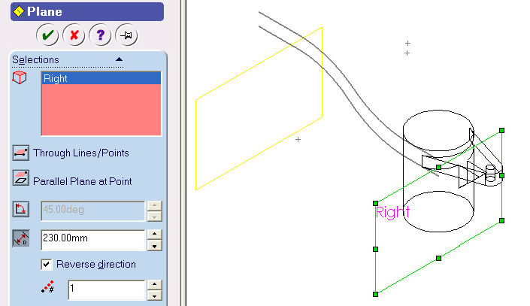

Figure 9 Reference plane for sweep profile

13. Click OK .

14. Select the Plane1 on the FeatureManager design tree or in the graphic window.

15. Select Sketch on the Sketch toolbar to open a new sketch for the sweep profile.

16. Sketch a rectangle. Then, sketch 2 points on the middle of the horizontal edges.

17. Click Add Relation on the Sketch Relation toolbar.

18. Apply Midpoint constraint to these two points.

19. Select the sweep path, and the bottom point, and apply Pierce constraint as shown in Figure 10.

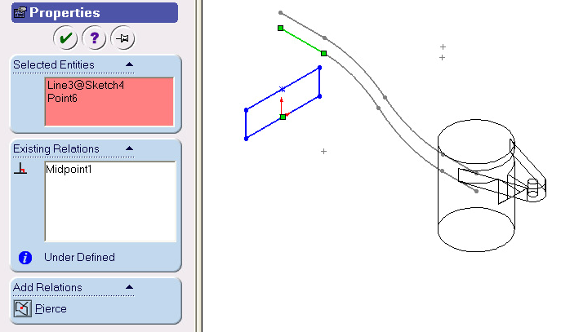

Figure 10 Pierce Constraints between Profile and the Path

20. Select the guide curve, and the top point, and apply Pierce constraint as shown in Figure 11.

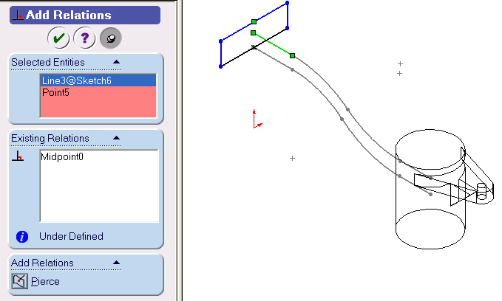

Figure 11 Pierce Constraint between Profile and Guide Curve

21. Dimension the width of the rectangle to 64 mm as shown in Figure 12.

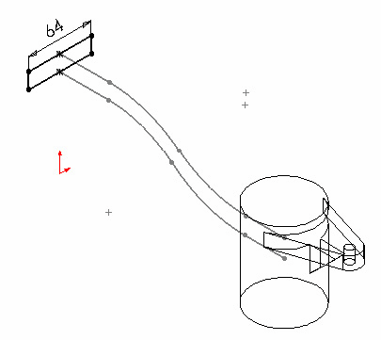

Figure 12 Profile dimension

22. Click Confirmation Corner or click Rebuild on the Standard toolbar to exit the sketch.

23. Select Sweep Boss/Base on the Features toolbar.

24. Select the path (Sketch 4) in the path box under the Profile and Path frame.

25. Select the guide curve in the Guide Curves 4 box as in Figure 13.

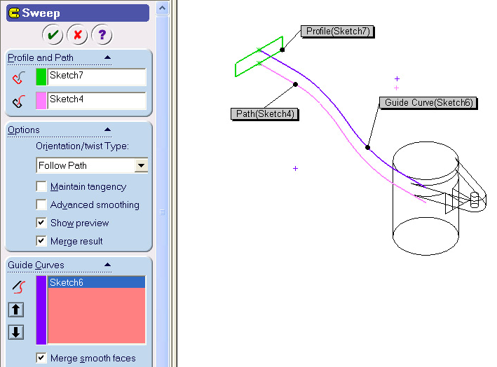

26. Select OK.

Figure 13 Sweep parameters.

27. Select the bottom surface of the lever head as shown in Figure 14, and open a sketch.

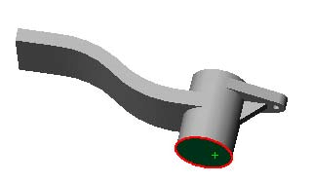

Figure 14 Sketch plane for lever handle cut.

28. Select the head circle, and click Convert Entities on the Sketch Tools toolbar to create a circle on the sketch plane.

29. Sketch three lines, and Trim the circle to form the cut profile as shown in
Figure 15.

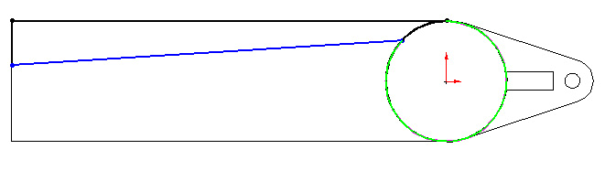

Figure 15 Lever Body Cut Sketch

30. Select Add Relation on the Sketch Relations toolbar. Select the arc and the angled line, and apply a Tangent constraint to them.

31. Dimension the sketch as shown in Figure 16.

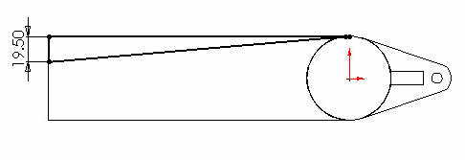

Figure 16 Lever body cut profile

32. Select Extruded Cut on the Features toolbar. Select Through All on the end condition drop down list box, then click OK

33. Select the last Feature created in FeatureManager Design Tree, i.e., Cut-Extrude 2,
you may or may not have a different name for this Feature.

34. Select Mirror on the Features toolbar. The body cut (Cut-Extrude 2) should be selected as the mirror feature. If not, select it. Then select Front plane on the FeatureManager design tree as the mirror plane.

35. Click OK to mirror the cut to the other side as shown in Figure 17.

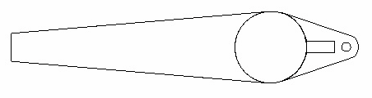

Figure 17 Lever body

Create Lever Handle and Head Hole Using Revolved Features

1. Select the Front plane on the FeatureManager design tree to open a sketch for the lever handle.

2. Sketch and dimension the profile as shown in Figure 18.
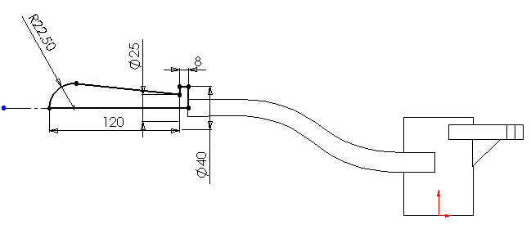

Figure 18 Lever handle profile.

3. Select Revolved Boss/Base on the Features toolbar.

4. Click OK to create the revolved lever handle.

5. Select the Front plane again in the FeatureManager design tree to open a sketch for the head hole cut.

6. Sketch the hole cut profile as shown in Figure 19.

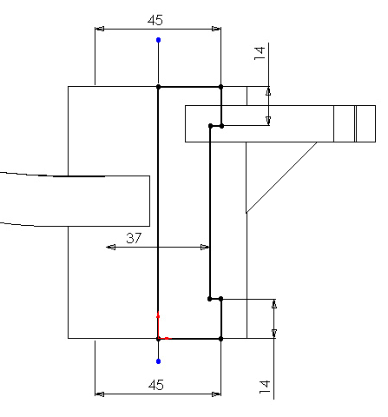

Figure 19 Head hole profile.

7. Select Revolved Cut on the Features toolbar, and Click OK create the head hole

Create Handle Rib and Fillets

1. Select the Front plane in the FeatureManager design tree to open a sketch for the rib.

2. Sketch and dimension the profile using Line as shown in Figure 20.
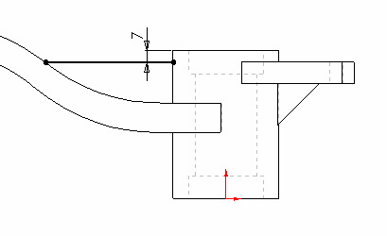

Figure 20 Handle rib profile.

3. Select Rib on the Features toolbar. Select Both Sides , enter 10 mm in the
Rib Thickness box and check Flip material side as shown in Figure 21.

4. Click OK to create the rib.

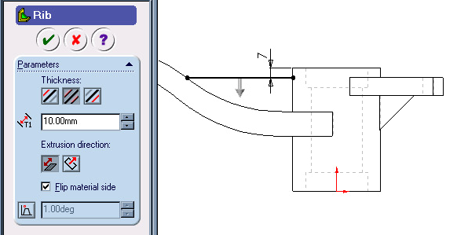

Figure 21 Handle rib parameters.

5. Select Fillet on the Features toolbar, and enter 2 mm in the Radius box.

Select edges around the rib edges, handle edges as in Figure 22. Then click OK
to create fillets. The final model for Cranking Lever is shown in Figure 23.

6. Save the Model.

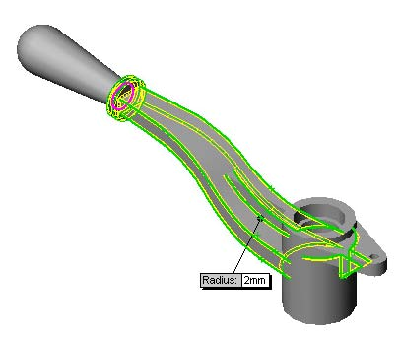
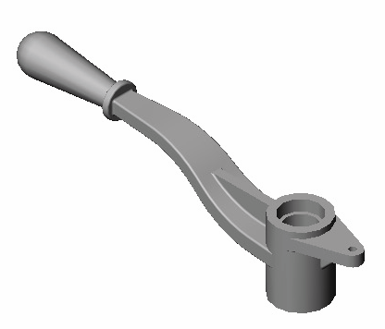

Figure 22 Cranking Lever fillets. Figure 23 Cranking Lever model.

